Fourth World’s Final Gasp
Well the flurry of excitement over Avengers: Infinity War has faded, the disk is now available in retail outlets everywhere (on a whim I bought my in a grocery store), and the tale of the evolution of the Infinity Gems/Stones from the early introduction of the unnamed gem on Adam Warlock’s brow to the culmination of 6 gems decorating Thanos’s fist has run its course.
In this post, I want to return to the prior thread and close out the final stages (at least so far) of the New Gods and Kirby’s Fourth World. Earlier posts traced the conception and execution at the hand of the King in the 1970s, the fallow years from the mid-1970s to 1988 (despite some shining moments involving both the Legion of Super-Heroes and the Teen Titans & X-Men) and the reawakening at the hands of Jim Starlin in Cosmic Odyssey.
But before moving forward, a single detail of the past should be noted for completeness. In anticipation of the success of Cosmic Odyssey or in an attempt raise awareness, DC issued a 6-issue limited series of The Forever People in 1987 and 1988. As limited series go, the art was good (perhaps even very good) but the story was notably forgettable. A trait that sadly would be a too often reoccurring one in next twenty years.
After Cosmic Odyssey had closed out in 1988, DC Comics relaunched both Mister Miracle and The New Gods titles. Both series ran for 28 issues each and came to an end in 1991. Both series were distinguished by the good writing of Peter David and Mark Evanier, respectively. Mister Miracle was especially amusing and was tightly intertwined with the Justice League books being written by David during the same time frame. Evanier’s tenure on The New Gods was marked by a more serious tone concerning the aftermath of Cosmic Odyssey (especially Bug’s death) and the universal struggle to make sense of war. Nonetheless, neither series provided storylines that stuck with the reader well after the reading was done and DC’s entire Fourth World efforts came to a close in 1991.
Between 1995 and 1998, DC took another swing at the Fourth World, with an entire spate of new books. Five in fact. Of those two books, New Gods (1995) and Jack Kirby’s Fourth World, lasted over a year. Neither book made it to two years. The other three – Mister Miracle (1996), Takion, and Genesis – were limited series with limited appeal. The entire enterprise came and went without making much of an impression despite fine writing and art on the two main works. I’ll return to this observation below.
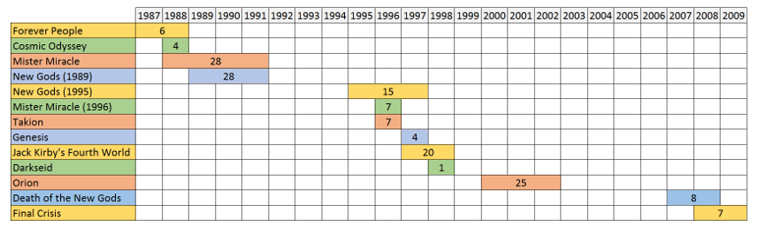
The next shot came in 2000 with a series primarily focused on Orion of the same name. Written and illustrated by Walt Simonson, the work, from the perspective of technique, was even better than the earlier incarnations but, nonetheless, failed to garner a lasting audience. Simonson mixed things up by focusing on the two sons central to the tension between New Genesis and Apokolips – Orion and Scott Free. The two sons were traded by their respective fathers, Darkseid and Izaya, in order to stop the war between their planets. This plot point, originally conceived by Kirby, should have a been the source of great drama but the stories were hard to relate to. Again, I’ll defer commenting on this until the conclusion below.
The final stage came with the storylines Death of the New Gods in 2007 and Final Crisis in 2008. Jim Starlin again takes over the writing chores for the first title but I’ll confess that the story didn’t reach the heights of Cosmic Odyssey. While worth reading, the characters failed to resonate and the ‘cosmic’ part didn’t quite have the wonder and awe of the earlier installment. Final Crisis was written by Grant Morrison and merely used the New Gods as another trigger for yet another reboot of the DC universe.
Before coming to the end, I would like to reflect on what keeps the New Gods from making a lasting presence in the DC Universe. There are two primary reasons. First, many of Kirby’s concepts are eye-catching and flashy but fail to ultimately satisfy. There is a great deal of promise but never quite enough of substance to really carry a long standing title forward. Second, the characters of the New Gods lend themselves to props or plot elements that propel the drama for more ordinary characters forward rather than serve as central figures themselves. This is why the best titles (e.g. The Great Darkness Saga, The Dark Phoenix/Darkseid event for the X-Men and New Teen Titans, and Cosmic Odyssey); the New Gods are back drops to the human drama not central players.
Final note: DC has once again dipped its toe into the New Gods with the Mister Miracle 12-issue limited series no under publication. When that series closes out, I’ll revisit this last contribution for old time sake.

