What Exactly is Insurance?
One would have to be living under a rock not to know of all the debate that rages within the media and the halls of government associated with the Affordable Care Act (ACA). In this post, I don’t want to weigh in that subject directly but I do want to explore a related topic – namely what is insurance.
The reason I think that is timely to do so is that there can’t be a reasoned (and reasonable) debate without being able to agree on what terms and words mean. Zealots from all sides of the political arena start from the premise that “if you are not part of my solution you are part of the problem”. Going hand-in-hand with this presumption of guilt for anyone not espousing their ideas is the presumption that their own use of words is the only correct one. The more annoying of these even delight in conflating words and ideas if it suits their needs – having the ends justify the means.
Nowhere does this it-means-whatever-I-want-it-to-mean word usage seem to show up on the political landscape more than in the discussions of economics. And within the subject of economics and its application to health care, no term seems to be as susceptible to vague interpretation as health care. The problem is what we exactly mean by health care. Is health care a type of insurance or is it something different? And what exactly is insurance?
To attempt to explore this last question, let me first tentatively define insurance:
Insurance is the process whereby a group of people pool their resources together (voluntarily or by law) to mitigate a risk that results from incomplete information about who and how many will be adversely affected by the outcome that results if the risk is realized.
This definition may seem a bit more complicated than the Merriam-Webster definition ‘an agreement in which a person makes regular payments to a company and the company promises to pay money if the person is injured or dies, or to pay money equal to the value of something (such as a house or car) if it is damaged, lost, or stolen’ but they both convey the same ideas. I’ll list those ideas and then explain them a bit with some examples.
The key features of insurance are:
- Bad part - There is an event that presents an adverse outcome (injury, car stolen, house burned down, death causing the loss of my income, …)
- If part - Uncertainty in whether the event will occur and to whom (if…)
- Payout part - A pool of money that is used to partially or wholly correct the situation (money or payments)
To understand this definition in more detail let’s consider a very simple case. Suppose there is a rare disease that affects only 10 percent of the population and which causes a long term disability where a person can’t earn a living for 10 months. The situation can be presented schematically as

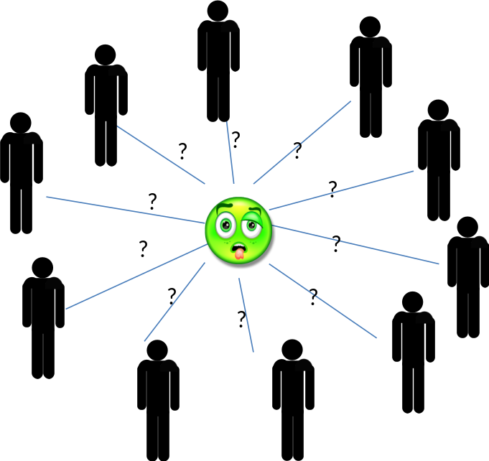

Now suppose that you are one of the people who could be afflicted. How much money should you save to mitigate the risk? Well, if you were mitigating this risk by yourself, the answer would be that you would have to save up 10 months of reserves (money, food, water, whatever) against the possibility that you would be the target. If you cooperated with the nine others in the community, than each of you could save 1 month of reserves with the idea that all of you would contribute to the one who gets ill. This savings for the possible use by someone else is called the premium.
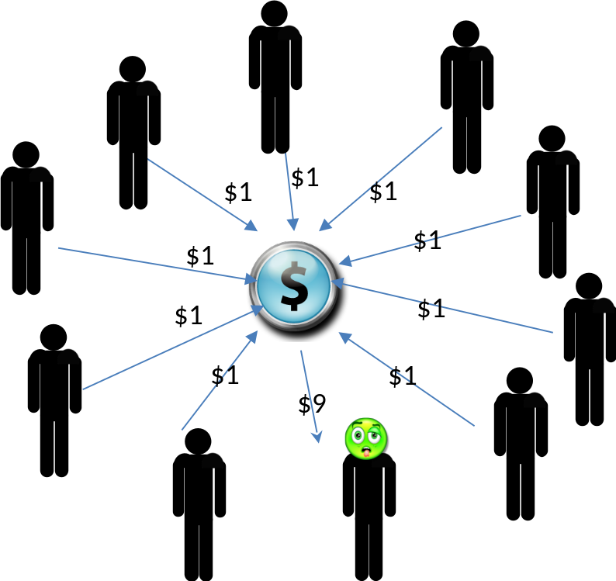

On the surface, all of this should seem very familiar and quite obvious. There are, however, several sets of tricky questions with which one has to wrestle.
First, it is clear that the situation is clearly advantageous for the one who gets sick but is it advantageous for those who remained healthy? True they only had to save 1/10 of what they would have had to save otherwise but that 1/10 is now gone and they cannot use it unless they become sick. In the case where each person mitigates his own risk, he is in complete control on how to judge that risk. He can decide at some point to stop worrying about the disease and he can begin to tap into his reserves. He can guess right or wrong, but he is the one making the choice. In the case of the ten-person community, each person surrenders control of their premium. Who then decides? How are the decisions reached? Since control is now surrendered, it often turns out that one or more of the healthy members regrets paying the premium, regarding it as a waste of resources. How does the system work if too few people participate because they reason that way? Should they be forced by law to do so (as is the case for car insurance)?
Second, is it always the case that exactly 1 person out of the 10 will get sick? Generally, the rate of infection is an average measure with some outbreak having fewer victims and others having more. How much should each member really donate to handle this uncertainty? Who gets to hold onto the reserves should no one get sick? How should the community divide the reserve if more than one member gets sick and there simply isn’t enough to satisfy the need? Answering these questions and caring for the reserves became the responsibility of the insurance industry. They employ armies of statisticians, called actuaries, who try to set reasonable amounts for the premiums. They also seem to employ armies of brokers for determining where the reserves go when not being paid out (e.g., where does the money get invested) and armies of lawyers to make sure only the minimum amount is paid. How should the community as a whole regulate these armies? What are the rights of the individual? What are the rights of the firm?
Both of the previous sets of questions naturally arise from the basic arrangement of insurance as defined above and are worth debate. But there is a third and trickier set of questions that are often posed that where the concept of the ‘if part’ is stretched outside of a decent boundary. When there mental gymnastics are engaged, the term insurance becomes mangled and its meaning is broaden to the point where it becomes meaningless.
This situation occurs when the ‘insurance’ is used to mitigate an adverse outcome that is guaranteed to happen. It is not a case of ‘if’ but of ‘when’. As a concrete example, consider the question as to when members of our 10-person community will become hungry? Clearly hunger is an adverse outcome (‘bad part’) that can be solved with an allocation of resources (‘payout part’) but is it a risk (‘if part’)?
If the community were farmers then the hunger question could be recast as a risk if the insurance where stated as ‘If a member’s crops should fail then that member would go hungry and crop insurance would satisfy a claim’. But it is disingenuous to call protections against any occurrence of hunger insurance.
Consider a car insurance policy. No insurer includes items of standard maintenance like oil change, replacement of wiper blades, shocks, struts, and tires. Even more ridiculous would be the expectation of an insurance policy that protects running of gas, not in the sense of being stranded on the road, but in the simple and regular sense of having consumed gasoline in the course of driving.
Let me be clear, I am not against having societal protections against hunger or methods for making sure other health needs of the poor or disadvantaged are being met. But it is disingenuous to call those protections a type of insurance. Doing so seems to be a marketing technique that is designed to confuse two related but distinct issues in the minds of the electorate.
(The interested reader is invited to read about the distinctions between term life insurance and ‘whole life insurance’ and the debate on Wikipedia about whether it is better to call the latter by the term assurance.)

