Free Electric Riders
In previous posts, I discussed the concept of the free rider and the harm that such a member of society can do to a common good. In this post, with a decidedly impish tone, I identify the growing number of free riders and the related villains that I will call cheap riders, how they are harming our road and highway infrastructure. And with a more serious air, I will suggest what can be done.
Who are these societal ne’er-do-wells? In what grimy back alley can we find them? How many of them are there and why aren’t the police cracking down? Well, we need go no further than our own neighborhoods. Look around your street or at your work. Find those among us who own and drive electric cars and you will find these despicable free riders. Seek out those of us with fuel-efficient hybrids and you’ve found the cheap riders who are also not contributing their fair share. Look for those of us that eschew car ownership completely but expect the advantages of mobile society and you’ll have discovered a different kind of rogue. Ranking the villainy of each of these groups is difficult as men of good conscience can agree to interpret the same facts differently. I judge the weight of their societal blight based on a combination of sheer numbers and on overall the snarkiness of their mindset.
Now before a group of traditional internal-combustion enthusiasts band together to form a flash mob that begins to tar and feather these more ecologically-minded (or in the case of the Tesla more futuristically-minded) of us consider that it isn’t their fault. To paraphrase Shakespeare’s Julius Caesar (Act 1, Scene 2), the fault dear reader lies not in our stars but in our poor understanding of economics.
The generally understood and designed way of supporting our roads was constructed in the days of yore to be a per-gallon tax on gasoline or diesel. The idea here is that ‘those that drive on it will be those that pay for it’. A fine sentiment that may have made sense back in the day when June Cleaver and her immaculate dress and fine pearls roamed the Cleaver household cleaning and cooking but which now seems dated and stupid in these more enlightened days of electronic everything.
Consider first that marvel of modern engineering the Tesla. A fully electric car, the Tesla neither consumes a drop of gasoline nor does it emit a molecule of exhaust gas from the combustion of a fossil fuel. Stealthy and silent, you can’t hear it come upon you nor can you hear the damage it does to the roads upon which it travels. Nonetheless, its passage on the roads does do damage both in the physical and in the economical sense. The Tesla driver is able to take advantage of the roads without paying for their upkeep, effectively circumventing the ‘those that drive on it are those that pay for it’ maxim. And to heap insult on injury, many places, such as the progressively-minded University of Maryland, provide free parking and free charging to this scoff laws.
This guilt is equally born by those who have plunked down far less money to own a Leaf or a Volt or whatever other kind of electric car is out there. In all these cases, the tragedy of the commons is occurring before our very eyes and rather than scream in outrage we applaud their contribution to society.
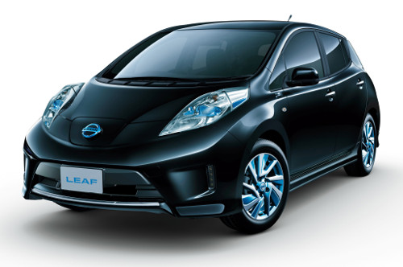
Closely behind this no-emissions crowd, is the more sinister hybrid owner, who makes up in volume what he lacks in technology. Exemplified by the ubiquitous driver of the Toyota Prius, he seems to be, on the surface of it, a nice enough kind of guy. He drives to the same markets you do, you pass him on the road to work every day, and you both buy your gas at the same stations. It is his ability to blend in that tricks you into missing the inestimable harm he is causing to our roads. Found in far greater numbers than his all-electric brethren, he puts large number of road-bashing miles on our nation’s bridges and boulevards while paying a minimal amount of gasoline tax for the ‘privilege’.
Some numbers should help to put this dire situation into clearer focus. Take a side-by-side comparison between the Toyota Prius and the Ford Fiesta; both vehicles being similarly-sized offerings in the small car category. The Prius tips the scales with a curb weight of 3072 lbs compared with the Fiesta’s slightly lighter 2537 lbs. Assuming a 60-40 split between city and highway driving, the Prius’s effective gas mileage is 49.8 mpg compared with the Fiesta’s effective 35.8 mpg. The implication here is clear. The Prius delivers 20% more pounding to the road (3072/2537) than the Fiesta does while paying 40% less for the upkeep (49.8/35.8).
But no demographic is as sinister as the car-less. These people would pass themselves off as being above the fray – free from the mad obsession with driving from hither to thither. After all, why can’t people live where they can bike to work, or walk to the market. This holier-than-thou attitude blinds them the fact that all of their basic services and creature comforts come from the nation’s roads. How else does the organic food they eat make it to market? How do they products they consume, the electricity that they use, the medical services they pine for come to their locale without the infrastructure used by the driving crowd?
So the answer seems to me to be quite clear. All of us have a vested in interest in the common good that is the nation’s highways and byways. Just like public schooling or national defense or police and fire services, the roads are a common good that works for all and that should be paid for by all. The idea that ‘those that drive should be those that pay’ is ridiculous and should be met with as much scorn as is heaped upon those that say “I don’t have any children why should I pay for schools”.

