Turning an Old Saying on its Head
Time is money. From our earliest years to the twilight of our lives, each of us hears that sentence over and over again. It slides across the page in print and pounds our ears in radio, film, and television. It’s usually uttered by some ruthless wolf of Wall Street or miserly business man with no heart. It’s a cruel phrase that weighs profit in one hand and people in the other and finds the human side of the equation wanting. It’s the proverbial elephant in the room that we fervently wish to be false but fear is true – that the almighty dollar rules our life, exactly as we are warned in that classic song by the O’Jays.
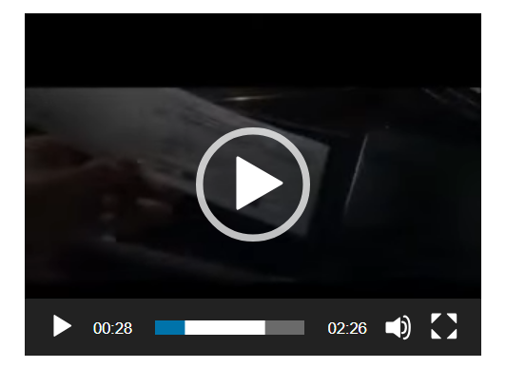
<iframe width="420" height="315" src="https://www.youtube.com/embed/Ll3uipTO-4A" frameborder="0" allowfullscreen></iframe>
But how many of us really understand what that time is money is all about? Is money really the evil necessity that prevailing wisdom warns us about? How might our attitude towards money be different if we simply turned that old trope around to read: Money is time?
Let’s take a moment to review what money really is by looking at its origin. It’s common knowledge that, prior to the invention of currency, bartering was the only way of trading goods and services. We’ve all learned that it school (at least we should of) and there is that Schoolhouse Rock song
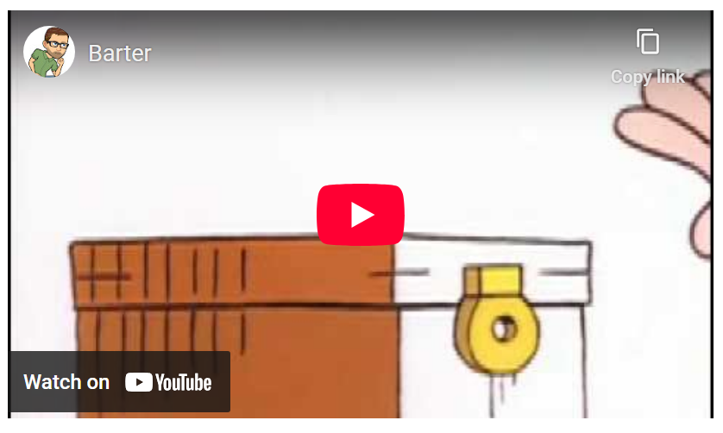
<iframe width="420" height="315" src="https://www.youtube.com/embed/J7hNOt2Y0J8" frameborder="0" allowfullscreen></iframe>
that tries to explain how money arose from the bartering system. The song is catchy but its message is muddled. Money wasn’t invented to make it easier to carry goods around or to make change. It was invented to save the most precious commodity a human has: his time.
Living with currency of all sorts (paper and electronic) makes it easy to ignore just how time consuming barter must have been. A typical scenario might have looked just like this. Let’s suppose that Charlie lives in an agrarian society where there is division of labor but no currency. Charlie raises chickens and since he can concentrate on their breeding and rearing, he can produce far more chickens in a unit of time than he could if he didn’t specialize. Having more chickens than he needs he is willing to trade some of his for sheep that his neighbor Steve breeds. He is also willing to trade with Pam for some of her pigs or William for some of his wood but not with Fran or Harry since Charlie dislikes fish and has no use for hay.
Problems arise when Charlie wants pigs but Pam is unwilling to trade because she wants hay. Unfortunately, Harry won’t trade with her because he wants sheep. Steve, however, doesn’t want hay because he needs wood to fix his house. Steve’s willing to trade with William has his mind on the nice fish tacos he could make if only he had some fish. Fran won’t trade with William, even after William has offered his finest oak lumber because Fran is dreaming of a nice chicken sandwich but is lacking the main ingredient. By visiting each in turn, Charlie is able to piece together a plan of action proceeds to make four transactions that he doesn’t want to make to finally arrive at the one he does. First he trades chicken to Fran in return for fish. Next he takes the newly acquired fish and gives them to William in exchange for some nice wood. And so on. The figure below shows the whole wacky scheme.
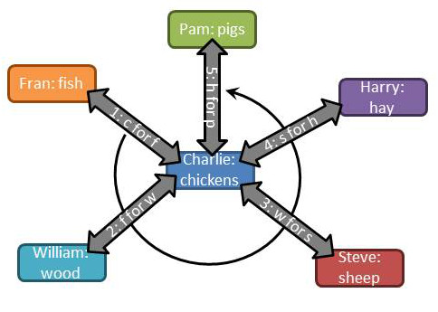
Charlie not only has to spend his time moving goods around this vicious circle but he also needs to spend time learning enough about all the other goods that he knows the worth of his chickens relative to all the other goods in his economy. Failure to know what his chickens are worth will prevent him from bringing home the bacon and cause them to come home to roost.
Many of us don’t relate to farming unless we are playing Harvest Moon or Farmville. Fortunately for us, this idea of horse trading from A to B to C and so on is kept alive in sitcoms. My fondest memory of this is the episode of M*A*S*H entitled ‘For Want of a Boot’ in which Hawkeye tries to get a new boot by making a chain of transactions. Of course it blows up in his face just as he’s about to achieve his goal as last person reneges, setting off a chain reaction that sets him back at square one with only a long useless day to show for his efforts.
Obviously the situation would be greatly improved if there were a central entity with whom everyone could transact business and who also knew the relative worth of each person’s goods. Fortunately for our little farming village, money is such an entity.
The invention of currency allows for a single transaction between each seller and a buyer saving a lot of time. The market where the money and goods are exchanged provides the framework for determining the relative worth of each good.
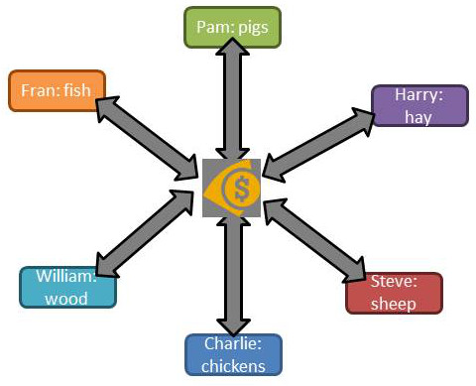
The adoption of currency also allows our little group to preserve the worth of their goods in a non-perishable form. Fish may spoil and wood may rot. The chickens may die and the sheep grow old. The hay may get moldy and the pigs may get skinny. But the value of the good is secure once it is traded for currency. Money also allows for the expansion or contraction of the economy when a new member arrives (Tim making tools) or an existing member leaves (Steve goes to greener pastures).
To summarize these benefits, we say that money:
- Acts as a medium of exchange
- Sets relative worth via the prices paid for each good
- Holds the value for future use.
In all of these cases, the aim is provide more time for everyone involved to live life and enjoy. So the next time you see ‘Time is Money’ and you cringe, turn that expression on its head and remind yourself that Money is time and that it is time that really counts.

