What Does the Fed Do Now?
Well the January jobs reports are in and the economy created a reported 257 thousand jobs in January. Hurray for the US economy! This comes hard on the heels of job growth numbers for the November and December of 423 and 329 thousand, respectively. The news is certainly welcome and the trend is encouraging but not all of the results are likely pleasing to either the current administration or the American public at large.
The fly in this particular batch of ointment is that the unemployment number has ticked up one tenth of one percent. Of course this is to be expected. As I discussed in an earlier post, when consuming the job statistics one has to make a sharp distinction between the unemployment rate and the workforce participation rate. Some of the folk who had dropped out of the work force entirely are now, no doubt, coming back in as job openings become available.
Indeed, Bloomberg’s lead article on the January numbers, entitled Jobs Report Crushes It, agrees with this idea saying that
A 257,000 January increase in employment capped the biggest three-month advance in 17 years and delivered the strongest wage gain since 2008, figures from the Labor Department showed Friday in Washington. The unemployment rate rose to 5.7 percent from 5.6 percent as the prospect of finding work lured hundreds of thousands into the labor force.
The article goes on to say that
Gains in purchases can trigger a virtuous circle of hiring and spending that will probably assure Federal Reserve policy makers that the expansion can withstand an increase in interest rates later this year.
And there is the rub. The American people, by and large, do not understand the distinction between good and bad rises in the unemployment rate. The public’s inability to make these distinctions is mostly due to the low economic literacy and discourse of many of the institutions that proclaim themselves as the guardians of the working man. Primary amongst these are the media, who gush and dance in sound bite and spin, about any ‘favorable’ movement in an indicator whether or not it is actually good. Also culpable are the schools, which employ teachers less economically literate than my butcher. After all public school teachers don’t have to worry about producing a product the public wants since the government will make sure the bills get paid and the lights stay on no matter how many students show up. My butcher on the other hand needs to show just where the beef is.
So the public is likely to get restless as the unemployment rate rises. As public sentiment goes so goes the administration, which will likely leverage political pressure of the Federal Reserve to lower unemployment.
For those who don’t know, the Federal Reserve (or the Fed it is affectionately known by everyone – even them) is charged with control the monetary policy of the United States. As the nation’s central bank, it has only three arrows in its quiver:
- Open Market Operations – buying or selling of bonds to basically create or delete money from the economy. Buying bonds will increase the money available in the economy and selling decreases it.
- Reserve Requirements – sets the percentage of deposits that a bank must hold in reserve. Lowering the reserve requirement frees up more money to be loaned and raising the reserves limits the amount.
- Discount Rate – fixes the interest of a loan from the Fed to a bank.

The effect of each of these is to raise or lower the interest rate that banks charge each other for bank-to-bank loans (federal funds rate), which then trickles down to the end consumer as the rate to borrow. These three arrows are shot at two distinct targets with the intent of keeping inflation fairly constant at about 2% per year and keeping unemployment also fairly constant at about 5% per year.
The Fed has even gone to the trouble of creating a web-based video game in which the player can pretend to be the Fed Chairman. The rules of the game are succinctly summarized when you are appointed chairman and are now in charge.
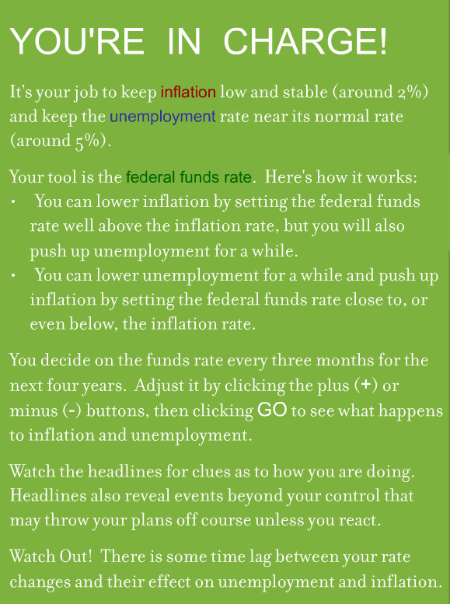
The simulation, while visually appealing, is primitive its fidelity and doesn’t inform the player what model is used to determine how the simulated economy will respond to the changes he makes. But considering that this is meant to be an educational tool my guess is that the rules are really simplistic. The following snap shows one of my attempts at managing the economy.
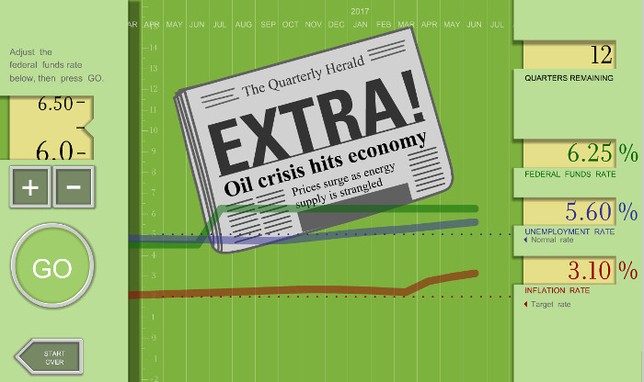
I suppose the Fed’s intent is to make it clear how hard it is to do their job and, perhaps, have us show a little gratitude for their steering an ocean liner successfully through troubled waters.
And maybe I should be grateful but I can’t help think that the Fed can’t possibly do a credible job of controlling inflation and unemployment by essentially adjusting the federal funds rate. This particular jobs report is a perfect case in point. One of the rules of the game states that ‘you can lower unemployment for a while and push up inflation by setting the federal funds rate close to, or even below, the inflation rate.’ That rule can only be true if something else, say the work force participation rate, remains constant.
In this particular case, keeping the federal funds rate low, as it currently is, is actually raising the unemployment rate and that is a good thing. Capable people who had fled the workforce need to come back in and swell the ranks, even if they are just looking for jobs at this point. It also isn’t a given that inflation needs to rise as these workers find jobs and begin to gather paychecks. That point of view only makes sense if one only assumes that the output of goods and services remains low so that ‘more money is chasing few goods’. But the recent decline in gasoline prices that has pushed inflation down (at least in practical if not statistical terms) is due to the industry of workers flooding into the energy sector.
So what does the Fed do? I suspect that they will coax the federal funds rate to rise and that, in the process, they will smother what is a good thing. I mean what else can they do when they are trying to achieve fine control using the crudest of tools?

An Ultimatum You Can’t Refuse
What do the terms ‘greedy capitalist’ and homo economicus have in common? Both terms are used, albeit with different connotations and by different groups, to describe a member of a society who pursues his own rational self-interest, trying to maximize it with each decision made. But what is rational self-interest? How do you define it? What is being maximized? And is the pursuit of one’s own self-interest necessarily incompatible with being a good neighbor? At the crux of these questions is the definition of rational self-interest.
Traditional economic analysis tends to view self-interest solely within the material context. Much like playing a board game, the success that you have had in maximizing your personal self-interest is completely judged by the amount of stuff you’ve accumulated. Cars, houses, jewelry, and money are all victory points that allow a person to rank themselves. You can declare yourself to have arrived at the good life when your house is bigger, your car more expensive, your jewelry more gaudy, and your bank account larger than the Joneses down the street. In this view, a rational person never fails to make a decision that increases his material wealth. This then is the definition of homo economicus – an individual who tries to maximize his utility when he is a consumer and his profit when he is a producer. You can go one step further in this description if you believe that the wealth one person enjoys is often or always at the expense of another. In this case, you would characterize a person pursuing his self-interest as a ‘greedy capitalist’.
But is this really how people act? It is true that we can find excellent examples of miserly, parsimonious, and bitter old men in literature. Scrooge in Dickens’ A Christmas Carol and Old Man Potter in Frank Capra’s It’s a Wonderful Life come immediately to mind. And certainly there are people who take materialism too far but does that mean that the system as a whole is corrupt or corrupting? I think not.
There is a fascinating game, in the sense of game theory, that is often used to determine the degree to which people will tend to maximize their utility by following their own rational self-interest. It’s called the Ultimatum Game.
It works essentially like this. The game begins when the game administrator (shown in blue below) approaches two random people with a pile of cash and invites them to play.
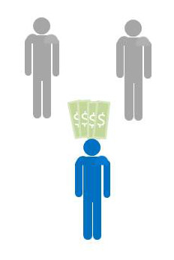
The rules are simple. The administrator will randomly designate one of them as the proposer and the other as the responder. The administrator will give the proposer the money and the proposer will decide on a split between himself and the responder. The responder’s only move is to decide to accept the proposal or reject it. If the responder accepts the proposal, they both get to keep the money in the proportions defined by the proposer. If the responder rejects the proposal he and the proposer walk away empty handed. The administrator emphasizes that the proposer gets only one chance to make an offer – there are no negotiations – and that this is the only time they will be playing this game.
Assuming that both players are homo economicus, the results of the game are easy to predict. The proposer should keep most of the money for himself and give only a small percentage, nearly zero, to the responder, because the proposer realizes that the responder will rationally maximize his own utility and will take any money offered. This way the responder will leave with more money than he had before the game began. The responder may lament the fact that the mere luck of the draw separates him from the proposer but money is money and free money is free money and so he accepts.
When this game is run experimentally, the results are quite different. The responder accepts the split only when it is close to 50-50 and often rejects when the offer strays to far from an equal split. Furthermore, the proposer, without having the benefit of playing this game before, often offers a split close to the 50-50. Why do both participants often behave unlike homo economicus?
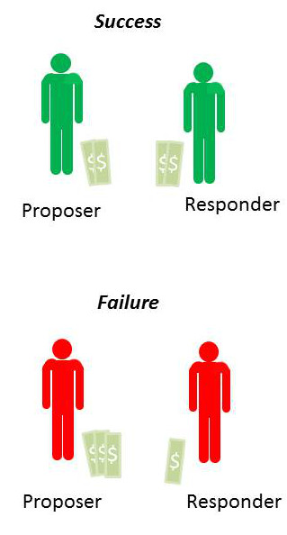
In practice, the experiment is done with more care and in a double blind fashion, as explained by the Foundation for Teaching Economics’ lesson plan found here. But the results remain the same.
- The mean split is 60-40 (proposer gets 60% and the responder 40%)
- Most common split is 50-50
- About 20% of the offers that fall outside the ‘fair’ range are rejected.
How does one explain the proposer’s is generosity? How does one understand why responder ‘cuts off his nose to spite his face’ when the split is too low? As discussed in great detail in the accompanying appendix to the lesson plan, this game has been applied in a variety of circumstances where variations in age, gender, background and other factors have been examined and controlled. There appears to be no confounding variable that allows the administrator/experimenter to pre-determine when the participants will behave like homo economicus. Even the amount of money has been varied. Relatively vast amounts were brought to the developing world, where people subsist on only a few dollars a day, and the results remained the same.
A much more cogent explanation is that the definition of rational self-interest needs to be expanded from the materialistic realm to consider things like reputation, human compassion and altruism, and wisdom. And that these traits act to balance the purely materialistic instincts.
Virtue in the ancient world was defined not by a super-abundance of a trait but rather as the correct amount or a balance. A warrior who acted reckless and drove into battle with an overly great amount of physical courage was no more lauded than the coward who sat in the corner timidly, wanting for danger to pass by. The correct balance between caution and courage was the virtuous position.
Here in the ultimatum game, I see reflections of these ideas of virtue. The game results provide ample evidence that a human being engaged in a free market does not necessarily become selfish. The free exchange of goods and services is not inherently corrupting to those participate and they are no more likely to be preoccupied strictly with material possessions than if they had not engaged. The free market, like any tool, can be misused and can create an injustice, but it is not intrinsically flawed.
Lord Acton is famously quoted as saying “All power tends to corrupt; absolutely power corrupts absolutely”. I wonder what he would say about the Ultimatum Game. I’m not sure, but I like to believe that he would recognize the free market place as a place where people can come together to trade without the threat of coercion.

