Bookies & How to Set Odds
In honor of American Pharoah winning the first Triple Crown in 37 years, this week’s column will concern itself with that fine art of subtle economics – making book. For those you aren’t familiar with the terminology, to make book is the phrasing used to describe how a bookie balances the risks associated with backing a gambling opportunity. The idea behind making book is to guarantee a positive expected income for the bookie no matter what happens in the event.
The treatment here is patterned after ‘The Parable of the Bookmaker’ found in the book ‘Financial Calculus: an introduction to derivative pricing’, by Baxter and Rennie and the very readable discussion of ‘The Art of Bookmaking’ Matt Elliott.
Both treatments consider, for simplicity, the case with a sporting event with two possible outcomes. I’ll stick with the horse racing theme used by Baxter and Rennie.
Suppose that we are having a runoff between the great Triple Crown winners of yesteryear and American Pharoah. I think that, without a doubt, Secretariat is the greatest of the past winners; an opinion that is shared in sporting circles. Now let’s imagine that we are pitting Secretariat against American Pharoah as our sporting event of the millennium.
As bookies, we want to accept wagers from bettors who are both favor Secretariat and those who favor American Pharoah, but we want to do so in such a way that regardless which horse actually wins, we can meet our payouts and still take home a tidy profit. How do we do this?
First, let’s start by examining the probability that each horse will win the race. Since this is a fantasy race, we can run the race as often as we like, and suppose that in doing so we find that Secretariat is 3 times more likely to win than American Pharoah.
Now we have to set the odds. The actual language and notation associated with quoting the odds seems to differ from country to country and culture to culture so I am going to give a set of definitions that maximize the overlap with all cases. First define the stake as the amount of money that the bettor (or punter as it is sometimes known as) places on the outcome. A winning bet pays the bettor back his original stake plus an additional amount of money called the return, since it represents the return on his investment. Thus the successful bettor walks away from the track with the sum of these two, which is called the payout. In symbols, if st is the stake and r is the return then p = s + r is the payout. The unsuccessful bettor simply walks away.
Now if we set our odds consistent with the probabilities found in our fantasy running, we would set the odds as follows:
- Secretariat: a stake of 3 gives a return of 1 for a payout of 4
- American Pharoah: a stake of 1 gives a return of 3 for a payout of 4
In other words, the probability each outcome is implied as the stake/payout giving P(Secretariat) = 0.75 and P(American Pharoah) = 0.25, where P(x) is the probability that x will win the race. Note that as expected, Secretariat is three times as likely to win as is American Pharoah.
Well this is certainly the scientific way to set the odds. Unfortunately, it is also stupid. To see this, we calculate the expected payout. To keep things concise, let’s use add to our symbol vocabulary by letting AP and S stand for American Pharoah and Secretariat, respectively. In the event that Secretariat wins, the profit the bookie makes as follows: he gets to keep the stake offered for American Pharoah and has to give up the return on Secretariat. In symbols, profit(S) = st(AP) – r(S). In the event that American Pharoah pulls off the upset, the bookie’s profit is the stake on Secretariat minus the return on American Pharoah, which in symbols is profit(AP) = st(S) – r(AP). To get the expected profit, the bookie multiplies the profits associated with these two events by their probability of occurrence and finds that his expected profit is zero (left as an exercise to the reader). This result holds no matter how much money is staked on either horse, since there are only two options – they balance out.
So a bookie offering such odds works for free in the long run and finds himself at the end of his career having, on average, earned no money. More likely, before he gets to the point of having a quiet retirement he finds that he is bankrupt due to the fact that on any given occasion he is liable to lose a huge amount of money.
The amount he is liable for does depend on the stakes offered and the easiest way to understand this is to look at a table of outcomes given different stakes.
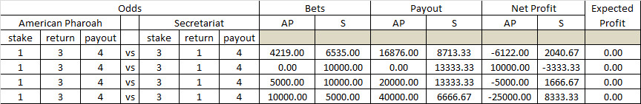
Notice that there are four different scenarios with different amounts places as bets on the two horses. In all cases, the bookies expected profit is zero so that were the race to be run every day, the bookie would, as predicted above, break even. However, during that time the bookie’s profits would wildly fluctuate between a reasonably handsome profit of $10,000 when American Pharoah pulls of the upset and nobody bet on him to a disastrous loss of $25k when many people back the longshot and he wins.
Obviously, the bookie needs to keep his financial health (and as a result his physical health as well). In order to do that, he needs to ‘slant’ the odds in his favor. He does this by actually playing with the percentages sold of the racing contracts so that he has a positive profit no matter which horse wins.
Several examples of how to set the odds to make a profit are shown in this next table.
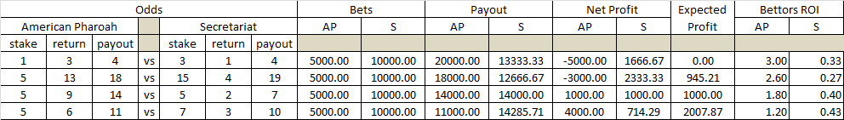
Before beginning to discuss the results shown in this table, note that the amount bet on the two horses is fixed at $5K for American Pharoah and $10K for Secretariat. I’ll briefly discuss the added complexity associated with attracting the appropriate amounts for both horses below.
The first case is the fair-odds, break-even case that caused our bookie’s concern. In that case, the implied percentage of the race came out exactly to 100 percent. This percentage, denoted by o, is given by o = st/p. For the first case, o(AP) = 0.25 and o(S) = 0.75; adding up to 1.0, as expected. In the other cases, the bookie sets the odds in such a fashion that the corresponding percentages add up to be more than 1.0. In the second case o(AP) = 5/18 = 0.28 and o(S) = 15/19 = 0.79 for a sum total of 1.07. This extra 7-percent margin give the bookie a positive expected profit but still exposes him to substantial loss if the longshot come in.
A better setting of odds is in the third case, where o(AP) = 5/14 = 0.36 and o(S) = 5/7 = 0.71. Again the margin is set at 7 percent (0.36+0.71 = 1.07), but in this case the bookie is sure to make a profit of $1,000 every time.
In the final case, the bookie can make even more profit by having a margin of 15 percent, but he does so at the expense of the bettor (how else?). In particular, the bookie realizes this profit by cutting into the return on investment of the bettor who backs the longshot. The return on investment (ROI) is defined as the return divided by the stake, or r/st. Notice how the ROI drops progressively as the bookie’s exposure to risk drops.
In realistic situations, the bookie never gets a fixed amount plopped on each horse with the subsequent opportunity to set the odds in such a way that favors him. Rather, he needs to sell contracts with the bettors and then adjust the odds as bets come in so that he makes book. More details of how this is done can be found in Matt Elliott’s discussion but I’ll note, in passing, that a margin of 7-percent seems to be a customary target but that it seems that the bookie is happy when he can achieve 5 percent.
I’ll close with one last point. Throughout this discussion, I’ve intermixed gambling terms like bookie, odds, payout, and longshot, with terms usually reserved for business situations, like return on investment, contract, and sell. Gambling and business meet squarely in derivatives trading and hedge funds all across the financial markets.

