To GMO or Not to GMO
There has been a lot of recent buzz centering on the fear that certain segments of the population have about genetically modified organisms or GMOs. These apprehensions are a part of an ever-growing concern that people around the world have in the way that their food is produced and how healthful said food might be. Concerns over GMOs rank up there with the movement to have free range livestock and organically grown foods. So what does all this biological science have to do with a blog on economics you might ask. Well, simply put, everything.
At its core, economics is the study what goods and services society produces where, when, and how; who produces it; and who consumes it. Sometimes, it even ventures a guess as to why but that question is broached far less often than at first it may appear. Since the production of goods and services happen in the faces of finite resources and perpetual scarcity there is always a downside to every decision. If resources are being spent one way they are not being spent on something else.
So of course, the decision to embrace GMOs fully, partially, or not at all is, at its core, a decision about how resources will be spent to satisfy on of the most basic human needs – the need to eat.
Identifying the particular risks of using GMOs is the province of a host of people, including the biologist, the botanist, the farmer, the food distributor, the politician, and so on. Once the risks have been listed, the weighing of these risks is purely economics and is the province of us all.
However, it is hard to properly weigh the risks when a twofold set of errors is in play as it seems to be now. The first error is one of emotional rather than rational thinking. The second is the lack of vision is seeing the lost opportunity or unseen costs of choosing one over the other.
I mention these errors because there is mounting evidence that the developed countries are so mired in a dread of the GMO-monster that they are consigning millions of people in the developing world to avoidable chronic hunger, malnutrition, or death.

Emotional Thinking
The first of these errors, the indulgence in emotional thinking, seems to be gaining ground in many of the modern debates. Within the past decade, there has been a rise in trendy, boutique causes where the passion is profound but the logic is scarce. A familiar example is the movement in certain circles to avoid vaccinating a child due to the fear that the vaccinations cause autism. There isn’t strong evidence to support this conclusion but that doesn’t stop certain people from engaging in emotional attacks against those who honestly disagree with this conclusion.
Advertisers and marketers are eager to fan the flames of emotionalism if it helps sell a product and one such case is the recent switch by Chipotle to ‘non-GMO ingredients’. Chipotle’s website presents a slick picture
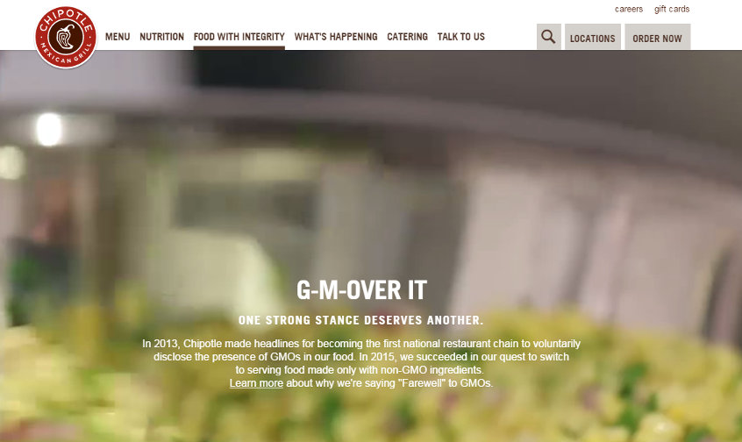
with catchy little lead-in phrase (G-M-Over It) and a short paragraph extoling the companies conscientious “Farewell” to GMOs. Following the ‘Learn More’ link leads to an equally emotion-filled excerpt:
Chipotle is on a never-ending journey to source the highest quality ingredients we can find. Over the years, as we have learned more about GMOs, we’ve decided that using them in our food doesn’t align with that vision. Chipotle was the first national restaurant company to disclose the GMO ingredients in our food, and now we are the first to cook only with non-GMO ingredients.
But if the reader were to persist in reviewing the reasons why Chipotle is saying “Farewell” to GMOs that reader would find a lot of far less emotionally-laden and circumspect words. Buried in the ‘fine print’, are phrases like “we don’t believe the scientific community has reached a consensus” and “we believe it is prudent to take a cautious approach to GMOs”. Even further in, Chipotle admits that while it is now shunning GMO plants, it has not eliminated GMOs from its supply chain.
But it is important to note that most animal feed in the U.S. is genetically modified, which means that the meat and dairy served at Chipotle are likely to come from animals given at least some GMO feed – Chipotle website
So how much of a “Farewell” can they have made? It seem more likely that this new campaign to eliminate GMOs (or appear to be doing so) is not designed to protect customers from their dangers as much as it is to boost the flagging stock price of company, which has been on a downward trend since February of this year.

Lost Opportunities to Eat
If this emotionalism were simply fueling an advertising campaign to separate consumers from their money, then one might argue that this it is a victimless crime with no real repercussions. But in world with limited resources, there are significant lost opportunity costs.
One unseen cost is that the use of land, livestock, and crop resources at less than peak efficiency means that less food is being produced than otherwise would be. That would be okay if there were plenty of food – that is to say the supply of food matched the demand. In that case, there would be no incentive to raise production and no pressure for prices to rise. Such is the long term trend in the US (although food prices have been rising recently and it may be that the bottom has been reached) but is not the case in the developing world.
The Genetic Literacy Project recently published an article by Michael Dzakovich that points out fears over GMOs have prevented their use in Africa.
While many farmers in industrialized countries have been safely and successfully using genetically engineered crops for almost two decades, adoption in the developing world has been significantly slower, only recently eclipsing the U.S. in terms of total acreage. Michael Dzakovich

Mr Dzakovich provides a vivid picture of the unseen costs of slow adoption of GMOs when he writes
At dinner during the conference, a discussion about the debate over genetically GM crops within the United States turned to the situation in Africa, when Erostus Nsubuga, a Ugandan conference delegate, said “People are dying of hunger in Uganda. We are willing to use any technology.”
It was a startling statement and wake up call, challenging our complacency. As Americans continue to quibble about phantom fears related to genetically modified crops, 20,000 people—more than six World Trade Center disasters—die every single day from malnutrition, at least some of whom would be saved if GM crops were legalized.
Other articles on the Genetic Literacy site suggest that GMOs may help reduce carbon emissions and lower toxic pesticide use.
Clearly there are pros and cons in adopting wide-spread use of GMOs and the risks and the benefits need to be carefully considered. But emotional arguments and slick advertising campaigns only serve to further hide and obscure the lost opportunity costs and people may be unnecessarily dying as a result.

