Value and Trade
I suppose the origin of this particular column came from a rather comical conversation held over dinner. My wife mentioned that her father used to tease a cook he knew about her efforts in the kitchen. Her father contended that cook’s efforts were proof that Marxism was wrong about the value of a thing made in the economy. According to Marxism, the value of any object is determined by the total amount of labor required to make it.
The cook would select a great recipe for the main course, would purchase the finest ingredients, and would labor long and diligently over the preparation. Of course, the meal would often be a great disappointment and, sometimes nearly inedible. Any restaurant serving such a dish would soon go out of business.
The inverse situation also occurs. There seems to be many instances were by accident, an entrepreneur just happens to ‘catch lightning in a bottle’. A simple idea brought to market with minimal effort makes a fortune for its owner. If you are thinking about the pet rock then you are reading my mind.
A very comic example of this latter situation occurs in the original movie version of the Producers, where Max Bialystock moans:
“How could this happen? I was so careful. I picked the wrong play, the wrong director, the wrong cast… where did I go right?”
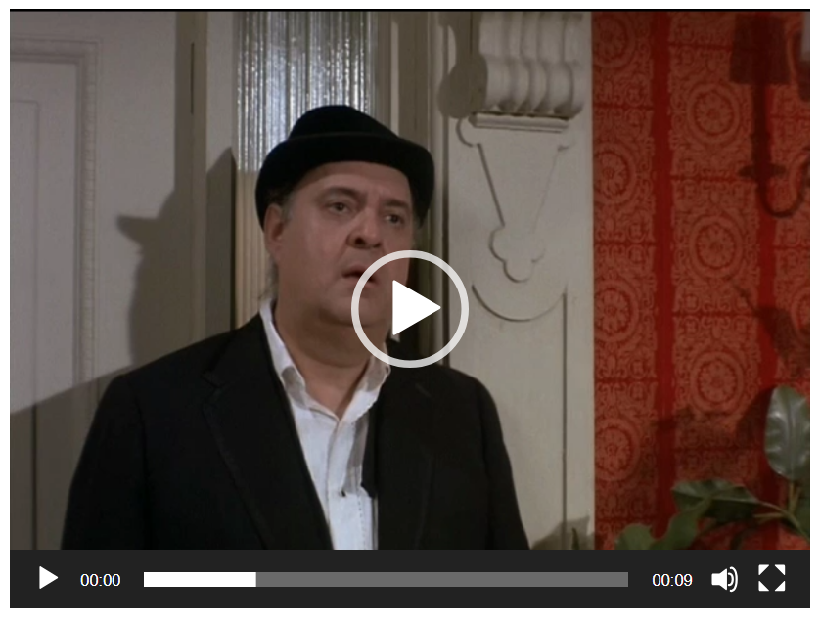
So what to make of this Marxist idea? How much truth is there in the idea that if it took twice the amount of effort to grow one type of crop, say a bushel of wheat, as it did to grow another, say a bushel of corn, then the bushel of wheat holds twice the value as the bushel of corn.
Oddly enough the idea originated well before Marx, with roots being traced back to the philosophical works of the Middle Ages. Thomas Aquinas is credited for noting in his Summa Theologica that
"... value can, does and should increase in relation to the amount of labor which has been expended in the improvement of commodities."
This concept also shows up in the classical school of economics. It was touched on by Adam Smith in his Wealth of Nations but it doesn’t seem that Smith actually embraced the idea as being applicable for anything more than the most primitive of societies (or rude societies as he put it).
Other classical economists, for example Ricardo, held more broadly to this concept making it part of their structure for economics. Although even then, there were doubts about the universality of this idea. The labor theory of value was embraced by Marx as an important and operative principle but it seems clear that the notion, with no additional provisos, is untenable. The notion that the buyer in the transaction has no place in determining the value of the thing being purchased is short-sighted and laughable.
Perhaps the best illustration of how much of value lies in the eyes of the customer is the following passage from Chesterton’s The Queer Feet:
The Vernon Hotel at which The Twelve True Fishermen held their annual dinners was an institution such as can only exist in an oligarchical society which has almost gone mad on good manners. It was that topsy-turvy product--an "exclusive" commercial enterprise. That is, it was a thing which paid not by attracting people, but actually by turning people away. In the heart of a plutocracy tradesmen become cunning enough to be more fastidious than their customers. They positively create difficulties so that their wealthy and weary clients may spend money and diplomacy in overcoming them. If there were a fashionable hotel in London which no man could enter who was under six foot, society would meekly make up parties of six-foot men to dine in it. If there were an expensive restaurant which by a mere caprice of its proprietor was only open on Thursday afternoon, it would be crowded on Thursday afternoon.
If the labor theory of value is not a viable approach for determining value, what is? That is a question that occupies a great deal of economic discussion even until today and there is no universally held belief. Mainstream economists do lean toward the idea that free trade best uncovers the value of a good or service because in the free market the value of the thing will be determined best by the currency that will be offered to purchase it.
As a result, trade is actually seen as the mechanism by which value is created or imparted to a good or service. Free trading allows for the assessment of value by letting lots of people ‘vote’ on the value. To paraphrase Churchill, this economic democracy is the worst form of finding value except all the others that have been tried.
Please pass me the pet rock.

While
This approach
A short and sweet summary of the modern position is put forth in the brief article on trade from economicthinking.org:
In short, every policy that restricts free trade, free contract, or free entry into the market diminishes wealth for individuals and the nation as a whole.
Economic schools of thought
General references:
http://www.pragcap.com/a-cheat-sheet-for-understanding-the-different-schools-of-economics
http://www.zerohedge.com/news/2014-06-25/pocket-guide-understanding-different-schools-economics
http://www.zerohedge.com/sites/default/files/images/user3303/imageroot/2014/06/20140625_econ.jpg
School of Thought | General Summary | Economic Unit | Personal Freedom | Value & Wealth | References
Austrian
Behavioral
Chicago
Classical
Keynesian
Marxism
Neoclassical

Bankers – Friend or Foe?
The 2008 recession added a lot of new phrases to the economic lexicon. Terms like ‘sub-prime mortgages’ and ‘produce the note’ found their way, nearly overnight, into domestic dinner conversations and water-cooler discussions. Perhaps none of the Great Recession taglines garners as much attention and derision as the phrase ‘too big to fail’.
Applied to the banking industry, ‘too big to fail’ spawned a variety of political reactions, from bitter laughter, to contempt, to despair, depending on one’s own personal circumstances.

