Energy Use and Wealth Creation
Its common ‘wisdom’ bandied about at water coolers, dinner tables, and political gatherings, that while the United States has 5 percent of the world’s population is uses 24 percent of the world’s energy. Sagely nods and enlightened shakes of the head always come in the wake of such an utterance. But what does this statistic really mean – that we are wasteful, that we take from others, what?
To the common man, this statistic indicates just how wasteful the United States is, just how predatory its consumption is, and so on. But it turns out that really isn’t the case. The real situation is much more nuanced and subtle and the results show a few ‘surprising’ things – surprising relative to the common wisdom and preconceived notions of just how bad the situation is in the United States.
First, the United States is comparable to its North American counterparts of Canada and Mexico in both energy consumption and wealth creation but actually ranks above both of them in how efficiently it use its energy. Second, the United States is much more efficient a wealth creation machine per unit energy than any other country its size in either Asia or Europe. Third, the United States produces a tremendous amount of energy, much of which is used by the rest of the world.
So the answer to the question posed above is that the fact that the United States has 5 percent of the world’s population and uses 24 percent of its energy doesn’t really mean much at all. Let’s see why.

The Methodology
Good conclusions rest firmly on good data so let’s start by collecting individual statistics on the various countries around the world. The following table shows the population, gross domestic product (GDP) per capita, total GDP, energy use per capita, area, and efficiency (to be defined below) of 21 nations from various continents.
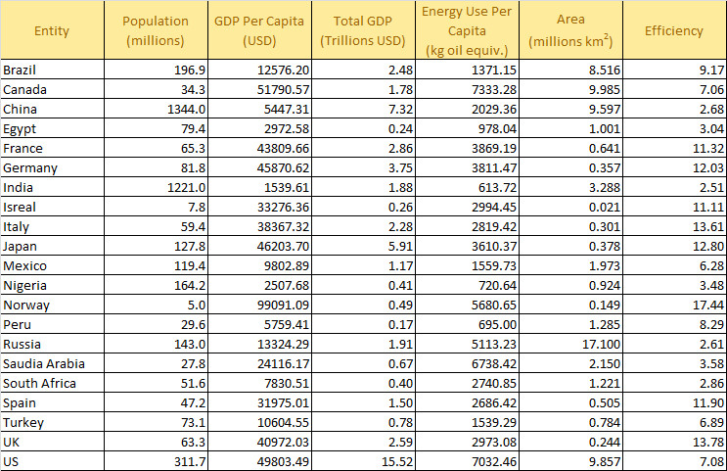
The data referenced to calendar year 2011 since that is the latest year where data were available for all 5 categories. GDP values have units of United States Dollars (USD). The unit of energy use per capita is kilogram oil equivalent (KOE), which is a normalized unit of energy that allows for world-wide comparisons.
To promote transparent discussions, each of the data points was obtained in the following way:
- Population and GDP values – Google search using ‘population <country name> 2011’
- Energy Use – Google search using ‘energy consumption <country name> 2011’
- Area – Google search using ‘area <country name> square kilometers’
where <country name> stands for one of the 21 names listed above.
The efficiency metric value is calculated as the ratio GDP per capita to energy use per capita and, as a result, has units of USD/KOE and state how much, in terms of goods and services, were produced per unit of energy.

The Interpretation
Okay, with great data comes great responsibility. So how do we interpret the data responsibly? The first, and most obvious response, is to compare apples-to-apples. The easiest way to do this is to compare energy use per capita in a bar chart.
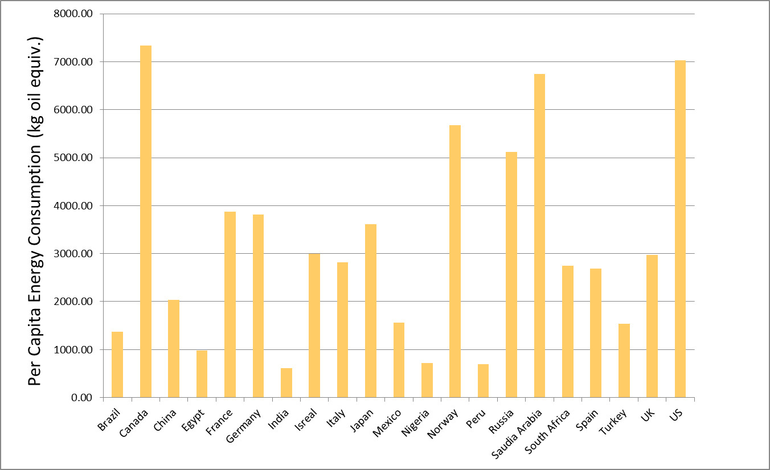
Perhaps surprisingly, Canada is the largest per capita consumer of energy in the sample studied. In 2011, Canada consumed approximately 7333 KOE versus the United States 7032 KOE. Saudi Arabia and Norway are close, consuming 6738 KOE and 5681 KOE, respectively. China, one of the world’s largest consumers of energy and one of the greatest polluters has a modest energy consumption of about 2000 KOE, two thirds less that the United Kingdom and about half of Japan.
But does this apples-to-apples comparison really tell us the full story? The answer is clearly no. What matters isn’t just how much of a commodity is consumed but also what is accomplished as a result of that consumption.
The situation has its analogy in basic family economics. It is one thing to spend (i.e., consume) $10,000 on a new roof and an entirely different matter to spend $1,000 on Pet Rocks. The first one is a larger expenditure, by a factor of 10 compared to the latter, but is clearly a better investment.
The most honest measure for what was produced by a country is the GDP per capita, taken as the value of all the goods and services made by the average citizen. There is no way to further evaluate the production beyond that since matters of cultural, societal, or philosophical valuation vary from person to person. The GPD measures, in some sense, what others in the market are willing to pay and nothing else. Nonetheless, it’s all there is.
This approach leads directly to the efficiency metric defined in the table above. When efficiency is displayed in a bar chart a much different story emerges.
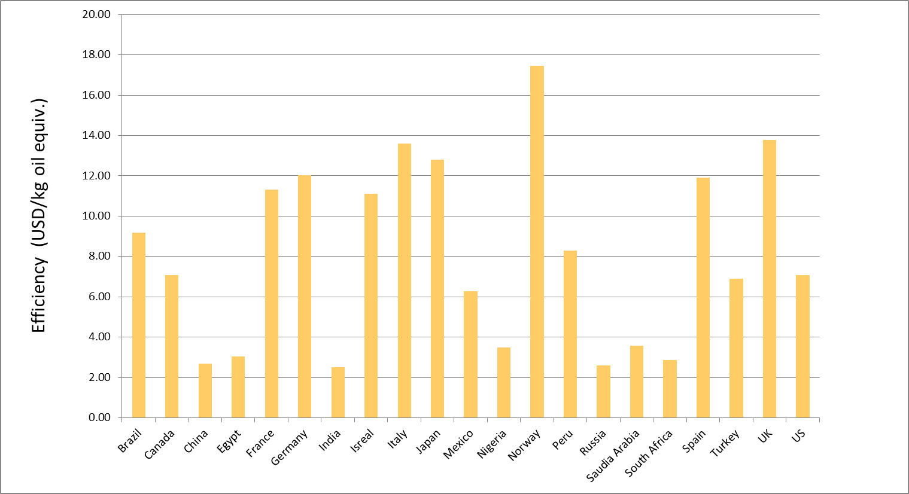
The United States and Canada each fall squarely in the middle of the pack, with their values of efficiency falling almost exactly on top of the median value for this sample.
At this point, the reader may be thinking that this is still not a true apples-to-apples comparison. After all, shouldn’t some adjustments be made for size and complexity of a country? The most obvious factors that I thought of that influence efficiency would be
- Climate (how hot or cold)
- Area (how big or small)
- Economic system (capitalist, social democracy, communist, etc.)
- Work force participation and training
Certainly a greater percentage of energy is consumed in colder countries compared to more temperate ones just to ensure the survival of the population, and this expenditure is not reflected in the GDP values. In addition, the amount of energy consumed for transportation is another expenditure that is not directly reflected in GDP. Finally, political forces shape the overall productivity of the work force either through the system of economic organization and/or through the percentage of able-bodied and trained citizens in the work force. The Soviet Union was notorious for having a very poor return on its energy expenditure even though it had immense resources.
Of these four factors, the only one that is relatively easy to work with is the size of the country in area, which is taken as a proxy for the size of the transportation expenditures. The following graph shows a scatter plot of efficiency versus country area.
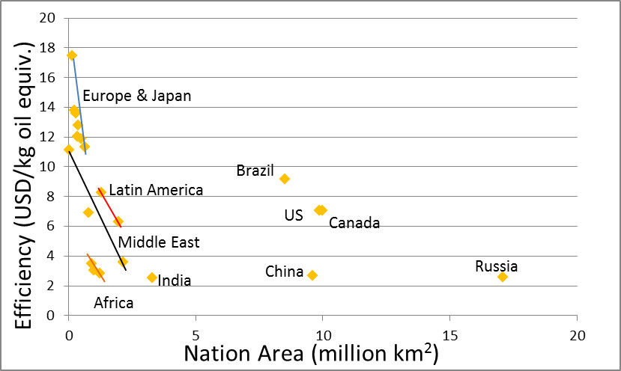
There are clear correlations between the size of the country and the efficiency, with the European (Norway, France, Germany, Spain, Italy, and the UK) countries and Japan topping the list. The Latin American countries (Peru and Mexico) also do pretty well although Mexico (with a 6.28 efficiency) definitely underperforms relative to its two neighbors to the north. For the most part the Middle East (Israel, Saudi Arabia, and Turkey) and Africa (Egypt, Nigeria, and South Africa) have terrible efficiencies well below the median, except for Israel, whose performance is indicative of the European countries.
For countries larger than 2 million square kilometers, only Brazil outperforms the United States and Canada. How much of this is due to climate is unknown but it is worth noting that Brazil has focused on energy efficiency and renewable energy sources in the past couple decades and some of that effort must be reflected in these numbers. Of course, it hasn’t been without a price as the cost of food in Brazil has risen over the years.

Parting Thoughts
None of the analysis presented above is meant to defend the United States from the observation that energy is wasted. Most citizens in the United States pay only a little attention to how they consume energy since the cost to them is relatively small. It is clear that we can do better. However, it is also not the case that US citizens consume energy like a drunken sailor on leave spends money. Given the size of the nation, in both area and population, and the innovations and discoveries that originate here, the US makes a good return on the energy it consumes. In addition, the US produces the largest amount of oil and natural gas in the world, and is second in production of coal and the generation of electricity (http://www.eia.gov/beta/international/). It is patently unfair for intellectuals to continue to promulgate the myth that the US consumes energy at the world’s expense, a myth all the more dangerous since it is wrapped up in that innocent-looking little statistic that they like to throw around.

