Hernando de Soto
In doing the research for the previous post on China and government held debt and the earlier one on energy usage and wealth creation, one country stood out – the country of Peru. It stood out not because it topped any particular list but because of the great strides that Peru has taken over the last quarter century to reform it government and economy. These reforms are reflected in the very low ratio of government held debt to GDP and in the relatively high efficiency with which it uses energy to create wealth.
During the 1980s, the situation in Peru was quite different. Hyperinflation, which totaled in at an amazing 2,220,200% in the five year period from 1985 to 1990, was a crippling problem, social unrest lead to the rise of the Marxist Shining Path (Sendero Luminoso), and the population had little to no faith in the government, dubbing even their president as Alan ‘Crazy Horse’ Garcia.
During the 1990s, Peru elected Alberto Fujimori and his policies helped put the country on a stable trajectory and get its macroeconomic house in order. But how exactly did he accomplish this transformation? Well government is complicated and any success it enjoys has many creators but the Peruvian economist Hernando de Soto played a big role.
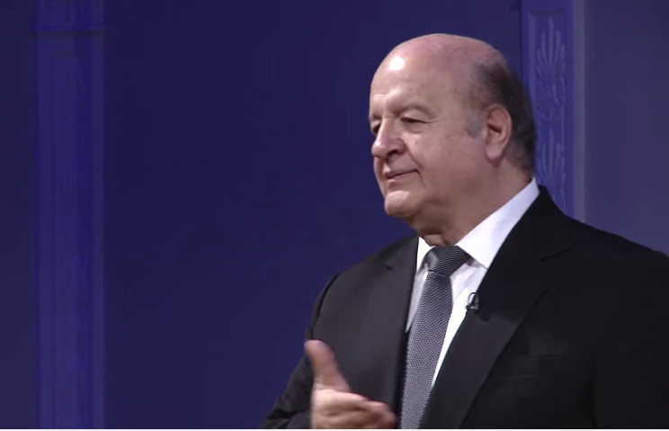
de Soto was born in the Peruvian city of Arequipa in 1941 but was moved to Switzerland in 1948 following a military coup and the self-exile of his father a diplomat. When de Soto returned to Peru he found that the economic situation was appalling. In reaction to this, he founded the Institute for Liberty and Democracy (ILD) whose influence helped to enact over four hundred laws and regulations enabling the poorer members of Peruvian society to benefit from the having access to capital.
de Soto is perhaps best known for his experiments with the ‘stopwatch’. The idea behind his experiment is to determine how long it takes for a prospective entrepreneur to open a business. In other words, de Soto hopes to quantify the transaction cost required to become a legitimate business owner who operates within the law and enjoys the corresponding privileges, including formal recording of the title of ownership and well-defined protection of assets under the rule of law.
What he found was depressing. He tried to setup a small shirt factor and discovered that it would take 278 full days to get all of the permits needed and that, along the way, the would-be business man had to navigate a level of corruption where the bribe was the accepted currency. NPR recently aired an engaging piece on de Soto’s efforts which premiered on their Planet Money regular feature.
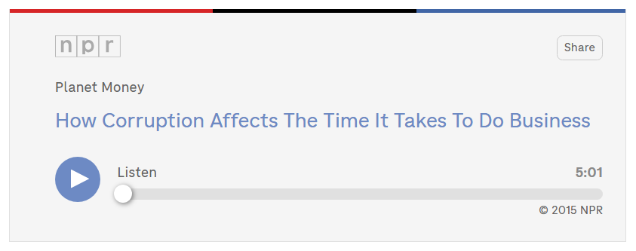
<iframe src="http://www.npr.org/player/embed/384119672/384119673" width="100%" height="290" frameborder="0" scrolling="no"></iframe>
As a result of his efforts, Peru has gone from the hyperinflationary times of the 1980s to a sustained average growth of approximately 6.6% for the last decade while simultaneously having a very low percentage of government-held debt to GDP around 20%.
Due to these successes, de Soto has been called upon by many foreign governments to help craft economic policies suited to the developing world. As a self-styled ‘third-worlder’, de Soto maintains a fierce objection to the theses of many of the ‘western economists’ who publically maintain that there is too much capitalism in the world. He has been powerfully critical of the general notion suggested by Thomas Piketty that capital causes friction between societal groups and that society should move away from such notions. de Soto convincingly asserts that Piketty engaged in rash guesswork when analyzing the situation in the developing world and that Piketty’s book Capital in the 21st Century represents Eurocentrism at is most extreme.
The basic idea underlying de Soto’s analysis, is that there are really two types of economies in the world: legal and extra-legal. The world’s elite enjoy the benefits of working within the legal system – benefits that include most especially the right to their property. The rest of the world, some 5 to 6 billion, sits outside these protections. This group finds itself in the precarious position where the only protections they enjoy are arbitrary ones conferred locally by some microeconomic or microlegal structure. Go 2 miles in any direction and the protections vanish. Step one toe out of line and the protections vanish.
This lack of access to true capital, defined by de Soto as the formal recognition of property rights and all the protections implied by such a recognition, is what holds the poor down. He traces the self-immolation of Tarek al-Tayeb Mohamed Bouazizi, which led to the Arab Spring, to the expropriation of his property – that is to say by the arbitrary way in which this street vendor was robbed of his wares and his livelihood because he had no formal protection for his property rights.
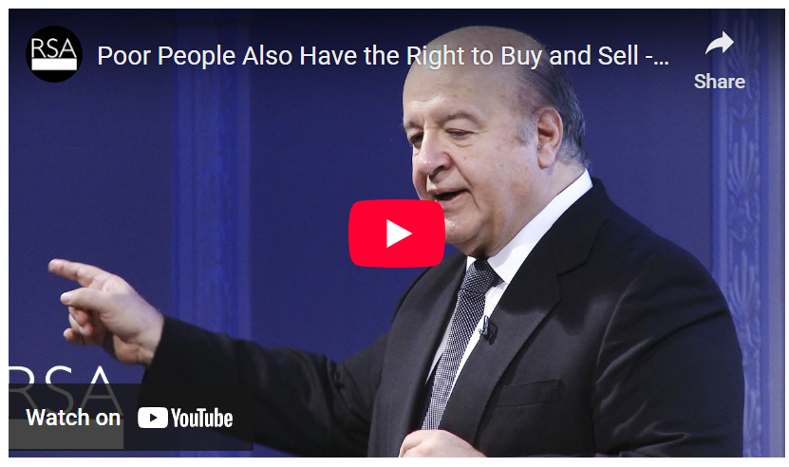
<iframe width="560" height="315" src="https://www.youtube.com/embed/6RXdLYP-dxM" frameborder="0" allowfullscreen></iframe>
While he cares most about the poor in the developing world and for ways to lift them out of the extra-legal economy and into the legal one, de Soto also has some criticism for the West. He has sharp criticism for the lack of transparency in both Europe and the United States evident in the recent financial crisis.
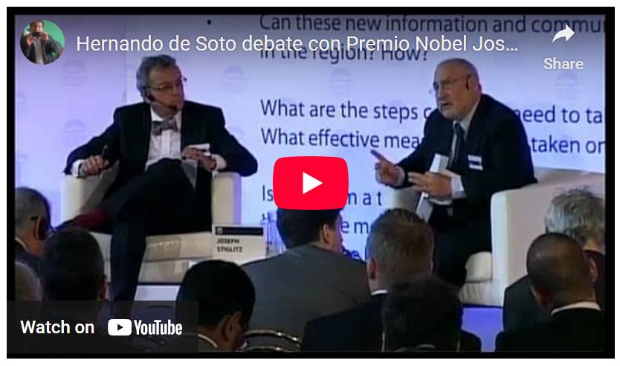
<iframe width="560" height="315" src="https://www.youtube.com/embed/r-n3ux36Rz8?t=21m45s" frameborder="0" allowfullscreen></iframe>
I suppose de Soto see these tangled webs of toxic assets, credit default swaps, and derivatives as steps in the wrong direction; as ways in which the elite erode the property rights of many to enrich a few. I think he’s absolutely correct.

