A Flood of Hazards
Although the hurricane season for calendar year 2015 began on June 1 and ends on November 30, there really is no denying that the meat of the season falls in the middle to the latter end of that time span, particularly heating up (or is it raining down?) in late September if you are in the mid-Atlantic states.
They say all politics is local and so is best analyzed from that point-of-view. I don’t about how true that is but I do know that all weather is local and the local weather here in the mid-Atlantic region could be a lot better. As I am writing this post, Tropical Storm Joaquin is dumping lots of rain and the lights in my house have flickered a couple of times. Local television programming is festooned with crawlers that display a warning from the National Weather Service warning of the possibilities of flash floods.
Now, I don’t live in a flood zone but I am familiar with the struggles of those who do. I grew up in western Pennsylvania where floods were common and people I knew routinely lost personal property, entire houses, and even their lives, when the rivers crested above their banks. I am sympathetic to the poor and lower-middle class who were forced to near the rivers since that was where cheap housing was available. And every kid who went to school in my day was told cautionary tales about the great Johnstown Flood in 1889 that killed over 2,000 people in that small town in central Pennsylvania when a dam failed after days of heavy rain.
We were also taught about the importance that wonderful safety net that is federally funded flood insurance to help those who live in flood zones and, therefore, need the protection. For many years, I believed that claim without any skepticism, subjecting it to no critical analysis but later in life I was introduced to the idea of a moral hazard that changed my outlook.
The National Flood Insurance Program (NFIP) was established in 1968 with the express purpose of protecting people by providing what private insurance could not – flood damage protection. Homeowners and businesses in these areas could obtain flood insurance under the program and over its nearly 50 year history, NFIP has paid out over $43 billion in claims to over 5.5 million people (source).
Under the program, homeowners or business located in federally designated flood plains are required to buy the insurance, although the full burden of the premium is not typical born by the insured. According to Mary McGee of Colgate University, in her article entitled Moral Hazard and The National Flood Insurance Program, homeowners and businesses pay only 10% of the actual actuarial cost of the premium. Other sources put the percentage paid closer to the 35-40 % range, but everyone agrees that the insured doesn’t foot the entire bill.
On the surface, this seems okay since the target group to be insured was originally conceived to be the economically disadvantaged who afford housing on safer ground. But because homeowners and businesses don’t bear the full cost of this risk, they are encouraged to build in flood plains. In other words, rather than assisting lower-wealth people who couldn’t settle on higher ground the NFIP encourages people on the higher end of the wealth scale to take risks that they would ordinarily shun because someone else bears the cost. This behavior is a textbook example of a moral hazard.
According to a CBO report on the NFIP (page 2), about 40 percent of subsidized properties are worth more than $500,000 and approximately 12 percent are worth more than a million. Rather than protecting the most vulnerable amongst us, federally-subsidized flood insurance is promoting risky behavior by those in society who can easily afford to avoid it. Both the Washington Post and the New York Times have called attention to this in articles about the unintended consequences of the NFIP.
Even the stalwart champion of responsible governance, John Stossel, has admitted to the fact that his very expensive home was replaced on our dime by the NFIP
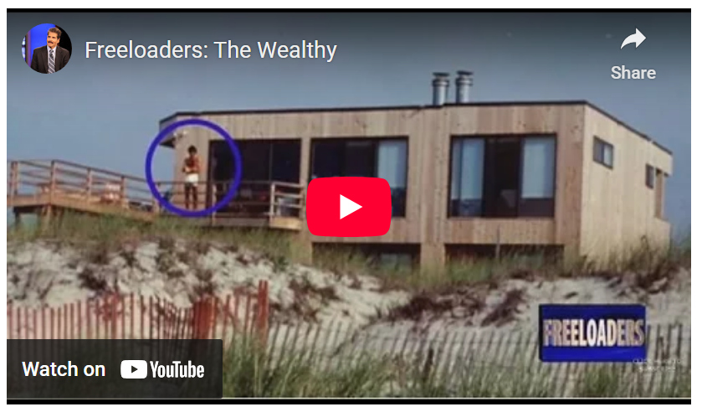
<https://www.youtube.com/watch?v=_9MYyNYTcsM>
In the course of that debate, the fundamental fact that surfaced that the NFIP encouraged people to build expensive homes on coastal property because they knew that, should they suffer a loss, they would be restored. This is exactly the trend found by a group at NOAA. In the article Normalized Hurricane Damage in the United States: 1900-2015, the authors point out
Unless action is taken to address the growing concentration of people and properties in coastal areas where hurricanes strike, damage will increase, and by a great deal, as more and wealthier people increasingly inhabit these coastal locations. – R. A. Pielke Jr. et al
So until such time as the moral hazard caused by the NFIP, each natural flood of water will be accompanied by an unnatural flood of dollars leaving taxpayer’s hands ending up in the hands of people who built in a flood zone because they didn’t bear the cost of such risky behavior.

