The Math Doesn’t Add Up

In his 1988 book Innumeracy, the mathematician John Allen Paulos explores the inability of many people, some highly educated some not, to grasp what large numbers really mean. The book was something of a best-seller and is often discussed within certain intellectual and academic circles but its influence seems to be short-reached based on the fact that people still seem to be innumerate.
This failure is particular troublesome when the large numbers are associated with probability and statistics, and even more bothersome when the large numbers are about money and the statistics are about who hold what in terms of wealth.
A recent example of this kind of sloppy thinking is found in the following video, which went viral recently

<iframe width="560" height="315" src="https://www.youtube.com/embed/Zmji36q8E4o" frameborder="0" allowfullscreen></iframe>
As Neil Cavuto, the host of the show, pointed out to Keely Mullen, the organizer of the Million Student March, the central question here is not one of judgement but of numbers. Society can decide politically where it stands on her three core demands for free public college, the cancellation of student debt, and an across the board $15 dollar/hour minimum wage. The economics question is how to pay for it.
And here the innumeracy comes rushing to the front and crashing down on her. All she could say in defense of her program is that she doesn’t believe Cavuto that confiscating the wealth of the rich would not be enough to pay for her core demands. She couldn’t argue with his points.
At the heart of the discussion was the concept of ‘who pays for this all’. Here her poor understanding of large numbers has harmed her. The basic numbers are:
- The total wealth in the US held by households and nonprofits is approximately $82 Trillion dollars
- The wealthiest 1% holds, on average, 35.86% of the wealth
- Student debt is 1.2 trillion dollars
- The average US cost for public colleges is $9410/year
- The number of students enrolled in higher education is 17.5 million students
Now let’s do some trivial analysis. First let’s calculate the wealth held by the one percent by multiplying the percentage wealth held by the total wealth. This value comes out to be 29 trillion dollars of wealth. It is a misleading number but we’ll come back to that. Next let’s estimate the total cost for public college. A reasonable estimate is that about 2/3 of the student population attends public college resulting in a yearly cost of 100 billion dollars. So, on the surface, if we make the one percent cough-up their fair share there should be ample money to meet the first two demands.
Just for giggles, let’s assume their fair share is 100%. How long can we run the system? Well 29 trillion take away 1.2 trillion for student loan forgiveness leaves 28 trillion of with which to pay for free college. At 100 billion a year, that gives us 255 years of free college. So what if the system eventually runs out we will all be cozily dead and by that time (255 years into the future) we may not need college – we can just learn like they did in the matrix.

<iframe width="420" height="315" src="https://www.youtube.com/embed/6vMO3XmNXe4" frameborder="0" allowfullscreen></iframe>
At the very minimum, Keely could have thrown these numbers into Cavuto’s face. Had she done so, he no doubt would have pointed out the difference between wealth and fungible wealth. To understand the difference, let’s consider how that 29 trillion held by the one percent is put to use.
For the sake of argument, let’s assume that all 29 trillion were placed in a simple savings account and then ask what purpose does that money serve? Clearly the bank will loan it out for some businesses to get started, or loan it to a family to buy a house, and so on. So we can’t simply take the money out of the bank and spend it on colleges with no consequences. True the money is in the economy either way, but only in certain cases is it used to produce while in other ways its movement results in nothing.
In reality, that 29 trillion is tied up in lots of ways and earmarking it for one function will hurt people who depend on it for other functions. The pros and cons of such a movement is what economics is all about.
A more profitable use of Keely’s time would have been to rail against the following two statistics.
- The cost of college has grown four times faster than inflation
- The amount of wealth held by the one percent has fluctuated only about 2% up or down in the last 35 years
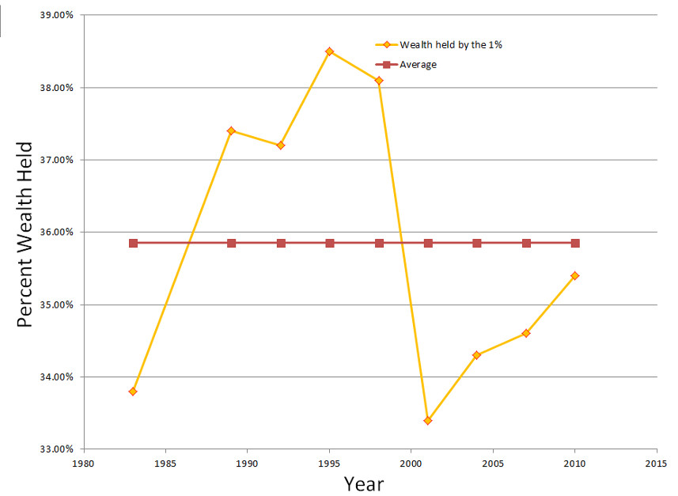

So what she should really be marching about with her 999,999 fellow students (or is that number too large?) is the fact that higher education is a bubble market – it consumes lots of money and produces far too many students for whom the math simply doesn’t add up.

