Greed and Gasoline
It’s always interesting to get perspective on things associated with the economy before jumping to conclusions. Taking a long, hard look at things from the vantage of a few years after the events have come and gone help to put them in context and also help to frame the right kind of questions to ask, which often leads to interesting answers.
Gasoline prices are a case in point. Only a few years ago the average price of a gallon of gasoline ranged between $3.00 and $4.00 and people were lamenting the high prices – sometimes in very funny ways.
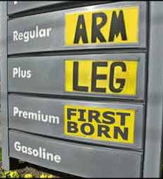

That trend continued well into 2014, before trailing off substantially in the fall of that year as the influence of the world-wide energy boom finally propagated into the US economy as a whole. These trends are nicely summarized by AAA’s historic fuel report chart reproduced here
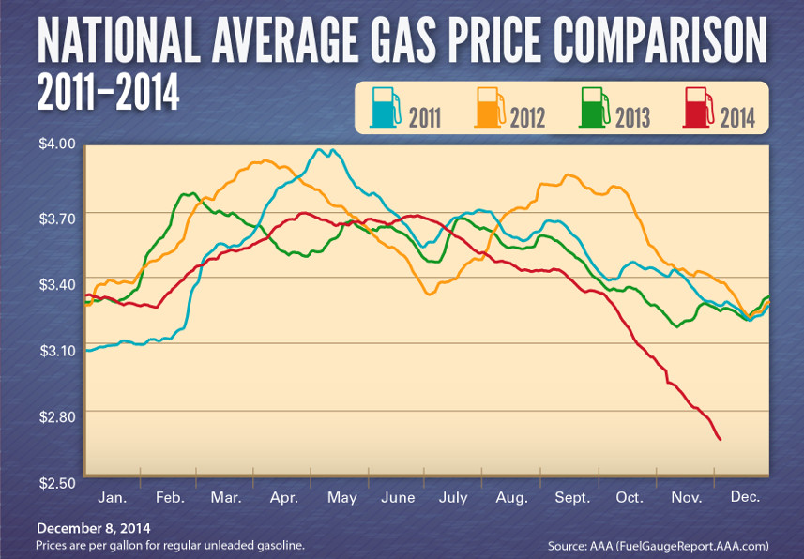
Of course the energy boom has to be understood as really resulting from two different forces. The first is the well-publicized increase in oil production around the world (supply) and the second is the profound change in driving and car-purchasing habits that many people engaged in during the oil price-peaks in 2011-2013 (demand). It is difficult to judge the interplay between these two effects to the point where a sharp line can be drawn which delineates the influence of one from the other. Nonetheless, it is clear that increase of supply of oil on the world stage is the main force driving prices.
During the ‘high price’ years, the accusation was often leveled against the oil companies that they were price gouging – their greed led to our misery. That claim may or may not be true, but it is well-supported that their ‘greed’ is the primary motivation for the current downward pressure on gasoline prices, giving us one of the longest ‘low price’ periods in recent memory.
It is conceivable that for most people this claim is nonsense. After all, if they believe greed results in price gouging, how then can greed drive prices down? The answer to this question is found in the law of supply and demand and in the outcomes of the dynamics of the Prisoner’s Dilemma.
The fastest way to drive up oil prices is to lower the supply relative to the demand. The law of supply and demand is a well-known principle but one whose full implications are often difficult to understand. One such point is that rising prices to do not imply rising profits. Other factors, such as market share and rising production costs, are reflected in the costs as well. In the particular case of gasoline prices, market share is the key feature.
Currently, there is more oil on the world stage than at any other point in recent times. So the ‘logical’ question to ask is why don’t the greedy oil producers simply cut production thereby lowering the supply. Lower supply with current demand equals higher prices equals higher profits.
This logic is flawed since it implies that all the oil producers are in perfect collusion with each other and that their collusion is so solid that each member will be content with the profit-sharing plan they all agreed to (predicated, of course, that they have actually entered into an agreement at all). Since the going in position is that the producers are greedy – here defined to mean that they will attempt to maximize their profits – one has to grant the strong possibility that one or more of them will betray the others when the order to lower production comes. Betrayal will mean that oil production will remain high and prices low, so that the net effect to the consumer is negligible; but to the producer who betrays first, their profits will soar as their market share increases. Since total profit is determined by profit per unit and the number of unit sold, the betrayer can increase his profit without lowering production, providing the other producers don’t think the same way.
But the other oil producers aren’t saps and they can work this out just as well as their fellow co-conspirators. So they all ‘betray’ the cartel and either keep their production steady or increase it, regardless of whatever they may say to each other. The overall effect is that greed keeps oil supplies high and prices low. This outcome is a direct consequence of free market forces and is good for the consumer.
So the next time you go to the pump and fill up your tank on $1.95/gallon gasoline, take a moment to thank a greedy oil producer for their greed.

