Is Anybody Up There Listening?
Very few commodities are as hot in the mainstream comics right now as is the purple-pussed, multi-chinned, mad Titan Thanos. So, one would expect that the Marvel machine would run on his popularity for as long as possible. And, indeed, we have been treated to a spate of appearances in various forms over the past several years. Some have been good, some not so good, but none are as bad as the installment ‘Thanos: A God Up There Listening’ (TAGUTL).
TAGUTL is a four-issue limited run that follows the last of the mad Titan’s living children, Thane,
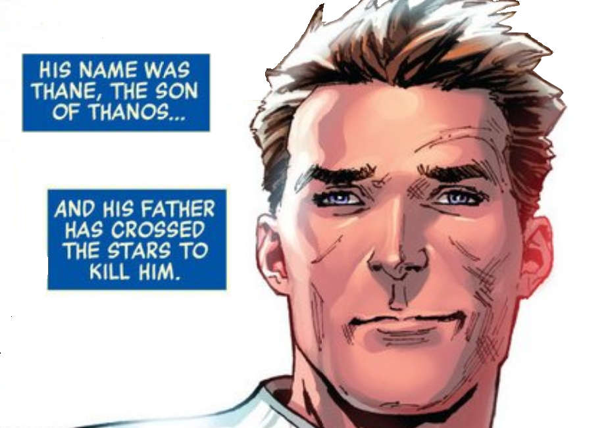

as he tries to grapple with his new-found abilities and the fact that his father is probably the biggest mass-murder the universe has ever seen. It builds idiocy upon the already highly unbelievable edifice erected during Infinity.
For those you missed the events of the Infinity series in the summer of 2013, Thane is a half-Inhuman and half Eternal (the Titans on the Saturn’s moon of the same name are Eternals – a post for another day) who lived in the Inhuman city of Orollan as a healer
<insert Thane as a healer>
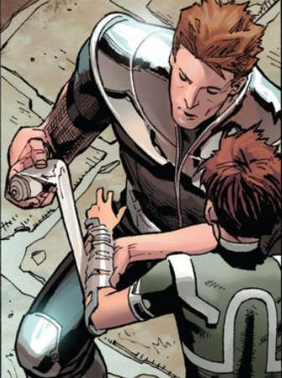
and as relatively normal person. Having not been exposed to the Terrigen mists that cause the transformations in the Inhumans, he exhibited no special powers to speak of (although compassion and a desire to heal others should be regarded as a super-power all on its own).
Things changed when Thanos, desiring to wipe all his progeny from existence as yet another demonstration of his fealty to Mistress Death, showed up on Earth to find his last remaining whelp. Seeking the location of his son, Thanos confronts Black Bolt, king of the Inhumans. A violent and spectacular battle ensues, in which Thanos has the clear upper hand. But, even as Black Bolt falls he activates a Terrigen bomb that spreads the mist over the whole globe, sparking a birth of potentially thousands of Inhumans outside of the control of the imperial house.
Thane falls victim to the Terrigen mist with horrific results. The Deviant strain inherited from his father, comes to the fore and, in a blink of an eye, he wipes all other life in Orollan.
<insert Thane over the bodies of his victims>
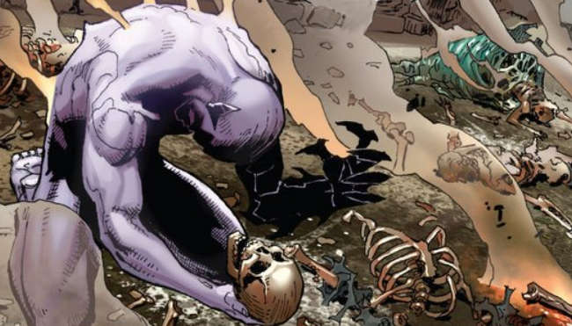
Almost immediately after the massacre, the Ebony Maw, one of Thanos’s little helpers, shows up bearing gifts. The Maw has brought a set of armor purported to help control Thane’s new abilities and to protect the people around him. I suppose that it is possible that Thane, under the shock of all the death he caused, could agree without asking any details. But more realistically, shouldn’t Thane have been on his guard when a stranger shows up out of nowhere, freely announcing his heritage? Instead, Thane is quite happy to accept the ‘gift’.
<insert Ebony Maw comes bearing gifts>
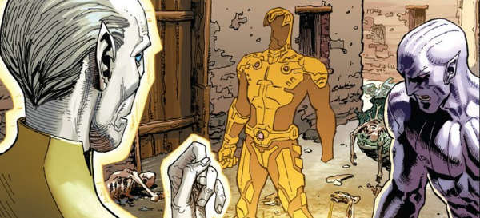
Well the good times don’t last, as at almost the exact instant the last stich is donned, Ebony Maw surrounds Thane with a containment field and then fawningly turns him over to Thanos. We are treated to a touching Father-Son moment.
<insert Father-son moment>
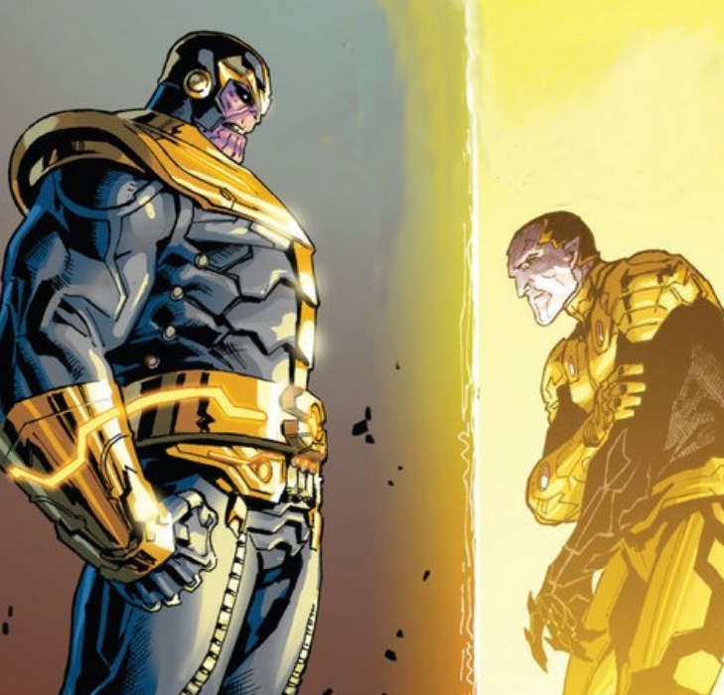
Eventually, Thane frees himself, and embraces his big daddy with his ‘right hand of justice’, freezing Thanos in almost the exact pose he occupied at the end of Marvel Two-in-One Annual #2 when Adam Warlock pulled the same trick.
<insert Freeze dried Thanos>
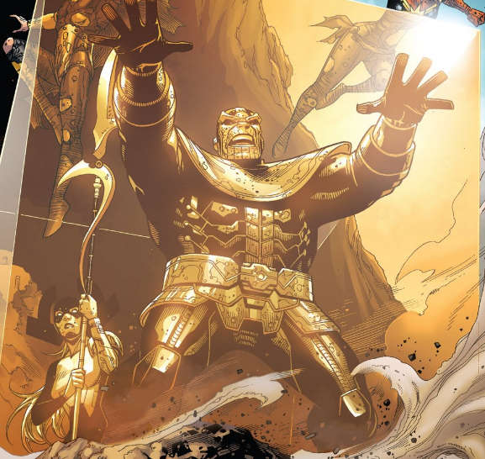
At this point, one might expect Thane to fall into the once-bitten-twice-shy category, but no, Thanos: A God Up There Listening, finds him quite willingly accompanying the Ebony Maw of planet to learn more about his dad. They soon arrive at Planet Malady, where, according to the narrative, the atmosphere acts as an extremely strong alcoholic gas. Stopping in Sclerosis Syd’s fine pub, they soon find the being they are looking for in the form of Trynka.
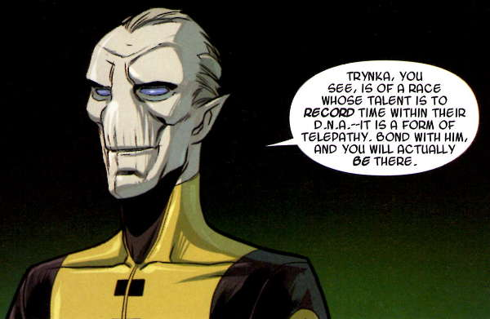
It seems that Trynka was an eye-witness to the one time when Thanos decided to take on Ego, the Living Planet, and that Thane, by telepathically linking with him, can experience all the events as Trynka did.
And how is this telepathic link mediated? It seems by an elegant technique, where Trynka projects his eyeballs out of his head and onto Thane’s – the optic nerve serving as the hard-wire link between the two.
<insert eyeballs>
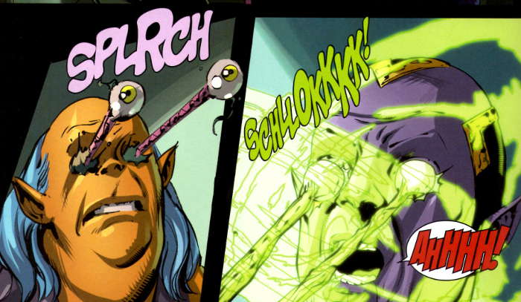
Immediately, Thane finds himself onboard the bridge as Thanos orders his fleet to assault Ego with missile barrage. The missiles strike Ego cleanly, and as the surface of the living planet burns, Thanos turns for a talk and a caress with Mistress Death, who may or may not really be there as no one else can see her. Thane, watching the tableaux from vantage of Trynka’s memories, immediately concludes “Oh God…He’s Insane.” Here then is the idea that was first put forth in the Thanos Rising series – that it is possible that Thanos has imagined all his interactions with Mistress Death since she remains unobserved by all but him. Thus having him earn the adjective ‘Mad’ in his description as the Mad Titan.
The character of Thanos has fascinated me for a long time, a very long time. I’ve followed his evolution from a shadowy villain, to a profoundly ambitious threat to universal existence, to an almost philosophical but severely flawed intriguer under the pen of Jim Starlin. In all these incarnations, there are two constant components of Starlin’s canon. First, Mistress Death is a real entity who interacts with Thanos and can be seen by others in the storyline. Second, despite his raw power, Thanos is a clever, manipulator who uses direct force as a final resort.
The current ideas that were put introduced in Thanos Rising and further explored in TAGUTL through the Starlin canon completely away. Here we have a truly stupid madman, suddenly deciding that his sexually promiscuous past must be erased in a tribute to an entity that only he can see, and that he will go about it in the most stupid way imaginable.
Basic physics seems to elude our purple fiend so that he thinks a frontal assault with a simple missile barrage is all that is needed to kill a living planet. Assuming that Ego is the size of Pluto (a dwarf planet) that gives the Living Planet an advantage in mass of over 3 billion, billion times, not to mention the Galactus engine it possesses as a power source and mode of transportation. How then does this stupid version of Thanos think he can win?
The TAGUTL narrative gets even more stupid as it progresses, insulting the reader’s intelligence with a variety of unbelievable plot points. Without adding too much in the way of spoilers, we learn that:
- Thanos and his crew can be surprised when Ego retaliates
- that they all may or may not have died
- that Ego can eat people, bringing them into his core
- that Thanos likes lava
- that Thane can’t remember which of his arms kills and which brings living death
- that Thane is also mad in that he may have left Earth on his own and not with the Ebony Maw
and so on.
I suspect that the editors have a similar assessment to mine. I base this conclusion on the fact that the series was released all at once, with all four issues coming out at the same time and all without the usual Marvel bonus digital edition.
If you haven’t read it, I recommend against it. And if you work at Marvel, I have to wonder is anybody up there listening? If so, just let Starlin write Thanos. All of us will be a lot better off.

