Well, it’s March and most people have abandoned their resolutions. Here, we are not abandoning it but rather expanding it a bit and redirecting some of the effort. At the core is still the idea of working through the basic concepts of quantitative finance during the year of 2026 but we are going to supplement the content of van der Wijst’s treatment with other texts. The obvious question is why? The obvious answer is that van der Wijst’s chapters (beyond the easy Chapter 2) are both too long and too wandering and obscure for an easy consumption.
The central idea of Chapter 3 is a statistical analysis of risk and how diversification mitigates that risk and how these ideas propagate and mature in various asset pricing models such as the capital asset pricing model (CAPM) and the arbitrage pricing theory (APT) for determining the return (and therefore the price) of a given asset such as a stock, a corporate bond, a hedge fund, etc., and also the famous Black-Scholes model for pricing options.
Nonetheless, van der Wijst drops the student right into discussions about correlation matrices and weighted outcomes that result from various possible scenarios. This treatment, while mathematically rigorous and interesting, I believe misses the intuition building that can only come from solving simple-appearing problems that challenge the student to go deeper and have a strong working knowledge of risk beyond the statistical measures that can be deployed.
After looking around at a variety of texts, I landed on supplementing this exploration using the book entitled Quantitative Finance: A Simulation-Based Introduction using Excel, by Matt Davison.
Davison’s Chapters 2 and 3 make an excellent precursor to the more abstract treatment of van der Wijst’s Chapter 3. There are three questions that are particularly thought-provoking that illustrate what Davison calls key concepts.
One of the first of the key concepts is that in analyzing risk one must first look past the expected return. This idea was discussed in an earlier blog (Economics and Ergodicity) but the circumstances are rather complicated and dense. Davison does a much better job by stressing that “variance is a good measure for distinguishing good bets from bad bets (provided their expected values are equal)”.
To illustrate this he gives a number of simple ‘what-if’ questions in Chapter 2.
For example, in Question 1, Davison asks us if we would prefer a $10-payout with certainty or a 50-50 shot of either getting $0 or $20 from a bet. The expectation value for each trial is $10 but one would have to be deeply confused to go for the latter case and, indeed, when one examines the standard deviation (STD) one arrives at:
- STD[$10-sure thing] = $0
- STD[50-50 bet] = $10
Here I have chosen to explicitly use standard deviation instead of variance to avoid giving explicit answers in dollars-squared (I believe Davison uses variance because of its more convenient properties and for the fact that if figures into CAPM).
He expands this idea that the expectation value is not sufficient on its own in the following question when he asks the reader to consider the following family of possible ‘bets’:
The game involves paying $1 to pull a single card from a standard 52-card deck. If the player gets an ace-of-spades, he wins $50, otherwise he gets nothing. Of course, the player would be stupid to take this bet as his expected winnings are negative ($1/26 or about $0.04 to be precise and the standard deviation of this game is approximately $6.87, making it a very stupid bet, indeed) but the real set of questions center on the banker. Davison points out, that with the stakes amplified by a factor of 100, that:
***
I expect that none of us would take the bet that had us risking the loss of $4900 (with probability (1/52)) to obtain the chance of gaining $100 (with probability (51/52)), even though this bet has the positive expected value of … about $4.”
***
The point he is making is that despite the fact that a naïve expectation calculation would tell us that we should, on average, expect to make $4 each time the game is played we intuitively (or quantitatively) sense (or understand) that the standard deviation also scales to $687 and that that value is too high to blindly accept the expected value as a good guide.
To better illustrate this idea, I constructed a simple simulation of the bank where I ran a succession of the same bet (1,000 trials in total) and I repeated this scenario 16 separate times. The cumulative sum for each scenario looks like:
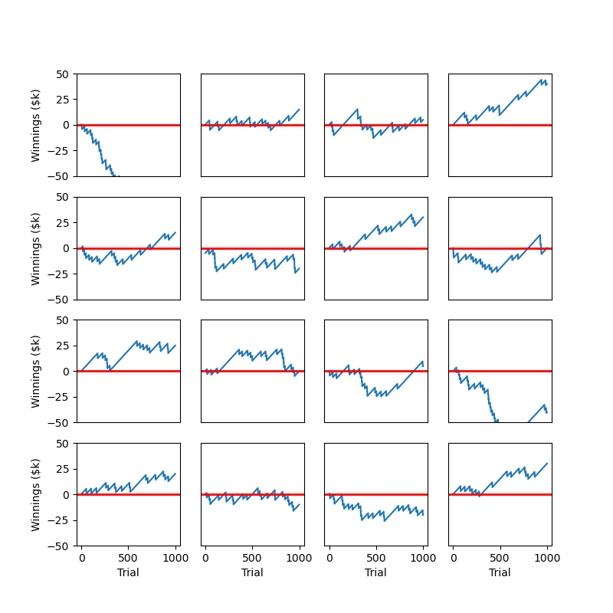
In 5 of the scenarios, the bank ended with a loss with the first scenario (upper left) being a dismal failure that went south quickly and never recovered. In that scenario, the final bank balance was -$70k. Despite the fact that several of the scenarios ended with gains, none these demonstrated a ‘steady’ profit and many hovered around zero with often prolonged dips into negative territory.
There is one silver lining, which is a point that Davison makes in Questions 5a and 5b (although he doesn’t use this bet in those questions): the division into many smaller pieces helps to dilute the risk. Suppose instead of a 1000 separate trials, the player and the bank decided to scale the bet upwards by a factor of 1000, with the cost to play now at $100,000 and the payout being either $0 (for 51 out of 52 possibilities) or $5,000,000 (for the elusive ace of spades). Again, the maximum expected loss for the bank is $4,900,000 but the odds of this occurring are (51/52)¹⁰⁰⁰, which is approximately 4 chances in 1 billion trials. As evidenced by the plot above, none of the repeated bets got anywhere near those limits (recall the worst case scenario for the bank ended with a $70k shortfall – a far cry from nearly $5 billion).
So, the fundamental point is clear that both the expected value and the variance, taken as a pair, will be critical for quantitative finance. With these basic concepts better in hand, we will return to van der Wijst’s analysis of correlation and covariance in the next post.

