HCI520: p2-tERM PROJECT DESIGN SPECIFICATIONS

Topic: The 3-Point Lighting Setup for Product Photography
This topic comes directly from my own experience working with design and photography. A lot of what I’ve learned hasn’t come from formal tutorials, but from actually trying to photograph objects and realizing something always felt “off” even when I couldn’t explain it. Over time, I started understanding how lighting changes the entire look of an image, especially in product photography where small details matter a lot.
Instead of treating lighting as something overly technical, I want to break it down into something more intuitive. The focus is not just on naming the lights, but on understanding how each one actually affects the final image and why that matters when someone is trying to present their work professionally.

Learner Description
Target Learners:
The main audience for this system is design students, artists, or makers who need to photograph physical work. This includes things like handmade products, models, or prototypes that need to be documented for portfolios or shared online.
Motivation:
Most of these learners already care about how their work looks, but they get stuck when it comes to photographing it. Their images might look too harsh, too flat, or just “not right,” but they don’t really know what to fix. So the motivation here is very practical—they want their work to look more polished and intentional, especially for portfolios, internships, or social media.
Prior Knowledge:
Learners have Factual Knowledge of basic camera hardware such as a phone or light source (Recognizing 1.1), and Conceptual Knowledge of visual principles like contrast, balance, and composition (Understanding 2.1).
What they are missing is the connection between lighting choices and the final result.

Learning Objectives (LOs)

To keep the experience realistic within a 15–30 minute time frame, I focused on the parts of lighting that actually make the biggest visible difference.

LO | Objective | Cognitive Process | Knowledge Dimension
LO1 | Identify the Key, Fill, and Back lights within a standard three-point lighting diagram | 1.1 Recognizing | A. Factual
LO2 | Predict how adding or adjusting a bounce card affects shadow density on an object | 2.2 Inferring | B. Conceptual
LO3 | Execute a lighting setup that reduces harsh shadows by placing light sources in a virtual environment | 3.1 Executing | C. Procedural

Assessment
The assessment is designed as a Simulated Studio Challenge because I didn’t want it to feel like a traditional quiz. The idea is to make it feel closer to an actual photography task rather than just testing memory.
The system starts with a short visual identification activity and then moves into an interactive “virtual shoot.” For eg, learners might first identify which light is acting as the main source in a diagram. Then, they might be asked to predict what happens when a bounce card is moved closer to the object, focusing on cause-and-effect rather than guessing.
Questions:
- “Which light source is responsible for the highlight or ‘halo’ effect on the edge of the object?”
- “If the shadow on the object appears too dark, should you move the bounce card closer or further away?”
- “Which light would you adjust to soften shadows without removing them completely?”
Finally, they will adjust lights in a virtual setup to achieve a specific result, like reducing harsh shadows while still keeping some depth in the image. Instead of only marking answers as right or wrong, the system gives visual feedback so learners can immediately see how their decisions change the outcome.

Teaching Outline
The system will follow a guided discovery approach so learners understand lighting by actually seeing changes happen, rather than just reading explanations.
Module 1: The Components (5 minutes)
Introduces Key, Fill, and Back lights through simple visuals and short explanations. The focus is on quickly understanding what each light does.
Module 2: Shadow Behavior (10 minutes)
Learners interact with a slider or controls to see how adding a fill light or bounce card changes shadows. This helps build intuition about how light behaves.
Module 3: Hands-On Placement (15 minutes)
Learners place lights around a product in a virtual setup and immediately see the results. This connects their actions to the final image in a very direct way

Wireframes

Screen 1

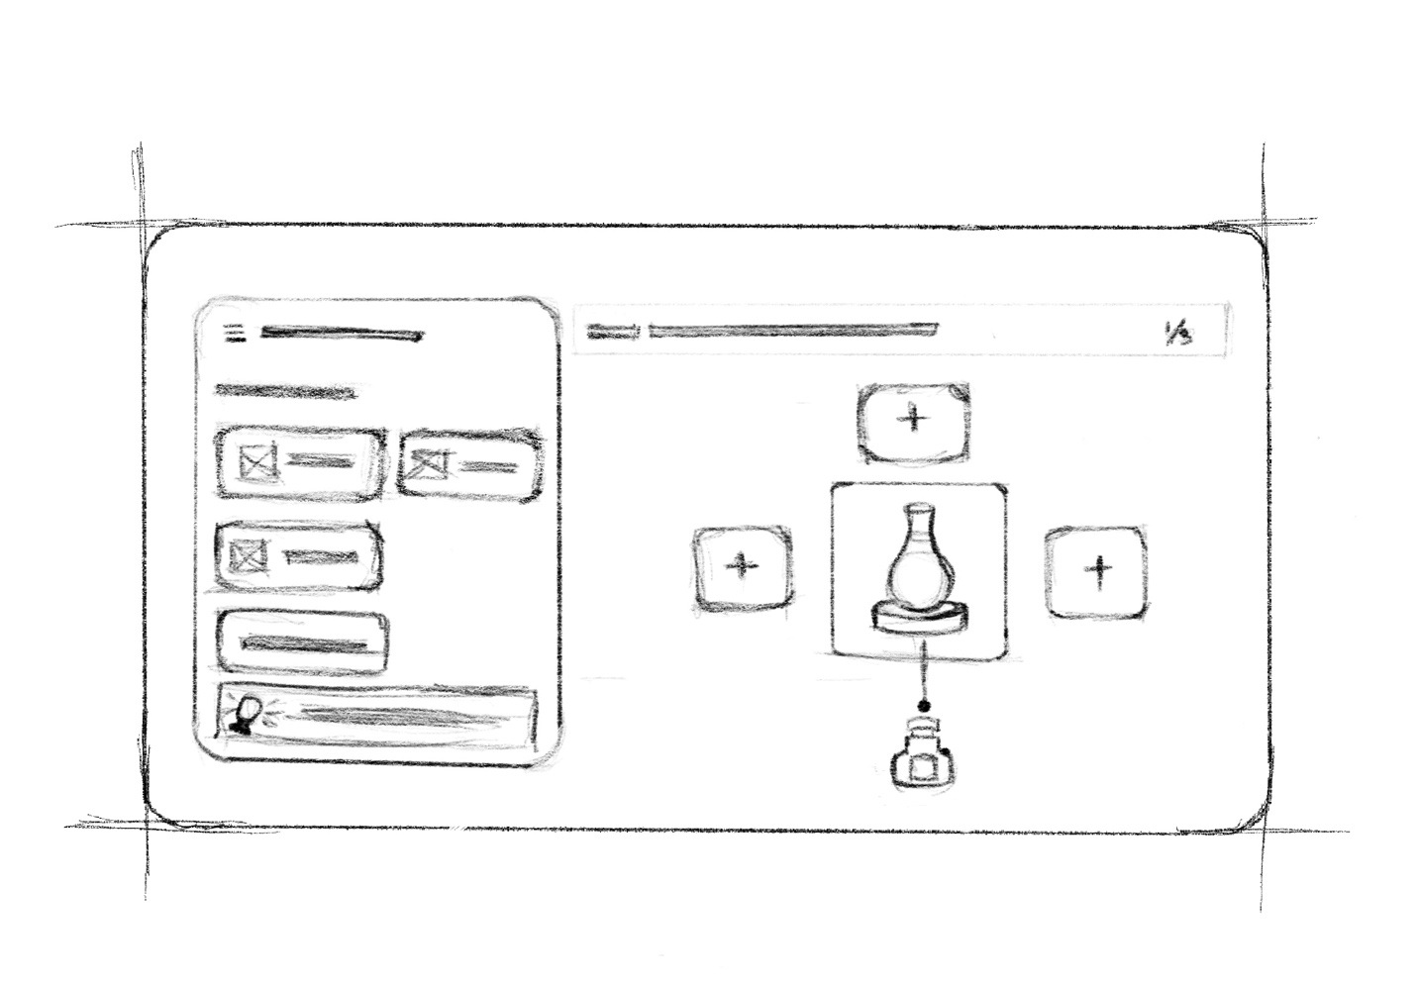

A top-down view of a photography setup with empty positions for lights. Learners choose a light type (Key, Fill, Back) and drag it into place, helping them understand spatial positioning

Screen 2
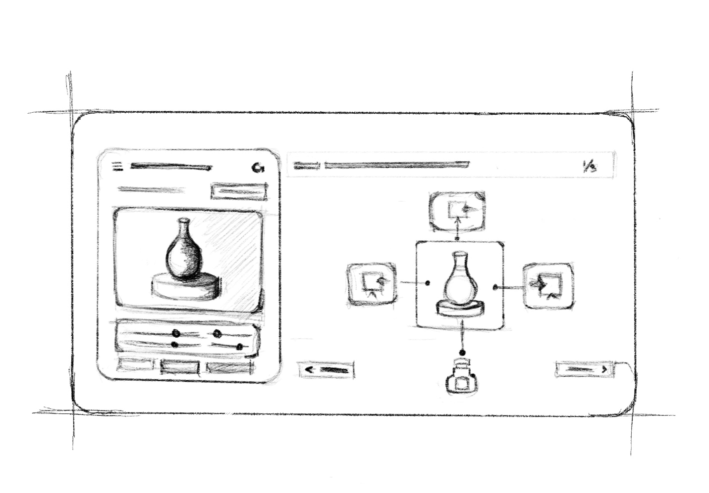
A split-screen layout where one side shows the studio setup and the other shows the resulting image. As learners move lights around, the image updates in real time, making the relationship between setup and result very clear.

Partner Statement

I am completing this project individually and am responsible for the instructional design, Bloom’s taxonomy mapping, and wireframe development.

