 2018-02-22

Dear Maám Yumang,

Please excuse Robert for being absent for 3 days.

Sincerely yours,

Robert

Signed by:

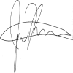

Moreno, Richard      Trina Mae, Abarquez

College Dean   School President