2018-02-22

Dear Maám Yumang,

Please excuse Robert Pool for being absent for 3 days.

Sincerely yours,

Robert Pool

Signed by:

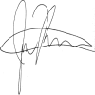

Moreno, Richard    ${School President-Name}

College Dean ${School President-Position}