 2018-02-22

Dear Maám Yumang,

Please excuse Pool for being absent for 3 days.

Sincerely yours,

Pool

Signed by:

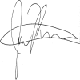

Moreno, Richard      ${School President-Name}

College Dean   ${School President-Position}