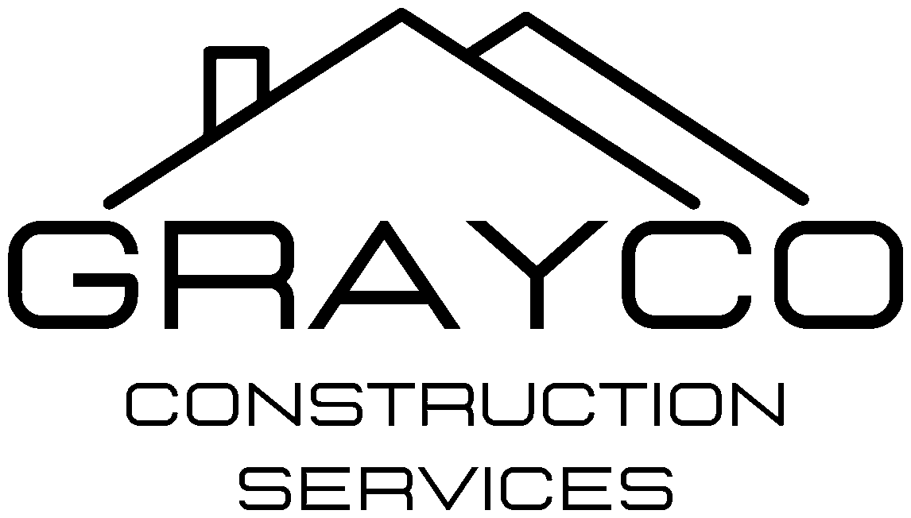
GrayCo Construction Services, LLC
4007 Broadway Rd., Bartlett, TN 38135 | (901) 585-0944 | TN License # 85034
EMPLOYEE TRAINING
Health Effects of Lead, Asbestos and Mold
Every GrayCo employee and subcontractor worker who may disturb paint, building materials or moldy surfaces gets this training before starting work, and again every year. It goes with the Lead Safety Program, the Asbestos Awareness and Control Program and the Respiratory Protection Program. Training takes about 30 minutes. Every attendee signs the sign-off sheet at the end.
WHY THIS MATTERS
- You cannot see, smell or taste lead dust or asbestos fibers. Damage can build up for months or years before you feel sick.
- Most of the harm is permanent. Prevention is the only real protection.
- What you carry home on your clothes, shoes, tools and truck can poison your children and family.
1. LEAD
Where you find it
- Paint on homes and buildings built before 1978: doors, windows, trim, porches, beams, cabinets, exterior siding.
- Soil around older buildings and playgrounds, old pipes and solder, some old roofing flashing.
- Dust is made when you sand, scrape, cut, demolish, heat-gun or power-wash painted surfaces, and when you sweep or dry-dust.
How it gets into your body
- Breathing dust or fumes.
- Swallowing dust: eating, drinking, smoking, chewing gum or touching your face with dusty hands.
Early warning signs (short-term or higher exposure)
- Headaches, tiredness, trouble sleeping
- Irritability, mood changes, trouble concentrating
- Stomach pain, cramps, nausea, constipation, loss of appetite
- Metallic taste in the mouth
- Muscle and joint pain, weakness
Many people with high lead levels have no symptoms at all. Only a blood lead test shows how much lead is in your body.
Long-term health damage
- Brain and nerves: memory loss, slower thinking, depression, numbness or weakness in hands and feet. Very high levels can cause seizures, coma and death.
- Kidneys: permanent kidney damage and kidney disease.
- Heart and blood: high blood pressure, heart disease, anemia (low red blood cells).
- Reproduction: lower sperm count and damaged sperm in men; miscarriage, stillbirth and premature birth in women.
- Unborn babies: lead passes from mother to baby and can cause birth defects and brain damage. Tell your supervisor if you are pregnant or planning to be; it stays private.
Children and families (take-home lead)
- There is no safe blood lead level for children. Small amounts of dust can lower IQ and cause learning, behavior and hearing problems that do not go away.
- Children under 6 and pregnant women are at the highest risk. This is why childcare jobs such as the Head Start centers have extra rules.
- Never wear work clothes or boots home or into your house. Change and wash up before getting in your vehicle.
Medical testing (OSHA lead standard for construction)
- Workers exposed at or above the action level get blood lead testing paid for by GrayCo: every 2 months for the first 6 months, then every 6 months.
- A blood lead level of 40 µg/dL or more means testing every 2 months and a medical exam. At 50 µg/dL or more the worker is removed from lead work with full pay and benefits until the level drops below 40.
- Results are given to you in writing and kept confidential.
2. ASBESTOS
Where you find it
- Buildings built before 1981, especially: drywall joint compound and texture, plaster, floor tile and mastic, pipe and boiler insulation, popcorn ceilings, roofing, siding and transite panels, window glazing and caulk, duct wrap.
- If it is not on the survey as tested negative, treat it as asbestos. GrayCo crews do not disturb asbestos. Stop and call the supervisor.
How it gets into your body
- Breathing fibers released when material is cut, drilled, sanded, broken or crumbles. Fibers stay in the lungs for life.
Health damage
- No warning signs: asbestos causes no pain or symptoms when you breathe it. Disease shows up 10 to 40 years later and cannot be cured.
- Asbestosis: scarring of the lungs that causes shortness of breath, coughing and chest tightness, and gets worse over time.
- Lung cancer: smokers exposed to asbestos have a much higher risk of lung cancer than either alone.
- Mesothelioma: a deadly cancer of the lining of the lungs or stomach, caused almost only by asbestos. Even short exposures can cause it.
- Other cancers and disease: cancer of the throat (larynx) and ovaries, and thickening or fluid around the lungs (pleural disease).
- Families: fibers carried home on clothes have caused mesothelioma in workers' wives and children.
Signs to report to a doctor (from any past exposure)
- Shortness of breath, lasting cough, chest pain, coughing up blood, unexplained weight loss. Tell the doctor you have worked around asbestos.
3. MOLD
Where you find it
- Anywhere water has gotten in: leaks, floods, crawlspaces, attics, behind drywall, under flooring, HVAC ducts. It grows within 24 to 48 hours of water damage.
- Disturbing it (tearing out drywall, carpet or insulation) sends spores into the air.
Health effects
- Allergic reactions: sneezing, runny or stuffy nose, red itchy eyes, skin rash.
- Breathing problems: coughing, wheezing, asthma attacks, sore throat.
- Hypersensitivity pneumonitis: repeated heavy exposure can inflame the lungs and cause fever, chills, shortness of breath and fatigue; it can become permanent.
- Infections: people with asthma, lung disease, diabetes or a weak immune system can get serious lung infections.
- Irritation and headaches from mold odors and the chemicals it gives off.
Mold found on a job is stopped and handled by change order, the same as lead and asbestos.
4. HOW YOU PROTECT YOURSELF
- Know before you start: check the job file for the year built, lead and asbestos reports, and the work plan.
- Follow lead-safe work practices: containment, misting, no dry sanding or dry sweeping, HEPA vacuum only, no open-flame burning or high-heat guns.
- HVAC is shut off during lead abatement and renovation work.
- Wear the respirator assigned to you, fit-tested and with no beard where it seals. Wear disposable coveralls, gloves and shoe covers.
- No eating, drinking, smoking or chewing in the work area. Wash hands and face before every break.
- Change out of work clothes and wash up before leaving the site. Bag dirty coveralls. Do not shake them out.
- Keep tools, lunch and phone out of the work area or bagged.
- Stop work and call the supervisor if you uncover suspect material, damaged paint, or mold that is not in the scope.
5. WHEN TO GET MEDICAL HELP
- Report any symptom on this sheet to your supervisor the same day. GrayCo pays for work-related medical exams and testing.
- Get emergency care right away for trouble breathing, chest pain, confusion, seizures or fainting.
- Tell any doctor you see that you work around lead, asbestos or mold.

TRAINING SIGN-OFF
By signing, I confirm I attended this training, received a copy, had my questions answered, and understand the health effects of lead, asbestos and mold and how to protect myself and my family.
Trainer: Date:
Job / location: Language given in:
1. Name (print) / signature: Company:
2. Name (print) / signature: Company:
3. Name (print) / signature: Company:
4. Name (print) / signature: Company:
5. Name (print) / signature: Company:
6. Name (print) / signature: Company:
7. Name (print) / signature: Company:
8. Name (print) / signature: Company:
9. Name (print) / signature: Company:
10. Name (print) / signature: Company:
11. Name (print) / signature: Company:
12. Name (print) / signature: Company:
13. Name (print) / signature: Company:
14. Name (print) / signature: Company:

