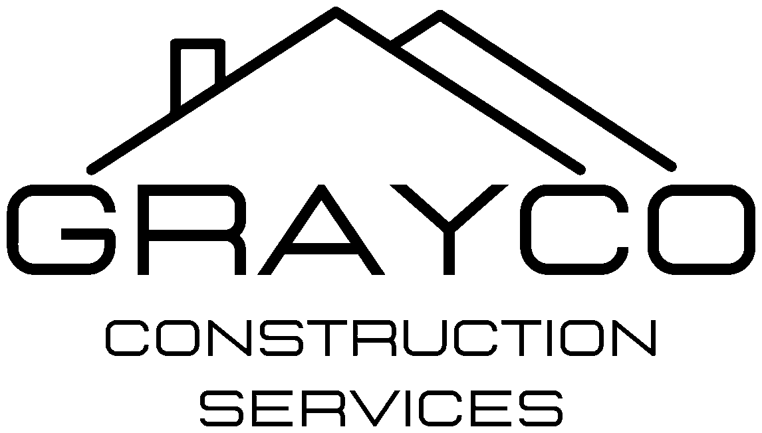
GrayCo Construction Services, LLC
4007 Broadway Rd., Bartlett, TN 38135 | (901) 585-0944 | TN License # 85034
STANDARD CONTRACT CLAUSES
Hazardous Materials – Lead, Mold and Asbestos
Required on every GrayCo contract, proposal and contract exhibit. Have GrayCo's attorney review this wording once before it becomes the standard. Clause 2 is used on any job where hazardous waste will be hauled off site.
CLAUSE 1 – HAZARDOUS MATERIALS (EVERY CONTRACT AND PROPOSAL)
Hazardous Materials – Lead, Mold and Asbestos. GrayCo's price does not include the testing, abatement, removal, encapsulation, remediation or disposal of lead-based paint, lead-contaminated soil or dust, mold, asbestos-containing materials, or any other hazardous or regulated material, unless that work is specifically listed as a priced line item in this Proposal or Contract. If any of these materials are discovered or suspected during the Work, GrayCo will stop work in the affected area and notify the Owner in writing. The solution will be agreed and carried out by written Change Order. The Change Order will adjust the Contract Sum and Contract Time for testing, required notifications and permits, licensed abatement or remediation, air monitoring, clearance testing, disposal, and delays caused by the discovery. GrayCo is not responsible for pre-existing hazardous materials or for any exposure, damage or delay caused by them.
CLAUSE 2 – HAZARDOUS WASTE DISPOSAL, PAID AS INCURRED
Disposal of Lead-Impacted Soil and Hazardous Waste – Paid as Incurred. As stated in GrayCo's Proposal, removal and disposal of lead-impacted soil and other hazardous or regulated waste is excluded from the Contract Sum. Hauling and disposal costs will be paid as they are incurred. These costs include landfill and tipping fees, hazardous waste fees, dumpsters and roll-offs, transportation, TCLP testing and manifests. GrayCo will invoice them separately at actual cost plus ___% markup, with landfill tickets, hauler invoices and lab results attached. Each invoice is due within 15 days of receipt and is not subject to retainage. If an invoice is not paid when due, GrayCo may stop hauling and disposal work, and the Contract Time will be extended for the delay. Each invoice will be documented by Change Order, and approval of the Change Order will not delay payment for disposal already performed.
Notes for use
- Fill in the markup (10% to 15% is typical for pass-through costs).
- Keep disposal out of the contract sum when possible: on public and federally funded jobs, adding it can push a contract over a bond threshold (for example, $150,000 on CDI Head Start).
- If an owner insists on a number, list it as a hazardous waste disposal allowance billed against actual tickets, with unused amounts credited back.
- Run TCLP before hauling. Under 5.0 mg/L lead = special waste to a Class 1 landfill. 5.0 mg/L or more = hazardous waste, manifest and EPA ID (Form 8700-12) required.
CDI Head Start – Des Arc cover note
"Per our October 30 proposal, disposal of the Des Arc playground soil is excluded from the contract price and will be billed as incurred with landfill tickets attached, as stated in the contract exhibit."

