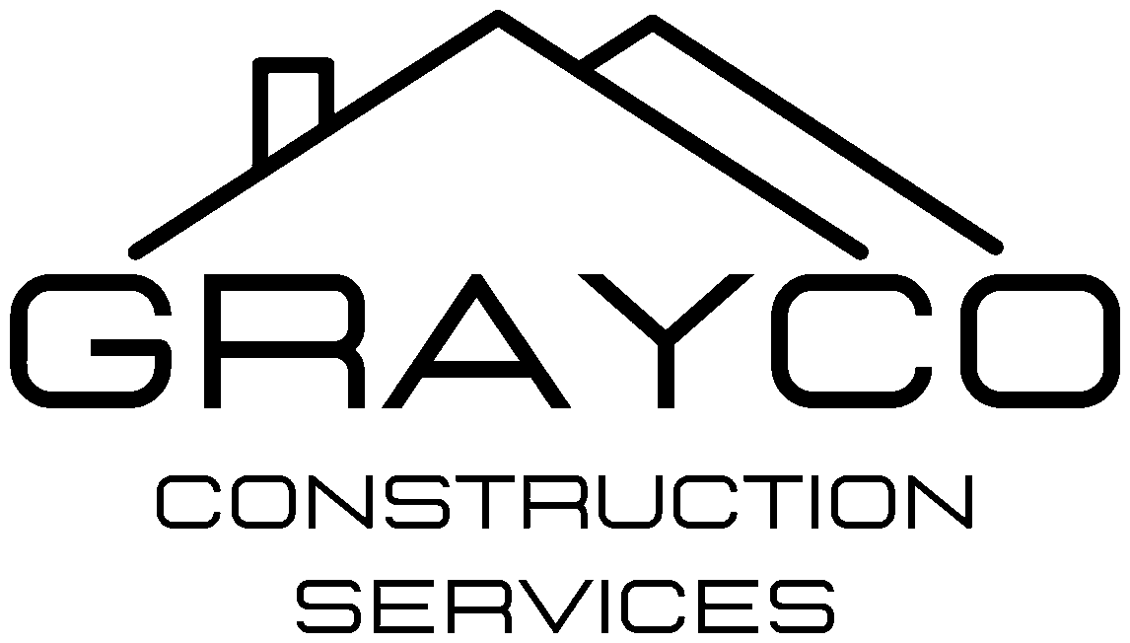
GrayCo Construction Services, LLC
4007 Broadway Rd., Bartlett, TN 38135 | (901) 585-0944 | TN License # 85034
CUSTOMER PORTAL
Residential Questionnaire – CRM Build Spec
Every residential job in the customer portal shows the Your Home section first, then a short set of questions for the job type. Year built is required on every job type and drives the lead and asbestos flags below.
YOUR HOME – ON EVERY JOB
- Property address
- What year was your house built? (required; "I'm not sure" checkbox allowed)
- Type of home: single-family, townhouse, condo, duplex, mobile/manufactured
- Number of stories: 1, 1.5, 2, 3 or more
- Approximate square feet: under 1,200 / 1,200–2,000 / 2,000–3,000 / over 3,000 / not sure
- Foundation: slab, crawlspace, basement, not sure
- Own or rent (rent = landlord approval needed)
- Will anyone live there during the work?
- Pets at home?
- Is the home in an HOA?
- Gate code, parking or access notes (optional)
YEAR-BUILT AUTOMATION
Built before 1978 – lead (EPA RRP)
- Customer sees: "Homes built before 1978 may have lead-based paint. GrayCo is an EPA Lead-Safe Certified firm and will use lead-safe work practices. At least 7 days before work starts, we'll send you the EPA Renovate Right pamphlet to review and sign."
- CRM flags the job PRE-1978 and adds to the job file: Renovate Right pamphlet and pre-renovation disclosure (customer e-sign, auto-sent 7 days before start; job cannot start until signed), renovation recordkeeping checklist, test kit documentation form, firm and renovator certificates, lead/mold/asbestos change order clause in the proposal, lead-safe signs in English and Spanish.
Built 1978–1980 – possible asbestos
- Customer sees: "Some building materials from this period contain asbestos. If we find suspect materials, we'll stop and talk with you before going further."
- Pre-1981 jobs (including pre-1978) get a POSSIBLE ASBESTOS flag: estimator checks for suspect materials at the site visit; proposal includes the change order clause.
"I'm not sure"
- Customer sees: "No problem. Our office will look up the year from county property records before your estimate."
- CRM creates an office to-do to look up year built on the county assessor site. Job cannot be scheduled until year built is filled in.
QUESTIONS BY JOB TYPE
Roofing
- What do you need? Leak repair / storm damage / full replacement / inspection
- About how old is the roof? Under 10 / 10–20 / over 20 years / not sure
- Current roof type: shingle / metal / flat or low slope / tile / not sure
- Is water coming inside right now?
- Are you filing an insurance claim? Yes / no / not sure yet
- Photos of the roof or damage (upload)
Siding & Gutters
- What do you need? Siding / gutters / both
- Current siding type: vinyl / wood / fiber cement / brick or stone / not sure
- Which sides of the house? One / two or three / whole house
- Any rotted wood or water damage you can see?
- Photos of each side (upload)
Kitchen Remodel
- How big is the project? Refresh / partial (cabinets and counters) / full gut
- Keep the same layout?
- Who is buying appliances? GrayCo / customer / keeping existing
- Budget range: under $15k / $15k–$40k / $40k–$75k / over $75k
- When would you like it done? (text)
- Photos of the kitchen now (upload)
Bathroom Remodel
- How many bathrooms? 1 / 2 / 3 or more
- Tub or shower? Tub / walk-in shower / combo / not sure
- Any accessibility needs (grab bars, curbless shower)?
- Budget range: under $10k / $10k–$25k / $25k–$50k / over $50k
- Photos of each bathroom (upload)
Painting & Drywall
- Interior, exterior or both?
- How many rooms? 1–2 / 3–5 / 6 or more / whole house
- Ceilings included?
- Drywall repairs needed? None / small patches / water damage / large areas
- Do you have paint colors picked out?
- Photos of the rooms or damage (upload)
Flooring
- Which rooms? (text)
- What is on the floor now? Carpet / hardwood / tile / vinyl or laminate / not sure
- New floor type: LVP / hardwood / tile / carpet / need advice
- Any stairs?
- Any soft or bouncy spots in the floor?
Insurance Claim
- Type of damage: wind or hail / water / fire or smoke / tree fell / other
- Date of loss
- Insurance company
- Claim number
- Has an adjuster been out yet? Yes / no / scheduled
- Has water been dried out or damage boarded up?
- Photos and adjuster estimate (upload)
Lead, Mold or Asbestos
- What are you concerned about? Lead paint / mold / asbestos / not sure
- Has anything been tested? Yes, I have a report / no / not sure
- Where in the home? (text)
- Do children under 6 live in or often visit the home?
- Test report or photos (upload)
Additions, Decks & Porches
- What are you building? Room addition / deck / covered porch / garage / other
- Approximate size (text)
- Do you have drawings or plans? Yes / no / need design help
- Is your home in an HOA?
- Photos of the area or plans (upload)
General Repairs
- List what needs fixing (text, one item per line)
- How soon do you need it? Emergency / within 2 weeks / this month / flexible
- Photos (upload)

