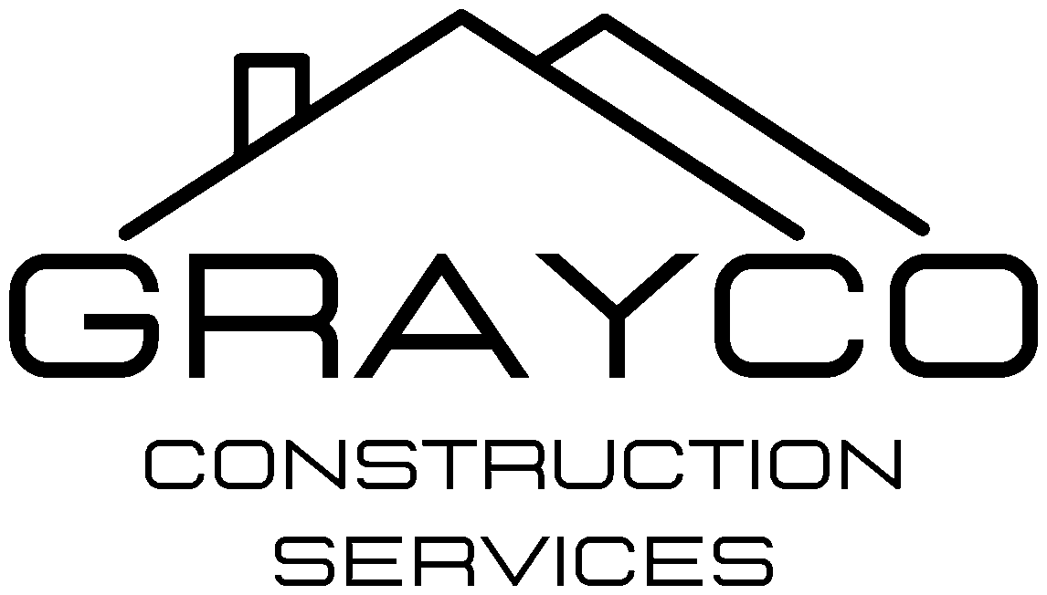
GrayCo Construction Services, LLC
4007 Broadway Rd., Bartlett, TN 38135 | (901) 585-0944 | TN License # 85034
EPA AND STATE FORMS INDEX
Required on Every Lead, Asbestos or EPA Job
GrayCo standard: on any job with lead, asbestos, mold or another EPA issue, these forms go into the job file automatically. Download each from the link and save it in the CRM forms library.
EPA RRP – EVERY LEAD-PAINT JOB (TN AND AR)
- Renovation recordkeeping checklist (GrayCo version also in this package) – https://www.epa.gov/system/files/documents/2026-08/recordkeeping-checklist-4-30-2029.pdf
- Pre-renovation disclosure form – customer signs; pamphlet given at least 7 days before work – https://www.epa.gov/system/files/documents/2026-08/pre-renovation-form-exp-4-30-2029.pdf
- Renovate Right pamphlet – https://www.epa.gov/lead/renovate-right
- Renovation notice and child-occupied facility notification forms – https://www.epa.gov/sites/default/files/documents/tenantform.pdf
- Test kit documentation form – https://www.epa.gov/system/files/documents/2026-07/test-kit-documentation-form.pdf
- Paint chip sample collection guide – https://www.epa.gov/system/files/documents/2026-05/paint-chip-sample-collection-guide.pdf
- Small Entity Compliance Guide to Renovate Right – https://www.epa.gov/lead/small-entity-compliance-guide-renovate-right
- RRP firm certification ($300, 5 years, renew 90 days before expiration) – https://www.epa.gov/node/255913
ARKANSAS DEPARTMENT OF HEALTH – LEAD ABATEMENT
- Lead-based paint notice of intent (10 working days before abatement) – https://healthy.arkansas.gov/wp-content/uploads/ADH_Lead-Based_Paint_Notice_of_Intent.pdf
- Contractor and consultant (firm) application – https://healthy.arkansas.gov/wp-content/uploads/ADH_Application_for_Lead-Based_Paint_Contractor_and_Consultant.pdf
- Individual certification application – https://healthy.arkansas.gov/wp-content/uploads/ADH_Application_for_Lead-Based_Paint_Certification.pdf
MISSISSIPPI MDEQ – STATE-RUN RRP AND ABATEMENT
- Firm certification application – https://www.mdeq.ms.gov/wp-content/uploads/2023/07/LBP-Firm-Cert-App-7-17-23.pdf
- Individual certification application – https://www.mdeq.ms.gov/wp-content/uploads/2025/09/LBP-Individual-Cert-App-9-25-25.pdf
- Lead-based paint project notification form – https://www.mdeq.ms.gov/wp-content/uploads/2025/07/LBP-Project-Notification-Form.pdf
- Differences between EPA and Mississippi RRP rules – https://www.mdeq.ms.gov/wp-content/uploads/2017/05/DIFFERENCES-BETWEEN-EPA-AND-MS-RRP-REGS.pdf
TENNESSEE
- EPA runs RRP firm certification. Tennessee's own pre-renovation education rule: signed pamphlet acknowledgment, or pamphlet sent by certified mail at least 7 days before work, or a written record of attempted delivery. Keep records 3 years.
- TDEC RRP page – https://www.tn.gov/environment/program-areas/solid-waste/toxic-substances/lead-hazard-program/lead-renovation-repair-and-painting.html
ASBESTOS
- EPA guidance for the renovation/demolition notification (10 working days; filed with AR DEQ, TDEC or MDEQ, usually by the abatement sub) – https://www.epa.gov/system/files/documents/2022-08/filling-demo-reno-form-guidance.pdf
- Asbestos waste shipment record – one with every load; abatement sub or landfill provides the form. Keep the signed copy.
HAZARDOUS WASTE (ONLY IF WASTE FAILS TCLP)
- EPA Form 8700-12, Site ID notification – https://epa.gov/hwgenerators/instructions-and-form-hazardous-waste-generators-transporters-and-treatment-storage-and
- Arkansas DEQ version – https://www.adeq.state.ar.us/hazwaste/programs/pdfs/notification-of-rcra-subtitle-c-waste-activity.pdf
GRAYCO STANDING RULES
- Renovate Right pamphlet to the customer at least 7 days before any lead job.
- HVAC shut off during lead abatement or renovation.
- Lead and asbestos signs say no eating, drinking or smoking, in English and Spanish.
- Employee training covers the health effects of lead, asbestos and mold, with signed sign-off.
- Any lead, mold or asbestos found is resolved by change order; hazardous waste disposal billed as incurred.

