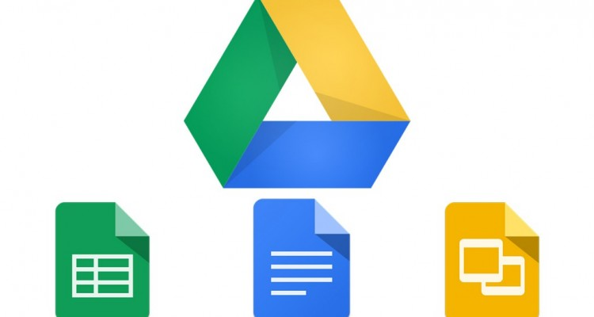

**Google** Drive *with* Sheets, Docs & Slides

____________________________________________________

*“Googles Mission is to organise the world’s information and make it universally accessible and useful”*

Googleis a name that everyone in the world today knows. It’s even now become a verb in the English language, to ‘google’ something has become an action. The organisation itself has been on the forefront of the technology industry. Not only do they work with online based products and services but they have now gone onto bigger and better things like their self-driving cars and Google Glass for example. They employ over 40,000 people based all over the globe, including their European headquarters in the Docklands in Dublin’s city centre. It was founded by Larry Page and Serge Brin as a privately owned company on the 4th of September 1998 and went public in August of 2004. They have over 1.17 billion unique users of their google search engine every month and over 50% of these are coming from mobile devices. Which explains why they have moved onto mobile software applications for the smartphone market like Google Drive, Docs, Sheets, Slides and of course Maps. Google have given their customers a map for anywhere in the globe and a complete office suite all in their pockets for access no matter where you are.

**Google -** Technology Industry

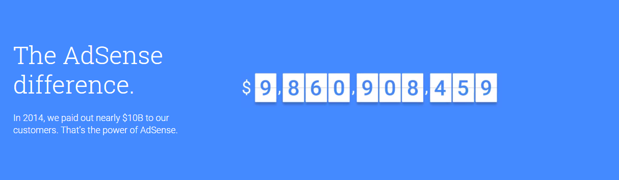As of November 2015 Google is now a subsidiary of Alphabet Inc. A new umbrella corporation to house all of their businesses and projects under one name. Googles search engine is the most trafficked website in the world according to the 2015 rankings. Their main competitors in search engine websites are Microsoft’s Bing and Yahoo. Even though these search engines are competing with Google Search, they are still way off in means of catching up. As of April 2016 Bing, Googles closest competitor, only attracts 350 million unique visitors a month where Google has over 1.17 billion so it’s clear what the preference is for the online population. In global digital advertising Google accounted for more than 31% of the market, generating $38.4 billion in advertising revenue alone. Companies from all over the world are willing to pay the fee to put the right ads in front of the right consumer. In 2014 32% of Googles $68 Billion came from sources other than its own websites, the majority of it coming from their AdSense service which allows non-Google websites to include Google’s ads into their web pages. In 2014 Google paid out nearly $10 Billion to their AdSense customers. But Google don’t only rely on advertising as their only source of revenue. 11% of Googles 2014 revenue came from non-advertising related projects from online and offline businesses. They have their own repertoire of technological projects and services to which generate revenue for them to continue to build on what they have. They make a mobile-to-TV streaming device known as Chromecast, a laptop made to primarily be used while connected to the internet known as a Chromebook and as I said earlier they are currently leading the drive to produce the world’s first self-driving car. Google Play Store is their Android compatible version of Apples App Store. The App store brings in 75% more revenue but the Play Store is more user friendly for entry level application programmers as you have to pay a licence fee to make an iOS compatible application. Google have also been investing in a solar power plant in the Mojave Desert, their projects are not contained to being online at all times which shows how diverse the company is with regard to new innovative ideas. As the internet increases in availability all over the world, it was a natural action that Google took to expand its operations around the globe. Today Google has more than 70 offices in more than 40 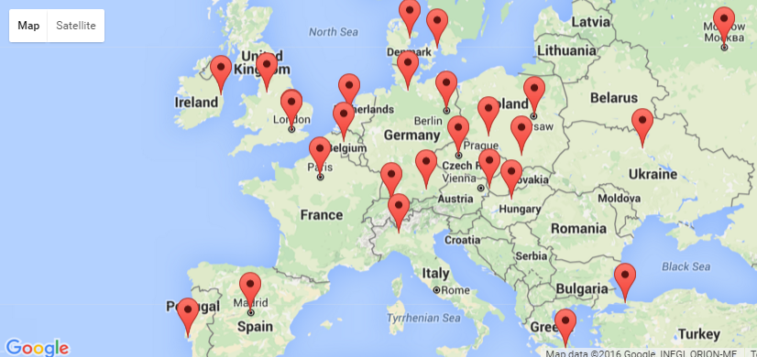countries. In Europe alone they have 30 offices scattered all across the mainland and Scandinavia* (*- *not shown on the image above*). The expansion of google has been pivotal in how they gather their information and give their users geographically relative search results. For business, big data will play an increasingly important role as the years go on. Every single industry sector will introduce computer generated data analysis to determine what their customers need and what is the best way to provide what they want.

**Competitive Analysis**

Googles main competitors vary from whichever particular service you wise to compare. Since they have such a wide variety of services they have a wide variety of competitors to take into consideration. In regards to their search engine competitors their main rivals are now considered to be Microsoft’s Bing and Yahoo. Bing in itself isn’t the first choice for the majority of web users. It essentially does the exact same thing as Google Search but the brand value and attractiveness just isn’t present. As I’ve said earlier in the report Bing only attracts a mere 350 million unique users which is a drop in the ocean compared to Googles massive 1.17 billion unique monthly users. The quality of data that Google can produce from all of these unique users would be far more accurate and reliable than Bing’s analysis of their search trends. Google can take advantage of these unique users for targeted advertising for businesses related to their search queries and results. If we compare to Yahoo! search they are closely following Bing with 300 million unique monthly users of their engine. Google obviously has the majority of the market share of search engines which is completely justified. I can remember when Microsoft first released Bing and when I went onto it the first time there was too much useless aspects to their page so I left the site and went straight back to the simple white background and one search bar that is Google. Bing have improved their search engine site by getting rid of the pointless aspects but it’s far too late to catch up. I don’t see ‘to Bing something’ become a verb in any language anyways that’s for sure.

With regards to Google Drive with Docs, Googles main competitor for this type of application would yet again be Microsoft and their MS Office applications. Microsoft have a cloud service similar to Google Drive known as OneDrive. Both companies offer fast and reliable services that run on the majority of operating systems. But if you are acquiring cloud services for a business google offer a 30TB service for $300 a month. If you needed that much space with OneDrive you’d have to upgrade to the Azure cloud services which could set a business back much more than $300 a month.   
The upside to Google Drive and Docs is that they are easily incorporated with each other. Upon opening Google Docs for example (*word processor)* you are asked to sign in with your google/Gmail account. This then connects all of your google applications together so once you save your Doc it is instantly available on your Google Drive. Whereas with Microsoft’s OneDrive and Office Applications that service is also there but it’s not as fast, easy and automated as Google Drive is. I created a sample spreadsheet in the Excel App and found it to be too much effort to save it to OneDrive. Now you may call me lazy but Ryanair conducted a study where they checked to see how many clicks it took to book a flight and at which point in this booking process did the customer leave the site because of the amount of clicks that were required. They instantly changed their site to allow their customer’s book a flight in *literally* a few clicks. Making the whole process far less time consuming and easier for all parties involved. Google have the right idea by making the saving process basically automatic but Microsoft decided to waste time and make it all manual. At the end of the day it’s the little things like this that can give a service the upper hand and competitive advantage.

__________________________________________________________________________________

**Google** Docs

Google docs is an online word processor that allows the user to create and format text documents while collaborating with other people at the same time. It offers great functionality at no extra cost the only thing you need is a computer or smartphone and in order to save it to the Google Drive an internet connection and Google ID is required. All of the basic formatting requirements for documents are available to use such as font styling and size, indenting and paragraphing tools. The display of the application is very user friendly. The menu options are in expected areas as well as the editing toolbar buttons. Upon completion of the text document the user has the choice of export file types. It can be saved as a ‘.docx’ file for compatibility with MS Word or it can be saved as a ‘.PDF’. The saved work is then stored on the users Google Drive account for easy access and sharing capabilities. To the right is an extract of the Lorem Ipsum text that I formatted in Google Docs on my iPhone for an example of the general capabilities of the application. There is a heading in italics, centred paragraph underneath and bullets points in italics as well. You can also use the insert tool to add images, tables and comments to your document. As a frequent MS Word user I was very impressed by how the developers of the application laid out Docs. If you have any knowledge at all with word processing applications it will take less than 2 minutes to learn where everything is and how to use the tools to the best of their abilities.

Again with any Google Drive application your file is easily saved to the cloud for quick and easy access wherever you or your colleagues may be in the world.

**Google** Sheets

Google was very ambitious releasing a spreadsheet program that would become a rival to MS Excel. It hasn’t gotten to the same level as Excel but it has come a long way since its initial deployment in 2007. Google Sheets is an online spreadsheet application which allows the user to create and format spreadsheets and simultaneously work with other people who may be required to view or add to the document at the same time. Sheets is basically a simplified version of MS Excel, a program that every business in the world uses to generate reports upon many other uses. Similar to Docs and Slides it is a free service that is easily integrated with the users Google Drive account. With Sheets the user can import and convert Excel, .csv, .txt and .ods files to a google spreadsheet and when completed the spreadsheet, Sheets has an export function that can export the spreadsheet as an Excel, .csv, .txt or .ods as well as PDF. Similar to Excel, Sheets has a formula tool to perform calculations on the data in the spreadsheet and the ability to create charts to visualize the data before you. Below I have included an example spreadsheet of an employee list which I created in Google Sheets and converted the file to an .xls.

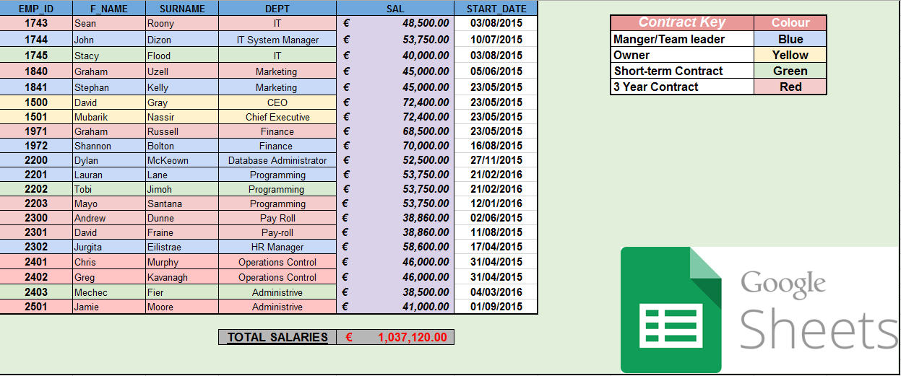

Included in this spreadsheet are most of the basic functions of Google Sheets. The text formatting is kept simple for the purpose of the example, just bold and italics were used in some of the cells. All of the colouring of the rows and columns were done on Sheets as well as the formula for working out the total salaries on the bottom. This whole spreadsheet was created and saved as an Excel file using Google Sheets on my own iPhone in less than half-an-hour. This kind of portable spreadsheet application is extremely beneficial to any busy person who tends to always be on the move going from meetings to meetings. Why not do something productive while your commuting? Google Sheets allows you to do this with ease.

**Google** Slides

Presentations and business come hand-in-hand in organisations worldwide. Presenting project plans, regional sales reports or even pitching a new innovative idea to senior management is exactly the reason why people need a free, user-friendly and reliable alternative to MS PowerPoint. Again Google have proven that they are up to the task of directly competing with Microsoft, who created the leading software application for presentations (*PPT*). Using Slides the user can create and edit their presentations by themselves or with their co-workers and share it effortlessly. The user interface is simple like Docs and Sheets so no need to waste time trying to find what you’re looking for. They can import a MS .pptx file and edit it in the Google Slides application on their desktop or smartphone and also download their presentations as a PDF, .ppt or even as JPEG images. Slides also lets the user publish presentations made in the application to embed them into a website. The user has the freedom to construct slides with a variety of themes and animations to choose from. Templates are also available if designing and formatting isn’t one of the users’ strongpoints. With the incorporation of the users Google Drive account they never have to press a save button. Everything that they do on the slides is automatically saved in real-time and instantly available to their co-workers. The fact that Slides is so user-friendly is immensely beneficial to who-ever decides to use it.

*(Example of Slides in Appendices)*

**Conclusion & Google of the Future**

Again I stress, the reason why I think Drive, Slides, Docs and Sheets are so good is due to the fact that they are easily accessible from a smartphone. Smartphones were the latest big jump in the advancement of the technological impacts on todays societies. All you have to do is download the apps from the App Store or Google Play.   
As a daily commuter all I do on the train is stare into the abyss that is the dirty floor of the DART. Since I have discovered how great these applications are I have started to just mess around with them in order to become completely literate with them. Now imagine being under stress with deadlines or meetings to get to, you can just take out your phone and just get some work done so you don’t have to do it at home and the quality of the work being made will be on-par with the work you could have done on a desktop.

Clearly Google have been pleasing their end users of their range of software applications. What they have done to help the globalisation of e-Business has changed the way common business is done for the foreseeable future. Every single type of business can benefit from what Google has to offer with regards to marketing and advertising and general administrative operations. These two departments of a business can be considered some of the core factors to how it operates. Marketing gets your business out there to attract the customer base to make profits and the administrative side keeps everything together and flowing smoothly. What Google have accomplished since their beginning is a true success story of two young entrepreneurs eager to change the world. I’m sure I’m not alone in saying that I think they have achieved their mission and goal to make information universally accessible no matter where you are. Not only have they achieved this goal through brilliant innovative ideas but they don’t seem to want to stop anytime soon. The future of Google seems to be going in the direction of machine learning. Creating systems that learn about the individuals the use them on a day-to-day basis. Think about the possibilities having a machine made to study data trends and vast amounts of other information. Google have also looked for projects outside our atmosphere. In a very egalitarian move they are currently planning to launch 180 low orbit satellites in order to provide internet access to areas of the world that don’t have the infrastructure or finances to do it for themselves. Why restrict people just because of where they are situated in the world? Everybody has the right to have vast quantities of information at their fingertips no matter what their circumstance.

**Appendices**

1. *Google Slides Example*

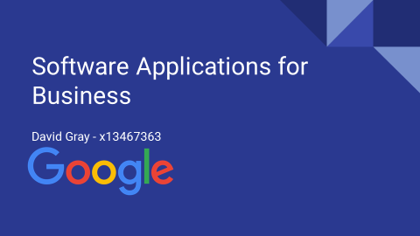

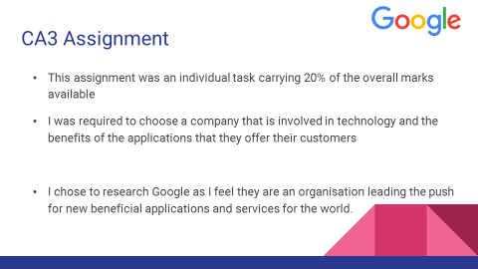

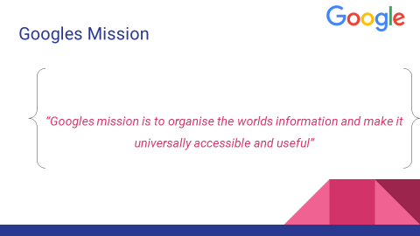

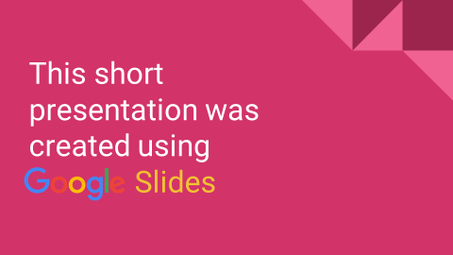

**References**

**Google Information**

N.p., 2016. Web. 13 Apr. 2016. - <https://www.google.ie/about/company/facts/>

N.p., 2016. Web. 13 Apr. 2016. - <http://www.investopedia.com/university/google-porters-5-forces-analysis/>

**Docs, Sheets & Slides**

"Google Docs Review | Top Ten Reviews". *TopTenREVIEWS*. N.p., 2011. Web. 13 Apr. 2016. - <https://support.google.com/docs/answer/49008?hl=en>

"Overview Of Google Docs, Sheets, And Slides - Docs Editors Help". *Support.google.com*. N.p., 2016. Web. 13 Apr. 2016. - <https://support.google.com/docs/answer/49008?hl=en>