**Tas-Books Report**



David Gray *x13467362*

**Current System:**

The current system in O’Connor Pets Limited is a manual paper based system and they are experiencing problems with this system. The shop has a group of regular customers which has not increased in the last few years, while their more expensive competitor has seen an increase in customer base. In my opinion this is down to the lack of an online presence and general bad business practices that O’Connor Pets isn’t seeing an increase in customer base. In the modern day business environment an online presence and a well organised record keeping system is essential to successful operations. It can help with advertising and getting your business out there for people to notice and hopefully come to spend their money.

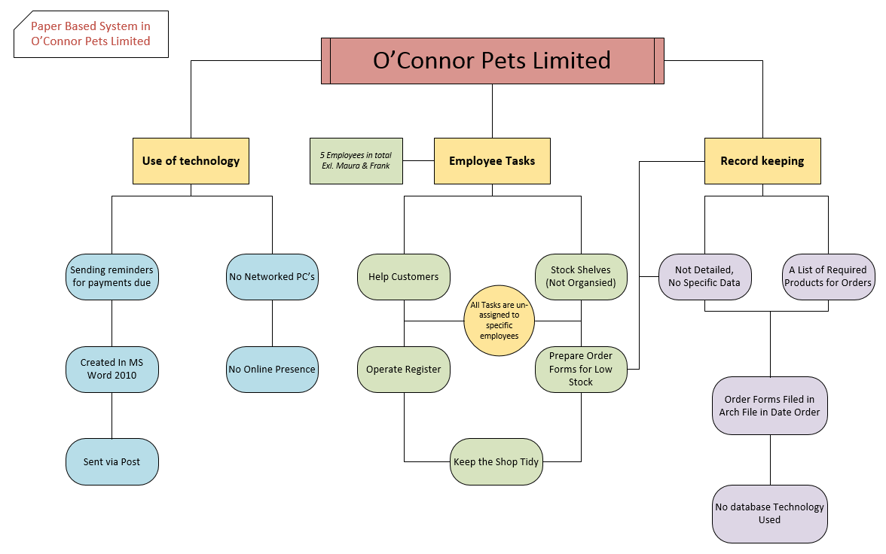

As shown in my diagram above, the use of technology is virtually non-existent in O’Connor Pets Limited. Maura sends all of her reminders via post instead of using an invoice reminder system like the one integrated in TasBooks or even an email. I don’t think any business has a chance at keeping track of invoice reminders using this method, eventually one will get lost in transit or will get sent twice by accident. The lack of PC’s on the same network can cause problems if Frank and Maura have to work together on certain documents. If they were to introduce a network they could easily share information and resources together so there would be no excuse for confusion. Technology would really help with keeping up to date with invoices and general contact with customers or suppliers.

In O’Connor pets there are 5 employees excluding Maura and Frank. These 5 employees have no unique designated job roles. This causes problems because no-one has any specific responsibilities in the daily running of the shop. The employees can record the stock items that need to be restocked but they do not take note of any quantities needed. When Maura is ordering these stock items she has to basically estimate on how much she will need to fill the shelf and have reserve stock for the stock room. This causes overstock problems, which result in O’Connor Pets selling over-stock items at a loss. Maura then keeps track of all of her orders from suppliers by keeping them in paper form in a ring binder. This method of record keeping can be very un-organised and difficult to keep track of.

When the orders once into the shop for re-sale, Frank will stock the items on any available shelf space. Again, nothing is organised in the shop. Customers have commented that it is much easier to find the product that they are looking for in the competitor’s store.



Maura and Frank could be losing valuable business by not having some sort of order on their shop-floor. Maura will order items in if customers request as well. This can be seen as a good way to retain loyal customers but in the long run it isn’t worth it cost involved as only 40% of these orders are ever picked up and paid for. Double orders sometimes occur because of the lack of communication between Maura and Frank regarding if they have already ordered said item/items. All of these chaotic business practices will only lead to O’Connor Pets making loss after loss, financially and with their customer base. Good business are business that believe in stringent planning and organising. Without a plan there can be no precise action. The importance of having an organised shop floor for stock is essential to retaining their already dwindling customer base and if they want to win back some of the customers they lost to their competitors they must act on this with a project plan.

**Proposed Solution & Benefits:**

O’Connor Pets Limited in my opinion really suffers due to the lack of information technology in their day-to-day operations. . With the proposed introduction of Tas-Books Maura and Frank will finally be able to keep track of their purchases and sales at a glance. Tas-books will allow them to quickly find out which products they have already ordered in so this will stop the double ordering problem which will result in more cash. Tas-Books enables O’Connor Pets Limited to create new/existing customers and suppliers that they conduct business with on a regular basis. They can view outstanding balances that these customers have with them or that they have with their suppliers.

The proposed solution to O Connors Pets’ paper based problem is introducing the book-keeping tool Tas-Books.

Upon opening Tasbooks Maura/Frank can see at a glance what exactly is going on with regards to their customers, suppliers and finances.

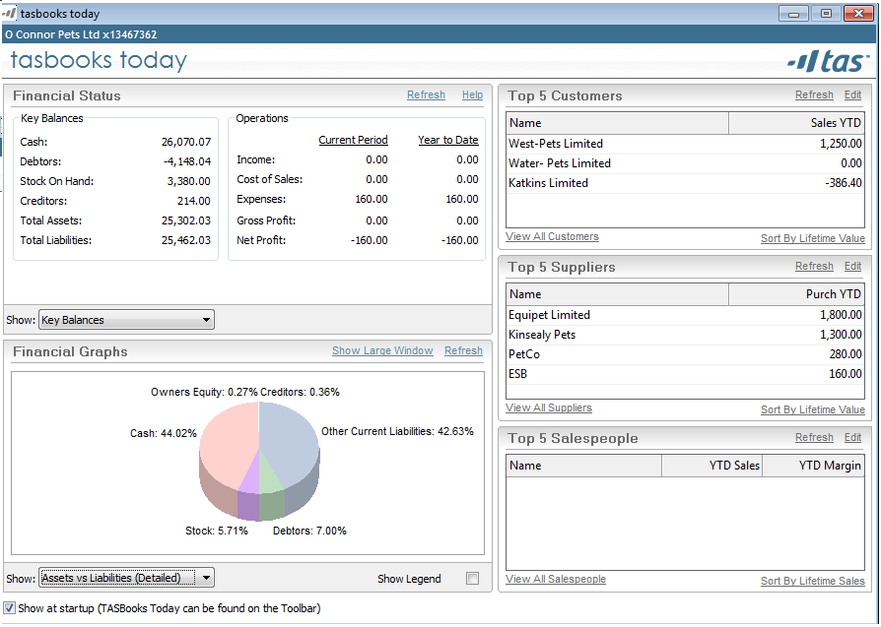

First off though they will need to put money into their bank account, which Tas-Books can perform to keep track of money going in and out of the business. This is beneficial because it lets Maura or Frank look at their transaction history of payments easily without having to look at bank statements which can be difficult to make sense of sometimes.

Initially Frank had to put a Directors Loan into the business of €25,000. This is done in the Bank window of Tas-books (421).

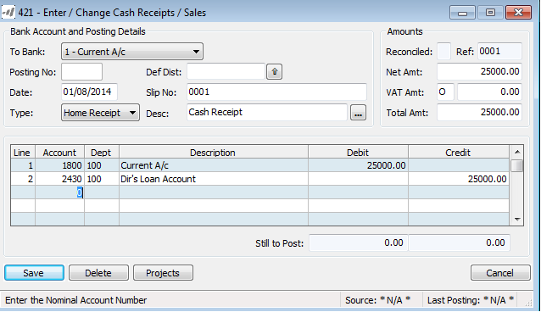

___________________________________________________________________________

Tas-Books is also capable of performing an Inter-Bank Transfer of funds within the business. On the image below I have shown exactly how it is done.

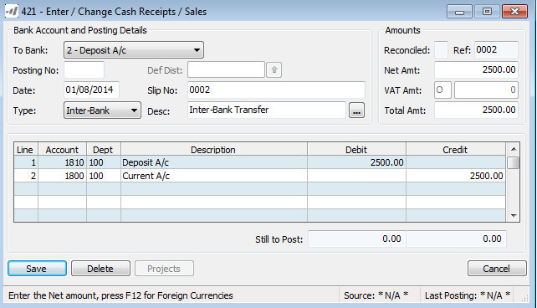

This feature of Tas-Books is very beneficial to any small business as it is an easy to read and easy task in general to perform if the person has any computer knowledge at all. Managing the funds in bank accounts is very important because if they aren’t kept track of Maura or Frank could be in for a shock when the next statement comes. At least with Tas-Books they can at least know exactly how much money is in the respective accounts that they own with the business.

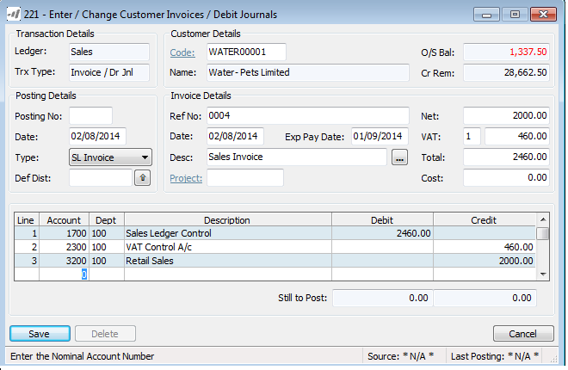Once the company’s finances are accounted for, O Connor Pets can start creating the accounts for their customers and suppliers. This tool is perfect for Maura and Franks needs as they are not a huge organisation they are just a small business and Tas-Books is perfect for keeping records for small invoices and receipts alike. The tool can send reminders to customers that they have an overdue payment as well as checking to see the outstanding balance and the remaining credit balance (if any). When all the customers and suppliers have been created Maura is free to create and send invoices without using MS Word 2010. This is a much better use of technology within O’Connor Pets and it will save time and money on postage.

This is an example of a sales invoice that the user can create on Tas-Books.

_________________________________________________________________________________

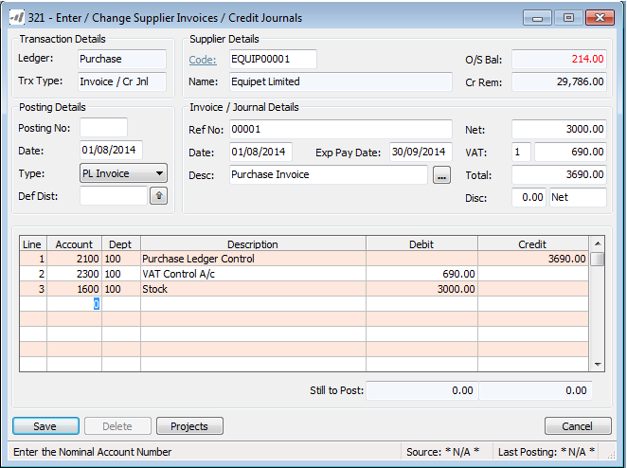From this window Maura can enter the customer code which identities which supplier she is buying from. She can also give the invoice a reference number for easy referral to later if needs be. Tas-Books automatically calculate the VAT so it is then added onto the total price of the sale.

This is an example of a purchase invoice that the user can create on Tas-Books.

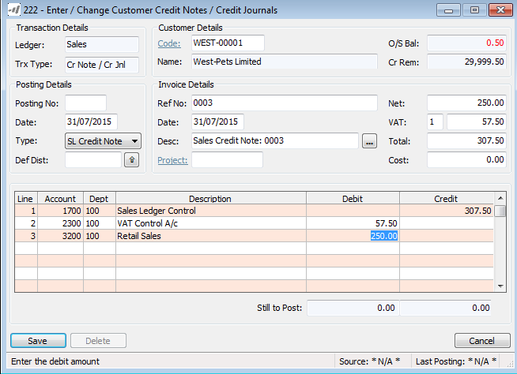

The image above is a screenshot of the Customer Credit Notes tool in Tas-Books. A Credit Note is a note sent by O Connor Pets to West-Pets Limited informing them that your account with us is being 'credited' with the amount mentioned. West-Pets will then have a record of the sales invoice and credit notes for referral as well as O’Connor Pets.

___________________________________________________________________________

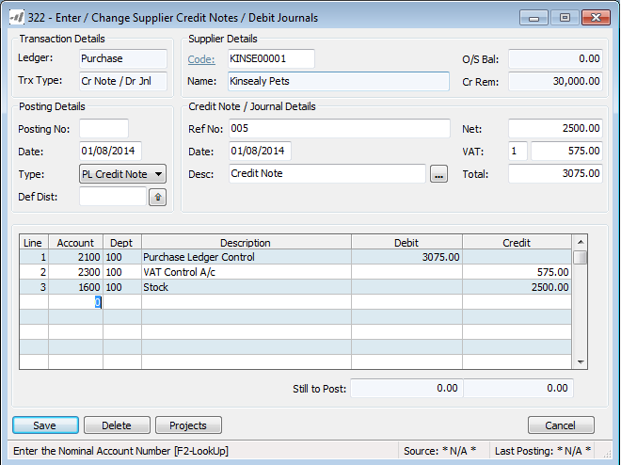

The Image above is the tool for Supplier Credit Notes. This is a credit note coming from one of O Connor pet’s suppliers (Kinsealy Pets) letting them know their account is being credited. This helps both parties involved by making it easier to keep track of their respective accounts and stock in and out.

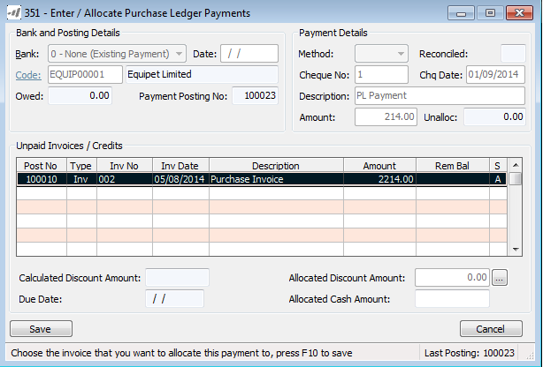

This image shows the Allocate Purchase Ledger Payments. Its showing the amount of money owed to Equipet Limited by O’Connor Pets. This is beneficial to the business because it outlines the amount owed, the amount paid and the amount that is still left to pay on the account (Unalloc).

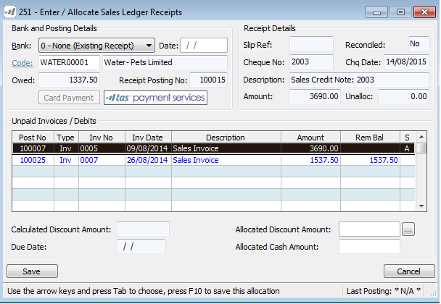

The Allocate Sales Ledger Receipts tool assists O Connor Pets in recording which customer has paid what and when. The tool also has similar features to the purchase receipts like the remaining amount that is owed to O’Connor Pets by Water Pets Limited. In general the tool is much easier than the way Maura probably used to account for payments using her flawed paper based system.

**Benefits:**

The benefits of this new computerised system of keeping accounts are endless when compared to their original paper based system. There will no longer be any need for hard copies of invoices or no arch lever files. They will be able to stop using post for methods of sending invoices which is ideal for saving time, paper and money on postage. Maura and Frank will be able to keep track of their business’ finances and stock easier than before which is crucial to the survival of O’Connor Pets Limited.

___________________________________________________________________________

**Computerised System Diagram**



This diagram shows how TasBooks can change how the day to day operations of the business can be improved. Simple things like using the benefits of technology can bring any business from the stone-age to the Information Era. At the end of the day all TasBooks does is record information and produce reports of this said information. Doesn’t seem like much but this information and knowledge is the key to successful business.

**Proposed Implementation Project Plan**

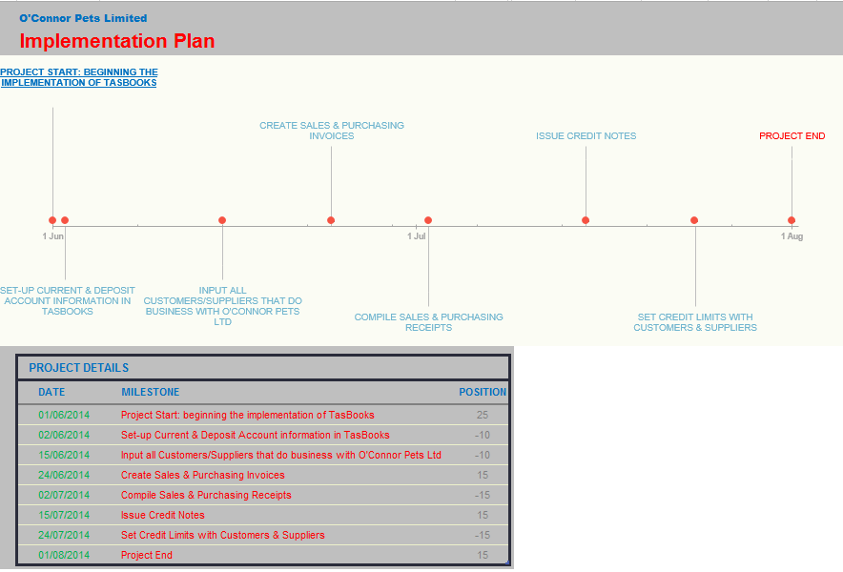

**Robert Anthonys Decision Making Hierarchy**

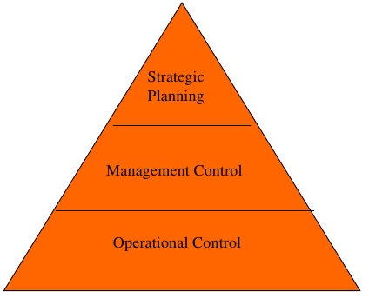

**Strategic Planning:** Strategic planning can be defined as a business’ process of defining its direction and making decisions on allocating resources to achieve this strategy. In regards to O’Connor Pets, Maura will need to plan out everything about the business operations. This includes the studying of her competitors’ as-well to gain more knowledge of the goals she must set out to reach in order to compete with her competitors aggressively. Tas-Books will help her greatly when she needs to order stock in. Tas-Books can keep track of the amount of stock that is left in the stock room so Maura can order more stock accordingly.

**Management Control:** The managerial level controls and organises tasks and supervises the activities that need to be carried out. Maura should create more specific tasks for her employees. Give them designated roles within the running of the business. This, in my opinion, will give the employees a bigger sense of responsibilities which is good for the moral of the employees and provide better results for the business in general. Maura can then summarise how the new designated roles have benefited O’Connor Pets and use this data to improve even more and if goals aren’t reached she could switch the job roles around to make sure the right person is doing the right job.

**Operational Control:** The operational level ensures that the day-to-day actions are consistent with the plans and objectives that are set out. Maura sets out the tasks from the managerial aspect of things but she can’t figure out if it’s working efficiently until the operations are carried out for a certain time-period. They (the employees) report back to Maura on specific things to do with the tasks set out and Maura can use this information to benefit the business or fix a problem that has arose.

**Reports**

*Audit Trial (1)*

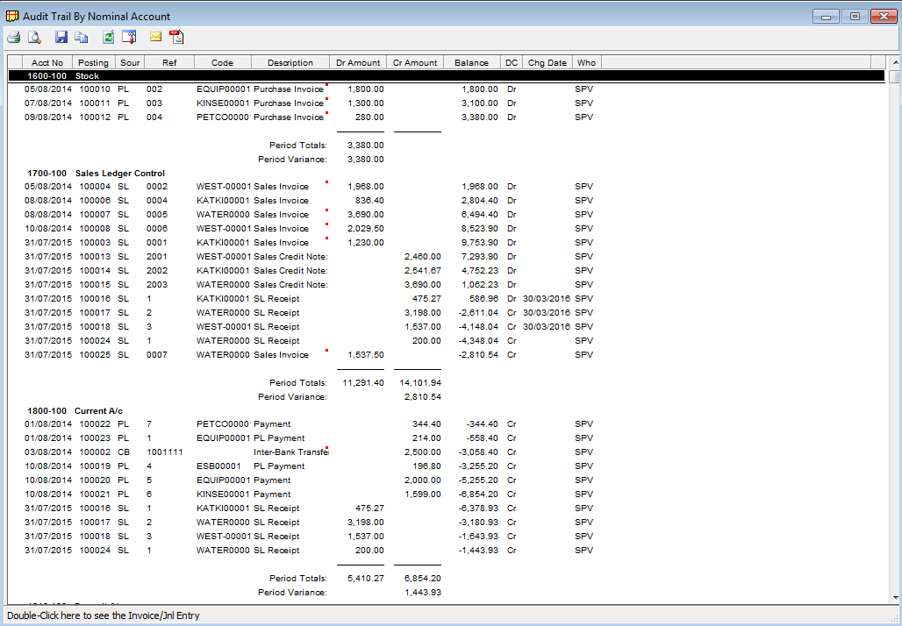

*Audit Trial (2)*

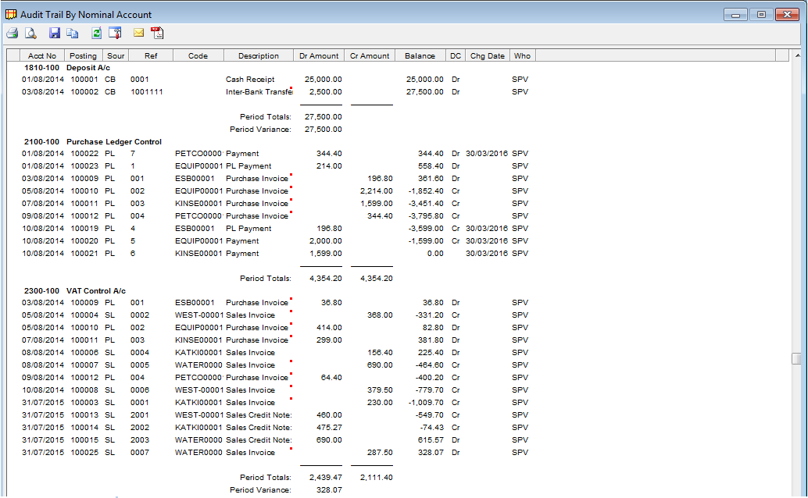

*Audit Trial (3)*

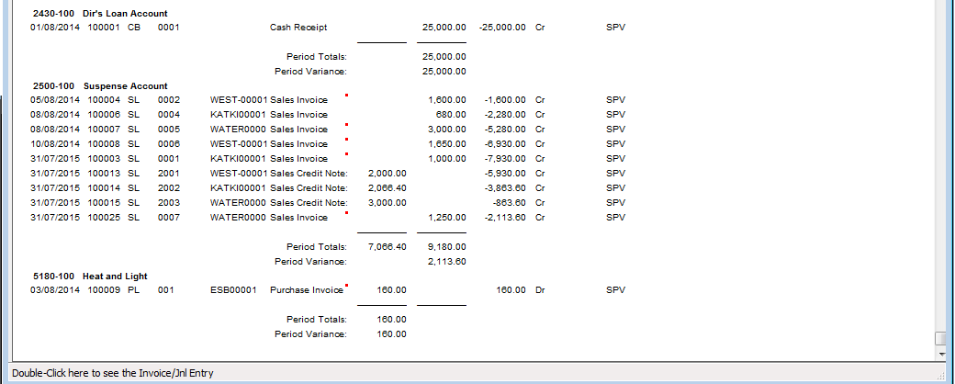

*Sales Report*

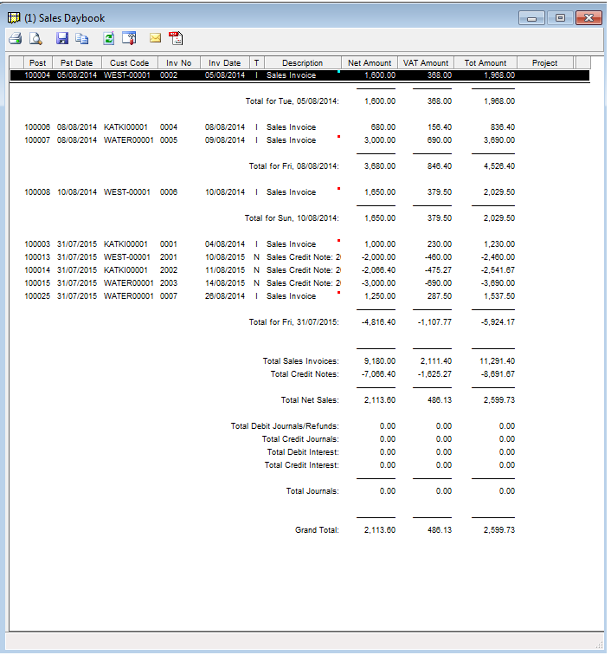

*Purchase Daybook*

