Giuseppe Bongiovi

Portfolio Theory Final Project

Skewness And Kurtosis: A Portfolio Application

1. **Introduction**

In traditional models for equities, many models assume that the structure of a stock follows a log-normal distribution, and the returns can be approximately normal. If an asset follows a normal return distribution, then from the mean and variance one could optimize a portfolio that takes advantage of the statistical qualities of each distribution and construct a portfolio to make excess returns. However, empirical evidence within the stock market datasets show that the returns do not follow this assumption and that they exhibit significant skew and kurtosis within their returns which are respectively the third and fourth moments of expectation. In this paper we examine the relationship and explanatory power between skewness and returns and kurtosis and the realized volatility within a rolling 3-year window. We then form a Markowitz mean-variant efficient portfolio with constraints and examine our returns compared to a market weighted benchmark of the top 30 stocks in the SP500 by market capitalization.

1. **Literature Review**

The main motivations for this paper stem from the empirical evidence that the skewness and kurtosis of returns may have explanatory power for the future returns of an asset. In Amaya et al (2015) they conducted a study computing the skewness of the returns of high frequency data. From their data they constructed, they realized a weekly skew for each stock and then they conducted a strategy where they would buy the lowest skewed stocks and sell the highest skewed stocks. Using this strategy, they were able to produce returns of 19 basis points per week, possibly indicating a relationship between skew and returns. Since they were buying the lowest skewed and selling the highest skewed within the market, we see that the market possibly is reacting the high or low values of skew, indicating market opportunities where the market is overbought or oversold in respect to their valuations.

However, Shen et al (2018) attempted to replicate some of the data presented in Amaya et al but did not see the same behavior, though they only traded 30 stocks and their skewness calculations neglected the first half hour of trading in the markets. This possibly indicates only an opportunity present within the extremes of movement returns and not just a general market behavior. Their work also conducted a study of the relationship between the next time-step realized volatility and the realized kurtosis. They found a strong negative relationship between those two values. The literature is unclear about possible reasons for the relationship, but it can be speculated that high values of kurtosis are indicative of regime change within a market. An event, or lack of an event, catalyzes a “sell off” or a “melt up” and that this new regime change needs to be digested within the market. Long time participants start to sell their stock and believers of the regime change buy in, creating the lower realized volatility in the next time period of returns as supply matches demand. Shen et al makes note that there is some relationship between volume and kurtosis as the observed relationship between volatility and volume is well documented, but kurtosis was found to have a better fit and supersede volume in observing future volatility.

While Shen et al refuted Amaya’s claims, Jondeu et al conducted a study determining the monthly average realized skewness of the market and a value weighted monthly realized skewness. Their study exhibits a strong relationship between the co-skewness with the realized skewness of the market and the returns within the three-moment Capital Asset Pricing Model framework. Using his model of the average market skewness and a risk free rate he was able to attain excess returns in excess of his benchmark. This behavior can be indicative of the overall market sentiment, possibly explaining a correlation in returns between asset prices.

In Choi et al, they presented a negative relationship between the value of an assets skewness and returns but a positive relation between the skew and returns in the presence of high-impact information.

1. **Methodology**

In this paper, the methodology presented in Jondeu et al is heavily borrowed. In our Universe of the top 30 stocks in the SP500 by market cap on August 31st,2019 the skewness of the that universe is calculated for each asset and then averaged.

The skewness equation used for calculation is a normalized measure calculated as follows:

$${SK}_{i} = \sum_{i}{\frac{{\left(x_{i}-u\right)}^{3}}{n}} / (\frac{∑{\left(x_{i}-u\right)}^{2}}{n})$$

We then regress the averaged skewness for the universe against each assets returns for the next time step as follows much like in Jondeu et al in his Three - Moment Capital Asset Pricing Model, however we neglect the values of realized returns and variance in our regressions. In his claims, they do not add explanatory power within the model.

$$R_{i,t+1} = a_{i} + B_{i}{*SK}_{avg} + ϵ$$

We calculate the regressions using overlapping datasets with Generalized Least Squares(GLS). Harri et al present that the results given from using overlapping datasets is more efficient than using non-overlapping datasets but it is understood that the error term is a moving average. However the estimates that are given are considered good with the overlapping dataset. The skewness and returns datapoints share 62 observations when calculated from the data for a quarterly datapoint of 63 days.

An estimate for our expected return 63 days out is next calculated using the regressed coefficients and the next day realized quarterly average skewness . This mean is used as an estimate for mean-variance portfolio

The kurtosis of each asset is calculated as such

$$KU=\frac{1}{n}Σ_{i}^{n}{\left(\frac{x_{i}-μ}{σ_{p}}\right)}^{4}-3$$

The value of the kurtosis for each asset and the absolute skewness for the individual asset value is then regressed against the log realized variance as so,

$${log R}_{i,t+1}^{2}= a_{i} + B_{i,1}{*KU}_{i} + B_{i,2}*|{SK}_{i}| + ε$$

We use the log of the realized variance because of heteroskedasticity within the returns of lower values of kurtosis and skewness, when the skewness or excess kurtosis is close to a value of zero, the data shows that the variance of squared returns is much more pronounced and varied than for higher values of kurtosis and skewness. There is some collinearity in the data between values of skewness and kurtosis but they differ enough for their lower values to be different.

We then use both models for the returns and log variance to compute an estimated return and estimated variance. We use e to the expected log variance to get a value and discount the realized variance from last period to compute a next period expected variance. We create a covariance matrix using last period correlations and the next period expected variance. “quadprog” program package in R is used for the optimization program as follows:

$$argmin\frac{θ}{2}W^{'}ΣW-W^{'}μ$$

$$s.t. ⇒\text{ \{ W'B = 1 (beta neutral)} \\ \text{ =>\{W'1 = 1} \\ \text{ =>\{Wi >= 0}$$

Where Σ is the estimated covariance matrix, μ is the estimate returns and θ is a value varied until the tracking error is less than or equal to 0.0009 compared to the benchmark or until it hits a cutoff point where it is greater than 100,000

1. **Data and Results**

The data used is the daily returns of top 30 stocks by market cap in the SP500 on August 31 2019 from 4-01-2008 to 8-31-2019.

The daily returns are then calculated and the skewness and kurtosis values for each asset and calculated each using 63 days of returns such that any two adjacent values of skewness and kurtosis share 62 days of observations.

The skewness values are averaged out for each observation calculation and then the data values of average skewness, asset skewness and asset kurtosis are regressed as in the equations above. Then the regressions are used to forecast returns and variance for the next time step 63 days out and optimized using the optimization program above.

Below is the data for our optimizations.

T stat average: return regression

(Intercept) avgskew[]

12.520681 -1.344733

T_stat variance: return regression

(Intercept) avgskew[(]

66.43392 39.48851

Figure 1.

We see that for the above statistics that the average skewness has a negative t-stat indicating a behavior in which there is a negative correlation between the value of average skewness and returns on average which is consistent with many studies that analyze skewness and returns for weekly and monthly returns. We also see that the variance is wide, indicating that 68% of t-stat values encompass plus or minus about 6 away from the t-stat mean, indicating wide acceptance of average skewness as an explanatory variable albeit weakly for many assets. The high value of the intercept t-stat indicates a general trend between average skewness and next period returns.

*t-stat averages Variance regression*

*(Intercept) kurtregress[] abs(skewregress[])*

*13.8746777 -0.2521212 0.1215868*

*T_stat variance: variance regression*

*(Intercept) kurtregress[] abs(skewregress[])*

*23.40224 21.44528 19.41739*

*Figure 2.*

From figure 2 we see similar behaviors that we saw within figure 1.

|  |  |  |  |
| --- | --- | --- | --- |
|  | ex-ante-TE | ex-ante-IR | ex-ante-IC |
| 1 | 0.079452 | 20827.75 | 10413.88 |
| 2 | 0.07128 | 18685.54 | 9342.768 |
| 3 | 0.040628 | 10650.41 | 5325.203 |
| 4 | 0.037694 | 9881.365 | 4940.683 |
| 5 | 0.034059 | 8928.319 | 4464.16 |
| 6 | 0.031645 | 8295.447 | 4147.723 |
| 7 | 0.030981 | 8121.384 | 4060.692 |
| 8 | 0.029791 | 15.25301 | 7.626506 |
| 9 | 0.028862 | 7.388696 | 3.694348 |
| 10 | 0.029043 | 7.435057 | 3.717528 |
| 11 | 0.0284 | 7.270399 | 3.635199 |
| 12 | 0.02929 | 7.498237 | 3.749118 |
| 13 | 0.028493 | 3.647106 | 1.823553 |
| 14 | 0.028163 | 1.802429 | 0.901215 |
| 15 | 0.02822 | 1.806068 | 0.903034 |
| 16 | 0.027027 | 1.729757 | 0.864879 |
| 17 | 0.027067 | 1.732272 | 0.866136 |
| 18 | 0.027088 | 0.866807 | 0.433403 |
| 19 | 0.028692 | 0.918128 | 0.459064 |
| 20 | 0.023515 | 1.504975 | 0.752487 |
| 21 | 0.024336 | 1.557522 | 0.778761 |
| 22 | 0.028059 | 0.897874 | 0.448937 |
| 23 | 0.025744 | 1.647644 | 0.823822 |
| 24 | 0.026541 | 1.698636 | 0.849318 |
| 25 | 0.027941 | 1.7882 | 0.8941 |
| 26 | 0.027728 | 1.774605 | 0.887302 |
| 27 | 0.026286 | 1.682287 | 0.841143 |
| 28 | 0.026145 | 1.673295 | 0.836647 |
| 29 | 0.026295 | 1.682908 | 0.841454 |
| 30 | 0.033984 | 8908.795 | 4454.397 |
| 31 | 0.028492 | 1.823511 | 0.911755 |

|  |  |  |  |  |
| --- | --- | --- | --- | --- |
|  | post-TE | post-IR | post-IC | post-alpha |
| 1 | 0.048799 | 0.921385 | 0.460693 | 0.044963 |

Figure 3. figures are all with using estimated returns and variances in the optimization problem

In figure 3 we see estimate for the ex-ante Tracking Error(TE), ex-ante Information Ratio(IR) and ex-ante Information Coefficient (IC) for each optimization step and the final ex-post TE, IR, and IC and the post alpha. In many of the optimization problems, we see high ex-ante values for the IC and IR. These high values are due to the high risk aversion value selected while trying to get tracking error less than 3% in the final value or until it hit a value greater than 100,000 which was arbitrarily chosen. In our resulting analysis we see that these high IR and IC are not completely unwarranted within the calculations.

Out of sample returns

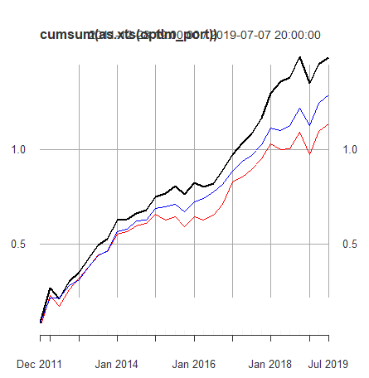

Black: Average Skewness,Kurtosis optimization model, rebalanced quarterly

Blue: Equal Weighted Portfolio, rebalanced quarterly

Red: Market Capitalization Weighted Portfolio

We then look at various optimized portfolios with different criteria that are stated.

[No Risk Aversion, using estimated covariance matrix]

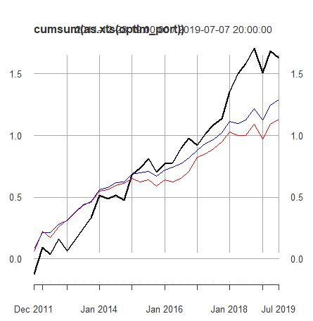

post-TE post-IR post-IC post-alpha

0.1765603 0.3603111 0.1801556 0.06361666

[Risk Aversion, using historical matrix]

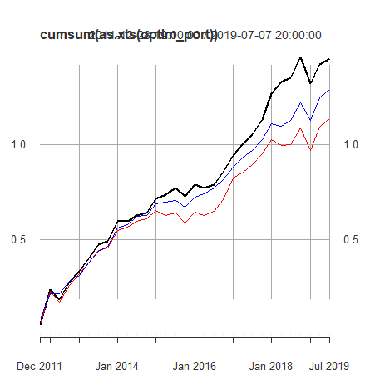

post-TE post-IR post-IC post-alpha

0.04937743 0.8296917 0.4148458 0.04096804

[no risk aversion, using historical matrix]

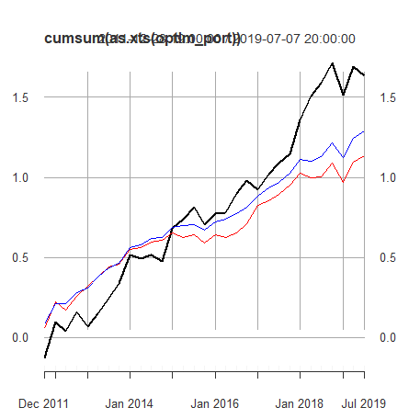

post-TE post-IR post-IC post-alpha

0.1774037 0.362563 0.1812815 0.06432

[Risk Aversion, estimate variance matrix assumes 0 correlation]

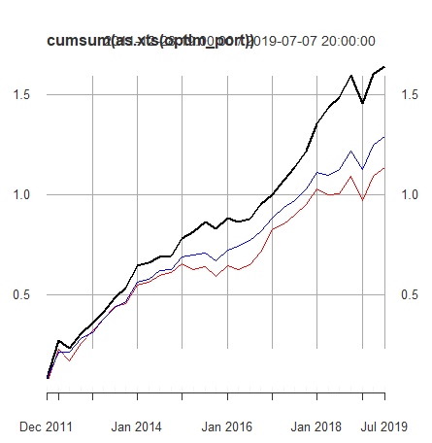

post-TE post-IR post-IC post-alpha

0.06294826 1.036773 0.5183864 0.06526305

[No risk Aversion, Estimate Variance matrix assumes 0 correlations]



post-TE post-IR post-IC post-alpha

0.162468 0.4430307 0.2215153 0 .07197833

In your analysis of different portfolios with different aversions to risk and using different covariance matrix estimates, we see a common theme related to our mean estimates. We see that in the beginning of the portfolio optimization, the strategy completely underperforms in comparison to the benchmark and outperforms towards the end of the out of sample dataset. The portfolios with no risk aversion parameters have much higher variance in the life of the portfolio which is evident in the values of the Tracking error relative to benchmark. The risk averse portfolios that optimized relative to tracking error always outperform the benchmark compared to those portfolios that have no optimization relative to benchmark and are not risk averse comparatively. We are curious why this behavior seems out of the ordinary for the investor who does not optimize on tracking error relative to benchmark.

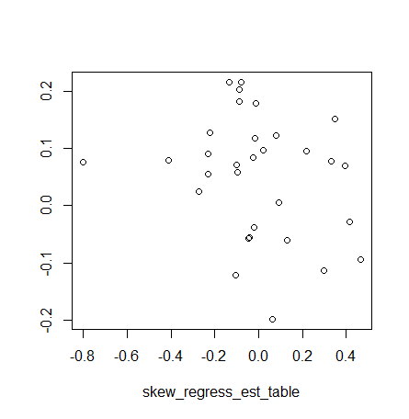

Figure 4. no risk aversion portfolio

When looking at the data, we can see from the plot that for low values of average skewness, close to zero, the variance in next period returns explodes rapidly. We can compare for the whole data sample for assets MSFT, AAPL, AMZN, and ORCL, in order from left to right in our plots below, and see the same behavior in action. It is important to note that the observations of average skewness share 62 daily observations from the last sample, however It can be believed that this behavior can extend out to other non overlapping time-series.

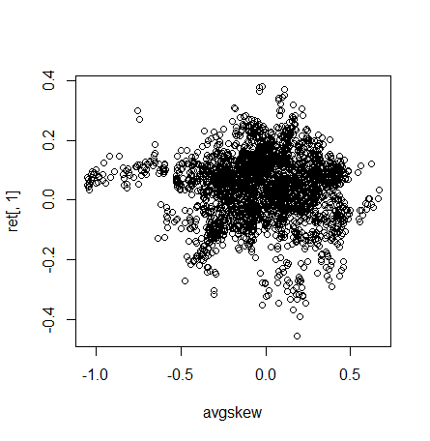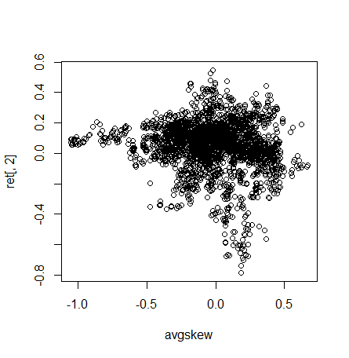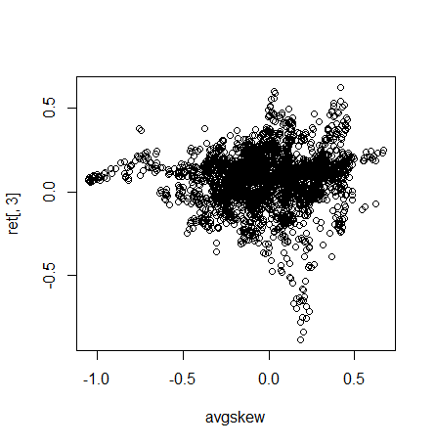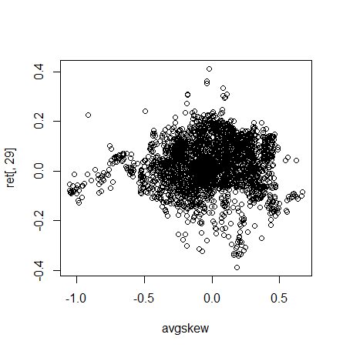

From the plots above we see an interesting behavior develop in which for values of lower average skewness the variance within the sample decreases dramatically comparatively to values of average skewness which is close to zero or slightly higher than zero. We see that a portfolio with no risk aversion poorly selects expected returns from the assets and samples if the values of average skewness is close to zero. The portfolio only outperforms thanks to higher absolute value of average skewness which have a lower comparative variance in returns. This out performance of returns thanks to the skewness of the market is consistent with Amaya et al observations when they only chose to trade stocks that are in the upper decile or lower decile of skewness as we can see from the data that the observations are more consistent at those levels. While our performance is inconsistent compared to Jondeu et al from which we borrow our ideas, we can see his out performance in action because of the low variance in returns for high absolute values in average skewness. In our sample we only had a universe of 30 stocks to select from, while in jondeu et al he had a universe of the entire market to select from so we should expect to see greater outperformance in his universe as he can select assets a bit more diverse than in our universe.

1. **Conclusions**

In our portfolio selection process, we optimized a mean-variant solution from our estimates of mean return and variance that were derived from our regression method using average skewness of the entire universe and kurtosis as explanatory variables, we were able to see outperformance in every single portfolio for the entire life of the portfolio, however we see that the portfolios that are risk averse relative to benchmark outperformed more consistently over the entire out of sample predictions. The under-performance in the beginning of the out of sample portfolios for non risk-averse universes are attributed to the poor ability to forecast when the observed value of average skewness is low or close to zero because of an explosion in variance around those values. Given a low variance it would be advised for an investor to optimize based on other criteria or trade as close to the benchmark as possible when dealing with a small universe of assets to trade. However, it seems as though trading on a market skewness is a promising endeavor for creating outperformance and in the presence of more restrictive criteria determining what an investor can buy or sell or how much to buy and sell, it would be recommended that an investor combine with another estimate of returns for when the skewness model breaks down or trade completely or partially in the benchmark asset. More analysis would need to be done within a wide range of timeframes and assets to determine if the behavior related to a market skewness is a systematic factor that could be reliably traded on for excess returns.

1. **References**

[1] Eric Jondeau, Qunzi Zhang, Xiaoneng Zhu, Average Skewness Matters, Journal of Financial Economics, Volume 134, issue 1, 2019, pages 29-47, ISSN 0304-405X, https://doi.org/10.1016/j.jfineco.2019.03.003.

[2] Keren Shen, Jianfeng Yao, Wai Keung Li, On the Suprising Explanatory Power of Higher Realized Moments in Practice, 2018, arXiv:1604.07969v1

[3] Diego Amaya, Peter Christoffersen, Kris Jacobs, Aurelio Vasquez, Does Realized Skewness Predict the Cross-Section of Equity Returns?, Journal of Financial Economics, volume 118, issue 1, 2015, pages 135 – 167, <https://doi.org/10.1016/j.jfineco.2015.02.009>

[4] Youngmin Choi, Suzanne S. Lee, Realized Skewness and Future Stock Returns: The Role of Information, 2004

[5] Adrian Harri, B. Wade Brorsen, The Overlapping Data Problem, 2009

1. **APPENDIX**

**CODE:**

library(quantmod)

library(PerformanceAnalytics)

library(e1071)

library(quadprog)

#calculate log difference)

logdiff = function(d){

len = length(d[,1])

rets = d[,]

for(j in 1:length(rets[1,])){

rets[1:len,j] = diff(log(rets[,j]))

}

rets = rets[2:len,]

return(rets)

}

ndx = read.csv("HW1-portfolio.csv",header = TRUE,fill = FALSE)

stock_port = subset(ndx,select = Ticker)

weights = subset(ndx,select = Sharesout)

symbols = as.vector(stock_port$Ticker)

#macro_var = c("DGS1","T10YIE","T10Y2Y","BAA10Y")

dataset <- xts()

#FREDdataset <- xts()

n <- length(symbols)

pb <- txtProgressBar(min = 0, max = n, style = 3)

for(i in 1:length(symbols)){

symbols[i] -> symbol

tryit <- try(getSymbols(symbol, from = "2008-04-01", to = "2019-08-31", src = 'yahoo'))

if(inherits(tryit, "try-error")){

i <- i+1

}

else{

data <- getSymbols(symbol, from= "2008-04-01",to = "2019-08-31", src = 'yahoo')

dataset <- merge(dataset, Ad(get(symbols[i])))

rm(symbol)

}

setTxtProgressBar(pb,i)

}

#for(i in 1:length(macro_var)){

# macro_var[i] -> symbol

# data <- getSymbols(symbol, from = "2008-04-01", to = "2019-08-31", src = "FRED")

# FREDdataset <- merge(FREDdataset,get(macro_var[i]))

# rm(symbol)

#}

class(dataset)

#class(FREDdataset)

#FREDdataset = FREDdataset[complete.cases(FREDdataset),]

WeightB = as.numeric(t(as.matrix(weights))*as.matrix(dataset[1,]))/(as.matrix(t(weights))%*%t(as.matrix(dataset[1,])))[1,1]

n = length(dataset[,1])

Lrets = dataset[,]

Lrets = logdiff(Lrets)

skewdata = c()

kurtdata = c()

ret = c()

vol = c()

cut = 63

#daily = 1

#monthly = 21

#quarterly = 63

#yearly = 252

returns = cumsum(as.xts(Lrets))

names = c()

for(i in 1:length(symbols)){

start = 1

end = 64

tempskew = c()

tempkurt = c()

tempret = c()

for(j in 1:(length(Lrets[,1]) - cut)){ #roll from 1 to the end of the dataset - averaging size

tempskew = rbind(tempskew,skewness(Lrets[(start:end),i],type = 1)) #rolling Skew calculation

#type 1 normalizes the measure

tempkurt = rbind(tempkurt , (kurtosis(Lrets[(start:end),i]))) #rolling kurtosis calculation

x = as.vector(returns[(end),i]) - as.vector(returns[(start),i]) #individual stock returns

tempret = rbind(tempret, x)

#row.names(tempret)[j] = index(returns[(end),i])

#print(end)

start = start + 1

end = end + 1

}

skewdata = cbind(skewdata,tempskew)

kurtdata = cbind(kurtdata,tempkurt)

ret = cbind(ret,tempret)

}

colnames(skewdata) = c(symbols)

colnames(kurtdata) = c(symbols)

avgskew = rowMeans(skewdata)

reg = Lrets[((cut + 1):length(Lrets[,1])),]

ret = ret[((cut + 1):length(ret[,1])),]

avgskew = avgskew[1:(length(avgskew) - cut)]

portReturns = returns%*%WeightB

portReturns = as.matrix(portReturns)

row.names(portReturns) = c(row.names(as.matrix(returns)))

portReturns = as.xts(portReturns)

colnames(ret) = c(symbols)

optim_port = c()

Bench_ret = c()

TE = c()

active_weight = c()

active_risk = c()

Lval = c()

Weight_Benchmark_i = c()

IR = c()

dates = c()

ddd = rep(1/30,30)

equal_weight_returns = c()

t_stat_table_ret = c()

t_stat_table_lovar_skew = c()

#t_Stat_table_lovar_kurt = c()

skew_regress_est_table = c()

for(j in 0:35){

#now we want to predict the next 63 days out

t = 252*3 + j*63 #tfinal

ts = 1 + j*63 #t-start

#these are the times to check for the regression

#after each iteration we push t-start and t-final out 63 days to our predicted value

#we then use the new values to calculate a new regression and then predict out

#another 63 days

#do this until data is exhausted

#if done correctly, data should be approximately 28 predictions long, i.e 7 years * 4 quarters

stock.fit = lm(ret[(ts:(t)),] ~ avgskew[(ts:(t))])

t_stat_table_ret = c(t_stat_table_ret,coef(summary(stock.fit)))

dpnext = avgskew[t+1]

skew_regress_est_table =rbind(skew_regress_est_table,dpnext)

xpredict = predict(stock.fit,data.frame(dpnext)) #here we predict the return of the stock

realvol = ret^2

mu = xpredict[1,] #save return for optimization

kurtregress = kurtdata[(1:(length(kurtdata[,1]) - cut)),]

skewregress = skewdata[(1:(length(skewdata[,1]) - cut)),]

volest = c()

for(i in 1:length(symbols)){

vol.fit = lm(realvol[(ts:(t)),i]~ kurtregress[(ts:(t)),i] + abs(skewregress[(ts:t),i]))

#snext = abs(skewregress[(t+1),i])

#knext = kurtregress[(t+1),i]

#newdata = data.frame(knext,snext)

#colnames(newdata) = c("kurtregress[(1:(t)), i]","abs(skewregress[(1:t), i])")

volpred = predict(vol.fit,newdata = data.frame(kurtregress[(t+1),i],abs(skewregress[(t+1),i])))

volest = cbind(volest,volpred[1])

t_stat_table_lovar_skew = rbind(t_stat_table_lovar_skew,coef(summary(vol.fit))[,3])

}

#now that we have the estimates of mu and vol we can optimize portfolio

#caveats:

# no beta bet, calculate betas for last 3 years

Benchmark_diff = diff(portReturns)

Benchmark_diff = Benchmark_diff[((cut + ts - 1):(t + cut - 1)),]

Beta = Lrets[((cut*2+ ts - 1):(t + cut*2 - 1)),]

cor_m = cor(Beta) #correlation matrix needed for optimization of the portfolio matrix

#i need a correlation esimate to minimize the estimated covariance matrix

cov_m = cov(Beta) #base covariance matrix for Tracking Error

Beta = BetaCoVariance(Beta,Benchmark_diff) #calculated daily beta for last 3 years of data

volest = exp(volest)*diag(cov_m)*63

#no shorts, no leverage, Tracking Error = 0.03 or 0.0009 = Wa'*cov*Wa

#we can solve using quadratic programming numerically

#we can use package quadprog to solve the convex function with constraints

#we can choose what kind of covariance matrix we want to minimize for our optimization program

#first D designates using estimated variances but uses historical correlations

D = sqrt(diag(as.numeric(volest)))%*%cor_m%*%sqrt(diag(as.numeric(volest)))

#second D designates using the esimated variance but assumes zero correlation between assets

#D = diag(as.numeric(volest))

#third D uses just a historical covariance matrix

#D = cov_m*63

A = rep(1,length(symbols))

ones = rep(1,length(symbols))

ones = diag(ones)

zero = rep(0,length(symbols))

b0 = rbind(1,1)

b0 = append(b0,zero,after = length(b0))

A = cbind((A),as.vector(t(Beta)),ones)

mu = as.matrix(mu)

L = 0.5

TE = 1

x = c()

eee = as.numeric(t(as.matrix(weights))*as.matrix(dataset[(t + 1 + 63*2),]))/(as.matrix(t(weights))%*%t(as.matrix(dataset[(t + 1 + 63*2),])))[1,1]

#eee2 = as.numeric(t(as.matrix(weights)))*as.matrix(returns[(t+1+63*2),])/(as.matrix(t(weights))%*%t(as.matrix(returns[(t+1+63*2),])))[1,1]

#if you want to use no risk aversion the loops need to be commented out

while(TE > 0.0009){

if(L > 100000){

break

}

else{

L = L*2

W = solve.QP(Dmat = L*D,dvec = (1)*mu,Amat = A, bvec = b0,meq = 2)

x = W$solution

TE = t(x - eee)%*%(cov_m*63)%*%(x-eee)

}

}

active_weight = rbind(active_weight,x)

#x2 = W$unconstrained.solution

optim_port = rbind(optim_port,t(x)%*%ret[(t+64),])

equal_weight_returns = rbind(equal_weight_returns,t(ddd)%*%ret[(t+64),])

Bench_ret = rbind(Bench_ret,as.numeric(portReturns[(t + 1 + 63*3)]) - as.numeric(portReturns[(t + 1 + 63*2)]))

dates = rbind(dates,as.character(index(portReturns[(t+1+63*3)])))

Weight_Benchmark_i = rbind(Weight_Benchmark_i, eee)

#row.names(Weight_Benchmark_i)[i,] = c()

active_risk = rbind(active_risk,TE)

Lval = rbind(Lval,L)

IR = rbind(IR,sqrt(TE)*2*L)

}

IC = IR/sqrt(4)

colnames(Weight_Benchmark_i) = c(symbols)

colnames(active_weight) = c(symbols)

rownames(optim_port) = c(dates)

rownames(Bench_ret) = c(dates)

rownames(equal_weight_returns) = c(dates)

#fix out of bounds error

postrisk = sqrt(var(optim_port - Bench_ret))*sqrt(4)

postalpha = mean(optim_port - Bench_ret)*4

sqrt(active_risk)

plot(cumsum(as.xts(optim_port)),type = "l")

lines(cumsum(as.xts(Bench_ret)),type = "l",col ="red")

lines(cumsum(as.xts(equal_weight_returns)),type = "l",col = "blue")

postIR = postalpha/postrisk

postIC = postIR/sqrt(4)

#equal_weight = as.matrix(returns)%*%as.matrix(ddd)

#equal_weight = as.matrix(equal_weight)

#rownames(equal_weight) = c(rownames(as.matrix(returns)))

#equal_weight = as.xts(equal_weight)

table1 = cbind(sqrt(active_risk),IR,IC) #ex-ante

table2 = cbind(postrisk,postIR,postIC,postalpha) #post-hoc

colnames(table2) = c("post-TE","post-IR","post-IC","post-alpha")

colnames(table1) = c("ex-ante-TE","ex-ante-IR","ex-ante-IC")

#write.table(table1,file = "ex_ante.csv",sep = ",",col.names = TRUE)

#write.table(table2,file = "post_hoc.csv",sep = ",",col.names = TRUE)

t_stat_table_lovar_skew = as.matrix(t_stat_table_lovar_skew)

rownames(t_stat_table_lovar_skew) = c(rep(symbols,32))

#algo to extract t-stat averages and variances

#write.table(t_stat_table_ret,file = "ret.csv",sep = ",")

#t_stats_table = read.csv("ret.csv",header = TRUE,fill = FALSE)

#t_stats_table = t(t_stats_table)

#ttt = c()

#for(i in (1:length(t_stats_table[,1]) + 1)){

# if(i%%4 == 0){

# ttt = rbind(ttt,t_stats_table[i-1,])

# }

#}