- 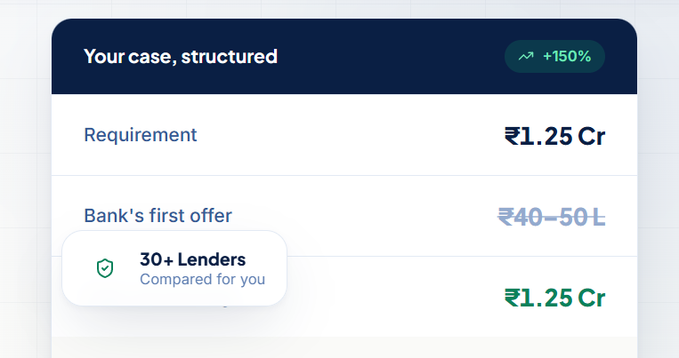
Here text behind 30+ lender is getting hidden
- * mark on zero fees on home loan
- ₹180 Cr+ funding facilitated
- Testimonial instead Engineer write – Parth Shah (Engineer)
Anuj Vora (Business Owner)
Shivay Kumar (MSME Client)
Akshay Gahrat
Personal loan — ₹6 Lakhs remove this 6 lakhs
- Add bank logos
- In Instagram profile link to be correctly updated
also 6 post that need to go have been shared on whatsapp
- Mob no - +91-9987603903
- Email – kdcapitals.9@gmail.com
- Office address - 407,408,409 Lets Work, Runwal Square, Lal Bahadur Shastri Marg, next to RUNWAL ANTHURIUM, Vardhman Nagar, Mulund West, Mumbai, Maharashtra 400080

