About HobBogs
The HobBogs of the Oasis Scourge—The Scourge being a former Talirian province south of the Weald—live mostly along the eastern rim, where the land softens into tangled roots and two boglands press in from either side. To be born here is to inherit a memory: of shifting ground, reed-songs, and quiet warnings carried through fog.

The HobBog stands low to the ground, moss-skinned, with keen, flapping swamp-ears. They move with a sure-footedness that looks instinctive—a balance earned from growing up on soil that never fully settles. Their hearing is sharp, their night-sense steady, and their hands quick with practical work — knotting a line, patching a hull, climbing a root in the dark.

HobBogs value memory over script. They retell events through small rituals and quiet gatherings, stories carried from hearth to hearth until the tale settles into the community—long accepted, ever flowing, and oft-maundered into truth.

Their children’s games follow rules that change as readily as the bog beneath them, and their commitments often behave the same—though in their own eyes, no folk alive are more trustworthy, loyal, or bound to those they call kin.

Their shiftiness is their strength, as their proverbs often tell:
“Shiftiness is shelter that knows how to walk.”

To outsiders, the bog peoples appear as one race. But within, they see it differently. The war-torn history between the FogWisps of Salt-Willow and the Deyves of Dusk Reed has long divided what was once a shared memory.

Beetle thinks
Beetle stood at the edge of the bank, one foot set into the mud, the other braced against a root worn smooth by years of passing. A reed burned low between his fingers, its smoke drifting from his mouth and thinning into the damp air.
“I’s my own I,” he thought. “And if I go—stake it all for a muddy fame—then maybe the bog forgets what I ain’t done.”
The smoke continued, merging into the hanging fog.
“Took my ease with dreams and smoke. And my tavern life pays not enough anymore with this pending gloom. The youngun’s ain’t feeding fully and Swamma is trading harder for less. I’ve borrowed too often from my own future. And the debt as the patrons say is coming due.”
Beetle watched a frog frogging toward a cypress log, half-sunk along the bank, not fully claimed by the marsh yet. Its bark had softened into a dark, ridged sponge, with thin runs of moss clinging where the water did not quite reach. It shifted slightly with the current, held in place by roots beneath the surface—caught, but not fixed.
As insects passed, water moved around it in slow loops, carrying fragmenting silt.
"So I pays it," he thought. "Or gets swallowed by a beast so large it would trample and devour our family's bog if it were so keen."
The smoke carried away into the lifting fog as the frog jumped up on the crown of the log. He watched the frog lay still waiting patiently upon his perch. The frog's body flattened low against the softened bark, mottled green and brown against the dark sponge beneath it. It did not crouch or shift. Its eyes held steady above the water as insects passed—touching down, lifting off, circling back again.
The frog did not follow them. It did not waste itself on movement it did not need. It waited, settled into the log as if it belonged there as much as the moss or the rot, giving nothing until the moment came to take.
A beetle climbed onto the log from the far side and moved along the ridged bark, its legs working over the softened grain. It crossed a strip of moss, hesitated at a split in the wood, then carried on, wandering without aim. The frog did not move. It held as the beetle passed within reach, as the space between them closed on its own. Then it struck, its tongue snapping out and taking the beetle in a single motion. The frog settled again almost immediately after a single, heavy gulp, returning to stillness.
“Nicest floating tavern you’s have there, little frog,” Beetle said out loud.
The frog, annoyed by the interruption, hopped to the other side of the log and croaked.
“Last night clung,” continued Beetle with his inner voice, “spilled drink, wet wood, bodies pressed too warm and too near.”
The tavern had been loud, careless. No one watching closely. No one counting closely either. He had taken what he could carry without drawing eyes. Not greed. Just what the future wouldn’t bite him for.
He had left the score in the main stilted hut where his parents slept and where they gathered for meals on rainy days. On a hook where the week’s traps were smoked and stored. His Swamma would have found it already, preparing the morning meals for the young’uns. Good timing too as she was planning to go to the trading isle that morning. New hides and skin cloths for everyone he presumed as she’d been talking incessantly about it for months. Well, it was a good night at the tavern, so she could make her way without having to haggle too much.
Beetle took another drag, still watching the frog and listening to the buzz of the insects. The cattails behind him shifted, parting with a soft whisper as something moved through them. Beetle did not turn. The smoke reed burned low between his fingers.
“You’s wake late,” his Swampa said. Not accusingly but still quite annoyingly.
Beetle pressed his heel deeper into the mud, feeling it give. He flicked the reed into the swamp.
“Ups in dark,” Beetle said.
His Swampa stepped beside him, the water taking his foot without a sound. He did not look at Beetle. His gaze rested on the log, noticing Beetle watch the frog.
“You’s see it?” his Swampa asked.
Beetle nodded. “Waits. Then eats.”
His Swampa gave a small nod. “Doesn’t waste itself.”
They stood there a moment longer. “East traps are empty,” his Swampa said.
“Craypaws cleared them,” Beetle replied.
“They do. More often now.”
Beetle flicked ash from the reed into the water. “Then why’s we keep setting them?”
His Swampa didn’t answer immediately.
A breeze moved through the reeds, bending them in a slow wave.
“West traps needs pulling,” he said.
Beetle shifted his weight. “They takes from us. We’s still set them.”
Now his Swampa turned slightly, just enough to look at him.
“They’s ours and lives in ours bog,” he said. A short pause. “What they takes is theirs.”
Beetle’s jaw tightened. “The pantry is richer,” Beetle said.
He nodded once. “Your Swamma said it.”
Nothing else. No approval. No question. Just acknowledgment. Beetle looked back out over the water. Farther out, where the current widened, something moved. A skiff.
It drifted unevenly, pulled only by the current. One side rode lower than the other, dipping slightly as it turned. A pole dragged behind it, tapping against the hull in a dull, hollow rhythm.
No lantern. No voice. No markings.
“…Not ours,” Beetle said.
“Not whose?” his Swampa queried.
“Skiff’s out theres,” Beetle proffered. “No markings – not ours. Maybe Tanglewoods,” Beetle pressed.
His Swampa followed his gaze. He watched it for a moment, taking in the way it turned, the way it failed to correct itself.
“Something’s odds with it—not a good odds,” his Swampa said.
Beetle leaned forward slightly.
“Could be worth something,” Beetle posed.
“Could be trouble,” his Swampa shot back.
Behind them, the frog struck again. Another insect gone. Stillness returned.
“I’s check it,” Beetle said.
“You’s pull the traps and not frets with it,” his Swampa replied.
Beetle didn’t move. The skiff drifted farther along the bend. A longer silence settled between them. The reeds whispered. The water pressed softly at the bank.
“Yours reed-kin already working their bogs and aiding the skiffs ‘o wars,” his Swampa said. Not harsh. Just stated. “They’s like that frog – workings and waitings patiently together.”
Beetle said nothing.
His Swampa stepped back into the reeds.
“Don’t you’s go worrying about that skiff.”
He disappeared into the cattails without another sound. Beetle remained at the edge of the water. He reached into his pocket, struck flint to a worked reed, and lit it, sending a thin stream of smoke toward the wandering skiff.

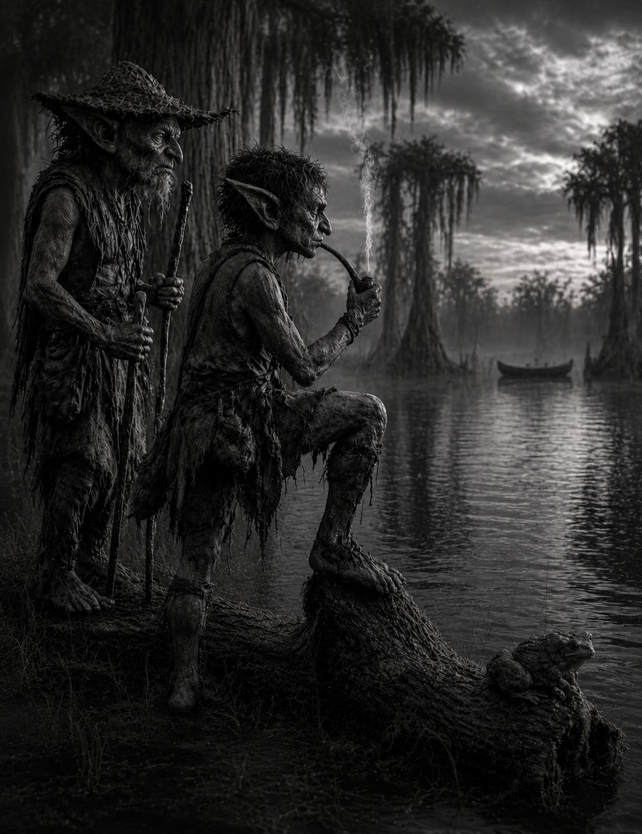
Beetle stepped onto the log. The frog, annoyed, slipped into the water with a soft plop. He settled in its place, watching the current take the skiff. It had caught the southwestern pull. It would snag eventually—on an islet or in the cypress roots.
He blew a slow ring into the air, then another, letting them drift and break apart above the water. When the reed burned low, he pinched it out and tucked it back into his pocket. Then he rose and made his way toward his hut, set on a small outcropping apart from his Swampa’s and the main family stilt where the young’uns gathered. His skiff sat there. And he meant to take it out.
Beetle spotted his skiff, a smaller version of his family’s, marked by the swirls and dashes his younger kin had painted. Most were rough, but his eldest sella—still seven years younger—had the skill. She had painted him a willow among the mangroves.
“You’s a willow, Beetle,” she would say. “A willow in the water-salt.” He loved her. She knew him for what he was and didn’t pretend otherwise.
Beetle pushed off into the silt-water, thick at the banks with an oozing mud. He was most at home in his skiff wandering the canals – often taking longer to get to wherever he was going for a nice smoke-reed and a dream. But now he had to find that skiff – and if it wandered too far, he may not find it in the swamp.
The current pulled at the pole as he set it into the silt, resisting at first before giving way. Beetle leaned into it, guiding the skiff along the bend, eyes scanning ahead where the reeds thinned and the water opened slightly. The bog was never still out here—always something shifting, something drifting—but the skiff had a weight to it, a wrongness that didn’t belong to the usual passing.
He slowed as he neared the stretch where he’d last seen it, letting the current carry him the rest of the way. Broken reeds marked its path, bent low and dragged thin along the surface. Something had come through here with no hand to guide it. Beetle angled his skiff toward the trail, pushing aside a cluster of cattails as the water darkened and deepened beneath him.
There—caught where the cypress roots thickened along a narrow choke, the skiff had lodged sideways, its hull pressed hard against the wood. It rocked slightly with
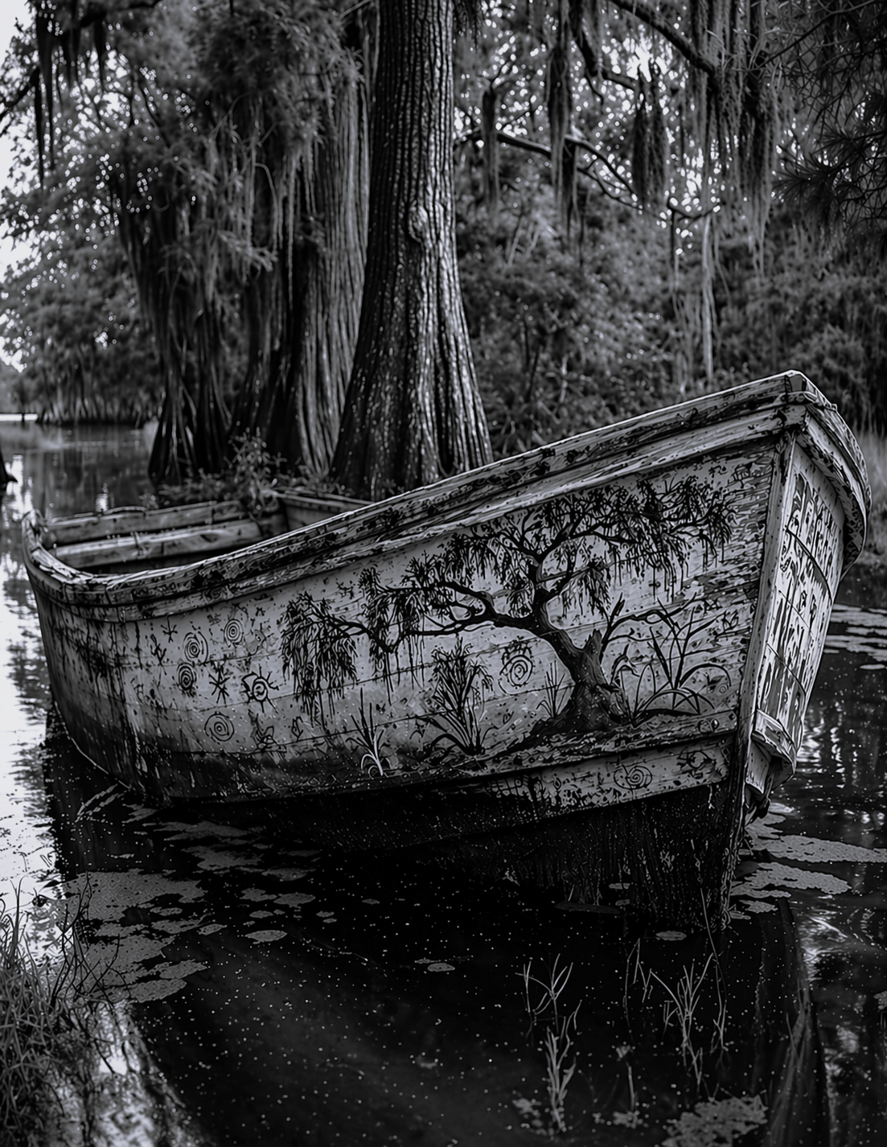
the current, tapping hollow against the roots. Up close, the damage showed clearer. The low side was split along the seam, water seeping in slow through the gap. No markings still. No sign of who it belonged to. Just the quiet creak of wood and the soft pull of the bog trying to take it.
Beetle steadied the skiff against the roots, pressing his own alongside it. The hull was wrong up close—heavier, the cut of it deeper than any he’d seen. Not from Salt-Willow. Not carved for these waters. It sat low, taking in more than it should, the seam split where it had been dragged hard and without care.
He reached in, pushing aside a damp cloth near the stern. It clung to his hand as he lifted it, thick with muckwater and something darker beneath. The smell came up slow. Not rot. Not yet.
Under it lay a hand. Small. The fingers worn, the nails flattened from field work. Not HobBog. Not from the marsh. Beetle held there a moment, then let the cloth fall back over it. Clean-boned. Clean cut. Not a tear you’d see from an alligator.
“Glenkin,” he said under his breath.
The water shifted around the hull, pressing it deeper into the roots. Beetle looked out past the choke where the skiff had lodged, back toward the stretch it must have crossed. No path for it here. Not unless it had been carried. Not unless something had driven it across the high ground between the waters.
Beetle wrapped the hand in the cloth, tighter this time, keeping the shape of it beneath the folds. He tied the strange skiff to the roots with spare rope in case his Swampa and the elders would want to see it for themselves—he knew already his Swampa would go to them. He set the hand low in his skiff where the water wouldn’t reach and pushed off from the roots. The current took him easier on the return, guiding him back through the bend, past the broken reeds and into the narrower channels.
He did not stop at the west traps.
The lines sat where they’d been set, bobbing lightly in the slow pull of the water. One had drifted closer to the bank, snagged near a cluster of roots. Beetle glanced once, then let the current carry him past. There was time for that. This was something else.
By the time he reached the outcropping, the fog had thinned to a low haze over the water. The main stilt stood quiet, the young’uns not yet out, the morning still pale. His Swampa was there at the edge, where the mud met the water, looking out over the same stretch Beetle had left. Beetle brought the skiff in without a word. The hull touched soft against the bank.
His Swampa did not turn.
Beetle stepped out, lifted the cloth-wrapped bundle, and held it a moment before setting it between them on the damp ground. The cloth darkened where the water had soaked through. He did not unwrap it.
“You wents,” his Swampa said.
Beetle said nothing.
A long moment passed. The water moved. Something shifted in the reeds beyond them. His Swampa crouched and pulled the cloth back just enough. He looked once. No more than that. The cloth fell closed again.
“They’s crossed,” he said.
Beetle watched him.
His Swampa stood, eyes still out over the water.
“Beetle, you’s found whats mattered. And there’s no being still-quiet for you. There’s more?”
“Only the skiff, Swampa. I’s tied it to some roots in the near western shores. You’s sees it. Nothing else I’s sees. The skiff’s….no markers on it.”
“From Dusk Reed, my tad. This’s Glenkin, he’s escaped and they’s followed. But following his into’s Salt-Willow? For a slave? More’s to this than I’s guess. The elders. I’s must go.”
Beetle’s Swampa put a hand on his shoulder, took the cloth and walked towards his family’s harbor where they stored most of their skiffs and journey boats.
Beetle watched him go, the cloth hanging heavy in his Swampa’s grip, darkening where the life’s water had soaked through. The harbor lay just beyond the reeds, the low knock of wood against wood carrying faint across the water. Others would see it soon. Elders. Watchers. It would move from his hands into theirs, and whatever it meant would no longer be his to own-which suited Beetle just fine.
He stood a moment longer at the edge, the mud cool around his feet. The water still pressed soft against the bank. The reeds still whispered. But it felt different now—like something had slipped beneath it, unseen but moving all the same.
His stomach pulled then, sharp enough to break the thought. Beetle exhaled, glanced once more toward the western stretch where the skiff had come through, and turned back toward the main stilt. Smoke first, then food. Or food first. Either would do.
Beetle stepped onto the main stilt, the boards creaking soft beneath his weight as morning light spread around it. The young’uns had gathered at the open edge where the trees broke just enough to see beyond the cypress line. They were already at their game, voices rising and falling as they pointed toward the distant peaks, each one claiming a name as if it might hold.
“That one’s Bent-Back today,” one called, squinting through the thinning haze.
“No—look’s, it’s sharper now. Tooth-Top,” another answered, shifting their stance as if the mountain itself had moved for them.
A third shook their head, stubborn. “Swampa’s Thumb. It’s always is.”
They argued without end, renaming the same rise with every glance. Beetle leaned against the rail, watching them for a moment. The peak sat where it always had, unchanged to any eye that held it long enough—but that was never the game. The bog shifted. The fog lied. The young’uns named what the day gave them, and that was enough.

It was then that the smell of food pulled him back. Inside, something warm sat waiting—fish and mash, still steaming where it had been left. Beetle took it without a word, eating slow this time, letting it settle where the hunger had been pressing. Outside, the children’s voices carried on, drifting between names that would not last past the hour.
Beetle finished the last of it and wiped his hand along the rail, letting the damp wood take what remained. The voices behind him rose and fell, the mountain renamed again and again. He did not turn back to it. The game would go on without him.
He reached into his pocket and brought out the lasting remnants of his smoke reed, turning it once between his fingers before striking it to life. The first pull came slow, settling him. The bog stretched out ahead in its usual quiet—channels winding through cypress into the thicker mangrove beyond, where the water darkened with its salt and the air grew close. Somewhere out there, past the eastern runs, something had crossed. He let the thought sit, then pushed it off with his next breath. Some glee could be had from all this. And though he went the night before, it seemed a good idea to once again visit. And mull his pending decision, that reappeared from the morning’s activities, over the brews and ales.
The main tavern was a ways away. Word would move there before it settled anywhere else, bent and shaped by whoever spoke it first. Beetle watched the smoke drift and thin into the air, already turning the story in his head—not changing it, just finding its edges. He flicked the ash away, set the reed between his teeth, and stepped back toward his skiff.
He untied the skiff and set it loose with a gentle push, letting it drift a moment before guiding it into the narrow run that led toward the mangroves. The water carried him easy at first, then tightened as the channels closed in, roots rising thick along the edges where the current slowed and turned. He knew these paths well enough to let the pole rest between strokes, steering more by feel than sight.
The air changed as he moved deeper. The cypress thinned and the mangroves took hold, their roots knotting down into the darker and saltier waters, tangling the flow into slow, circling pulls. Light came in broken through the canopy, shifting across the surface in patches that never held. Beetle moved through it without hurry, letting the skiff take what the water gave.
Much farther ahead, the channels widened again, opening toward the larger island where the boards rose higher and the structures grew heavier with use. Even from this distance he could make out the silhouettes of the watch posts to the east, still and upright against the sky, and beyond them the lower spread where the workers and runners kept their own. The tavern lay there somewhere along the western stretch, not yet loud, but it would be.
The channels opened wider as he neared the island, the water flattening where traffic had worn it smooth. The western edges came first—low huts set back from the banks, patched and leaning, smoke rising thin from cooking fires. This was where the workers lived, those who ran goods, mended lines, and fed the needs of both tavern and sentries. Small skiffs were tied loose along the shallows, easier to pull and go.
Beyond that, the land rose slightly, firmer underfoot, the structures thickening as he moved inward. The tavern sat farther in, among enormous red maples, not on the water like the rest, but built up and wide—two stories of dark green wood, set where all three harbors could feed it without crowding its doors. Even from the channels he could feel it waiting, the place where voices would gather and stories would take shape before they settled.
To the north, the local harbor stretched long and shallow, skiffs clustered close in familiar patterns. To the east, the narrow cut curved inward, a quiet run between arms of the island where traffic passed without drawing notice. And to the south, farther off, the water opened toward the sea lanes, where larger craft came in from the mainland and beyond. Beetle angled toward the northern side, easing his pole into the silt and letting the current carry him the last stretch in.
He moored the skiff to the dock and made his way up from the water, boots sinking slightly where mud met the worn stone path. The trek had taken longer than it should have—his own doing—and the sun had already pushed past its height. The tavern would come to life soon enough.

The path didn’t lead to the tavern so much as feed into it. Runners crossed through with bundles, others peeled off toward the side stacks, a few already drifting in and out without pause. No one checked who came or went. No one marked the moment. The place didn’t open or close. It just took people in.
Beetle moved with them.
The saloon slats shifted as bodies passed through—never still long enough to settle. Someone pushed out as he stepped in, the wood knocking once behind them before swinging again for the next. The sound inside took him immediately—voices layered thick, mugs striking tables, a chair scraping hard across the boards. Heat sat low beneath the rafters, holding the smell of smoke, wet timber, and old drink.
He didn’t stop. No reason to. No place for it.
He moved along the outer edge, where the floor dipped slightly near the support posts, and took his usual place with the room in front of him. Two fingers raised. A mug came without words. He drank and let the place settle into him. Same as always at first.
Trap lines argued near the back. A pair of runners worked out a split over something small and not worth the volume. Someone near the bar started a tune and let it die halfway through. The kind of noise that filled space without changing it. Then the slats hit harder. Not slammed—just pushed through with purpose. Three came in fast, not easing into the room, mud still wet on their legs, breath not yet settled. They didn’t look for a place. Didn’t wait to be seen.
“They found one,” the first said, already moving forward. “West runs. A skiff—no mark.”
A few heads turned. Not many yet.
“Cut clean,” the second added. “Not drift. Not break.”
That shifted more of the room. Conversations bent, some dropping off entirely. The third didn’t raise his voice. Didn’t need to.
“Hand in it.”
That carried.
Silence didn’t fall all at once. It moved—table by table, voice by voice, until what was left of the noise sat low and uncertain.
“Glenkin.”
That word held.
Beetle didn’t move. Just drank and watched who else didn’t.
He set the mug down half full. Around him the talk kept breaking apart and finding new shape, and none of it belonged to him anymore. He’d come for a card hand and a rented room if the night ran generous. That plan already felt like someone else’s.
A runner pushed through the slats before he’d finished the thought, breath short, eyes finding him fast in the crowd.
“Your Swampa wants you,” the runner said. “Elders is asking on you now.”
Beetle set two coins on the bar without counting them and followed the boy out, the noise of the room closing behind him like water over a dropped stone.
The elders didn’t keep him long. They had Swampa’s account and the hand itself, and what they wanted from Beetle was smaller and heavier at once: the telling, straight, from the mouth that had found it. Rumor already had a head start out of the tavern, and by morning it would wear a different shape in every mouth that carried it. Someone had to reach Saltrest first with the plain account, before the story arrived ahead of the truth and decided for everyone what had happened. Beetle had seen the hand. Beetle had seen the skiff. Beetle would go.
He didn’t go back for the mug. The extra coin, the card hand, the room above the saloon—all of it had thinned to nothing somewhere between the elders’ fire and his own front step. He slept short and rose before the young’uns, before even his Swamma had the morning fire drawing well, and took only what the trip needed: dried fish wrapped in cloth, a full skin of water, and the last of his smoke reed tucked away for later.

Journey to Saltrest
He knew the way well enough — he’d made the trip before, more times than his Swamma liked to hear counted, usually with a lighter conscience and a heavier purse after a good night’s takings. On those trips he stayed over with a friend near the trade docks, or rented a room above whichever saloon had space, and came home a day later smelling of drink and someone else’s coin. This time he carried no coin worth stealing and no plan to stay. The current took his skiff from the landing while the fog still sat low over the water, and he set the pole to a steady rhythm and did not look back at the outcropping.
The cypress thinned as the morning wore on, the water losing its tannin dark and taking on a paler, saltier cast. Traffic thickened around him — first a lone trapper poling home with an empty creel, then two boys ferrying bundled reeds between boglets, then a trade skiff riding low under hides stacked beneath oiled cloth. The banks pulled back as the channel widened, and the smell of the marsh changed with it, less rot and more brine, carried on air that moved harder than it had at home.
Past midday he pulled in at a landing built out from a trading platform, where three other skiffs sat tied against the pilings. An old FogWisp sat mending net there, her hands never stopping as she looked him over.
“Long way from your own water,” she said.
“Saltrest,” Beetle said, tying off and stepping onto the boards. He worked a knot from his shoulder as he said it, rolling the joint until it gave.
“Word’s already there ahead of you, most like,” she said, not looking up from the net.
“Not the true word,” Beetle said. He ate standing, the dried fish tough and salty, and drank until the skin ran light in his hand. He did not sit. Sitting invited talk he had no room for today.
The afternoon ran long and hot. He changed hands on the pole when his right shoulder began to burn, then again when his left did the same, and ate the last of the dried fish one-handed while the current carried him through the easier stretch. The mangroves closed in tighter here, roots knotting down into water gone fully salt, and the light came through the canopy in broken patches that never held still on the water. He did not think again about the mug he’d left half full, or the room he wasn’t renting, or the coin he wasn’t spending. The thinking was done. Only the poling was left.
He heard Saltrest before he saw it — noise carried thin over the water, then smoke and salt and roasting fish, then a harbor curving wide and open in front of him, hulls of every size crowded along docks that never seemed to run out of room. Voices came in more languages than he had names for. Past the packed skiffs and the wardens standing at the harbor mouth, a tavern bell rang for evening trade, and beneath it ran a current of talk already moving — about a hand, a skiff, a name — arriving from every direction he hadn’t come from. Beetle tied off where a warden waved him in and started walking before he let himself think about being tired.

