Java final project

Plants vs. Zombies Design Document

Xianxing Jiang

Requirement

This project is a simple vision of the game called Plants vs. Zombies.

In this game, there are two different types of Plants. They are sunflower, pea Shooter. Nut wall and cherry. All plants have their own function and cost. Sunflower will be your sunlight source, giving you 25 Sunlights every 5 sec and add sunlight into your totalsulight. Pea Shooter is a type of plant which will emit bullets every 2.4 sec. These bullets can attack zombies. All the bullets have the same speed and damage. Nut wall has high health points. Users can used them as a wall to restrict zombies move and cherry can help you to kill all the zombies at one time.

Zombies will try their best to pass from the right side of screen to the left side of the screen. Zombies will appear in a random place which depends on their position X,Y but all of them start at the right side of the screen. With time goes by, there will be more and more zombies appear. What users have to do is use plant to kill as many zombies as possible.

In the game view, the users have a GmaeMap which has five rows and each row has nine columns. Users can see plant’s IDcard at the top of the screen and buy plants through click their IDcards. Users have 50 Sunlights at beginning. Buy plant will cost some sunlight. If they do not have enough sunlights, the program will gives user a beep as warning sound. If users buy and plant plants successfully, that plant’s IDcard will get into a cooldown state. For example, if user buy and plant pea shooter successfully, the pea shooter’s IDcard will get into cooldown state. And the peashooter will start to shoot a bullet. When bullet hit a zombie successfully, the zombie will lose some health point and the bullet will disappear. When zombie’s health is zero, zombies will die. However, if a zombie moves in front of the plants and still alive, the zombie will stop in front of the plants and start eating them. This means plants begin to lose some health point. Plant’s health bar will reduce until it died. When the plants die, zombies will move forward to the house again.

If any zombie successfully reaches the left end side of the window, the game will end. And at the right to the screen, where will be a kill rank screen, user can see their kill number here. The kill rank screen will ask you to type your name. If your name is already on the rank list, the kill rank will keep your best kill number. If you are new player, the rank list will put your name and kill number on the list if you have more kill number than the last one. The kill rank will list top 9 best killers who kill most zombies. All of these images will store in a Hashmap.

Project’s Interface

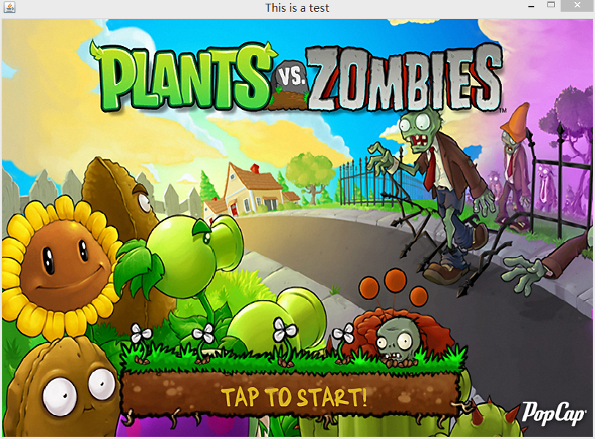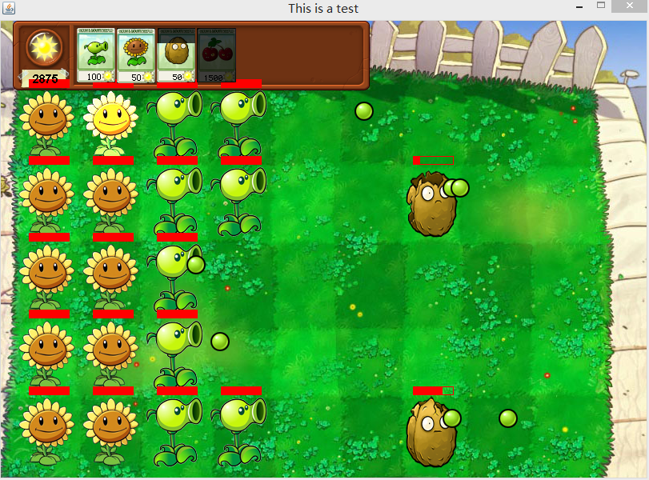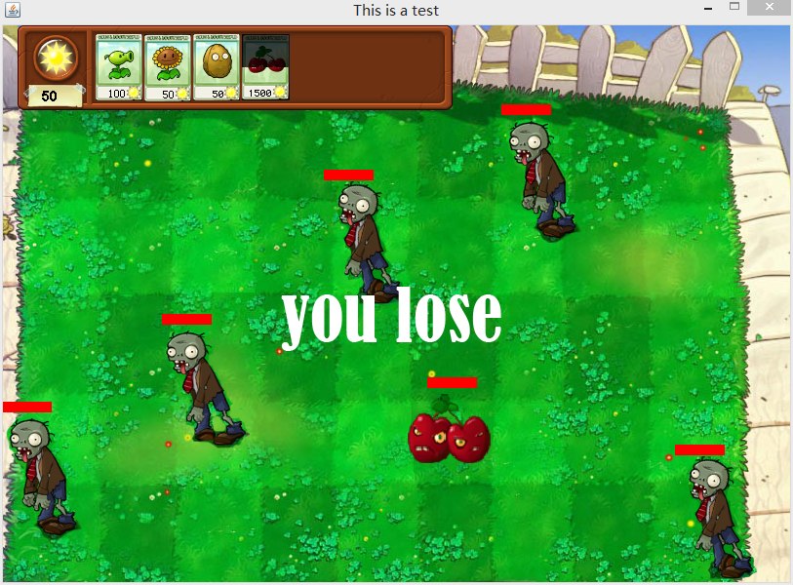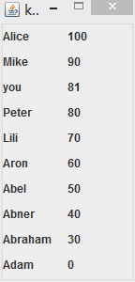

Top-down Design

|  |  |
| --- | --- |
| enter screen | Tap to start button |
| plants |
| clouds |
| road |
| house |
| zombies |
| Background image |
| Game map | the background image of the field |
| the weidth of the field |
| the height of the field |
| Gameover massage |
| the number of sunlight |
| Number of row |
| Number of col |
| the type plants inside the field |
| cherry | Position X |
| Position Y |
| the weidth of the image |
| the height of the image |
| the health bar of the plant |
| image |
| nut wall | Position X |
| Position Y |
| the weidth of the image |
| the height of the image |
| the health bar of the plant |
| image |
| peashooter | Position X |
| Position Y |
| the weidth of the image |
| the height of the image |
| the health bar of the plant |
| image |
| sunflower | Position X |
| Position Y |
| the weidth of the image |
| the height of the image |
| the health bar of the plant |
| image |
| zombie | Position X |
| Position Y |
| the weidth of the image |
| the height of the image |
| the health bar of the zombie |
| image |
| IDcard | tyep of the plant |
| Position X |
| Position Y |
| bright image height |
| bright image width |
| dark image height |
| dark image height |
| bullet | image |
| Position X |
| Position Y |
| damage |
| image | the images of all the items |
| kill rank | the weidth of the screen |
| the height of the screen |
| the number you killed |
| other player's data |
| Number of row |
| Number of col |

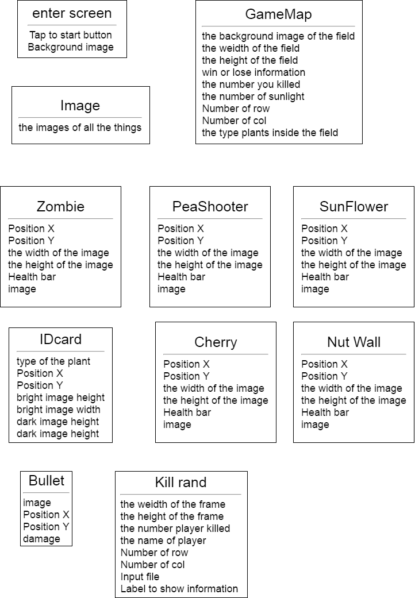

Buttom-Up Design

|  |  |
| --- | --- |
| clouds | part of the image |
| road | part of the image |
| house | part of the image |
| Nut Wall(NW) | planted by users and work as a wall |
| NW's cost | the cost of the NW |
| NW's image | Determine how PS looks |
| NW's health | Determine the health of NW |
| NW's position | Determines where to draw the NW |
| cherry | planted by users and work as a bomb |
| cherry's cost | the cost of the cherry |
| cherry's image | Determine how cherry looks |
| cherry's health | Determine the health of cherry |
| cherry's position | Determines where to draw the cherry |
| Pea Shooter(PS) | planted by users and defense zombies |
| PS's cost | the cost of the PS |
| PS's image | Determine how PS looks |
| PS's damage | Determine the damage of the PS's bullet |
| PS's health | Determine the health of PS |
| PS's position | Determines where to draw the PS |
| PS's frequency | Determine how often does PS do an attack |
| PS's CD | time's for shop to renew PS |
| SunFlower(SF) | planted by users and produced by sunlight |
| SF's cost | the cost of the SF |
| SF's image | Determine how SF looks |
| SF's health | Determine the health of SF |
| SF's position | Determines where to draw the SF |
| SF's frequency | Determine how often does SF produce sunlights |
| SF's CD | time's for shop to renew SF |
| zombie images | Determine how zombies looks |
| zombie damage | Determine the damage of the zombie |
| zombie's health | Determine the health of zombies |
| zombie's position | Determines where to draw the zombies |
| zombie's speed | Determines how fast the zombie moves |
| bullet image | Determine how bullet looks |
| bullet position | Determines where to draw the bullet |
| bullet damage | Determine the damage of bullet |
| Idcard imageA | Determine how Idcard A side looks |
| Idcard imageB | Determine how Idcard B side looks |
| Idcard type | Determine what type of play it refer to |
| Idcard cd | Determine the time need to cool down |
| Idcard enable | Determine whether it has renewed or is renewing |
| Idcard percent | Determine how many has been renewed |
| Idcard cost | store how much the plant cost |
| start button | to start the game |
| game map | the place to place plants |
| plantsArray | array to restore the plants |
| zombieArray | array to restore the zombies |
| bulletArray | array to restore the bullets |
| Kill | the number of the killing |
| Result | show result message |
| Image | Load images from files and store the images |
| kill rank label | label to store name and kill number |
| input file | the file where store player's information |

Domain and Range:

|  |  |  |
| --- | --- | --- |
| clouds | image | part of the image of the entering screen |
| road | image | part of the image of the entering screen |
| house | image | part of the image of the entering screen |
| NW's cost | final int | 50 |
| NW's image | image | The image from online |
| NW's health | final int | 800 |
| NW's position | point | 0<x<813, 0<y<600 |
| NW's CD | final int | 15 |
| cherry's cost | final int | 1500 |
| cherry's image | image | The image from online |
| cherry's health | final int | 100 |
| cherry's position | point | 0<x<813, 0<y<600 |
| cherry's CD | final int | 90 |
| PS's cost | final int | 100 |
| PS's image | image | The image from online |
| PS's damage | final int | 5 |
| PS's health | final int | 100 |
| PS's position | point | 0<x<813, 0<y<600 |
| PS's frequency | final int | 1400(ms) |
| PS's CD | final int | 7 |
| SF's cost | int | 50 |
| SF's image | image | The image from online |
| SF's health | final int | 300 |
| SF's position | final int | 0<x<813, 0<y<600 |
| SF's frequency | point | 2500(ms) |
| sf's CD | final int | 5 |
| zombie images | image | The image from online |
| zombie damage | final int | 10 |
| zombie's health | final int | 50 |
| zombie's position | point | 0<x<813, 0<y<600 |
| zombie's speed | final int | 5 |
| bullet image | image | The image from online |
| bullet position | point | 0<x<813, 0<y<600 |
| bullet damage | final int | 10 |
| Idcard imageA | image | The image from online |
| Idcard imageB | image | The image from online |
| Idcard type | plant | PS or SF |
| Idcard cd | int | depends on plant's CD |
| Idcard enable | boolean | T = ready to plant, F = still loading |
| Idcard percent | double | [0,1] |
| Idcard cost | int | depends on plant's cost |
| start button | button | Jbutton |
| game map | image | The image from online |
| plantsArray | plant[][] | nine col, five row |
| zombieArray | arraylist | [0,20] |
| bulletArray | arraylist | [0,135] |
| Kill | int | [0,30000] |
| Result | int | 0 = still processing, 1=win, 2=lose |
| Image | HashMap | 0<size<50 |
| kill rank label | Jlabel[][] | tw0 col, ten row |
| input file | File | file name:list.txt |

Bottom Up diagram

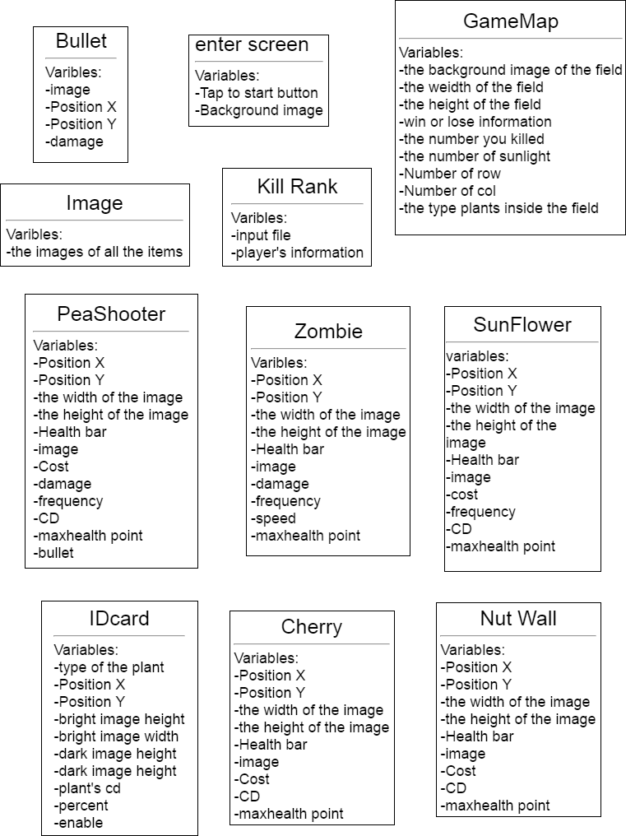

Diagram 3

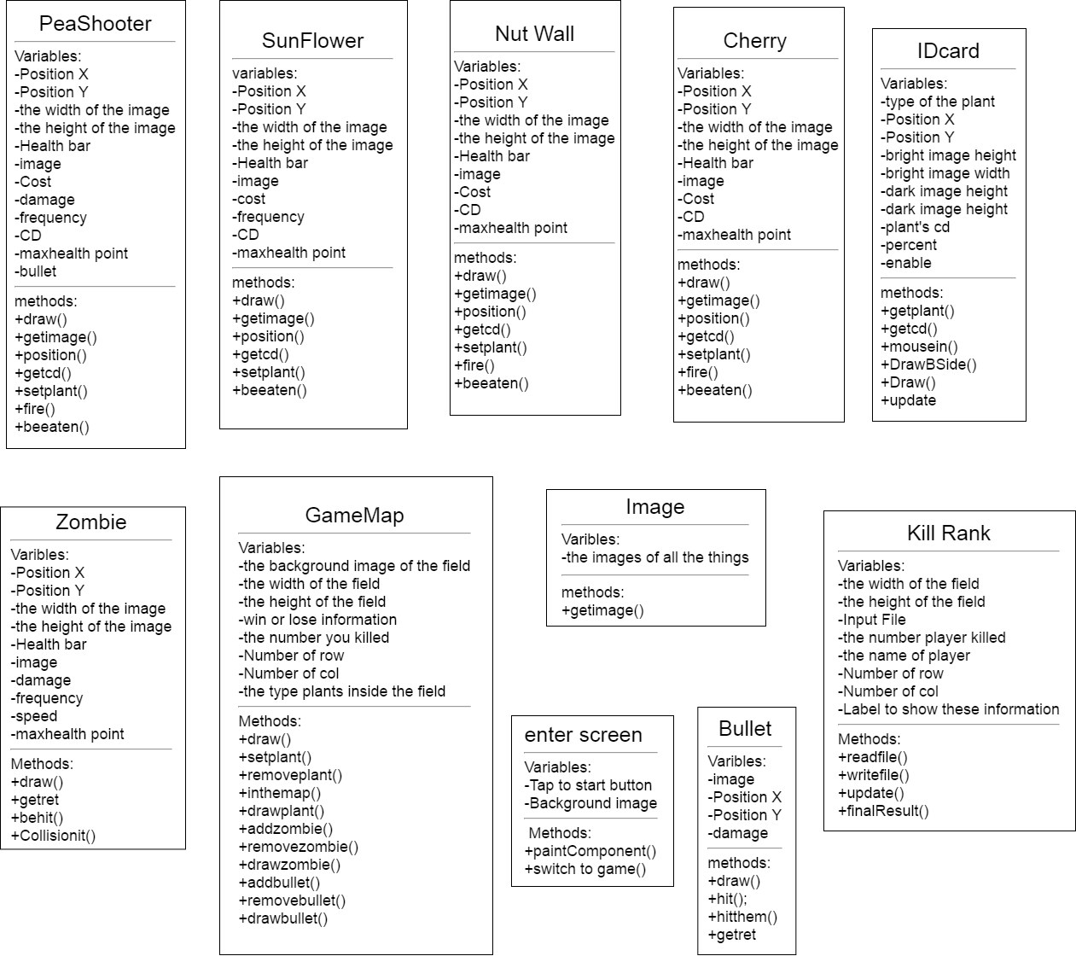

UML

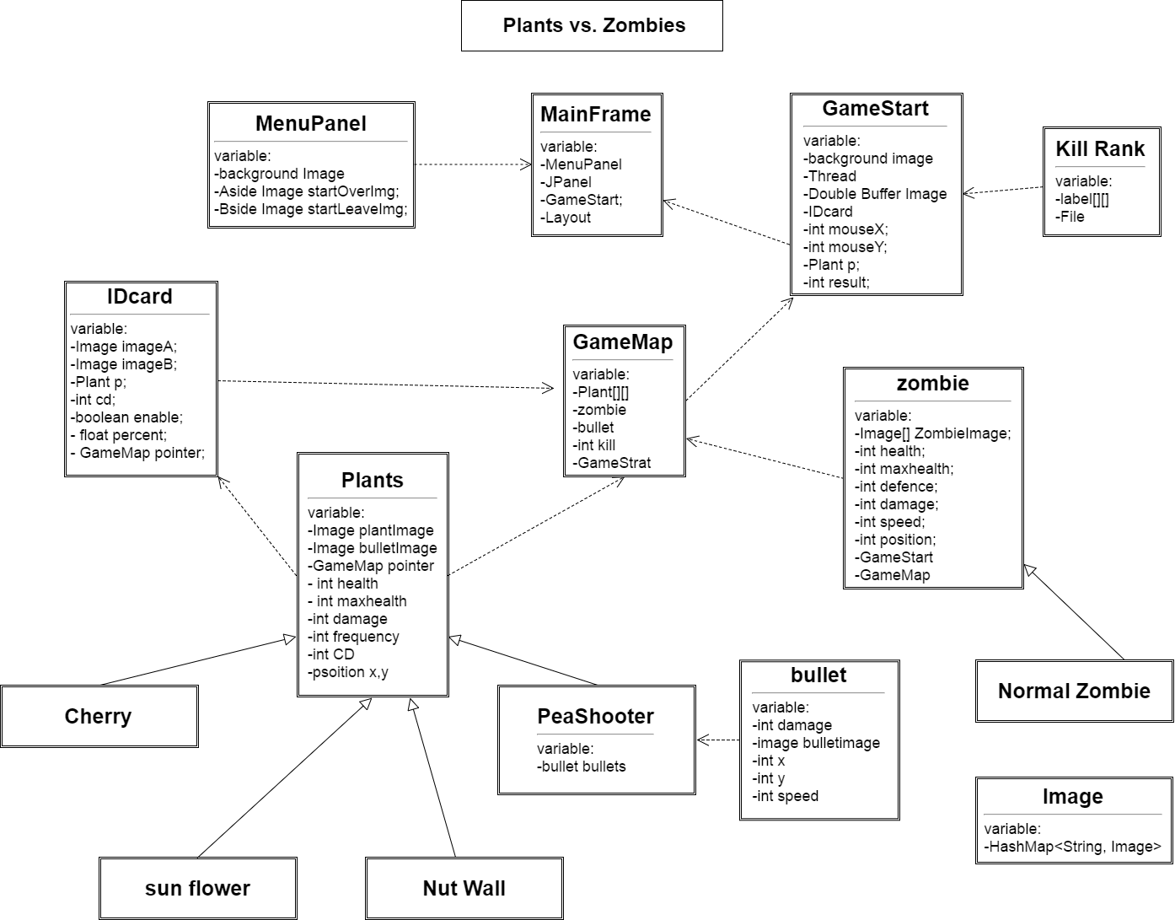

CRC Card

|  |  |
| --- | --- |
| MenuPanel(a panel work as Entering Screen) | |
| start button |  |
| the image of the button |  |
| the image of the button while mouse on |  |
|  |  |
| GameMap(the class contains other items) | |
| Store plants | plant |
| Store zombie | zombie |
| Store bullet | bullets |
| the number of zombie has been killed |  |
| when game end, stop the thread | GameStart |
|  |  |
| GameStart(a panel where gmae start) | |
| background image |  |
| a thread to run the game |  |
| create image of Double Buffer |  |
| Store, draw and remove item | GameMap |
| the place to place seed | Seed |
| store mouse's x position |  |
| store mouse's y position |  |
| Store the type of the plant user picked | plant |
| show final result |  |
|  |  |
| MainFrame(where the program start) | |
| entering Screen | MenuPanel |
| which layout it is |  |
| to start game | GameStart |
|  |  |
| Plant(a father class of all type of plant) | |
| how does plant looks like |  |
| how does bullet looks like |  |
| allow plant to add or remove itself | GameMap |
| how many health points left |  |
| the max health points |  |
| the damage |  |
| how often to do an attack |  |
| times of cool down |  |
| position |  |
|  |  |
| peashooter(inheritance from plant) | |
| can shoot bullet to defend zombies | bullet |
|  |  |
| sunflower(inheritance from plant) | |
| can produce sunlight |  |
|  |  |
| seed(allow user to pick what type of plant) | |
| what do it looks like |  |
| what do it looks like while loading |  |
| what type of plant it can produce | plant |
| time of cool down |  |
| whether it's ready or not |  |
| the percentage of how many sec left |  |
| position |  |
|  |  |
| zombie(a father class of all type of zombies) | |
| how does plant looks like |  |
| have defance(damage reduce) |  |
| how fast it moves |  |
| allow zombies to add or remove itself | GameMap |
| how many health points left |  |
| the max health points |  |
| the damage |  |
| how often to do an attack |  |
| ponsition |  |
|  |  |
| NormalZombie(inheritance from zombies, basic Zombie) |  |
|  |  |
| bullet(peashooter produce to deferend zombies ) | |
| how does it looks like |  |
| the damage it is |  |
| how fast it moves |  |
| position |  |
| allowed it remove itself | GameMap |
|  |  |
| image(a class store images) | |
| a container to store images |  |

|  |  |
| --- | --- |
| Kill Rank(a panel where show player's information) | |
| a thread to run the frame |  |
| Input file to read players' information |  |
| label to show players' information |  |
| method to re rank |  |
| show final result |  |
| write final result to file and save |  |

|  |  |
| --- | --- |
| NutWall(inheritance from plant) | |
| have high health point |  |

|  |  |
| --- | --- |
| Cherry(inheritance from plant) | |
| can kill all zombies at one time |  |

Javadoc

See Javadoc folder

Installation Guid

Before run PVZ.jar, you need to install JDK first. Here is the link where you can download java JDK. <http://download.cnet.com/Java-Development-Kit-64-Bit/3000-2218_4-75317068.html>.

After finishing the download, you will have . Click the EXE file and enter into install screen.

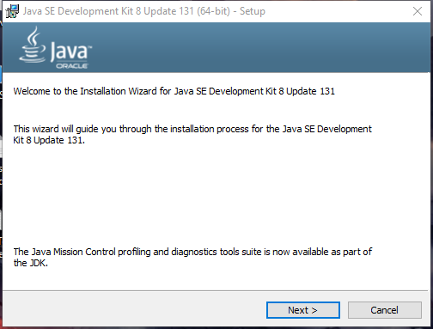

Keep click the next button until it finished install

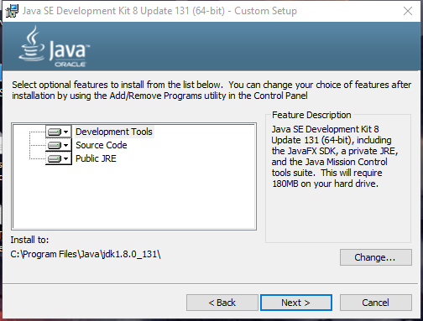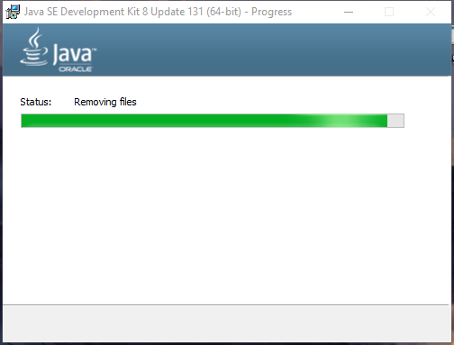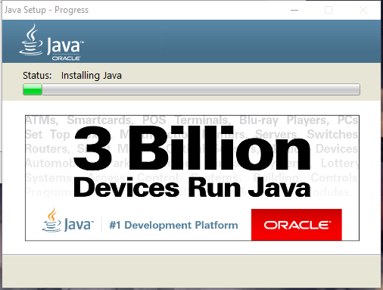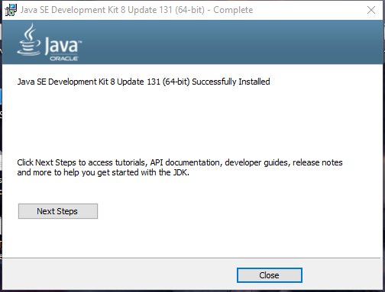

Wait until it finished install and then click the close button to finish the install.

After you finish install of JDK. Copy all things in the PVZ folder and you can start game now.

Make sure you have these three things are under same folder. Or the program will have some unexpected errors



User Guid

See PPT

Project Analysis

A: I used multithreads to run this game. One thread controls Main frame, The other thread controls kill rank frame.

B: in this program. I did nothing about recursion.

C: Until now, there is only one type of zombies. Therefore, In the future, I can pay more attention on adding some other type of zombies and make the program more fun.

D: before programming, find similar variables and similar methods of each class. If possible, create a father class and let other classes to inherit from father class. Then overwrite some of the method if needed. This will help you to reduce lots of repeating work.

Citation

All the images come from a game call “Plant VS Zombies.” PopCap Games. 5 May 2009.

Access date 4 June 2017.