04/27/2025
Logan Gray
Assignment 4: Testing

Part 1: Unit Testing (20 points)
- Write unit tests for at least 5 key functions using pytest
Tests can be found in tests/test_basic.py
- Achieve at least 90% code coverage
Can be verified by running “$ pytest --cov=src” in the root directory
- Document your approach to unit testing
In order to achieve 90% coverage, I decided I needed to write a unit test for each of the functions in tasks.py. For each function, I read and understood the code and tried to come up with test cases for each. I wanted enough cases so that all branches of code in the function would be run by at least on of the tests, and I tried to think of edge cases for each function and included cases for all possible types of input. For example, for generate_unique_id(), I made sure my cases covered when the passed list of tasks was empty and when the list of tasks had non-contiguous IDs. The general flow for the unit tests was to set up the data I needed, pass it into the function, and assert the result is what I expected.
- Have a streamlit button. On button press it runs the tests
This button can be found at the top of the page.

Part 2: Bug Reporting and Fixing (20 points)
- Document all bugs found using a standard bug report format
- Fix all bugs you've identified
- Provide before/after evidence of fixes
Here I will provide documentation of bugs I found with before and after evidence of the fixes. These fixes are implemented in the submitted repository.

Bug 1: Adding Task Throws Error
Behavior: Adding a task after deleting a task (that is not the most recently added) throws a duplicate element key error:
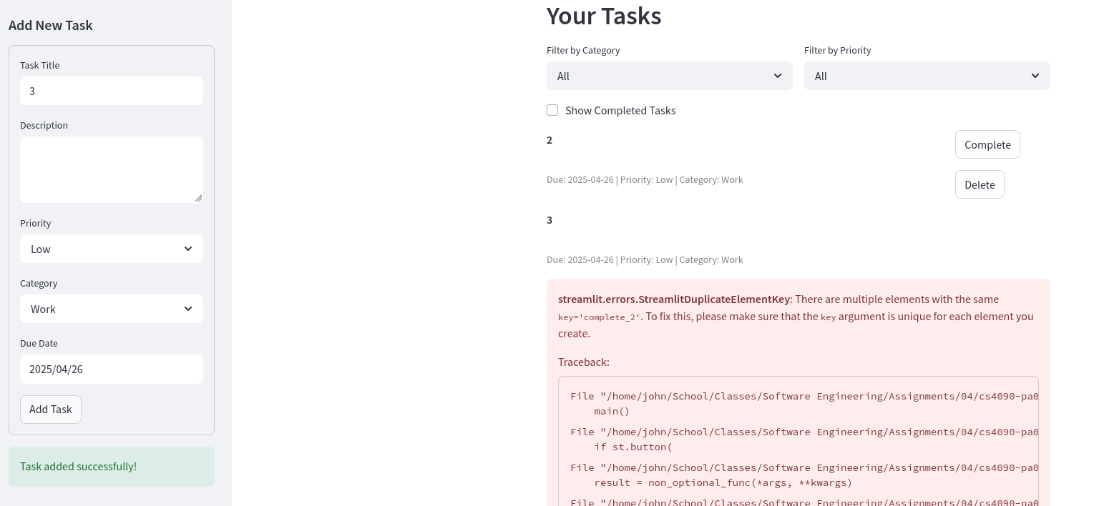
Expected Behavior: Adding a task appends it to the task list with no errors and the display is updated accordingly
Steps to Reproduce:
- Start with empty task list
- Add Task 1
- Add Task 2
- Delete Task 1
- Add Task 3 and an error will be thrown
Fix: This bug occurred because app.py did not correctly implement the logic for task ID generation when appending a task. Before the fix, new task IDs were generated with “len(tasks) + 1” which is not correct. Here a call should have been made to generate_unique_id() from tasks.py. I fixed the bug by replacing the incorrect logic with the appropriate function call:
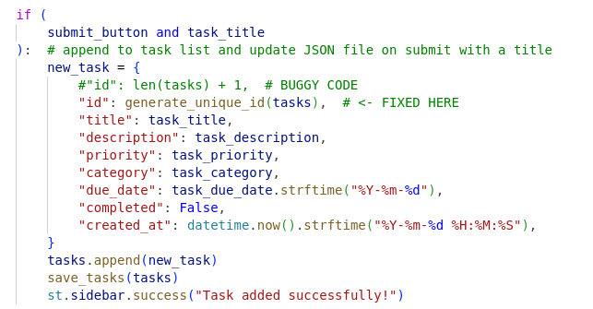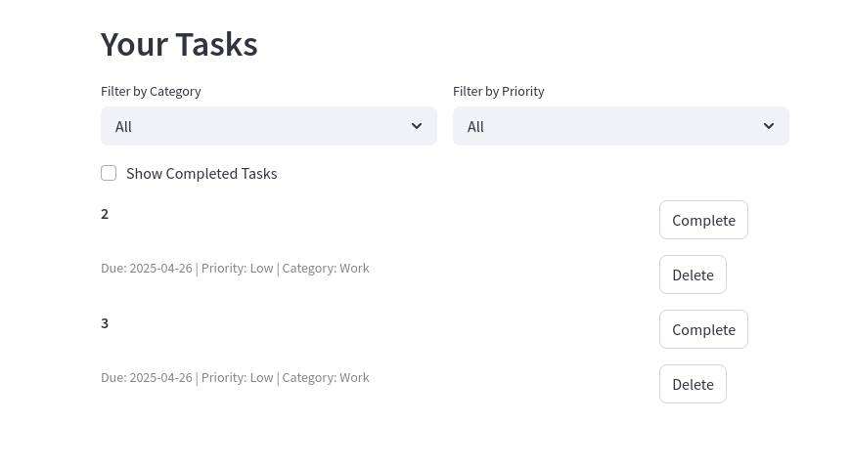

Bug 2: Tasks without Due Date Considered Overdue
Behavior: get_overdue_tasks() included tasks with no due date in the returned list
Expected Behavior: Tasks with no due date should not be included because they cannot be “overdue”
Steps to Reproduce:
- Construct a list of tasks including at least one task without a “due_date” key.
- Pass the list into get_overdue_tasks()
- Observe the returned list contains all entries without “due_date” keys
Fix: This happens because the function compares the due date to the current day with the < operator. If there is no due_date, the empty string is returned which is less than all dates and the task is considered over due. I fixed this by adding another condition to the boolean statement that checks if the task has a due date:
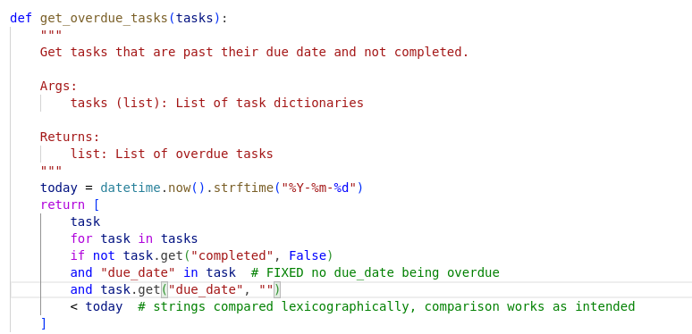

Part 3: Pytest Features (20 points)
For this part I populated the test_advanced.py file with unit tests that utilize fixtures and parametrization for the tasks.py functions. For each unit test, I came up with multiple test cases and added them as parameters. This was convenient because I didn’t have to have a separate assert call for each case.
Then, I added buttons to my streamlit app to showcase certain pytest functionalities. I added buttons for:
- Run Parameterized Tests
- Check Test Coverage
- Generate HTML Report
- Run with Mock

Part 4: Do Test-Driven Development (TDD) (20 points)

Feature 1: Mark All Tasks Complete/Incomplete
- Initial test creation
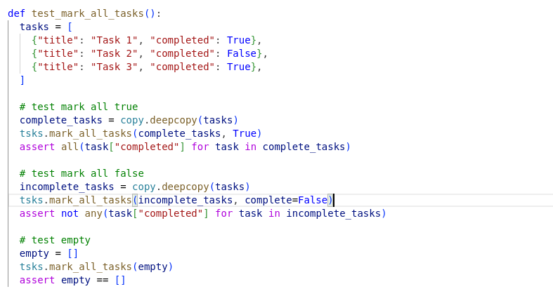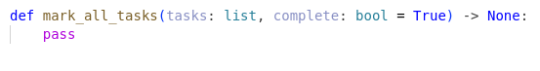
- Test failure demonstration
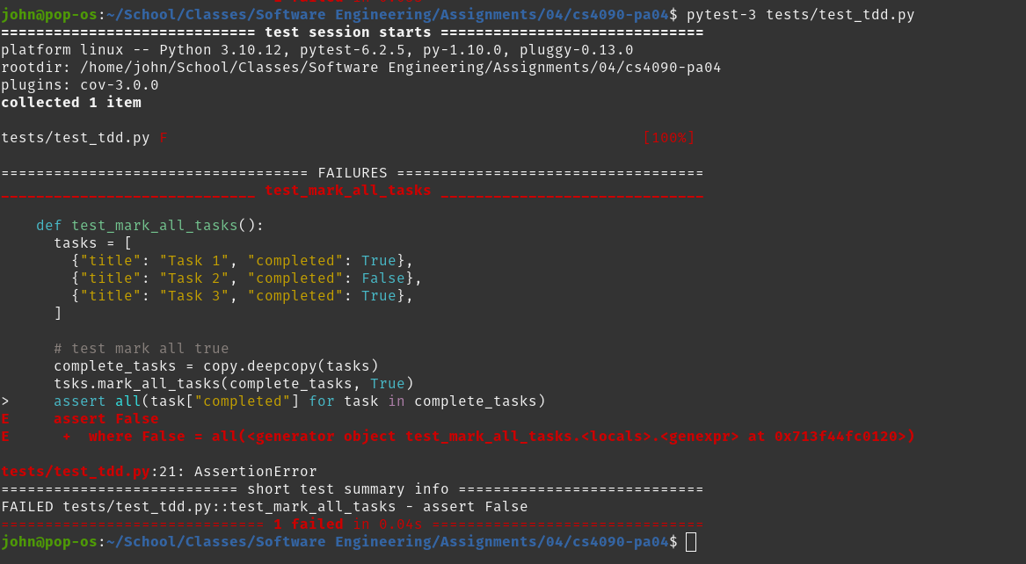
- Feature implementation
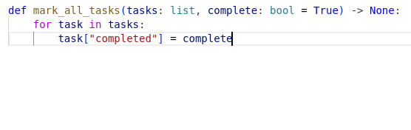
- Test passing verification
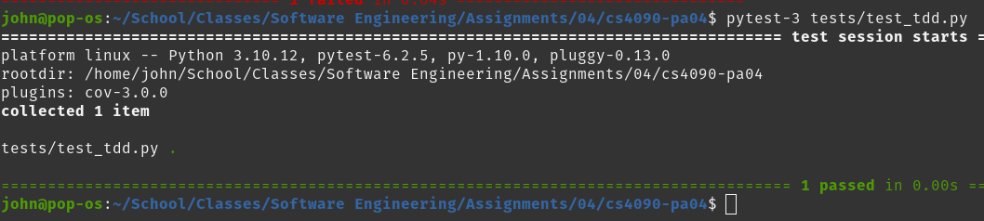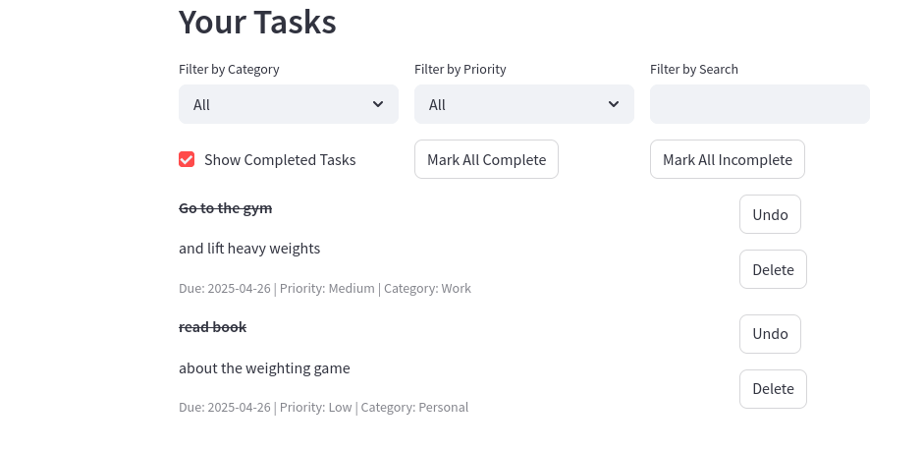
- Any refactoring performed
No refactoring was necessary

Feature 2: Task Editing with update_task()
- Initial test creation
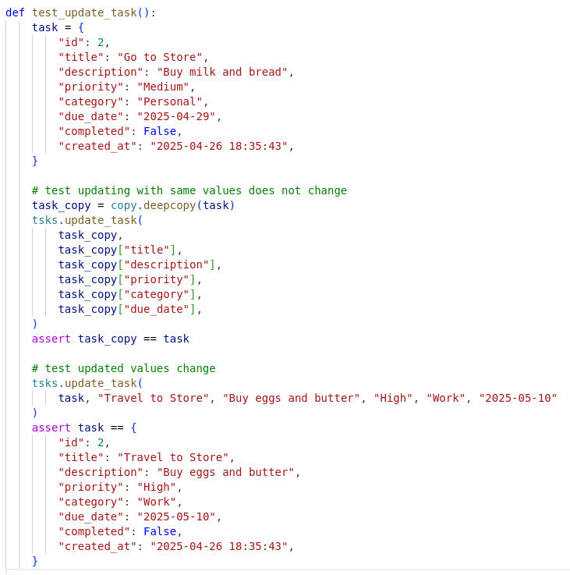
- Test failure demonstration
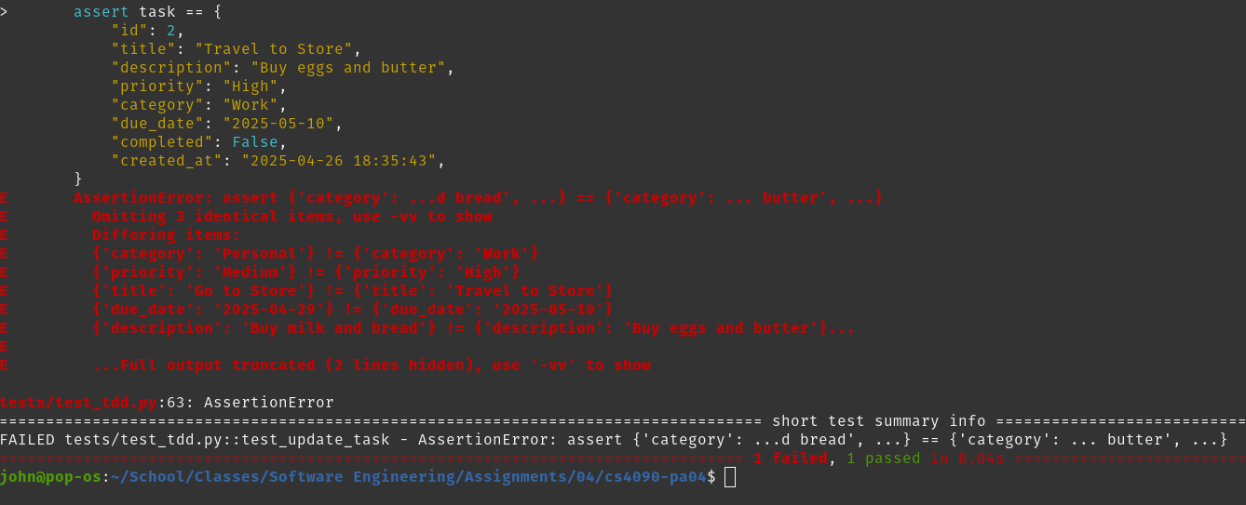
- Feature implementation
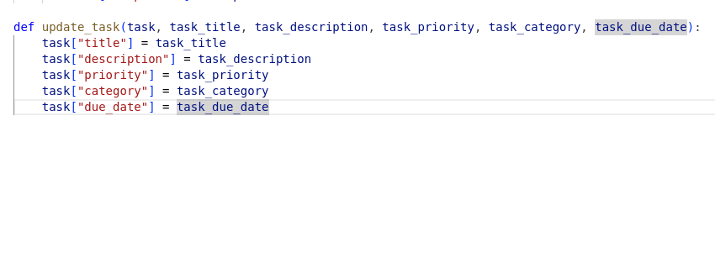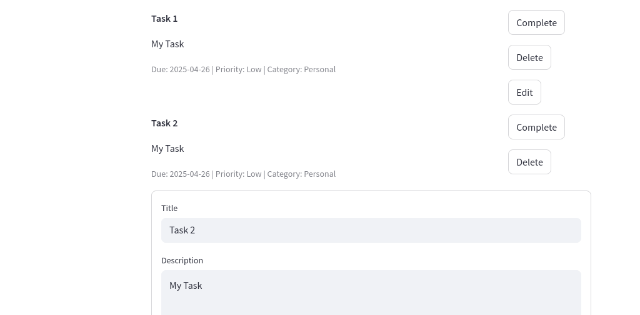
- Test passing verification
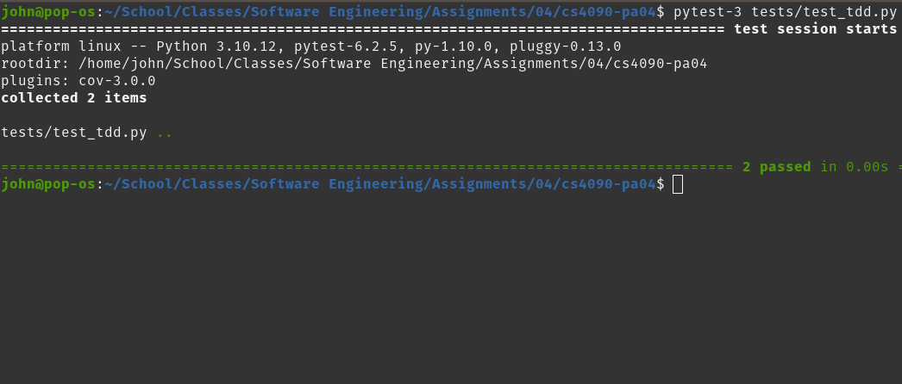
- Any refactoring performed
No refactoring necessary

Feature 3: Sorted Task List
- Initial test creation
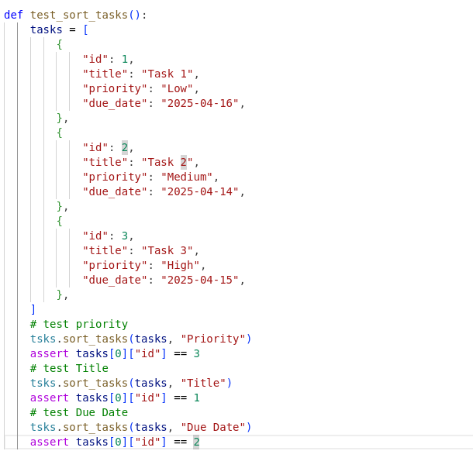
- Test failure demonstration
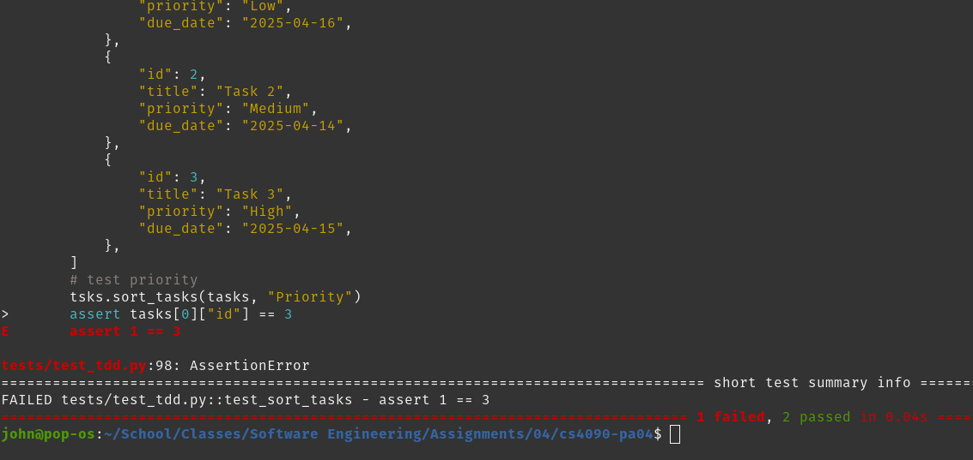
- Feature implementation
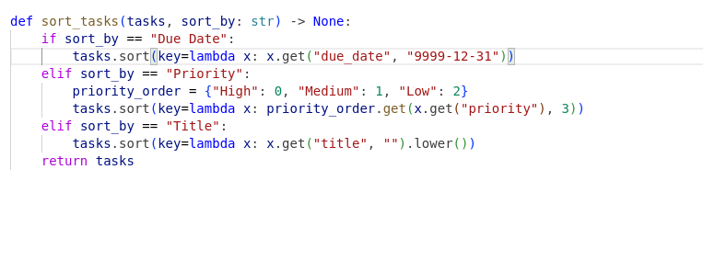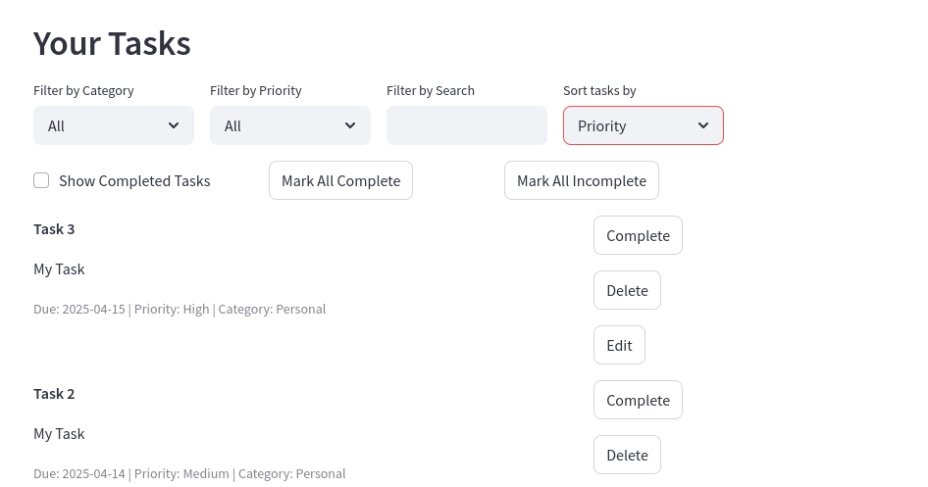
- Test passing verification
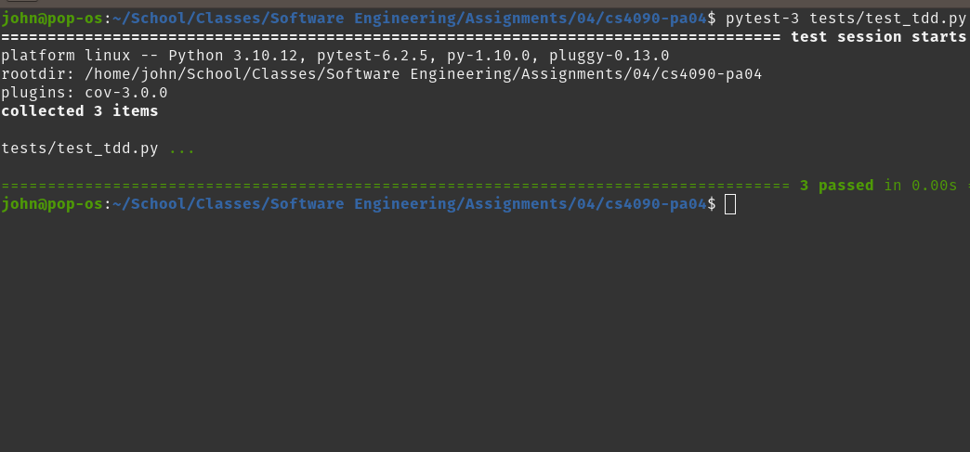
- Any refactoring performed
No refactoring was necessary

Part 5: Do Behavior-Driven Development (BDD)
For part 5 I implemented 5 BDD tests and added a button to the streamlit app to run them. The are located in tests/feature. The tasks.feature file contains the Gherkin syntax for my tests as required by the behave module, and the test_tasks.py file in the steps subdirectory contains the python code for running the tests. For my 5 tests, I chose to test the following functions:
- load_tasks()
- generate_unique_id()
- filter_tasks_by_priority()
- search_tasks
- sort_tasks
For each function, I thought of a Given-When-Then scenario with specific values and implemented the test accordingly

Part 6: Do Property-Based Testing (20 points)
For this part I used the hypothesis module to create 5 hypothesis tests for the functions in tasks.py. For each of these tests, I had to supply the @given decorator with a list of argument types to supply the test function with. For example, for test_generate_unqiue_id, in the @given decorator I had to specify a list of dictionaries with the value {“id”: <int>}. Then, when I run my tests with pytests, hypothesis runs my test functions many times with arbitrary values according to my given specification. This is a good testing strategy for finding edge cases and confirming correctness. When writing the test functions that take the arbitrary arguments, I just had to write them abstractly so they would be valid for any arguments that were passed. It was very similar to the parameterized unit testing.

