|  |  |
| --- | --- |
| Gray Quarter, Inc. |  |

Release Notes

|  |  |
| --- | --- |
| Master Script Upgrade Release Notes | City of Chesapeake Virginia |

# Document Control

|  |  |  |  |
| --- | --- | --- | --- |
| Date | Author | Version | Changes |
| 8/20/18 | John Schomp | V1.0 | Initial Version |
|  |  |  |  |
|  |  |  |  |
|  |  |  |  |

# Charlotte County Master Script Upgrade

## Summary

Gray Quarter, Inc. has upgraded the agency scripts extracted from the CHESAPEAKE Support environment from the version 2.x format to the newest scripting version 3.0 format. The original scripts that were stored in standard choices have been migrated into JavaScript files, using the Accela best practice directory structure. These standard choices have been converted to a structure that mirrors the record type structure for the agency. This document describes the details of the conversion, as well as implementation steps.

## Analysis

A review of the scripting shows that customary standards for scripting based on version 2.X have been used. “Variable branching” (using standard choices named specifically for the events and record types they are intended for) was used.

Several opportunities for code review and/or refactoring were identified. Please see the Recommendations section for details.

## Master Script Usage

The following events are in use for the CHESAPEAKE Production agency, shown with associated master scripts. The “Action” column describes the changes that will be required when implementing the upgraded scripts.

|  |  |  |  |
| --- | --- | --- | --- |
| Event | Script | Type | Action |
| ApplicationConditionAddAfter | ApplicationConditionAddAfter | MASTER SCRIPT - 8.0.0.0.0 | Replace with 8.0.1.0.0 version |
| ApplicationDetailUpdateAfter | UniversalMasterScript | MASTER SCRIPT - 8.0.1.0.0 | n/a |
| ApplicationSpecificInfoUpdateAfter | ApplicationSpecificInfoUpdateAfter | MASTER SCRIPT - 8.0.0.0.0 | Replace with 8.0.1.0.0 version |
| ApplicationSpecificInfoUpdateBefore | ApplicationSpecificInfoUpdateBefore | MASTER SCRIPT - 8.0.0.0.0 | Replace with 8.0.1.0.0 version |
| ApplicationStatusUpdateAfter | ApplicationStatusUpdateAfter | MASTER SCRIPT - 8.0.0.0.0 | Replace with 8.0.1.0.0 version |
| ApplicationSubmitAfter | ApplicationSubmitAfter | MASTER SCRIPT - 8.0.0.0.0 | Replace with 8.0.1.0.0 version |
| ApplicationSubmitBefore | ApplicationSubmitBefore | MASTER SCRIPT - 8.0.0.0.0 | Replace with 8.0.1.0.0 version |
| ContactAddAfter | ContactAddAfter | MASTER SCRIPT - 8.0.0.0.0 | Replace with 8.0.1.0.0 version |
| ContactEditAfter | ContactEditAfter | MASTER SCRIPT - 8.0.0.0.0 | Replace with 8.0.1.0.0 version |
| ConvertToRealCAPAfter | ConvertToRealCapAfter | MASTER SCRIPT - 8.0.0.0.0 | Replace with 8.0.1.0.0 version |
| DocumentReviewUpdateAfter | DocumentReviewUpdateAfterV2.0 | null | Replace with 8.0.1.0.0 version |
| DocumentUploadAfter | DocumentUploadAfter | MASTER SCRIPT - 8.0.0.0.0 | Replace with 8.0.1.0.0 version |
| FeeAssessAfter | FeeAssessAfter | MASTER SCRIPT - 8.0.0.0.0 | Replace with 8.0.1.0.0 version |
| FeeAssessBefore | FeeAssessBefore | MASTER SCRIPT - 8.0.0.0.0 | Replace with 8.0.1.0.0 version |
| FeeEstimateAfter4ACA | null | MASTER SCRIPT - 7.2.0 | Replace with 8.0.1.0.0 version |
| InspectionCancelAfter | MULTIINSPECTIONCANCELAFTER | null | Replace with 8.0.1.0.0 version of Universal Master Script. |
| InspectionMultipleScheduleAfter | InspectionMultipleScheduleAfter | MASTER SCRIPT - 8.0.0.0.0 | Replace with 8.0.1.0.0 version |
| InspectionMultipleScheduleBefore | InspectionMultipleScheduleBefore | MASTER SCRIPT - 8.0.0.0.0 | Replace with 8.0.1.0.0 version |
| InspectionResultModifyAfter | InspectionResultModifyAfter | MASTER SCRIPT - 8.0.0.0.0 | Replace with 8.0.1.0.0 version |
| InspectionResultModifyBefore | InspectionResultModifyBefore | MASTER SCRIPT - 8.0.0.0.0 | Replace with 8.0.1.0.0 version |
| InspectionResultSubmitAfter | InspectionResultSubmitAfter | MASTER SCRIPT - 8.0.0.0.0 | Replace with 8.0.1.0.0 version |
| InspectionResultSubmitBefore | InspectionResultSubmitBefore | MASTER SCRIPT - 8.0.0.0.0 | Replace with 8.0.1.0.0 version |
| InspectionScheduleAfter | InspectionScheduleAfter | MASTER SCRIPT - 8.0.0.0.0 | Replace with 8.0.1.0.0 version |
| InspectionScheduleBefore | InspectionScheduleBefore | MASTER SCRIPT - 8.0.0.0.0 | Replace with 8.0.1.0.0 version |
| InvoiceFeeAfter | InvoiceFeeAfter | MASTER SCRIPT - 8.0.0.0.0 | Replace with 8.0.1.0.0 version |
| LicProfAddAfter | UniversalMasterScript | MASTER SCRIPT - 8.0.0.0.0 | Replace with 8.0.1.0.0 version |
| LicProfLookUpSubmitAfter | LicProfLookupSubmitAfter | MASTER SCRIPT - 8.0.0.0.0 | Replace with 8.0.1.0.0 version |
| LicProfUpdateAfter | UniversalMasterScript | MASTER SCRIPT - 8.0.0.0.0 | Replace with 8.0.1.0.0 version |
| PaymentProcessingAfter | PaymentProcessingAfter | MASTER SCRIPT - 8.0.0.0.0 | Replace with 8.0.1.0.0 version |
| PaymentProcessingBefore | PaymentProcessingBefore | MASTER SCRIPT - 8.0.0.0.0 | Replace with 8.0.1.0.0 version |
| PaymentReceiveAfter | PaymentReceiveAfter | MASTER SCRIPT - 8.0.0.0.0 | Replace with 8.0.1.0.0 version |
| PaymentReceiveBefore | PaymentReceiveBefore | MASTER SCRIPT - 8.0.0.0.0 | Replace with 8.0.1.0.0 version |
| RegistrationSubmitAfter | null | null | Unused, delete event |
| RegistrationSubmitBefore | null | null | Unused, delete event |
| RelatedCapUpdateAfter | RELATEDCAPUPDATEAFTERV2.0 | null | Replace with 8.0.1.0.0 version of Universal Master Script. |
| ReportRunAfterInACA | REPORTRUNAFTERINACA | null | Not a master script, leave in place |
| ReportServiceRunAfter | null | null | Unused, delete event |
| V360InspectionResultSubmitAfter | V360InspectionResultSubmitAfter | MASTER SCRIPT - 8.0.0.0.0 | Replace with 8.0.1.0.0 version |
| V360InspectionResultSubmitBefore | InspectionResultSubmitBefore | MASTER SCRIPT - 9.3.0 | Replace with 8.0.1.0.0 version |
| VoidFeeAfter | VoidFeeAfter | null | Replace with 8.0.1.0.0 version |
| VoidPaymentAfter | VoidPaymentAfter | MASTER SCRIPT - 8.0.0.0.0 | Replace with 8.0.1.0.0 version |
| VoidPaymentBefore | VoidPaymentBefore | MASTER SCRIPT - 8.0.0.0.0 | Replace with 8.0.1.0.0 version |
| WorkflowTaskUpdateAfter | WorkflowTaskUpdateAfter | MASTER SCRIPT - 8.0.0.0.0 | Replace with 8.0.1.0.0 version |
| WorkflowTaskUpdateBefore | WorkflowTaskUpdateBefore | MASTER SCRIPT - 8.0.0.0.0 | Replace with 8.0.1.0.0 version |

## Edits to Standard Master Scripts

|  |  |  |
| --- | --- | --- |
| Master Script | Edit | Action |
| DocumentReviewUpdateAfter | Embedded updatePlanReviewWorkflow function | Identical to distribution function, no action needed as we will replace this master script with std version |
|  |  |  |

## Custom functions that conflict with Master Script distribution

Custom functions were found that matched standard functions that are part of the Master Script 3.0 distribution. The code was compared, and the following recommendations were made.

|  |  |  |
| --- | --- | --- |
| Function | Description | Disposition of custom function |
| addParameter | Matches the 3.0 distribution | To be Removed |
| contactObj | 3.0 distribution has more functionality | To be Removed |
| convertContactAddressModelArr | Matches the 3.0 distribution | To be Removed |
| createRefContactsFromCapContactsAndLink | Matches the 3.0 distribution | To be Removed |
| createRefLicProf | Matches the 3.0 distribution | To be Removed |
| doesASIFieldExistOnRecord | Matches the 3.0 distribution | To be Removed |
| generateReport4Workflow | Matches the 3.0 distribution | To be Removed |
| genericTemplateObject | Matches the 3.0 distribution | To be Removed |
| getACADocDownloadParam4Notification | Matches the 3.0 distribution | To be Removed |
| getACADocumentDownloadUrl | Matches the 3.0 distribution | To be Removed |
| getACARecordParam4Notification | Matches the 3.0 distribution | To be Removed |
| getACAUrl | Matches the 3.0 distribution | To be Removed |
| getAppConditions | Matches the 3.0 distribution | To be Removed |
| getCapId | Matches the 3.0 distribution | To be Removed |
| getChildren | Matches the 3.0 distribution | To be Removed |
| getContactObj | Matches the 3.0 distribution | To be Removed |
| getContactObjsByCap | Matches the 3.0 distribution | To be Removed |
| getContactObjs | Matches the 3.0 distribution | To be Removed |
| getContactObjsBySeqNbr | Matches the 3.0 distribution | To be Removed |
| getContactParams4Notification | Has a logic error, “param” is not defined. | To be Removed |
| getDocOperation | Matches the 3.0 distribution | To be Removed |
| getDocumentList | Matches the 3.0 distribution | To be Removed |
| getInspectionResultParams4Notification | Matches the 3.0 distribution | To be Removed |
| getInspectionScheduleParams4Notification | Matches the 3.0 distribution | To be Removed |
| getPrimaryAddressLineParam4Notification | Matches the 3.0 distribution | To be Removed |
| getPrimaryOwnerParams4Notification | Matches the 3.0 distribution | To be Removed |
| getURLToNewRecord | Matches the 3.0 distribution | To be Removed |
| getUserEmail | Matches the 3.0 distribution | To be Removed |
| getWorkflowParams4Notification | Matches the 3.0 distribution | To be Removed |
| handleError | Matches the 3.0 distribution | To be Removed |
| isEmpty | Matches the 3.0 distribution | To be Removed |
| licenseProfObject | Additional functionality | To be Removed |
| resultWorkflowTask | Matches the 3.0 distribution | To be Removed |
| runReport4Email | Matches the 3.0 distribution | To be Removed |
| runReport4EmailOrPrint | Matches the 3.0 distribution | To be Removed |
| sendNotification | Matches the 3.0 distribution | To be Removed |

## 

## The INCLUDES_CUSTOM Script is deprecated

The old INCLUDES_CUSTOM script has the following functions defined, but they are no longer needed. This script should be deleted to avoid any future confusion.

* preventPermitIssuance is defined in the “INCLUDES_CUSTOM” script, but the only reference in business scripts is disabled.
* getContactObjs is identical to the distribution version.

## Standard Choice Conversion Details

* Approximately 2129 Standard Choices containing scripts have been converted to approximately 374 script files. 10 new functions were created. In general, any standard choice code that was branched to more than once was converted to a separate custom function. The following functions were created:

|  |  |
| --- | --- |
| Standard Choice | FunctionName |
| EMSE;GlobalFlags | globalFlags |
| EMSE;SetContactRelationshipToContactType | setContactRelationshipToContactType |
| EMSE;LicProfLookup | licProfLookup |
| EMSE;BLD_ProffersInspectionCheck | proffersInspectionCheck |
| EMSE;ComplaintDuplicateCheck | complaintDuplicateCheck |
| EMSE;ServiceRequestDuplicateCheck | serviceRequestDuplicateCheck |
| EMSE;ZON_ProcessCPParents | zonProcessCPParents |
| LIC Establish Links to Reference Contacts | establishLinksToReferenceContacts |
| LIC Issue Business License | issueBusinessLicense |
| ENF CREATE CHILD CASES | enfCreateChildCases |
|  |  |

* All converted scripts have been tested for proper JavaScript syntax.
* To assist with testing, the original “*Branch*” standard choice names have been added as comments to the converted scripts. Once testing is complete these comments won’t be needed. For example:

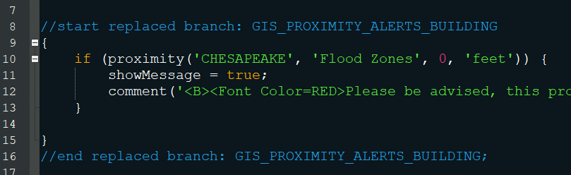

* The conversion algorithm may have created some instances where double sets of braces {{ … }} denote a code block. These can be removed if desired, but they have no impact on the script execution.
* In accordance with best practices, all references to *showDebug* within business scripts have been removed to simplify script debugging. Accela recommends setting this in one place, preferably using INCLUDES_CUSTOM_GLOBALS, which was designed for this purpose.

* Individual standard choices that were disabled are included but commented out inline. Any branch calls in this disabled code were migrated as “*br_nch*” as the branch function is no longer supported in 3.0. If this code needs to be enabled, these branch calls would have to be refactored. For example:

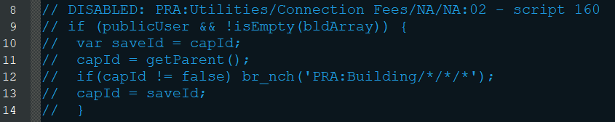

* Standard choice branches that were not referenced by any script were converted into JavaScript and placed into the Scripts\Unused Branches folder. This includes any code that was referenced by disabled standard choices. These should be reviewed.
* All script files have been formatted to JavaScript standards for indentation.
* The caret (^) is no longer valid for creating conditional logic. Standard JavaScript should be used instead (i.e., if, else, else if, switch)
* All references to Custom Fields, Task Specific Info, and Parcel Attributes that used braces (e.g., *{ASI Field})* have been changed to use the AInfo global Array (e.g., *AInfo[‘ASI Field’]*). Braces are now exclusively used to designate blocks of code.
* All references to the “*branch*” and “*endbranch*” functions have been removed. These are deprecated in Master Scripts 3.0.

## Code Analysis and Recommendations

Some recommendations on the existing code are as follows:

* The “email” standard function is used throughout the scripts. The Communication Manager functions could be used to send emails using templates, with the added benefit of recording the email text in the Communications tab.
* The “updateTask”, “closeTask”, and “branchTask” functions are used throughout. The newer “resultTask” standard function will perform the same action but follow the workflow configuration of the selected status.

* In some cases, getAppSpecific is being called for the current record, but this information is already retrieved and kept up to date by the master script environment. AInfo[“Label”] should be used instead so the script doesn’t have to retrieve the value from the database twice.
* Variables that are declared within business scripts should always be prefaced by the “var” keyword, so that they become local variables. Without the “var” keyword, the variable is global in scope.
* Review/Edit all TODO sections as shown below:

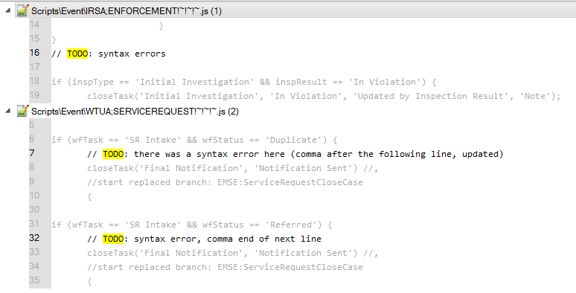

## Script Repository

A temporary DEV repository was created for this conversion

|  |  |
| --- | --- |
| Repository Protocol | Git |
| Repository URL | <https://github.com/grayquarter/chesapeake.git> |

To connect to the repository, the “EMSEToolConfig” standard choice should be configured as per the Accela documentation. The “EMSETool” portlet should be enabled for the appropriate users/groups.

## Standard Choices

The following Standard Choices must be configured. These are documented in the Master Script distribution in the documentation folder. The “Master Script Distribution_Std_Choices.zip” data manager package can be used to load these values.

* EMSE_EXECUTE_OPTIONS determines if Scripts or Standard Choices, or both should be executed by the master script. This should be set to select Scripts only.
* EMSE_VARIABLE_BRANCH_PREFIX determines the naming convention used to determine if a script is associated to a particular event.

|  |  |
| --- | --- |
| Event Name | Variable Branch Prefix |
| ApplicationConditionAddAfter | ACAA |
| ApplicationDetailUpdateAfter | ADUA |
| ApplicationSubmitAfter | ASA |
| ApplicationSubmitBefore | ASB |
| ApplicationSpecificInfoUpdateAfter | ASIUA |
| ApplicationStatusUpdateAfter | ASUA |
| ContactAddAfter | CAA |
| ContactEditAfter | CEA |
| ConvertToRealCapAfter | CTRCA |
| DocumentReviewUpdateAfter | DRUA |
| DocumentUploadAfter | DUA |
| FeeAssessAfter | FAA |
| InspectionCancelAfter | ICA |
| InvoiceFeeAfter | IFA |
| InspectionResultModifyAfter | IRMA |
| InspectionResultSubmitAfter | IRSA |
| InspectionScheduleAfter | ISA |
| InspectionScheduleBefore | ISB |
| LicProfAddAfter | LPAA |
| LicProfLookupSubmitAfter | LPLSA |
| LicProfUpdateAfter | LPUA |
| PaymentProcessingAfter | PPA |
| PaymentProcessingBefore | PPB |
| PaymentReceiveAfter | PRA |
| PaymentReceiveBefore | PRB |
| RelatedCapUpdateAfter | RCUA |
| VoidPaymentAfter | VPA |
| WorkflowTaskUpdateAfter | WTUA |
| WorkflowTaskUpdateBefore | WTUB |

* MASTER_SCRIPT_DEFAULT_VERSION (Recommendation is to set to 8.0.1.0.0)

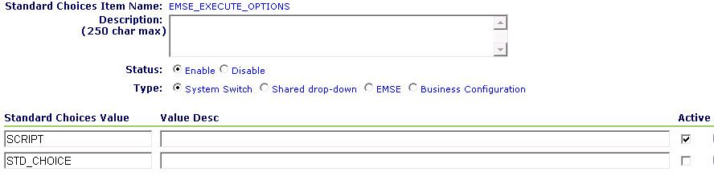

## Deployment to Higher Environments

After the initial migration, the deployment to a higher environment (e.g., DEV -> TEST, TEST-> PROD) can be achieved by the following steps:

|  |  |  |  |
| --- | --- | --- | --- |
|  | Step | Description | Est. Time |
| 1 | Create rollback package | In TARGET environment create a Data Manager export package that contains:   * all Event to Script associations (AA Configuration, Event Manager, Events, select all) * Master Includes (AA Configuration, Event Manager, Master Scripts, INCLUDES_CUSTOM) * Includes (AA Configuration, Event Manager, Master Scripts, INCLUDES*)   Save and run the job, saving the output in a dedicated folder. This package will only be used if a roll back is required. | 5 Minutes |
| 2 | Create master script package | In SOURCE environment create a Data Manager export package that contains:   * all Event to Script associations (AA Configuration, Event Manager, Events, select all) * Includes (AA Configuration, Event Manager, Master Scripts, INCLUDES*) * EMSE Standard Choices (AA Configuration, Standard Choices: EMSE_EXECUTE_OPTIONS, EMSE_VARIABLE_BRANCH_PREFIX, EMSEToolConfig)   Save and run the job, saving the output in a dedicated folder. | 5 Minutes |
| 3 | Deploy master script package | In TARGET environment create a Data Manager import job that will import the entire package in step 2. | 5 Minutes |
| 4 | Confirm EMSEToolConfig | In TARGET environment update the EMSEToolConfig standard choice with credentials and URL to access the environment repository. | 2 Minutes |
| 5 | Deploy Scripts | In TARGET environment deploy all scripts using the EMSE Tool. | 5 Minutes |
| 6 | Update INCLUDES_CUSTOM_GLOBALS | In TARGET environment update the INCLUDES_CUSTOM_GLOBALS script as needed for this environment (debugging options, environment variable, etc.) | 2 Minutes |
| 7 | Smoke Test | In TARGET environment perform smoke testing to ensure proper script execution. | 10 Minutes |