ESCROW HOLD BACK POLICY

GENERAL GUIDELINES
Last updated 11/04/2025

- If Escrow is to be held back for anything other than items that are weather-related, the request must be approved by the Underwriting Manager.
- The maximum term for an escrow withhold is 90 days.
- Add the Special Feature code on the loan summary page “Escrow Holdback”
- (conditions listed below- question prompts in each condition)
  - Repair Estimate from Builder or Contractor.
  - Post-Closing to complete the Escrow Closeout Cert Screen in FHAC within 30 days after the repairs are complete.
  - App Correction: Appraiser must comment on work to be done and add the repair schedule.
  - UW to approve 90-day Escrow Holdback.
  - Appraisal Final Inspection: Repairs Completed by MM/DD/YY.
- Disclose a Final Inspection Fee. If the file is new construction you may have to add two final inspection fees depending on the level of completion of the property at time of appraisal. Be Prepared to disclose an additional fee.
- Must have an invoice from the contractor who will be completing the remaining items.
- For FHA and USDA we require 1 times the cost of the repairs/completion items. Canopy must hold the escrowed funds. ( see below on how to enter in fees page).
- For VA, we require 1 1/2 times the cost of the repairs/completion items. Canopy must hold the escrowed funds. (see below on how to enter in fees page).
- For Conventional we require 1 1/2 times the cost of the repairs/completion items. Canopy must hold the escrowed funds. (see below on how to enter in fees page).
- Please see below for how to enter the escrow amount correctly in the fees page.
- Nothing will be disbursed until all items have been completed
- Once repairs are completed
  - Must order the final inspection and return the file to UW for review of the final inspection.
  - You must forward all invoices and instructions on the disbursement of the funds.
  - Any contractor that will be paid, must provide a W9

PROCESSING TEAM GUIDELINES
- If condition set is not already added, ensure the Special Feature “Escrow Holdback” was entered properly on the Loan Summary page
- Must have an invoice/bid from the contractor who will be completing the remaining items. This will be uploaded to the “Provide: Repair Estimate from Builder or Contractor for Subject Property” task
- Confirm all final inspection fees disclosed- property may need more than one inspection depending on level of completion of home at initial inspection.
- See below for how to enter fees for escrow holdback.
- Once the loan has funded and the repair completion date is approaching, you will be contacted by post closing to find out if repairs are completed and for you to order a final inspection report.
- Provide disbursement Instructions.
  - If a contractor completed the repairs, call the contractor from the invoice provided and request the W9 with their name, address and tax ID.
  - If seller is paying for repairs, must get the address to where the check will be sent-( the sellers new address)
  - If the buyer paid the contractor, then we need a paid invoice.
  - Put notes called “disbursement instructions” for where the check should go, seller, borrower, or contractor.
- All documents for escrow holdback (invoices, etc) should go in misc property
- When final inspection is provided, notify UW on file to review and approve. Once approved, notify the post closing team final inspection is approved and in the file.

Entering Escrow Hold back Fees:
Please see below for how to enter the escrow amount correctly in the fees page. This is so important that this is done correctly to ensure the CD is accurate and that the funds stay with Canopy and aren't wired to the title company.

If Repair Escrow is to be paid by Seller (most common). Add “Repair Escrow” fee type to section N as shown below.
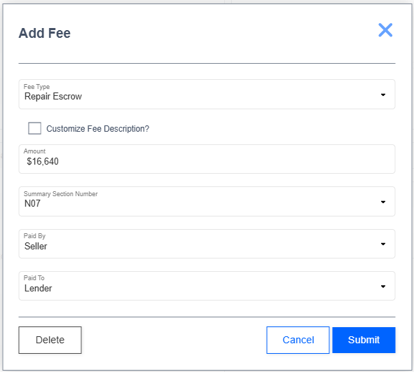
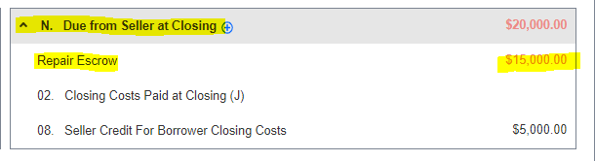

If Repair Escrow is to be paid by the borrower. Add “Repair Escrow” fee type to section K as shown below.

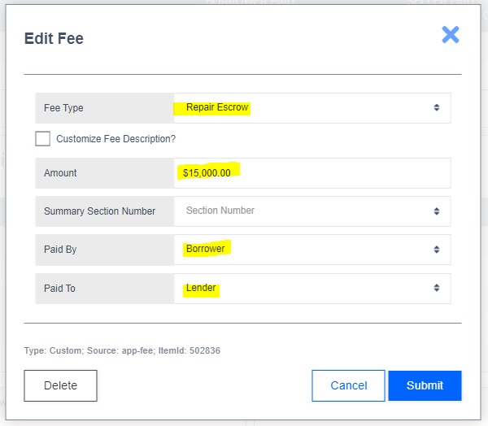
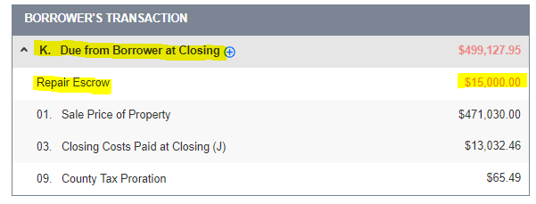

UNDERWRITING TEAM GUIDELINES:

- Must complete the Escrow Agreement to be executed by all parties AND once completed upload to Xdocs, “Documents to be signed at closing”. This can be found in the forms page and filled out via Adobe Acrobat, XodoSign
- Complete date “repairs due by” on the appraisal final inspection condition.
- For FHA the Mortgagee’s Assurance of Completion Form HUD-92300 must be completed and uploaded to docs to be signed at closing for signatures of all parties.
- UW to fill out ‘escrow holdback for the following item_____ in the amount of $_____” condition.
- Appraiser is still required to address any health / safety issues for postponed improvements. (health, safety, and soundness are not approved and must be addressed prior to closing)
  - Follow Agency guidelines for acceptable postponed items
  - The appraiser must comment on escrow holdback items, aligning with invoice and agreement.
- After Funding, and once UW is notified from the processor that final inspection is in the file, review the document and notify the processor of approval.

FOR FUNDING:
- DO NOT SIGN THIS OFF THE FOLLOWING CONDITIONS:
  - Escrow Holdback for the following item(s)_____ in the amount of $____
  - Post-Closing to complete the Escrow Closeout Certification Screen in FHAC within 30 days after repairs are complete.
  - Appraisal Final Inspection: Repairs Complete by_____
- File all Docs for Escrow related items in Misc. Property.
- Email specialhandling@canopymortgage.com per checklist

APPRAISAL TEAM:

- Do not sign off this condition, it is not a duplicate:
  - Appraisal Final Inspection: Repairs Complete by_____

FOR POST CLOSING:

- The Post Closer will be notified via email by the funding team to the special handling email that a loan has closed with an escrow holdback. (This is to be looked at and updated daily)

- The Post Closer will enter the details of the loan in the spreadsheet called Escrow Holdback Tracking. This is a shared document and has multiple tabs. Make sure that the ESCROW HOLDBACK tab is the one chosen.

- The Escrow Holdback Tab will be filled in with the borrower/escrow holdback information and the sheet will track the repair completion dates, the documents needed (Invoice/W9), when notify the team to order the final inspection, and the information on when to cut the check to the individuals.

  - Notify the Loan Team when the repair due date is approaching. This should be done two to three weeks before the repair is due, this will allow the loan team to verify the timeline and confirm if the repairs are on track to be completed.
  - When the repairs are complete, have the loan team order the final inspection/appraisal with the specialist team.
  - When final inspection is completed the loan team will upload into Xdocs under Appraisal Recert/Final Inspection and notify the post closing team at postclosing@canopymortgage.com
  - Review the instructions for disbursement of the funds (found in Misc. Property). Verify the address with the loan team if funds are to be returned to the Seller and/or Buyer including the invoice instructions

- Once all documents are provided and signed off on, have the check cut to the applicable parties and put a copy of the checks and tracking into Xdocs under Misc Property. (all documents are to be merged into 1 document).

