IT Support: Password Reset Guide
Last updated 10/15/2025

When to use this guide
Use this guide when a loan officer is locked out of Encompass or the Hub.

Steps
- Verify the caller by employee ID.
- Open the Okta admin console.
- Select the user, then choose Reset Password.
- Send the temporary password by text only.
- Never email a password.

Contacts
Team | Email | Hours
Help Desk | help@canopymortgage.com | 7am-6pm MST
Logins | logins@canopymortgage.com | 8am-5pm MST

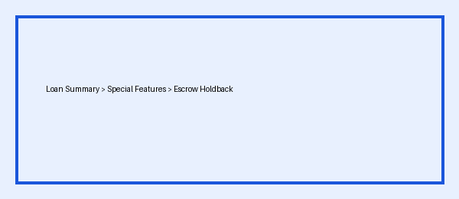
Screenshot: where to find the setting.

