ST0501 FRONT-END WEB DEVELOPMENT
INDIVIDUAL CA2 REFLECTION JOURNAL

Student Name: Chee Guan Zhe Admin Number: P2640583
Class: DCITP/FT/1A/12 Group No: Group 2

Objective :
This Reflection Journal requires you to critically analyze your CA2 project decisions, technical issues, and your responsible use of AI tools. Tutors are looking for depth of thought and examples that demonstrate understanding of your work.
Instructions:
- Answer all 3 parts below
- Total word count : 900-1200 words
- Use examples from your CA2 or class activities where relevant
- Submitted individually via BrightSpace.
- Attach your AI prompt logs using the Academic Integrity Declaration link (available in BrightSpace) in Appendix, this will not be included in the wordcount.

Part 1: Reflection on Styling Frameworks & Interactivity
- What changes are made to the original plan? Why are the changes necessary? And what impact do they cause e.g on the website, user experience, performance etc?
- Analyze the trade-offs between using a front-end styling framework (e.g., Bootstrap/Tailwind) and writing custom CSS in your project. How did your choice affect the efficiency, design flexibility, or maintainability of your website?
- Evaluate one interactive feature (e.g., form validation, DOM update, dynamic menu) you implemented: How well does it improve user experience? If you had to enhance it further, what changes would you make and why?

Word Count Suggestion: 250-450 words. (Write your answer here)

Compared to the original template, the current version shows a shift from a more generic, static layout to a cleaner and more user-focused design. Key changes include improved layout structuring. For example, better spacing, alignment and section hierarchy. Other than that, there is also improvement on the consistent colour themes, and enhanced readability through font choices. These changes is needed to make website more engaging and accessible, especially the young users. Website is more modern which improved user experience. Some additional styling resources may increase loading time. Overall the improvements make navigation clearer. For our project, we used tailwind which improve development efficiency since it provides ready-made utility classes for styling directly in the html. This allows me to quickly design layouts without a large amount of time. However, the trade-off is html become harder to read due to many class names. In contrast, custom css provides a cleaner html and more unique designs but it takes longer time. In this project, tailwind is a really good choice since it balanced speed and responsiveness. One interactive feature implemented is form validation. This improves user experience by providing feedback when user input wrong data, helping them to correct mistakes quickly , making the website more interactive. To enhance this feature further, I would add clearer visual feedback such as color or animations to indicate errors. Additionally, I could improve accessibility by ensuring screen readers can detect validation messages and by making interactions more intuitive for all users.

Part 2: Reflection on JavaScript & DOM Interactivity
- What changes are made to the original plan? Why are the changes necessary? And what impact do they cause e.g on the website, user experience, performance etc?
- Which JavaScript feature you added (e.g., image gallery, menu toggle, validation) made the biggest impact on your website’s user experience? Why?
- Think about the form your created in CA2 or practiced in class: What makes a form easy or hard for users to complete? What is one improvement you would suggest making a form more user-friendly, and why?

Word Count Suggestion: 250-450 words. (Write your answer here)

Comparing both original plan and current plan, the website was enhanced from a mostly static page into a more interactive and dynamic platform using JavaScript and DOM manipulation. Initially, the focus was mainly on displaying information, but the updated version includes features such as interactive buttons, dynamic content updates, and possibly form handling. These changes were necessary to improve user engagement, as static websites can feel boring and less responsive. By adding interactivity, users can now click buttons and receiving feedback. The impact is positive as it makes the website more modern and engaging which improves user experience. However, JS might affect the performance if not optimized properly especially when there’s a lot event listeners. One JS feature implemented is a DOM based interaction. This feature has the biggest impacts since it allows real-time changes on the webpage without a reload. For example, a menu toggle improves navigation on smaller displays while form validation helps user to input correct data. This reduces user’s confusion and improves usability. A form is easy to complete when it is simple, clear, and provides helpful guidance. Good forms has the following like clear labels, placeholder text and etc. On the other hand, forms become difficult to complete when they are too long, unclear and only shows error after submission. I would suggest adding a real time validation with clear visual feedback, such as highlighting incorrect fields and display helpful messages. This will for sure help users to quickly identify their mistakes and reduce their frustration.

Part 3: Reflection on AI Usage and Evidence of Understanding

- Analyze your use of AI during this project: Which specific problem or task did AI help you with, and why did you choose to use AI for it?
- Choose one example where you used AI to help with coding for your website. Show the original AI-generated snippet and your modified version. Explain what you changed and why. How did your changes make the code better or fit your project needs?

Word Count Suggestion: 250-450 words. (Write your answer here)

For me, I haven’t really used ai to help me code , while im using them right now to explain most of the tailwind codes to help me understand where and how I could apply them, as we js learnt it recently things still might be confusing. There is still a lot question I have to ask AI but in the process I learnt a lot. Other than that, I used ai to assist me on implementing a JS feature for interactivity, such as form validation. The original AI-generated solution provided a basic structure that worked functionally but was quite generic and did not fully match the needs of my website. The code did not consider edge cases such as empty inputs or incorrect formats. I modified the Ai-generated code by improving the logic making it more suitable for our my target users which included validation conditions, adding a clearer feedback message. I also tried to adjust the code structure to make it more readable and consistent such as using better variable and organizing the functions. These changes made the code more effective and aligned with the overall design of our website. From a user experience pov, the improvements allow users to receive clear feedback , which reduces confusion and makes interaction more efficient. From development pov, the refined code is easier to maintain and debug in the future. Overall the ai generated code provided me a good starting point, it required some modification to better fit the requirement I want. This process highlight the importance of not relying on Ai output but also adapting them to ensure the website quality and consistency.

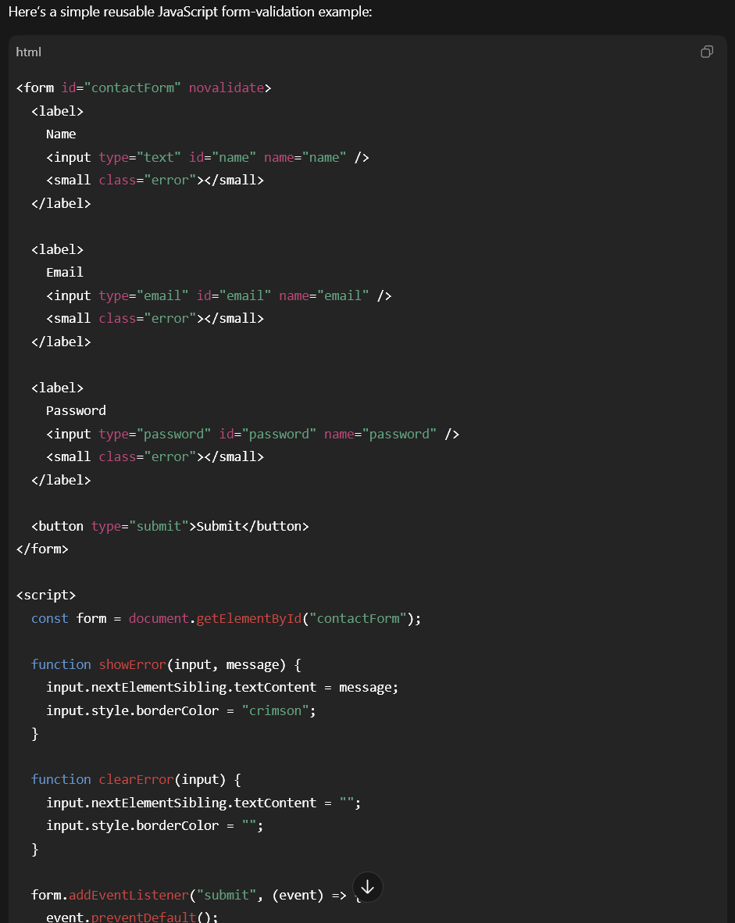

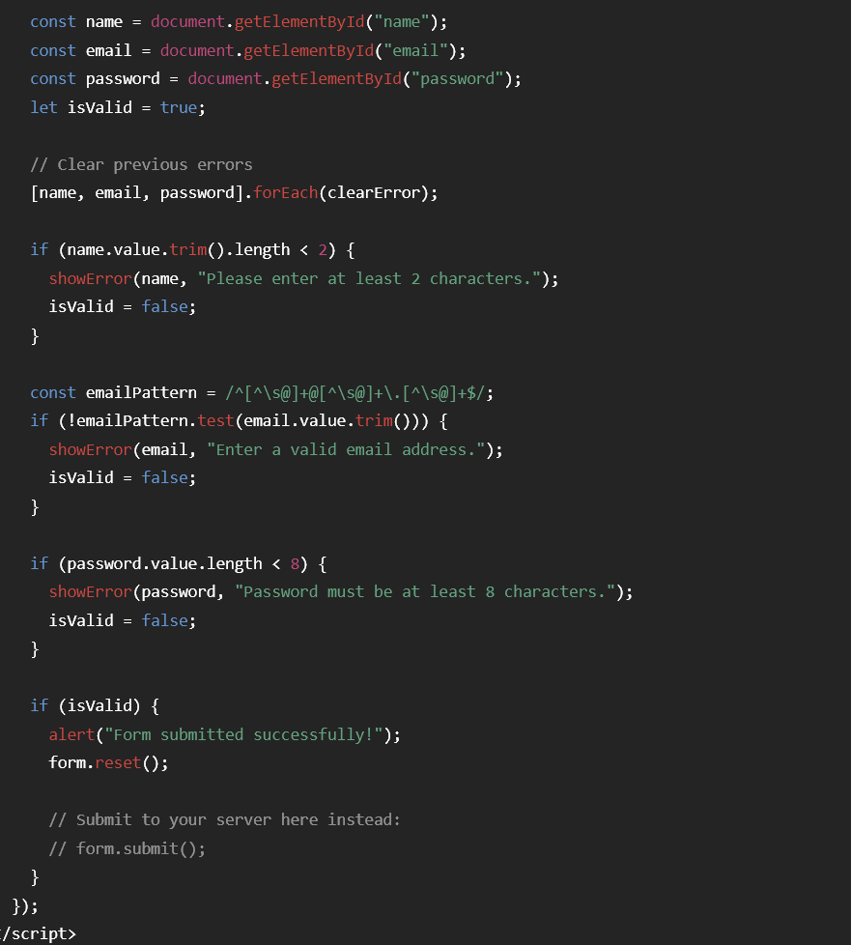

The modified one :
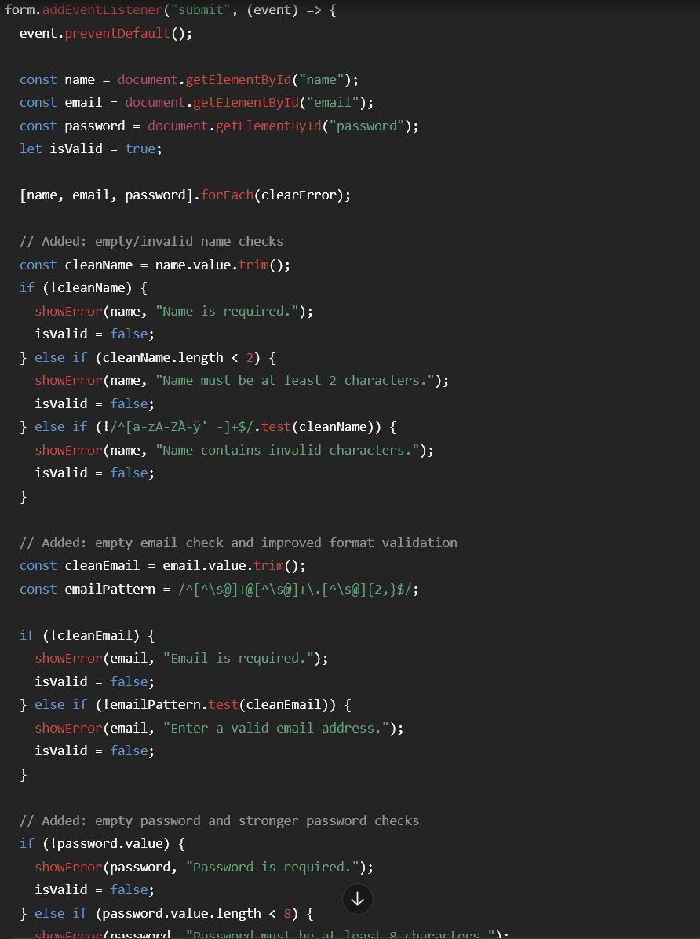
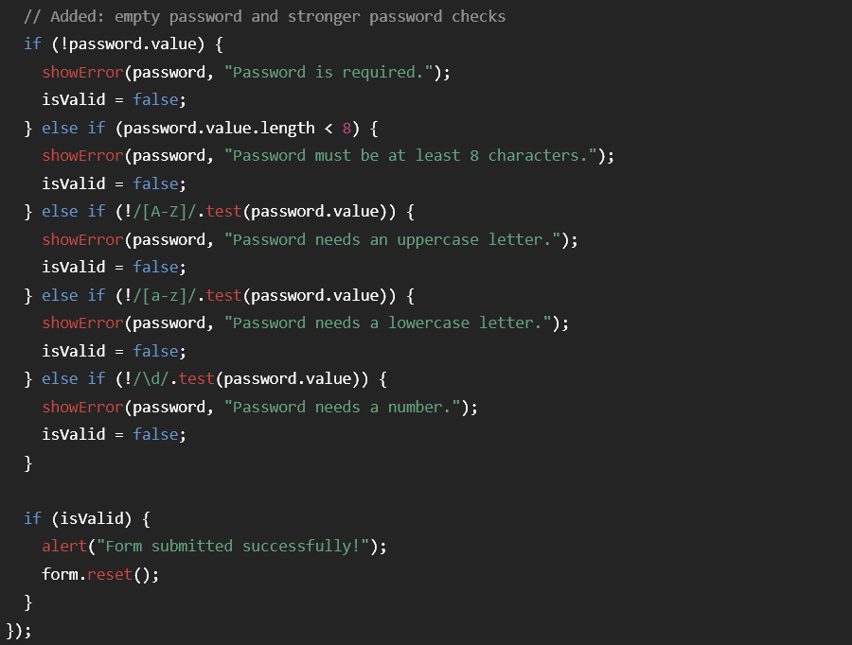

Appendix (e.g AI outputs or evidences you would like to include, this will not be included in the wordcount)

~~ The End ~~

