INDEX
Sl. No | Date | Name of Experiment | Page No. | Remarks

DIP PINOUT

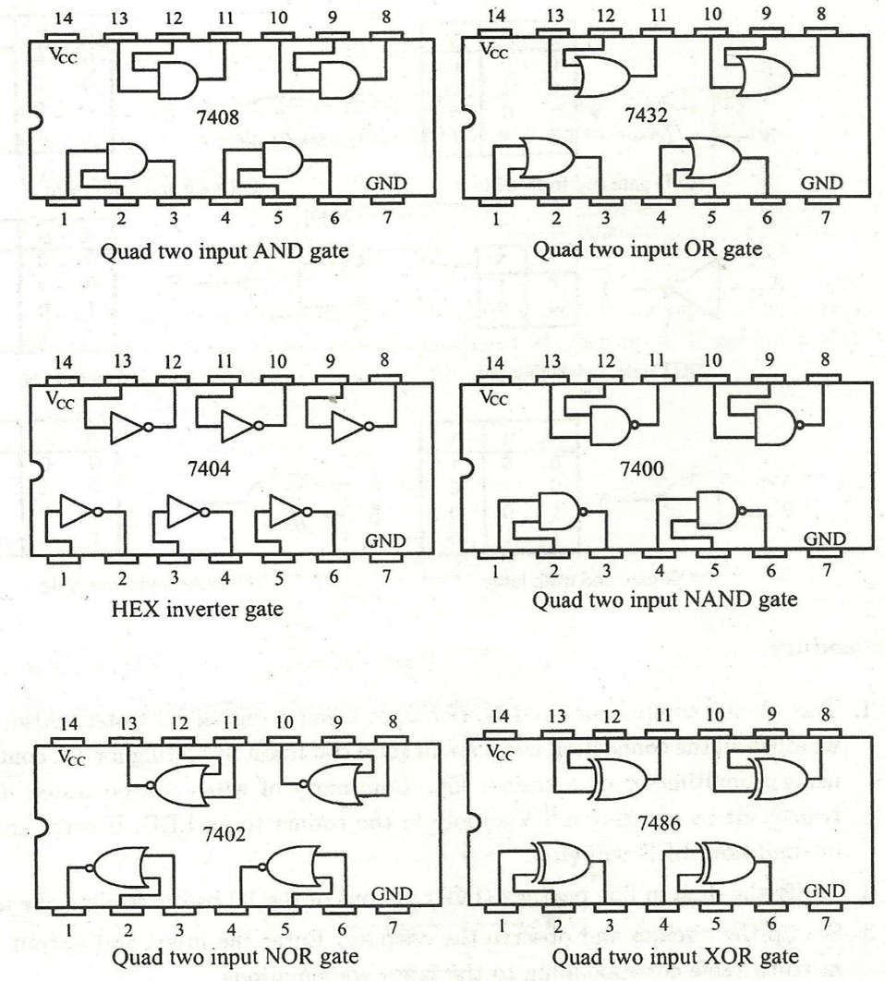

Date : / /

Experiment No: 1
EXPERIMENT No:
STUDY OF DIGITAL ICs AND IC TRAINER KIT
AIM
To familiarize with some basic logic gate IC packages and to verify the truth tables of the logic gates IC trainer kit. Also to familiarize with the digital IC trainer kit.

COMPONENTS AND EQUIPMENTS REQUIRED
ICs 7408, 7432, 7404, 7486, 7400, 7402 and IC trainer kit

THEORY

IC Trainer kit
IC trainer kit is an equipment mainly used to test and set up digital circuits while doing experiments. Integrated circuits can be fitted in sockets or breadboard provided in it. The associated circuit can be set up on the bread board. There are built-in voltage sources and clock signals in it. The frequency of clock can be selected by turning the knob into different positions. In order to feed monopulses manually, a debouncer switch is also provided. A number of select-switches are provided to represent low and high state for digital inputs. LEDs are provided to visualize the digital outputs.
Logic gates
A gate is logic circuit with one output and one or more inputs. Logic gates are available in integrated circuits (ICs).

AND gate: The AND gate performs logical multiplication, more commonly known as AND operation. The AND gate output will be in high state only when all the inputsare in high state. 7408 is a digital IC (14 pins) in the TTL family known as quad two input AND gates. Pin 14 is the supply pin. For standard TTL devices to work properly, the supply voltage level must be between +4.75 V and +5.25 V. Pin 7 is the common ground for the chip.

OR gate: It performs logical addition. Its output will become high if any of the inputs is in logic high. 7432 is a quad two input OR gate.
NOT gate: It performs a basic logic function called inversion or implementation. The purpose of the inverter is to change one logic level into opposite level. IC 7404 is a hex inverter.
SYMBOLS AND TRUTH TABLES
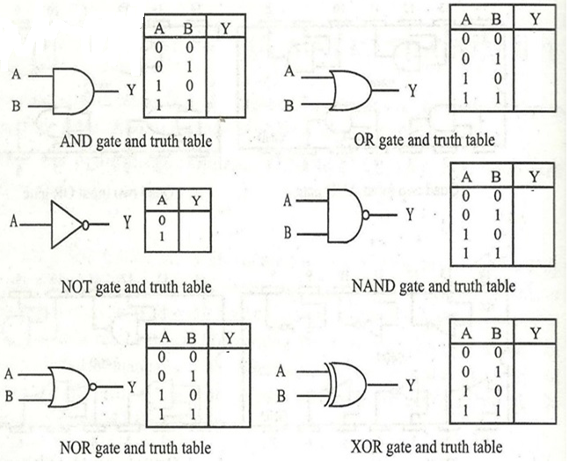
NAND gate: A NOT gate following an AND gate is called NAND gate. Its output will be low if all the input state are in high state. 7400 is a quad two input NAND gate.
NOR gate: A NOT gate following an OR gate is called NOR gate. Its output will be in low state if any of its input is in high state. 7402 is a quad two input NOR gate.
XOR gate: Its output will be high if and only if one input is in high state. 7486 is a quad two input XOR gate.

PROCEDURE
1. Test all the components and IC packages using a digital IC tester. Also assure whether all the connection wires are in good condition by testing for the continuity using a multimeter or a trainer kit. Continuity of wires can be tested using a trainer kit by shorting a 5V supply in the trainer to an LED of a panel. If wires are good, LED will glow.
2. Verify the dual in line package (DIP) pin out of the IC before feeding the inputs.
3. Set up the circuits and observe the outputs. Enter the input and output states in truth table corresponding to input combinations.

RESULT

REALISATION OF BASIC GATES USING NAND GATE
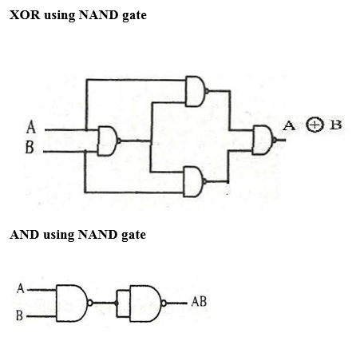
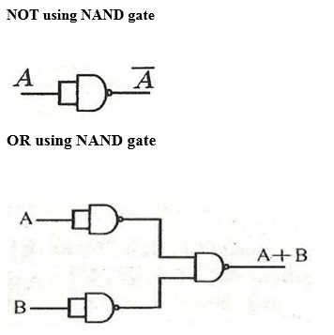

Date : / /

Experiment No: 2
EXPERIMENT No:
REALISATION OF BASIC GATES USING UNIVERSAL GATES
AIM

To realize the basic gates using universal gates.

COMPONENTS REQUIRED

IC trainer kit, IC’s 7400 (NAND), 7402 (NOR) and connecting wires.

THEORY

The NAND and NOR gates are very popular logic gates because of its covered property. It can be used to construct all the basic gates.
An inverter can be made from NAND gate by connecting all the input together and creating in effect a single common input as shown in figure. Also an OR gate and XOR gate can be generated with NAND gate as shown in figure.
In figure NAND gate is used to invert AND output from AND function as mentioned in the following equation
$$Y=\overset{̿}{AB}=AB$$
In figure G₁ and G₂ are used to invert the two input variable before they applied to NAND gate G₃. The final OR output is designed as follows by application of Demorgans theorem
$$Y=\overline{\overline{A }\overline{B}}=A+B$$
In figure, the circuit work as EX-OR gate by expression.
$$Y=\overline{A \overline{AB}+B\overline{AB}}-A\overline{B}+\overline{A}B=A⊕B$$
Figure gives AND output from NOR gates G₁ and G₂ are used to invert the two input variable before they are applied to NOR are G₃. Find AND output is designed as follows,
$$Y=\overline{\overline{A}+\overline{B}}=AB$$
In figure NOR gates are connected to form a OR gate as indicated in the following equation
$$Y=\overline{\overline{A+B}}=A+B$$
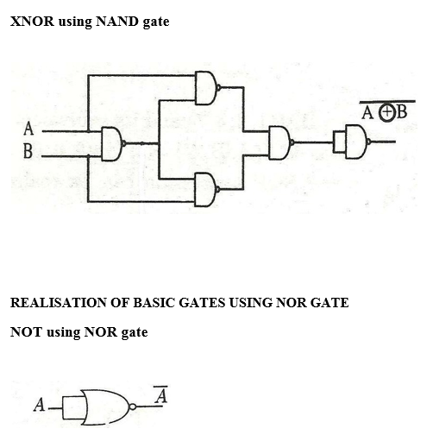

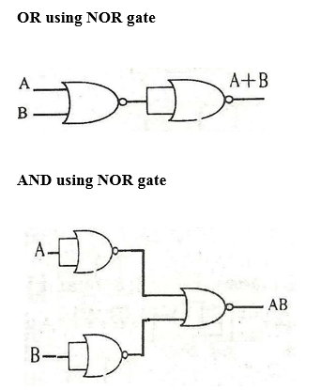

In figure NOR gate C₄ is used as an inverter to produce NAND gate from AND circuit
$$Y=\overline{\overline{\overline{A}+\overline{B}}}=\overline{AB}$$
In figure EX-OR gate is constructed from NOR gate as in the following equation,
$$Y=\overline{\left[A+\left(A+B\right)\right]+\left[\left(A+B\right)+B\right]}$$
$$=\overline{A}B+A\overline{B}=A⊕B$$

PROCEDURE

1. Tested all IC packaged using a digital IC tester also assure all connecting wires are in good condition by testing for continuously using a multimeter or trainer kit.
2. Assembled NOT, AND, OR, EX-OR, NAND, NOR gates circuit as in figures using NAND and NOR gate only.
3. Apply different input as in the truth table. Corresponding output are observed and verified.

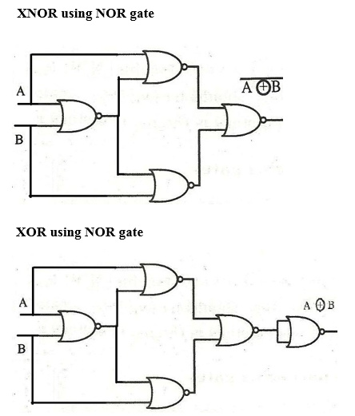
OBSERVATIONS
XOR using NAND gate AND using NAND gate OR using NAND gate
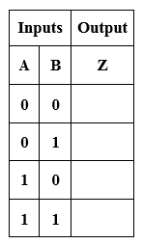

NOT using NAND gate XNOR using NAND gate NOT using NOR gate
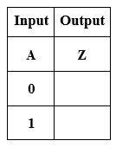

OR gate using NOR gate AND using NOR gate XNOR using NOR gate

XOR using NOR gate

RESULT

HALF ADDER

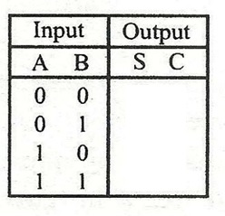
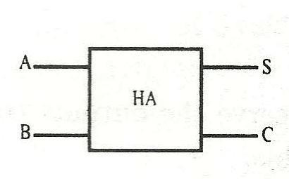
LOGIC SYMBOL TRUTH TABLE

K-MAP SIMPLIFICATION

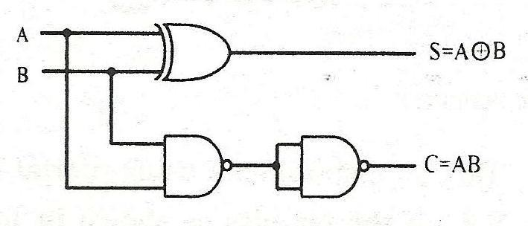
CIRCUIT DIAGRAM

FULL ADDER
LOGIC SYMBOL TRUTH TABLE
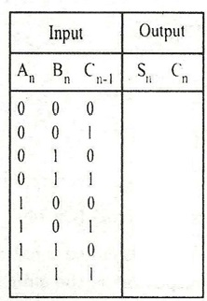
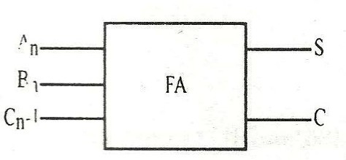

Date : / /

Experiment No: 3
EXPERIMENT No:
HALF ADDER AND FULL ADDER

AIM

To design and set up a half adder and full adder using basic gates and universal
gates.

COMPONENTS AND EQUIPMENTS REQUIRED

IC’s 7400, 7486 and IC trainer kit

THEORY

The simplest binary adder is called a half adder. Half adder has two input bits and two output bits. One output bit is the sum and the other bit is carry. They are represented by S and C respectively in the logic symbol.
A half adder has no provision to add a carry from the lower order bits when binary numbers are added. When two input bits and a carry are to be added, the number of input bits become three and the input combinations increases to eight. For this, a full adder is used. Like half adder, it also has a sum bit and a carry bit. The new carry generated is represented by Cn and carry generated from the previous addition is represented by Cn-1.
PROCEDURE
1. Verify whether all the components and wires are in good condition.
2. Set up the half adder and feed the input bit combinations
3. Observe the output corresponding to input combinations and enter it in the truth table
4. Repeat the above steps for a full adder circuit
5. Set up the circuit as shown in figures one by one. Observe the outputs corresponding to input combinations and enter it in truth table.

K-MAP SIMPLIFICATION

CIRCUIT DIAGRAM

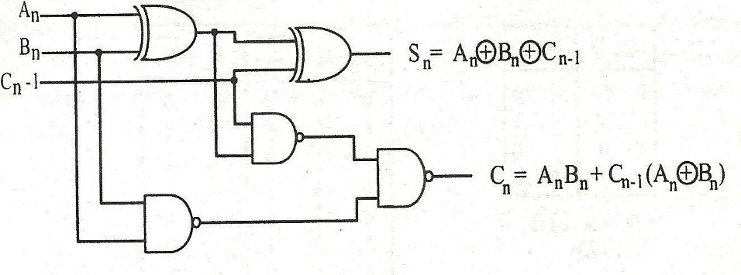

RESULT

TRUTH TABLE
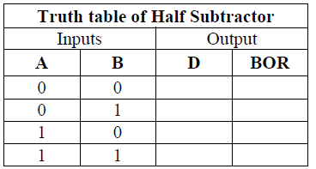

K-MAP SIMPLIFICATION

CIRCUIT DIAGRAM

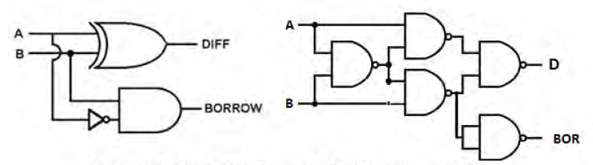
Experiment No: 4
EXPERIMENT No:
Date : / /

HALF SUBTRACTOR AND FULL SUBTRACTOR
AIM
To design and implement half subtractor and full subtractor using logic gates and verify the truth table

COMPONENTS AND EQUIPMENTS REQUIRED
IC’s 7400, 7486, 7408, 7410 and IC trainer kit

THEORY

Half Subtractor
The half subtractor is a combinational circuit which performs the subtraction of two bits. It has two – input bits and two - output bits. Refer to the truth table in which bit A is the minuend and bit B is the subtrahend. The lower significant bit of the output is called difference and the other borrow. The difference D is at logic 1 when any of the inputs A or B is exclusively at logic 1 and borrow C is at logic 1 only when subtrahend is greater than minuend. The half subtractor circuit using XOR and NAND gates is as shown in figure.
Full Subtractor
A half subtractor has no provision to process a borrow from the lower order bits, when binary numbers are subtracted. When two – input bits and a borrow are to be subtracted, the number of input bits become three and the input combinations increase to eight. For this, a full subtractor is used. Like half subtractor, it also has a difference bit and a borrow bit as outputs.

PROCEDURE
1. Verify whether all the components and wires are in good condition.
2. Set up the half adder and feed the input bit combinations
3. Observe the output corresponding to input combinations and enter it in the truth table
4. Repeat the above steps for a full adder circuit
5. Set up the circuit as shown in figures one by one. Observe the outputs corresponding to input combinations and enter it in truth table.
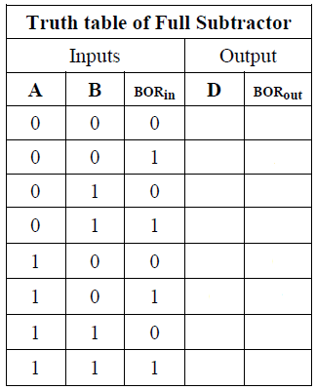
TRUTH TABLE

K-MAP SIMPLIFICATION

CIRCUIT DIAGRAM
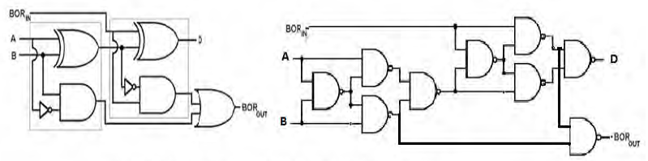

RESULT

4 BIT BINARY ADDER/SUBTRACTOR
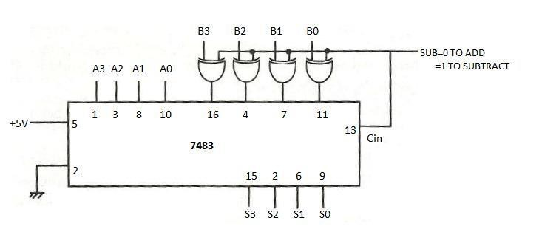

TRUTH TABLE

Date : / /

Experiment No: 5
EXPERIMENT No:

4 BIT ADDER-SUBTRACTOR AND BCD ADDER CIRCUIT
AIM
To design and set up the following arithmetic circuits using 4 bit binary adder IC 7483.
A.4 bit adder/ subtract circuit.
B. BCD adder

COMPONENTS REQUIRED
IC 7400, 7483, 7486 and IC trainer kit.

THEORY
The 7483 is a TTL IC with 4 full adders in it. This means it can add nibbles. To add bytes, we need to use two 7483 ICs. To add the nibbles, logic 0 is applied at SUB input. To subtract B₃B₂B₁B₀ from A₃A₂A₁A₀, logic 1 is applied at SUB input. The XOR gates function as controlled inverters. When SUB = 1,B₃B₂B₁B₀ is complemented. Now A₃A₂A₁A₀, complemented version of B₃B₂B₁B₀, and 1 at C_{in} pin are added together. C_{out} is ignored. Thus the 2’s complement of subtrahend is added with minuend. If minuend is less than subtrahend, the obtained output is 2’s complement of difference and there is no carry generated.Smaller no. can be subtracted from the larger number using the circuit, but it should be modified to subtract a larger number from a smaller.
PROCEDURE (4- bit binary add/subtract circuit)
Test the ICs using a digital IC tester. In order to add two number, apply 0 at mode pin SUB and 1001 at A₃ A₂ A₁ A₀ inputs and 1100 at B₃ B₂ B₁ B₀ inputs verify that the result at S₃ S₂ S₁ S₀ is 0101 and at count is 1.

DIP PINOUT OF 1C 7483

TRUTH TABLE AND KMAP SIMPLIFICATION OF BCD ADDER

In order to subtract a small number from a large number, apply 1 at mode pin SUB and 1010 at A₃ A₂ A₁ A₀ inputs and 1001 at B₃ B₂ B₁ B₀ inputs verify that the result at S₃ S₂ S₁ S₀ is 0001 and 1 at C_{out}. Carry is omitted.
In order to subtract a large number from a small number, apply 1 at mode pin SUB and 1001 at A₃ A₂ A₁ A₀ inputs and 1010 at B₃ B₂ B₁ B₀ inputs verify that the result at S₃ S₂ S₁ S₀ is 111 which is the 2’s complement of 1.
Single digit BCD adder
A single digit BCD adder performs the arithmetic addition of two decimal digits in BCD, and an input carry from a previous stage. Since each input digit does not exceed 9, the output sum cannot be greater than 9+9+1=19, where the 1 is input carry.
In BCD addition, if the sum exceeds 9 (i.e., 1001), 6 (i.e., 0110) should be added to the result to convert it into the correct BCD representation. For this purpose two 7483 ICs are required one for binary addition and the other for the addition of 6. A combinational circuit is set up to add 6 to the intermediate result up to add 6 to the intermediate result S’₃ S’₂ S’₁ S’₀ is greater than 9 or a carry is generated at C_{out} of upper 7483 IC. A 1 at the output C of the combinational circuit makes A₃ A₂ A₁ A₀ of the lower 7483 IC equal to 0110.
Since the maximum BCD sum is 18, most significant BCD digit of the final output can be represented by only one bit and it is taken from C.
C must be 1 when S’₃ S’₂ S’₁ S’₀ ≥ 1001 or C_{out} = 1. From the truth table, we get C= S’₃ S’₂+ S’₃ S’₁. Also C should be 1, when C_{out} = 1. Combining these 2 conditional the expression for C is required as C = C_{out} + S’₃ S’₂+ S’₃ S’₁.
PROCEDURE (Single digit BCD adder)
- Test the ICs using digital IC tester
- Apply 1001 at A₃ A₂ A₁ A₀ inputs and 0010n at B₃ B₂ B₁ B₀ inputs
- Verify that the least significant digit at at S₃ S₂ S₁ S₀ is 0001 and the most significant digit at C is 1.
- Verify the working of the circuit by applying other number.
SINGLE DIGIT BCD ADDER

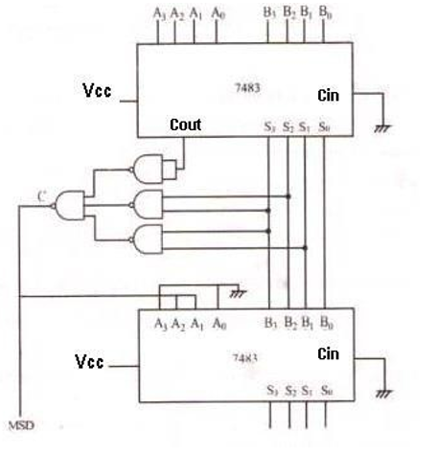

RESULT

BINARY TO GRAY CODE CONVERTER
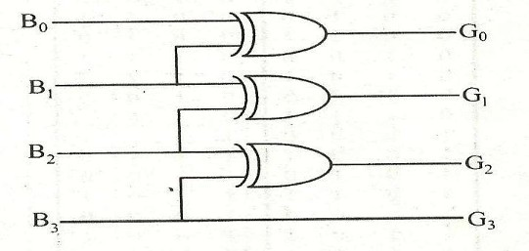

TRUTH TABLE AND K-MAP SIMPLIFICATION

Experiment No: 6
EXPERIMENT No:
Date : / /

CODE CONVERTERS USING BASIC GATES

AIM

To design and set up the following circuits
1. A 4-bit binary to gray code converters
2. A 4-bit gray to binary code converters

COMPONENTS AND EQUIPMENTS REQUIRED

IC’s 7486, 7408 and IC trainer kit

THEORY

To convert a binary number to corresponding gray code, the following rules are applied.
1. The MSB in the gray code is the same as the corresponding bit in a binary number.
2. Going from left to right, add each adjacent pair of binary digits to get the next gray code digit. Disregard carries.

As the first step to design a binary to gray code converter, set up a truth table with binary numbers B3 B2 B1 B0 and corresponding gray code numbers G3 G2 G1 G0. Set up a circuit realizing the simplified logic expression obtained using K maps for G’s as the functions of B’s.

To convert from gray to binary, the following rules are applied
1. The MSB in the binary number is the same as the corresponding digit in the gray code.
2. Add each binary digit generated to the gray code digit in the next adjacent position. Disregard carries.

GRAY TO BINARY CODE CONVERTER
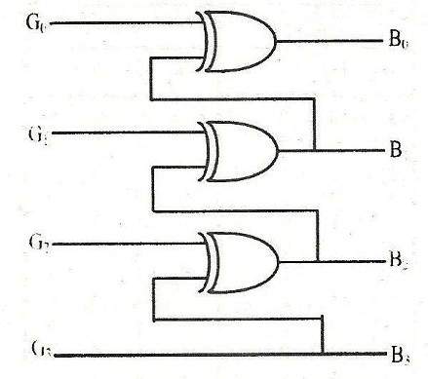

TRUTH TABLE AND K-MAP SIMPLIFICATION

PROCEDURE
1. Test all the components and IC packages using multimeter and digital IC tester.
2. Verify the truth tables of the circuit by feeding the input bit
combinations.

RESULT

VERIFICATION OF DE MORGAN’S LAW

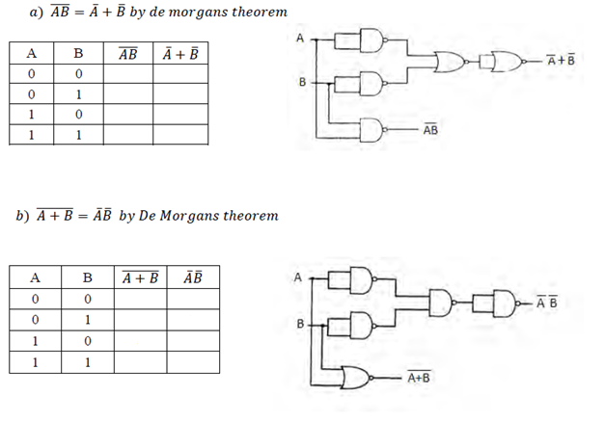
TRUTH TABLE

Experiment No: 7
EXPERIMENT No:
Date : / /

VERIFICATION OF DE-MORGAN’S THEOREMS
AIM
To verify De Morgan’s theorem for two variables

COMPONETS AND EQUIPMENTS REQUIREED
ICs 7400, 7402,7408,7432,7404 and digital IC trainer kit

THEORY
De Morgan’s two theorems are given below,
$$\overline{A+B+C+….}= \overline{A}\overline{B}\overline{C}$$
$$\overline{A*B*C*….}= \overline{A}+\overline{B}+\overline{C}$$
First theorem means that the complement of sum of variable is equal to the product of the complements. The meaning of the second theorem is that complement of a product of Boolean variables is equal to the sum of complements of the variable.
In general, De Morgan’s theorems imply that the complement of a function is derived by taking the dual of the function and then complement each literal.
De Morgan’s theorems are very useful to simplify the Boolean expressions so that the number of logic gates required to solve a Boolean expression can be reduced. In other words De Morgan’s theorems help to save the hardware cost and reduce the circuit complexity.
First theorem is verified using two variables as shown in figure and second theorem is verified as shown in figure.
PROCEDURE
1. Test all components using digital IC tester
2. Setup the circuits as shown in figure one by one.

3. Observe the output corresponding to input combinations and enter it in truth table.
4. Verify that the both the outputs in each figure are the same.

RESULT

2 BIT COMPARATOR
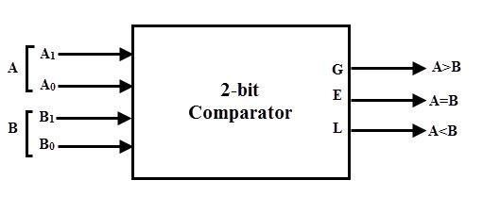

TRUTH TABLE AND K-MAP SIMPLIFICATION

DIGITAL COMPARATOR
Date : / /

Experiment No: 8 5EXPERIMENT No:

AIM
To design and setup single bit comparator using logic gates and verify the truth table.

PRINCIPLE
Digital or Binary Comparators compares the digital signals present at their input terminals and produce an output depending upon the condition of those inputs.
The digital comparator accomplishes this using several logic gates that operate on the principles of Boolean algebra. The purpose of a Digital Comparator is to compare a set of variables or unknown numbers, for example A (A1, A2, A3,An, etc) against that of aconstant or unknown value such as B (B1, B2, B3,Bn, etc) and produce an outputcondition or flag depending upon the result of the comparison. There are two main types of Digital Comparator available and these are.
Identity Comparator - an Identity Comparator is a digital comparator that has only one output terminal for when the inputs A = B.
Magnitude Comparator - a Magnitude Comparator is a type of digital comparator that has three output terminals, one each for equality (A = B), greater than (A > B) and less than (A < B).
This is useful if we want to compare two variables and want to produce an output when any of the above three conditions are achieved. For example, produce an output from a counter when a certain count number is reached. Consider the truth table of simple 1-bit comparator.

Digital comparators actually use Exclusive-NOR gates within their design for comparing their respective pairs of bits. When we are comparing two binary or BCD values or variables against each other, we are comparing the "magnitude" of these values, logic "0" against a logic "1" which is where the term Magnitude Comparator comes from. A 2-bit comparator compares two binary numbers, each of two bits and produces their relation such as one number is equal or greater than or less than the other.

CIRCUIT DIAGRAM

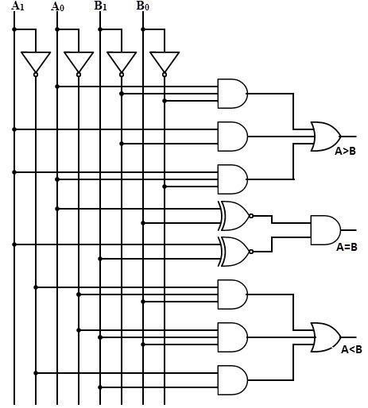

PROCEDURE

- Test all components and connecting wires.
- Set up the comparator circuit using logic gates. Feed two 2-bit inputs at A₁A₀ and B₁B₀. Observe the outputs.

RESULT

LOGIC SYMBOL AND TRUTH TABLE OF MULTIPLEXER

CIRCUIT DIAGRAM

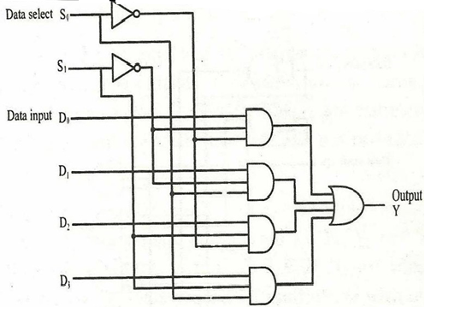

MULTIPLEXERS AND DEMULTIPLEXERS
Date : / /

Experiment No: 9
EXPERIMENT No:
AIM
To study 4:1 multiplexer and 1:4 demultiplexer using logic gates.
COMPONENTS AND EQUIPMENTS REQUIRED
ICs 74150, 74138, 7404, 7432, 741, bread board and IC trainer kit
THEORY
Multiplexer
Multiplexer (MUX) is a combinational circuit which selects one of the inputs and route it to the output. A multiplexer has data input lines, data select lines and output.
The logic symbol of a 4 lines to 1 line multiplexer is shown in figure. According to the two bit binary code on the data select inputs, corresponding data input line will be selected and routed to the output. For example, if S1 S0 is 00, D0 will be selected, if S1 S0 is 01, D1 will be selected and so on.
From the truth table it can be seen that output is given by the equation shown below. This Boolean expression can be realized using logic gates.
Demultiplexer
Demultiplexer (DEMUX) does the reverse operation of multiplexer. The data on a line is directed to any one of the output line according to the binary code on data select lines. The logic symbol of a1:4 demultiplexer is shown in figure. When the input on data select inputs S1 S0 is 00, logic state on the data line will be available on D0 output, if S1 S0 is 01, logic state on the data line will be available on D1 output and so on.

LOGIC SYMBOL AND TRUTH TABLE OF DEMULTIPLEXER

CIRCUIT DIAGRAM

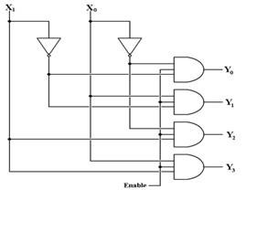

PROCEDURE
Multiplexer
1. Test all IC’s and wires. Set up the circuit and give a 4-bit binary
combination at D0 through D3
2. Feed all the four combinations at S1 S0 one by one, observe
corresponding output and verify it functions as multiplexer.
Demultiplexer
1. Test all IC‟s and wires. Set up the circuit and apply a logic 1 state at the Enable input.
2. Feed all the four combinations at X1 X0 one by one, observe the logic state at corresponding output and verify it functions as demultiplexer.

16:1 MUX USING IC 74150

CONNECTION DIAGRAM AND TRUTH TABLE

1: 8 DEMUX USING IC 74138

CONNECTION DIAGRAM AND TRUTH TABLE

RESULT

CLOCKED SR FF
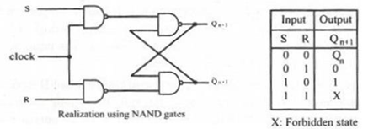
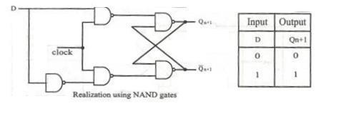
D FF

JK FF
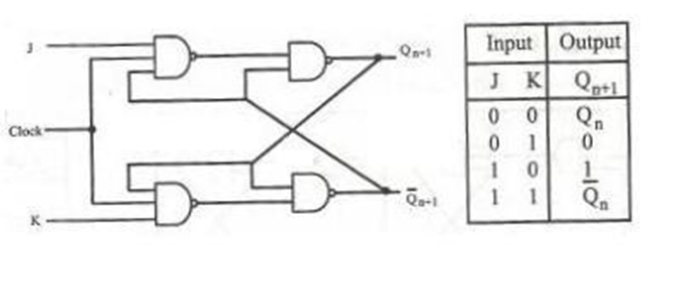

JK FF WITH PRESET AND CLEAR
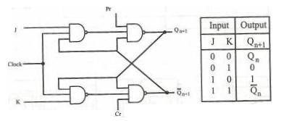

Date : / /

Experiment No: 10
EXPERIMENT No:
FLIP-FLOP CIRCUIT USING LOGIC GATES AND ICs

AIM
To setup and test the following flip flops.
1. Clocked SR Flip Flop
2. JK Flip Flop
3. D Flip Flop
4. T Flip Flop
5. Master slave Flip Flop

COMPONENTS AND EQUIPMENTS REQUIRED
IC 7400, 7410, 7474, 7474, 7476 and IC Trainer kit
THEORY
Flip Flop is the basic building block in any memory system since its output will remain in its state until it is forced to change it by some means.
SR Flip Flop
Clocked SR Flip Flop: “S” and “R” stands for set and reset respectively. There are four input combinations possible at the inputs. When S=R=0 the output will remains in its last state. When S=1, R=0, the flip flop will set its output and when S=0, R= 1, then the flip flop will reset. But S=R=1 is forbidden since the output will be intermediate. When the flip flop switched ON, its output state will be uncertain. When initial state is to be assigned, two separate inputs called preset and clear are used.
JK FlipFlop
The intermediate output state of SRFF when S=R=1 is avoided by converting it into JK flip flop. In this stage the JK flip flop will toggle its output complement of the last output). In all other input combinations the functions will be same as in SR flip flop.
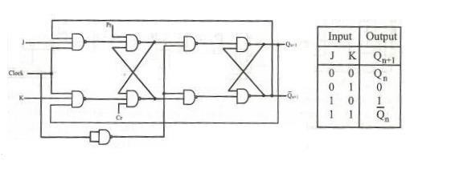
MASTER SLAVE JK FF

D FF USING MASTER SLAVE JK FF
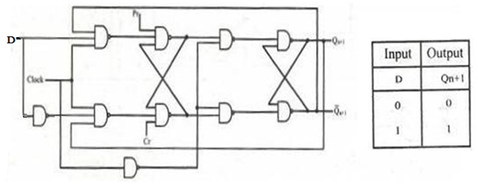

T FF USING MASTER SLAVE JK FF
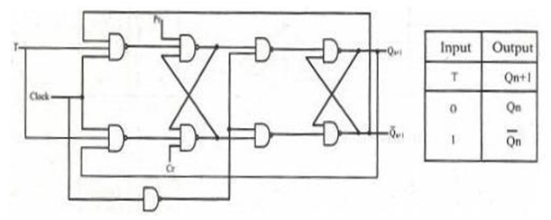
Flipflop ICs
The most common fipflop ICs are 7476, 7474 and 7473. IC 7476 is a dual negative edge triggered MSJK FF with preset and clear functionality. It is a 16 pin DIP chip. IC 7473 is a dual negative edge triggered MSJK FF with clear in 14 pin DIP. It does not have preset input. The IC 7474 is positive edge triggered dual DFF with preset and clear 14 pin DIP.

PROCEDURE
1. Test all components and IC packages using multimeter and digital IC tester.
2. Set up the flip flops using gates and verify their truth tables.

FLIPFLOP ICs

RESULT

RING COUNTER USING JK FF
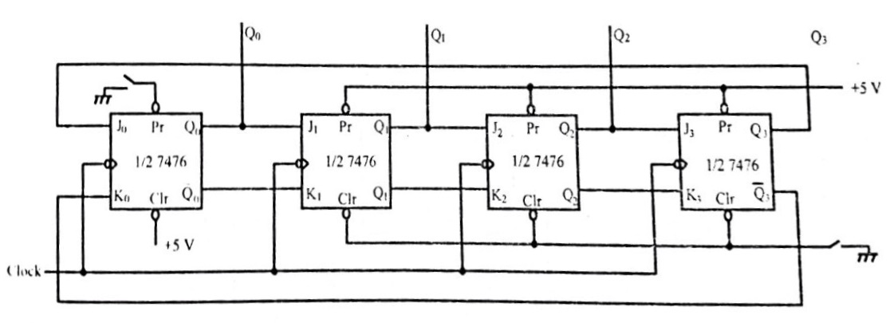
WAVEFORMS AND TRUTHTABLE FOR RING COUNTER

Date : / /

Experiment No: 11
EXPERIMENT No:

RING COUNTER AND JOHNSONCOUNTER

AIM
To design and set up four bit Johnson and ring counter using flipflops.
COMPONENTS AND EQUIPMENTS REQUIRED
ICs 7476, 7486 and digital IC trainer kit.
THEORY
Ring counter and Johnson counter are basically shift registers.
Ring counter
The ring counter utilizes one flip-flop for each state in its sequence, and it is therefore
wasteful of flip-flops. As it can be seen from the truth table, there are four unique output states for this counter, rendering a mode 4 ring counter. Ring counter is called a divide by N counter where N is the number of flip-flops.
Johnson counter
The module number of a ring counter can be doubled by making a small change in the ring counter circuit. The QI and Q outputs of the last flip-flop are connected to the J and K inputs of the first flip-flop respectively. This is the Johnson counter. Johnson counter is also called twisted ring counter or divide by 2N counter.

JOHNSON COUNTER USING JK FF
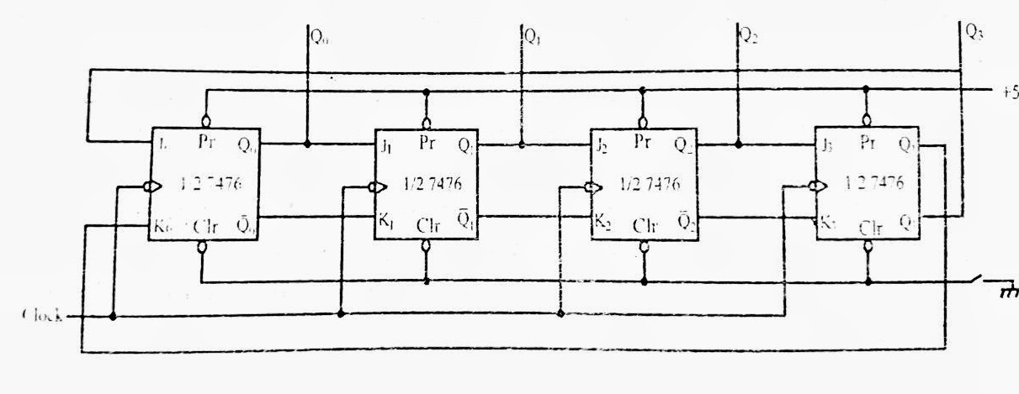
WAVEFORMS AND TRUTHTABLE FOR JOHNSONCOUNTER

PROCEDURE
1. Set up the circuit as per the circuit diagram
2. Verify the out puts as in the truth table

RING/ JOHNSON COUNTER USING MODE CONTROL

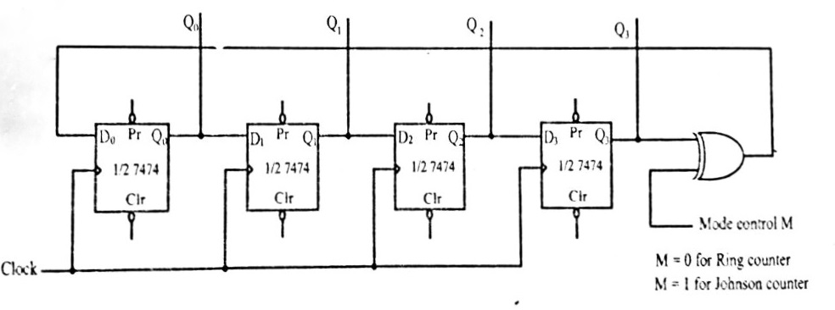

RESULT

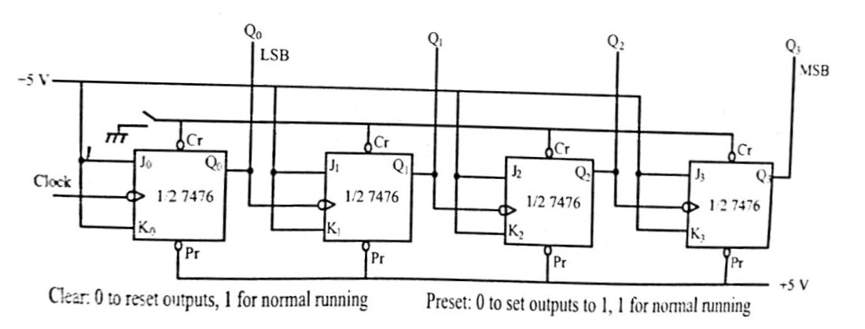
4 BIT BINARY UP COUNTER
TRUTH TABLE

ASYNCHRONOUS COUNTER
Date : / /

Experiment No: 12 9EXPERIMENT No:
AIM
To set up the following asynchronous counters and study their working
- 4 bit binary up counter
- 2. 4 bit binary down counter

COMPONENTS AND EQUIPMENTS REQUIRED
IC 7476, 7473, 7400, 7486 and IC trainer kit.

THEORY
A counter is a register capable of counting the number of clock pulses arriving at its clock inputs. In asynchronous counters the flip-flops within the counter are not made to change states at exactly the same time, here the clock pulses are not connected directly to the C input of each flip-flop in the counter.
In asynchronous counters, commonly called ripple counters, the first flip flop is clocked by the external clock pulses and each successive flip flop is clocked by the Q or Q’Output of the previous flip flop.

PROCEDURE
1. Test all ICs using digital IC tester. Test all wires for continuity using multimeter.
2. Set up the circuit for 4 bit ripple counter. Connect all PRESET pins to +5V to
disable it.
3. Tie up all CLEAR pins together.
4. Use monopulse/debouncer to feed the clock manually.
5. Clear all flip-flops initially, by connecting common CLEAR to logic low input. After the usage of CLEAR pins, keep it open.
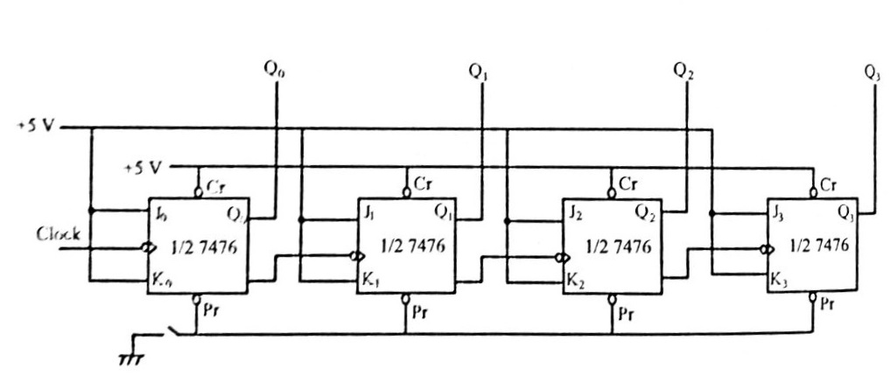
4 BIT BINARY DOWN COUNTER

6. Apply mono pulses. Counter starts counting up.
7. Move clock inputs of every flip-flop except FF0 from outputs to the Q outputs. Preset all flip-flops. Apply mono pulses. Counter will start counting down.
8. Observe the up counting and down counting

RESULT

BINARY UP COUNTER
TRUTH TABLE, EXCITATION TABLE AND KMAP SIMPLIFICATION

SYNCHRONOUS 4 BIT UP/DOWN COUNTER
Date : / /

Experiment No: 13
EXPERIMENT No:
AIM
To design and implement
1. 4 bit synchronous up counter.
2. 4 bit synchronous down counter.

COMPONENTS REQUIRED

IC 7476, 7473, 7400, 7408, 7432 and digital IC trainer kit.

THEORY
A counter is a register capable of counting number of clock pulse arriving at its
clock input. Counter represents the number of clock pulses arrived. An up/down counter is one that is capable of progressing in increasing order or decreasing order through a certain sequence. An up/down counter is also called bidirectional counter. Usually up/down operation of the counter is controlled by up/down signal. When this signal is high counter goes through up sequence and when up/down signal is low counter follows reverse sequence.

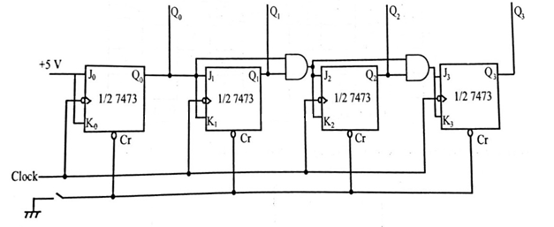
4-BIT UP COUNTER
PROCEDURE
1. Test all ICs using digital IC tester. Test all wires for continuity using multimeter.
2. Set up the circuit for 4 bit ripple counter. Connect all PRESET pins to +5V to disable it.
3. Tie up all CLEAR pins together.
4. Use monopulse/debouncer to feed the clock manually.
5. Clear all flip-flops initially, by connecting common CLEAR to logic low input. After the usage of CLEAR pins, keep it open.
6. Apply monopulses. Counter starts counting up.
7. Move clock inputs of every flip-flop except FF0 from outputs to the Q outputs. Preset all flip-flops. Apply monopulses. Counter will start counting down.
8. Observe the output

BINARY DOWN COUNTER
TRUTH TABLE, EXCITATION TABLE AND KMAP SIMPLIFICATION

4-BIT DOWN COUNTER
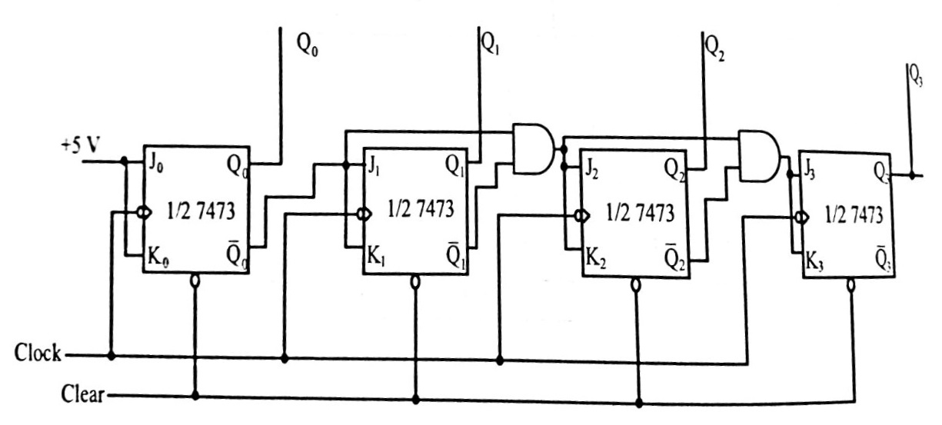

RESULT

