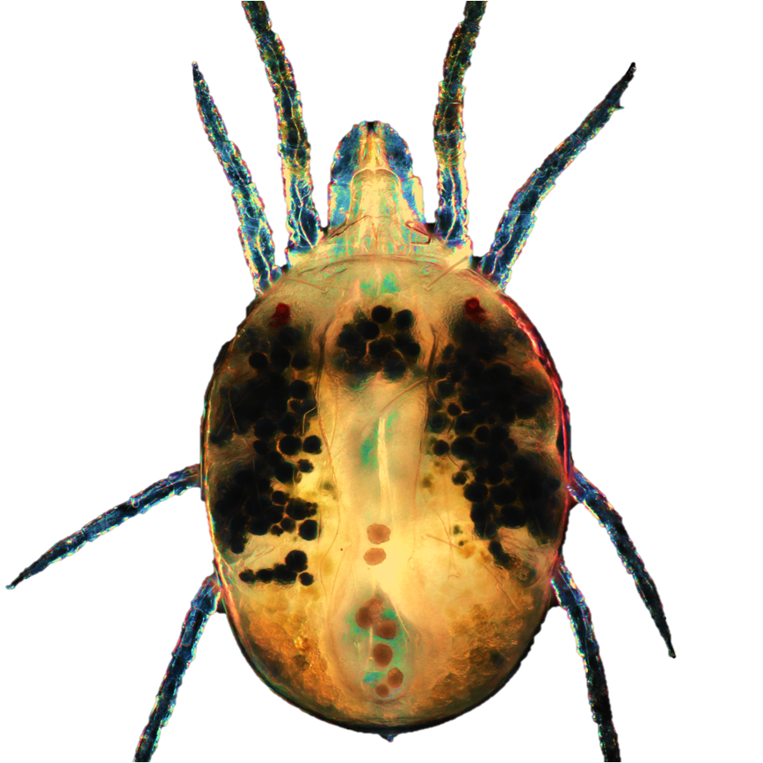
PhD Position – Molecular Mechanisms of Plant–Herbivore Interactions
Grbić Lab, University of Western Ontario

The Grbić Lab is seeking a highly motivated PhD student to explore the molecular and genetic mechanisms that allow herbivorous mites to adapt to their host plants. Using the two-spotted spider mite (Tetranychus urticae) as a model, our research integrates molecular genetics, functional genomics, enzymology, and RNAi-based approaches to uncover how these pests evade plant defenses and chemical control strategies.
The successful candidate will have the opportunity to:
- Characterize detoxification enzymes and host-adaptation pathways
- Explore plant defense responses and mite counter-defense mechanisms
- Develop and assess RNAi-based gene silencing tools
- Gain expertise in molecular biology, protein expression, transcriptomics, and plant bioassays within a collaborative, interdisciplinary environment
Qualifications:
- MSc or strong BSc (Hons) in molecular biology, entomology, biochemistry, plant science, or a related field
- Hands-on experience with RNA, protein, genomic, or molecular cloning techniques
- Interest in interdisciplinary research on plant–arthropod interactions
- Experience with bioinformatics is an asset

Application Instructions:
Please submit a CV, transcripts, and a brief statement of research interests (or cover letter). Applicants with relevant experience should also provide contact information for two referees.
Send all materials to Dr. Vojislava Grbić (vgrbic@uwo.ca).

