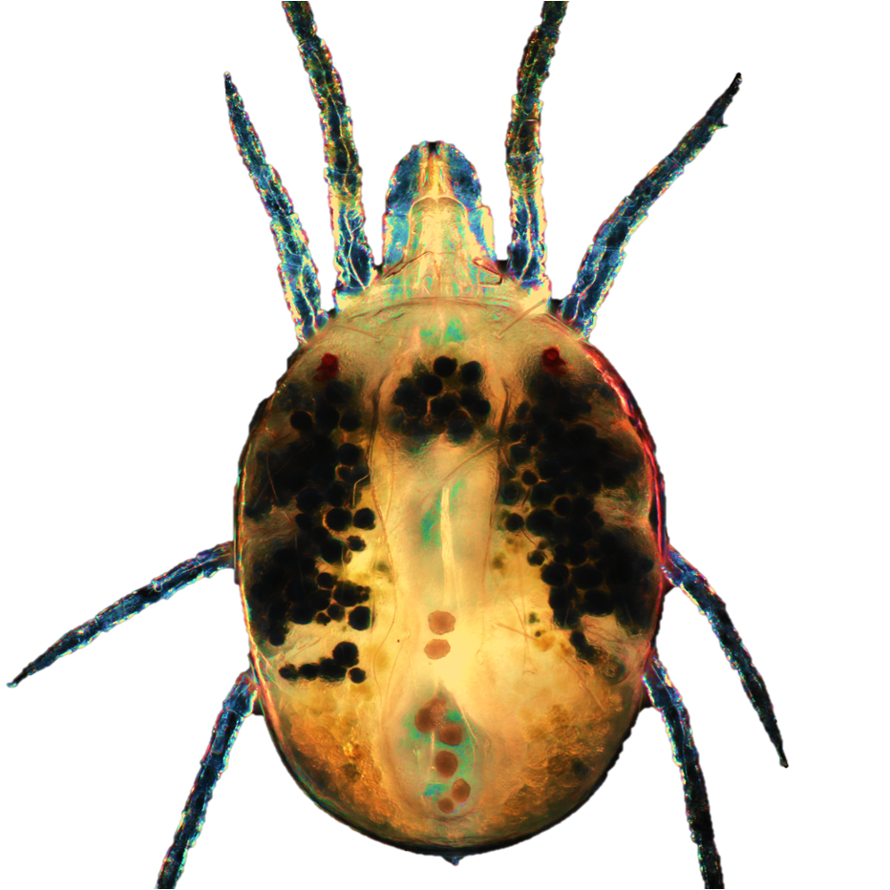
Postdoctoral Position – RNAi and Adaptive Mechanisms in Herbivorous Mites
Grbić Lab, University of Western Ontario

The Grbić Lab is seeking a motivated and innovative postdoctoral fellow to lead cutting-edge research on RNA interference, detoxification pathways, and adaptive mechanisms in the two-spotted spider mite (Tetranychus urticae). Our group investigates how herbivorous mites overcome plant defenses and chemical stressors by integrating RNAi technologies, functional genomics, and molecular biochemistry.
This position offers the opportunity to drive impactful research at the interface of molecular biology, plant–arthropod interactions, and pest management innovation. The successful candidate will:
- Develop and optimize dsRNA delivery systems for mites
- Dissect RNAi pathways and gene-regulatory mechanisms
- Functionally characterize detoxification enzymes linked to host adaptation and pesticide resistance
- Collaborate with plant scientists, structural biologists, and genomics specialists in a dynamic, multidisciplinary environment
Qualifications:
- PhD in molecular biology, biochemistry, entomology, or a related field
- Demonstrated expertise in RNAi, transcriptomics, protein biochemistry, or functional genomics
- Strong publication record with first-author papers
- Excellent communication skills and prior mentorship or leadership experience

Application Instructions:
Please submit a cover letter, CV, and contact information for three referees. Send all materials to Dr. Vojislava Grbić (vgrbic@uwo.ca).
We encourage applications from candidates eager to push the boundaries of RNAi and molecular adaptation research in a collaborative and high-impact setting.

