**Monitoring Air Miles at the Faculty of science (MNF) to reduce CO2according to UZH climate goal emissions**

GEO 885, Group 1

G. Biland, S. di Vincenzo1

1Department of Geography, University of Zurich

Date: 23.05.2022

Word count: 2178 words

## To do:

* **Einheitlich predicted oder modelled benennen.**

## Abstract

critic: more focus on research

To counteract the effects of climate change, a radical reduction of greenhouse gas emissions is essential. Reducing emissions is necessary for all areas of society, which includes the scientific community. Sustainable policies are being introduced progressively at universities, and for this paper relevant, the University of Zurich. The University of Zurich has actively chosen a more sustainable path and implemented “Strategy 2030” in 2022, which calls for climate neutrality until 2030. A flight emission reduction of 53% by 2030 is indispensable to achieving this goal. The first steps in the right direction have already been taken by the Faculty of Science (MNF). The MNF collected relevant information about all their paid flights from 2018 to 2020, including flight numbers, IATA codes of the origin and destination airports, booked service class (economy, premium economy, business, and first-class), and emission of greenhouse gas per flight. Analyzing the provided dataset, we were interested in how a chosen service class impacts flight emission. As a result, we conducted an R analysis to quantify the impact of selecting a lower service class on future flight emissions. The goal is to provide the MNF with concrete approaches, starting with choosing lower service classes and thus implementing the sustainability goals of the University of Zurich.

**Keywords**: academic flying, carbon emission, sustainability, environmental protection

## 1. Background

critic: Write abo the research gap.

According to C. Dib writing for Uniting Aviation, reducing flight emissions would be covered by the SDGs 15 and 17 (Dib, 2021).

In today’s world, the topic of emissions reduction is omnipresent and is being addressed in ever larger circles. Statistically, aviation emissions are responsible for only 2.4% to 3.8% of the total global emissions (Graver et al., 2019; Klöwer et al., 2020), yet they are straightforward to reduce at a relatively low cost. This is also what MNF in Zurich has decided and would like to change its flight behavior. An essential part of those emissions is caused by researchers who due to conferences, guest lectures, and, fieldwork fly frequently to foreign universities. In recent years, travel by airplanes done by academic staff received growing attention. Especially as Universities all over the world incorporate sustainable development strategies (Borgermann et al., 2022). Similarly, also the University of Zurich are setting an example to be carbon neutral and reducing air travelling by 53% by 2030. Although the majority in academic circles are in favour of this development, questions have arisen, in particular, as to whether this might not harm academic work as flying and face to face interactions play a vital role in an academic career (Klöwer et al., 2020; Kreil, 2021). Thus researching the relationship between academic flying and academic work and finding approaches to reducing emissions via air travel became the subject of multiple studies. The study of Kreil et al. (2021) proved for example that a reduction in air travel would not affect scientific work, but also be beneficial. Possible alternatives to long-duration flights were shown in the study by Klöwer et al. (2020) who demonstrated that virtual conferences have a higher attendance rate and how such annual global conferences could be held physically, for example, only biennially. Contrary to other papers, which thematized the problem on a more global scale, the aim of this paper is to find easy and applicable solutions to reduce air travel emissions at the university level, which are easier to implement.

## 2. Research goal

This study aims to provide the MNF with an analysis of all flight emissions by flight journeys that the MNF funds. The goal is to present concrete propositions on how the MNF can reduce its flight emissions by 53% by 2030 and the influence of flight classes on this reduction target.

Essentially, two complementary strategies will be investigated. How strong is the impact of the various flight classes and how impactful is the shift to solely economy flights? Further, the effect and gravity of short-haul flights in Europe will be assessed to make a clear recommendation on the number of flights to be reduced to achieve the climate targets.

## 3. Methods and data

### 3.1 Data

The data set containing all flights at MNF consists of 7018 individual flight segments, where connecting flights as well as outbound and return flights are listed separately. Either the flight number or the IATA codes of the departure and arrival airports were recorded for each flight segment. Likewise, for an individual element, the cabin class, and the year in which the flight was boarded were noted.

Table : Summary of all flights between 2018 and 2020 divided by cabin class and total flights per year

|  |  |  |  |  |  |
| --- | --- | --- | --- | --- | --- |
| Year | Economy | Premium | Business | First | Flights |
| 2018 | 2892 | 21 | 120 |  | 3033 |
| 2019 | 3083 | 23 | 141 |  | 3247 |
| 2020 | 703 | 6 | 28 | 1 | 738 |

### 3.2 Pre- processing

The data pre- processing was done using Python. As most of the data set contained missing values, the first step was to complete these NA values both for the flight numbers and the IATA-codes for the arrival and departure airport. For this, one parameter was essential: the IATA flight destination for each flight, on the basis of which the flight emissions could be calculated in the second step. To link these IATA codes to each flight number, a Python script was written, using an API developed by Aviation Edge (AviationEdge, 2022). The API was used to retrieve the corresponding IATA departure and arrival codes for each combination of IATA flight codes and IATA flight numbers and to read them into the record set. For the request function, the airline-IATA codes and flight numbers were used. The former parameter refers to the identification of the airline and the latter to the number of the specific flight. Further, these new values were compared with the existing IATA destination codes and in case of a missing value, it was replaced by the query from the API. In the second step, the same procedure was carried out with the emission calculations, using an API from GoClimate (GoClimate, 2020). The request for this API server used the parameters “Segments” consisting of departure and destination, as well as the flown cabin class and returned the emissions for each flight segment in kg of CO2 as well as the estimated price. The previously mentioned steps were repeated for the identical data set, but all cabin classes were changed to economy and the emissions were calculated again. From the 7018 original flights, 5239 could be matched, resulting in a 75% completeness.

### 3.3 Analysis

For the analysis, the data were first aggregated and supplemented with additional variables that were necessary for the statistical analysis. This included the flight distance for each flight, as well as the kgCO2 consumption per flight kilometer for each respective flight segment. For easy identification of the two data sets, the term "Observed" was used for the original data set and the term "Economy Modeled" was used for the newly calculated data set with only economy class flights. The analysis was then divided thematically according to spatial and statistical analysis. For the first part, all flight segments were mapped spherically, and the number of arrivals was calculated for each country. In the statistical part, the density of isolines was interpolated for all flights that landed in Europe and originated in Switzerland. For the short-haul analysis, the previously calculated values for the number of landings per country were used and calculated with a flight radius of 1000km from Switzerland. The radius of 1000km was obtained from the values of kgCO2 emissions per flight kilometer, which were plotted against the total flight distance of the flight, from which a threshold was selected. In a further step, the 3-year average of the emissions of all flights was calculated, as well as the emission reduction target of MNF with a minus of 53% compared to the 3-year average. This difference in emissions was then calculated per capita, so that the emissions over the next 8 years for each employee at MNF could be determined. Finally, the annual reduction rate was calculated in percent, once for the current state and once for the modeled economy flights. The annual reduction in the number of short-haul flights was also calculated using the average emissions per flight with a distance of less than 1000km.

A certainly not negligible problem of our approach is the difficult replication of the methods, as our script was specifically designed for our question and could not be easily adapted for new data. Alternative ways of answering the research questions are sparse since it is a purely statistical research picture.

## 4. Results

**This section illustrates your analytical results. The results include values of measurements, predictions, statistical test outputs, etc, and should follow a logical flow corresponding to research objectives and research questions. How did you answer your research questions? Did you accept or reject your hypothesis?**

As can be seen in Figure.1, flights of less than 1000km are responsible for the highest emissions per kilometer flown. The same applies to the substantial differences between business (red) and economy (green) and the fact that the emissions remain constant for the same flight class from a flight distance of 5000km. Thus, the emissions for a flight of 5000km are not higher per kilometer compared to a flight of 15’000 km.

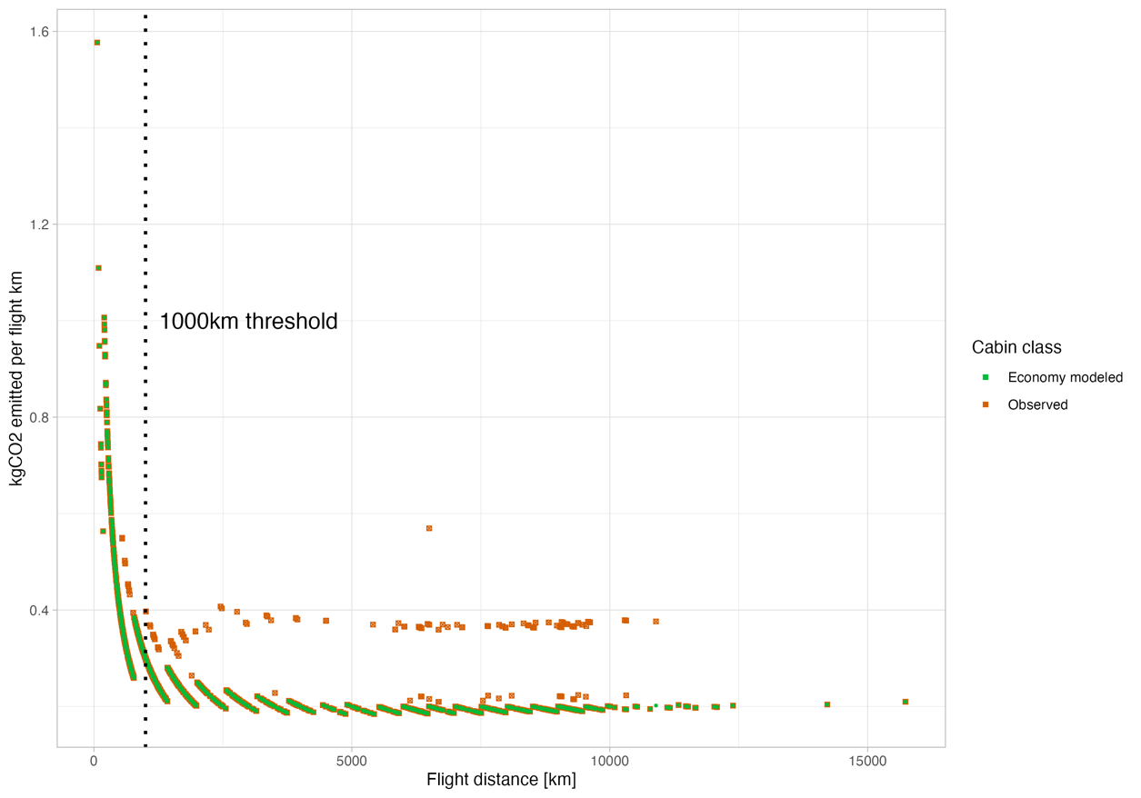

Figure . Emissions per flight km in kg CO2, plotted against the flight distance for each respective flight. Divided by cabin class, economy (green) and the observed flights (red).

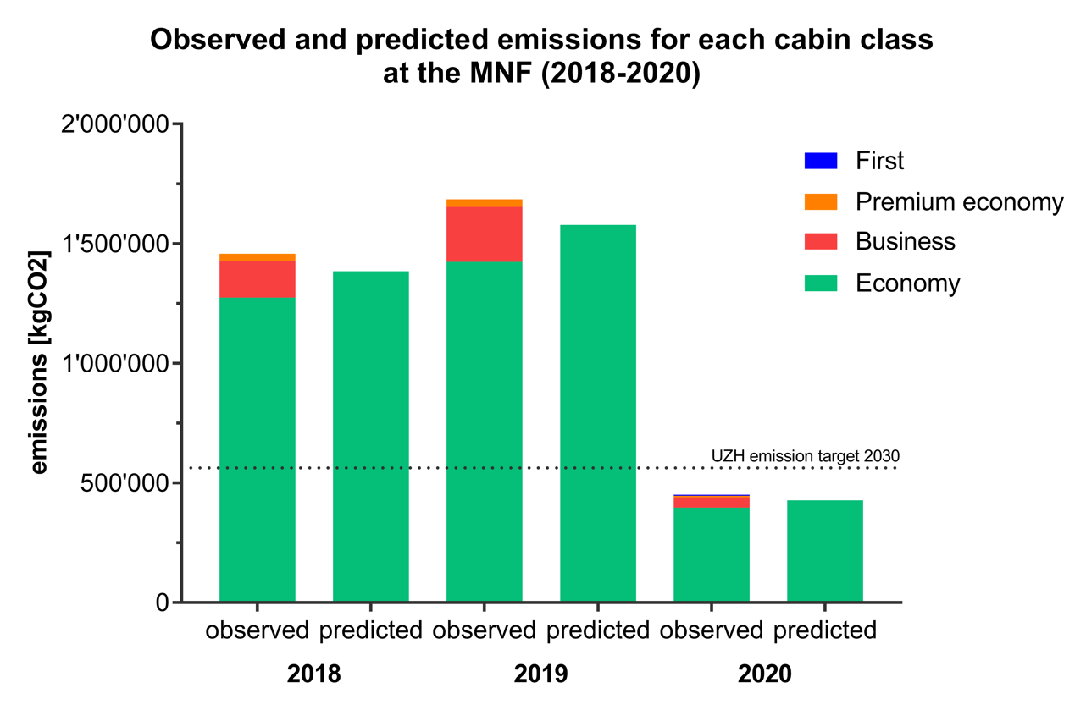

Figure . Emissions per cabin class (kgCO2) for the class "predicted" and "observed" with the cabin class First (blue), premium economy (orange), business (red) and economy (green)

### 4.1 Model 1: Emissions

### 

Figure : Emission isolines for European flights departing Switzerland

### 4.2 Model 2: Short-distance flights

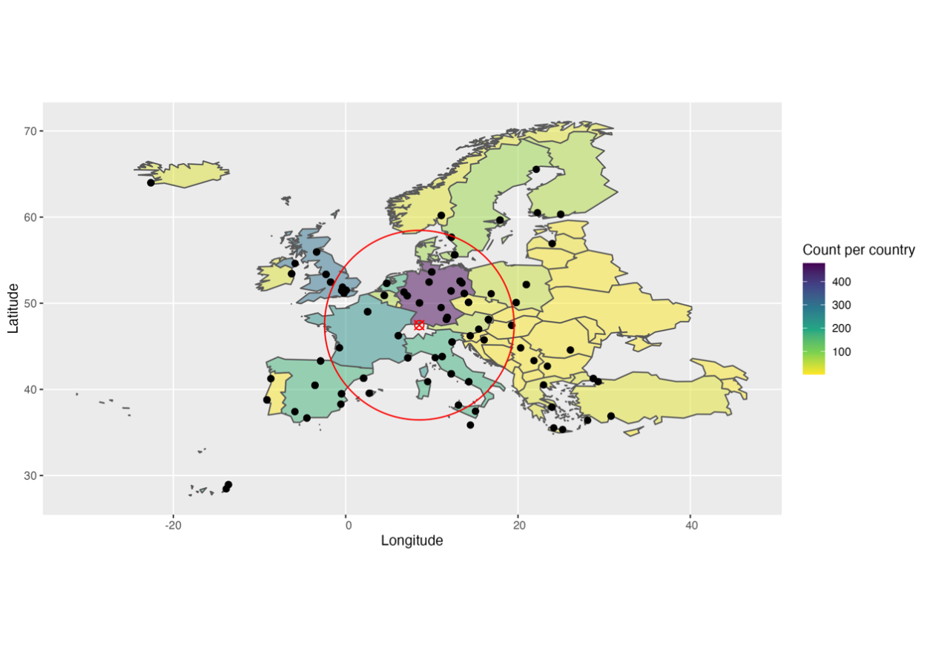

Figure . Flight arrivals counted per country which departed from Zurich. Red circle indicating a 1000km distance radius from Zurich.

The data shows that the minimum distance which is flown is 63.41km, while the maximum distance is 15731.34km. The mean on the other hand is 2800km, while the median is 1100km for all 7018 flights, which were paid by the MNF between 2018 and 2020. This significant difference in the median and mean shows that most of all flights were short-distance flights. The same result was derived from an analysis of the distance distribution, where 48% of all flights were less than 1000km (2601 short/5463 all).

Figure . Scenario 1: Comparison of reduction steps until 2030 between Economy and Observed model. Necessary flight reduction of 6.3% per year by flying economy.

Figure . Scenario 2: Reduction in short distance (<1000km) flight based on emissions [%].

Figure . Scenario 2: Reduction of short distance flights (<1000km) per capita.

### 4.3 Per capita and so on

However, as visible in Figure 1, the preliminary results show that the space and CO2 intensive flight classes cause only a tiny portion of the emissions. Thus, it can be hypothesized that the emission targets of MNF cannot be achieved with a mandatory booking of only economy class tickets. There were 5478 flights, of which 5162 were economy and 262 were business class.

The mean emissions in kgCO2/km flying for modeled economy flights is 0.311 kgCO2/km, while it is 0.317 kgCO2/km for the observed flights.

Table : Comparison of reduction of flights per year until 2030 and reduction of emissions and number of flights per capita/per year between observed and economy model.

|  |  |  |  |  |  |
| --- | --- | --- | --- | --- | --- |
| Reduction per year until 2030 | | | | Reduction per capita/  per year | |
| Model | Reduction until  2030 [%] | Reduction  per year [%] | Reductionflightsperyear | Emissions [kgCO2] | Number of flights |
| Observed | 53.05 | 6.63 | 362 | 144.13 | 0.22 |
| Economy | 50.25 | 6.3 | 343 | 128.97 | 0.21 |
|  | 2.80 | 0.33 | 19 | 15.16 | 0.01 |

Table : Reduction per year until 2030 and reduction of emissions and number of flights per capita/per year of only short-distance flights.

|  |  |  |  |  |  |
| --- | --- | --- | --- | --- | --- |
| Reduction per year until 2030 of short-distance flights | | | | Reduction per capita/  per year | |
| Model | Reduction until  2030 [%] | Reduction  per year [%] | Reductionflightsperyear | Emissions [kgCO2] | Number  of flights |
| Economy | 96.25 | 12.03 | 312 | 42.98 | 0.19 |

## 4. Discussion

**The discussion section describes the patterns, principles, and relationships shown by the results section. It also gives room for discussing unexpected results. No study is perfect. In this section, you may also list the limitations of the study in terms of the conceptual model, data, and methodology, and discuss to what degree the limitations may impact the validity of the results. Reflecting on limitations, you may state the future work with which you may suggest possible solutions to improve this study or potential new paths to expand the scope of the study.**

The potential for reducing emissions caused by flight behavior in academic circles was also analyzed by Wouter Achten and his colleagues and shows an important counterpart to our proposed reductions in the number of flights, namely how these reductions affect direct behavior in research. From switching to online conferences, emissions in research can already be reduced by only 44 (Achten et al., 2013).

## 5. Conclusion

**As a conclusion, you shall summarize the pieces of evidence in results that lead to clear conclusive statements and mention how these conclusions can contribute to the field of science and beyond. How do your findings benefit society or advance desired societal outcomes?**

This study clearly showed that the potential for reducing emissions caused by university flights is significant. Thus, the change of the flight class to economy is an essential and easily realizable step, which is further supported by the reduction of domestic short-haul flights to reach the climate target. Furthermore, the analysis of emissions shows how serious short-haul flights are in terms of their emissions per flight kilometer and that their reduction is an effective step towards the climate targets of the MNF. The spatial analysis of flights shows clear patterns of individual flights with a focus on Europe and North America. However, further investigation of the data is necessary to develop further approaches to reduce emissions and moderate their effective impact. For this, sufficient data and a wide range of variables are of enormous advantage to plan specific and effective steps to achieve the emission reduction of 53% by 2030 at MNF. By reducing emissions and meeting climate targets, we are making an indispensable contribution to protecting the climate and enabling future generations to experience the same quality of life as we do.

## 6. Author contribution

Both team member worked equally on this paper, while Gregory Biland focused on the programming, visualization and formal analysis part, Simona di Vincenzo worked in depth on the visualization and writing. The conceptualization, methodology and validation were done in equal.

## Acknowledgments

We would like to thank and express our gratitude to Mr. Ranacher and the confidence placed in us for this work. We would also like to thank MNF for providing us with the data and for the trust they have placed in us.

## References

Achten, W. M. J., Almeida, J., & Muys, B. (2013). Carbon footprint of science: More than flying. *Ecological Indicators*, *34*, 352–355. doi: 10.1016/j.ecolind.2013.05.025

AviationEdge. (2022). *Detailed Aircraft Information Database - Aviation database and API*. Retrieved from https://aviation-edge.com/

Borgermann, N., Schmidt, A., & Dobbelaere, J. (2022). Preaching water while drinking wine: Why universities must boost climate action now. *One Earth*, *5*(1), 18–21. doi: 10.1016/j.oneear.2021.12.015

Dib, C. (2021). *What contributions does air transport make to the UN sustainable development goals? - Uniting Aviation*. Retrieved from https://unitingaviation.com/news/general-interest/what-contributions-does-air-transport-make-to-the-un-sustainable-development-goals/

GoClimate. (2020). *GoClimate API Reference*. Retrieved from https://api.goclimate.com/docs

Graver, B., Zhang, K., & Rutherford, D. (2019). CO2 emissions from commercial aviation, 2018. *International Council on Clean Transportation*, *September*, 13.

Klöwer, M., Hopkins, D., Allen, M., & Higham, J. (2020). An analysis of ways to decarbonize conference travel after COVID-19. *Nature*, *583*(7816), 356–359. doi: 10.1038/d41586-020-02057-2

Kreil, A. S. (2021). Does flying less harm academic work? Arguments and assumptions about reducing air travel in academia. *Travel Behaviour and Society*, *25*, 52–61. doi: 10.1016/j.tbs.2021.04.011