**Monitoring Air Miles at the Faculty of Mathematics and Natural Sciences (MNF) to reduce CO2 emissions**

GEO 885, Group G1

S. Di Vincenzo1, G. Biland1

1Department of Geography, University of Zurich

Date: 21.04.2022

Word count: 666 words

Submissions should be written in English. Authors should keep to the limit of **750 words** (excluding references and figure/table captions). Please include the corresponding word count on the title page. Submissions that fail to follow the specified format and prescribed length will not be considered for inclusion.

## Abstract

The abstract briefly summarises the research plan, including relevant background information, data, methods, and expected results. Update your abstract (deliverable 1) and include the feedback from your instructors.

**Keywords**: academic flying, carbon emission, sustainability, environmental protection

## 1. Background

ASDASDASDASDASD

## 2. Research goal

The goal of this study is to provide the Faculty of Mathematics and Natural Sciences with an analysis of all flight missions funded by MNF. The goal is to present concrete proposals on how MNF can reduce its flight emissions by 53% by 2030 and what role the flight classes play in this reduction target.

## 3. Methods and data

The dataset used in this paper was provided by MNF and included all flight numbers of MNF-paid flights for 2018-2020. The dataset also included certain IATA- codes for the corresponding origin and destination airports. Information on flight distances and emissions emitted was not available. To create accurate and meaningful recommendations for reducing flight emissions at MNF, it is essential to complete the dataset with all IATA codes and corresponding emissions. Two different APIs were used in the data preprocessing, which retrieved the corresponding IATA codes for each flight number using a Python script and retrieved the emitted emissions for each flight segment in a second step using the obtained IATA numbers. With the data set now complete, the analysis is performed to analyze the effect of flight class on emitted emissions. For this purpose, R is used, taking only the emissions and not the flight distances. To determine the MNF reduction target, the average of all emitted emissions for the year 2018 to 2020 was taken as the measure. As only these data were available for this paper and a specific analysis of these data was pursued, no alternative remained open in terms of data selection and preprocessing of the data.

## ****4. Expected or preliminary results****

This section illustrates your expected analytical results. How do you expect to answer your research questions, and why? Do you wish to accept or reject your hypothesis? If you can already include preliminary results, that’s fantastic. However, including results is optional and will not contribute to your grade.

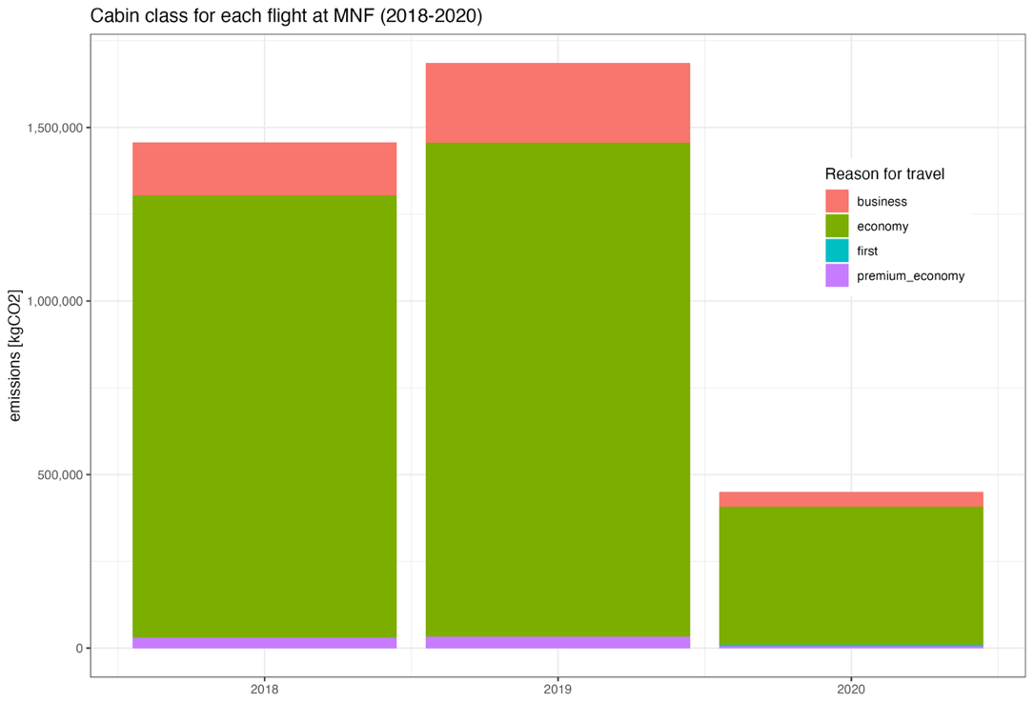

Figure 1: Distribution of emitted kgCO2 for each cabin class for every flight at the MNF in 2018-2020, distinguished by color.

## ****5. Impact****

The findings of this paper will contribute significantly to MNF's ability to meet your goal of reducing your aviation emissions by 53% by the year 2030. Likewise, this paper will demonstrate the varying implications of flight classes on the emissions emitted and illustrate how severe or not a higher flight class is on the emissions generated. Furthermore, the analysis will demonstrate for the first time the spatial distribution and focus of flights across the MNF and what spatial focus could be further explored with a particular attention to groupings for flights.

## References

Authority, F. (1973). Stating the obvious: An interdisciplinary approach. *Journal of Entirely Predictable Results, 63*, 1037–1068.

Fudgit, B., Publish, H., & Writer, A. (1997). *Looming deadlines and how to deal with them.* Norwich, UK: Partridge & Co.

Learned, C., & Expert, M. (1982). Reworking previous publications for fun and profit. In K. Doctor, & B. Professor (Eds.), *Proceedings of the 2nd International Conference on Something You Thought Was Relevant But Isn’t Really*, (pp. 120–149). Los Angeles.