



TOWER Proxy

Parent Instructions

**TOWER Proxy Parent Instructions**

**Introduction**

TOWER Proxy replaces TOWER4Parent as a means for you, as a parent, to access your student’s on-line academic information. As with TOWER4Parent, your student must create an account and authorize you to access their on-line academic information. Even if you had access with TOWER4Parent, your student must re-create the account and re-authorize its access. You must have a valid e-mail address to have a proxy account created and access the site.

**\*\*\*FERPA NOTICE\*\*\***

Your student controls who is designated as a proxy and what information the individual can see. Designating an individual proxy privileges will not be interpreted by Taylor University as providing a FEPRA release allowing the university to share additional private student information. In order for the university to share private information with you as a parent or guardian, your student must have a signed FERPA release on file in the Registrar’s Office.

**Establishing an account**

1. Your student must first create a TOWER Proxy account using your valid e-mail address. Your student has been provided information on this process.
2. When the account is created, you will receive an e-mail with authentication instructions.
3. Click on the link provided. The following web page will open in your default browser. Enter the temporary PIN provided by the e-mail. Click the “Submit” button.

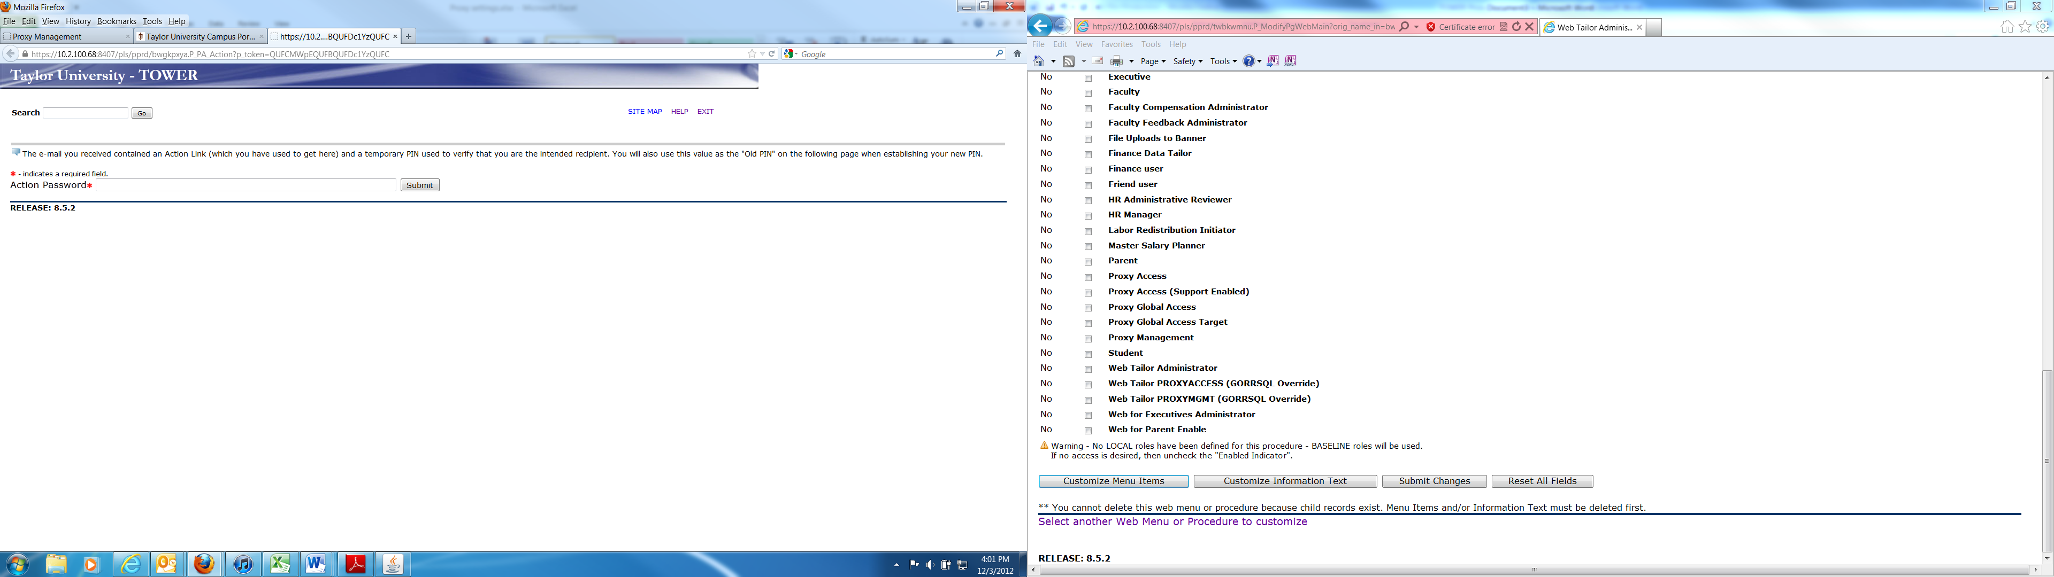

NOTE: You will be able to click on the provided link only **ONCE.** If you happen to close your browser before completing the process, you will need your student to reset your PIN which will generate another message allowing you to complete the process.

1. You will be asked to reset your temporary PIN. To do this, enter your e-mail address used to create the account and enter the temporary PIN (sent to you in the e-mail) as the Old PIN. Create and enter a new PIN. Enter the new PIN in the “Validate PIN” field. Click “Save.”

**\*\*\*Special note to TU employees\*\*\***

Be sure to closely verify the e-mail address used to create your account. Instead of ending with @taylor.edu it might end with @taylor**u**.edu. (Note the u after taylor)

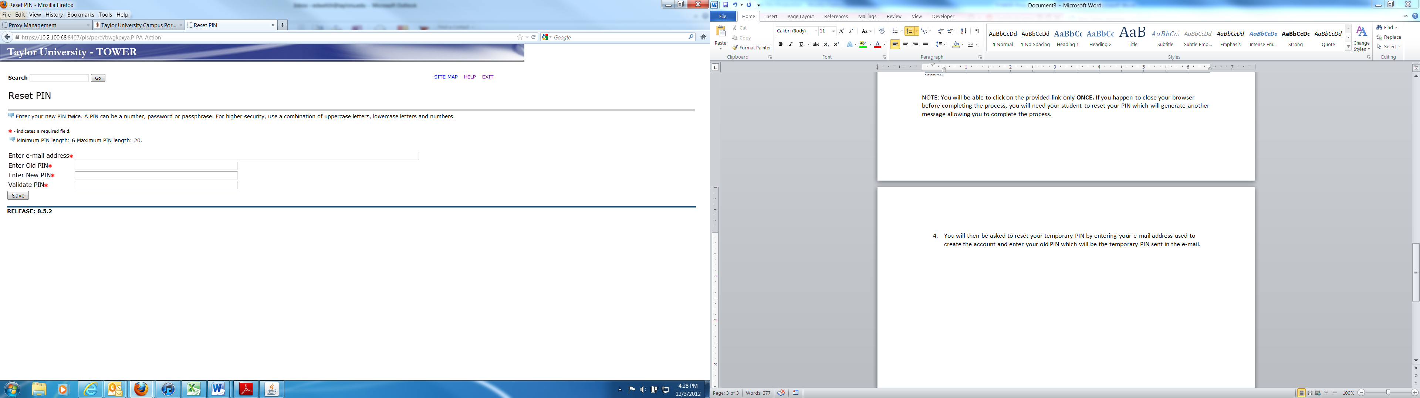

1. After resetting your PIN, you will be directed to the TOWER Proxy Access Home page. You will need to update the required information before accessing your student’s information. This includes: Mailing address, City, State, Country.

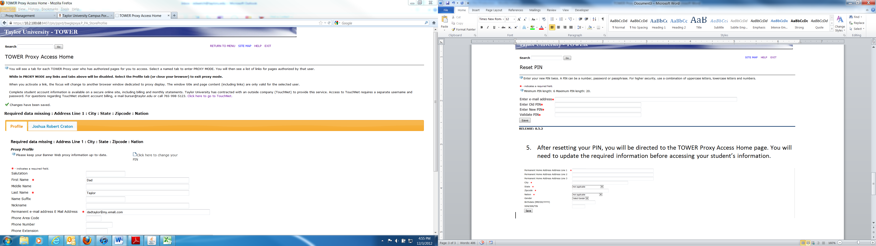 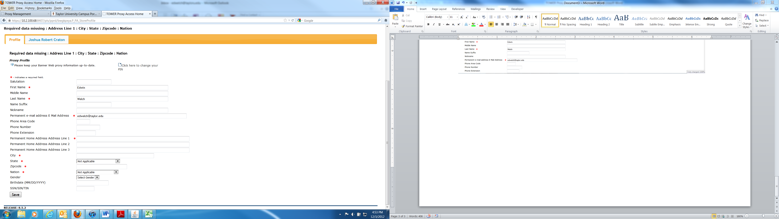

John Mark Taylor

1. If you have more than one student at Taylor who has authorized you to access their information, all of the names will appear across the page. To access your student’s on-line academic information, click on their name.
2. Click on the link to view the information listed. A new window will open with that information..

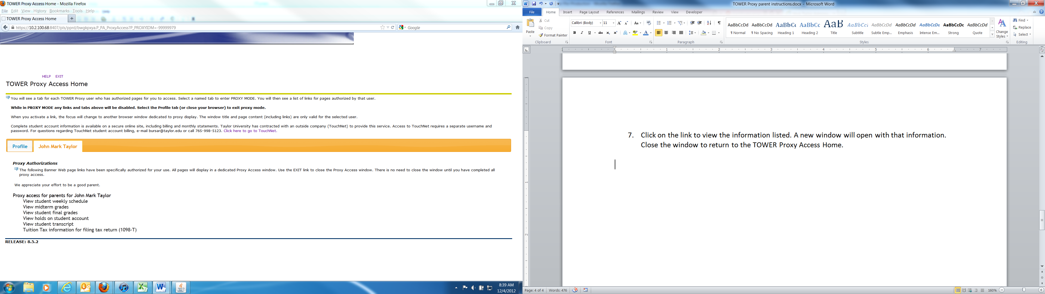

1. When you are finished viewing the information, close the browser window or click EXIT. You will be returned to the TOWER Proxy Access Home.
2. To exit the system, first click on the profile tab, then click on exit at the top of the page.
3. You may now close the browser.

Questions regarding TOWER Proxy may be directed to Information Technology at [**4040@taylor.edu**](mailto:4040@taylor.edu) or by calling **(765) 998-4040** or **(866) 694-1385**.