



TOWER Proxy

Student Instructions

**TOWER Proxy Student Instructions**

**Introduction**

Taylor University’s TOWER Proxy provides your parent or guardian on-line access to your academic information. TOWER Proxy gives you, the student, complete control of the process and allows you to authorize anyone with a valid e-mail address on-line access to your academic information.

**\*\*\* FERPA Notice \*\*\***

You the student control who is designated as a proxy. You also choose what information your proxy can access. Designating someone proxy privileges will not be interpreted by Taylor University as providing a FERPA release allowing the university to share additional private student information. If you wish to grant permission to the university to share private information with an individual, such as a parent, a signed FERPA release must be on file in the Registrar’s Office.

**Creating a proxy**

To provide someone on-line access to your academic information, you must first create a proxy account.

1. Log into myTAYLOR (https://my.taylor.edu)
2. Click on the TOWER link inside myTAYLOR (upper-right)
3. Once inside TOWER, move to the TOWER Proxy tab

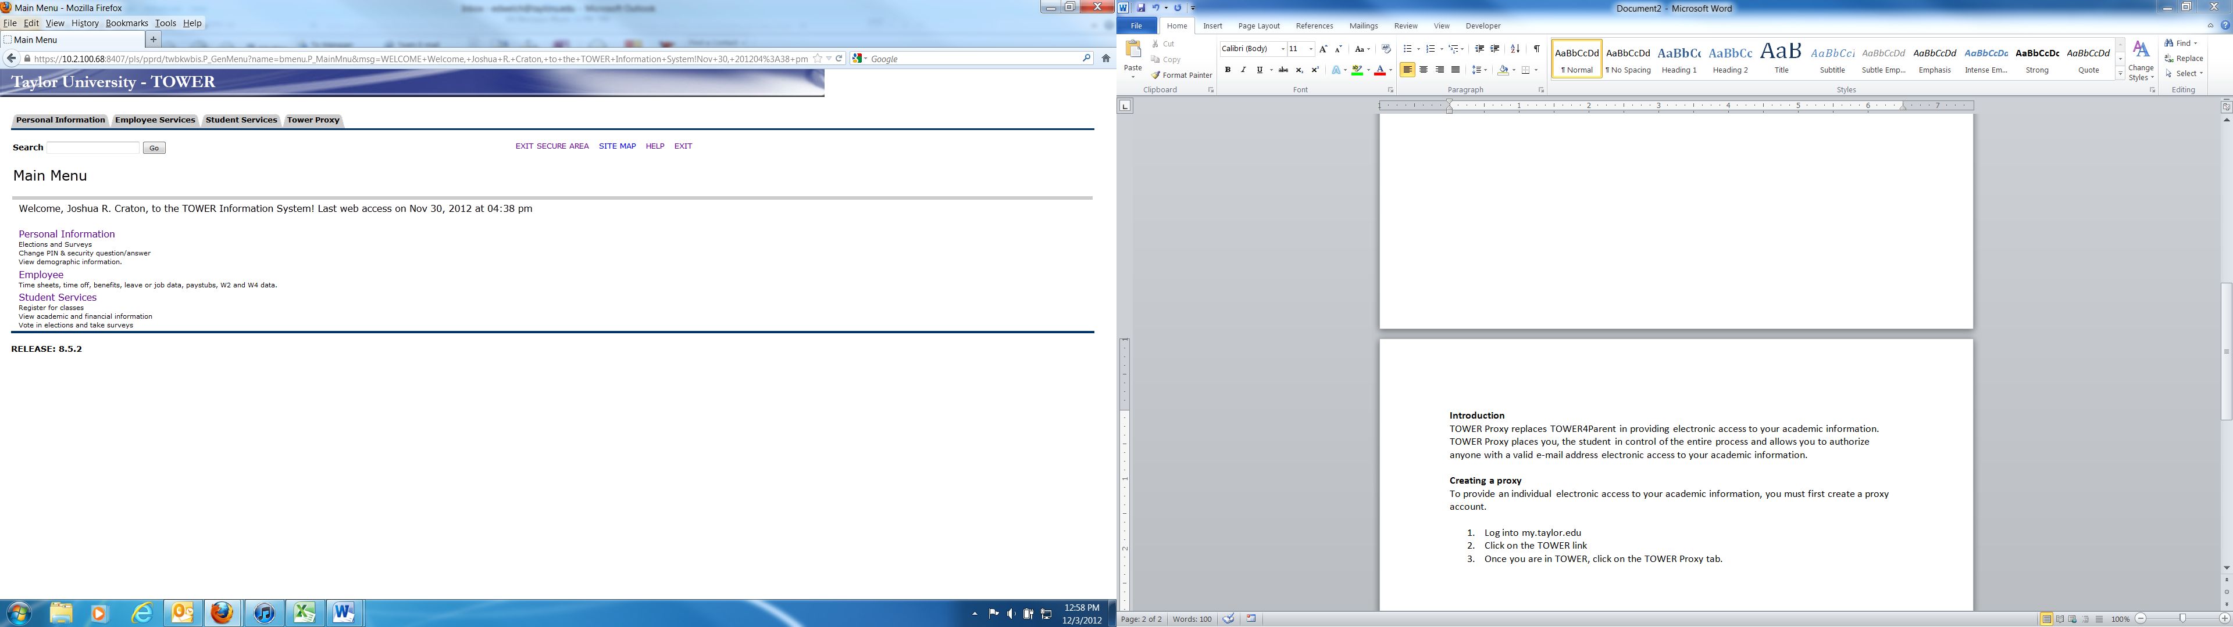

1. Click on “Proxy Management “ on the TOWER Proxy Access menu

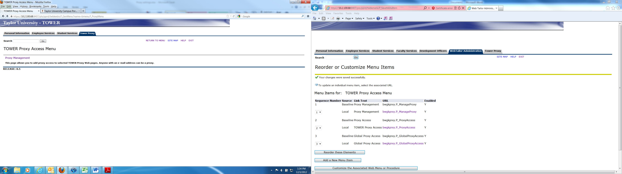

1. Click on “Add Proxy”

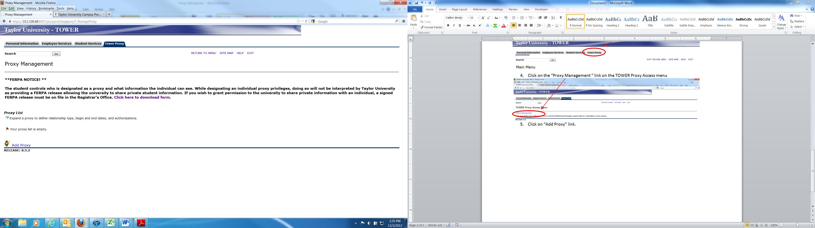

1. There are two ways you can add a proxy. You can chose from a list of previously created proxies or enter the appropriate information to create a new proxy.

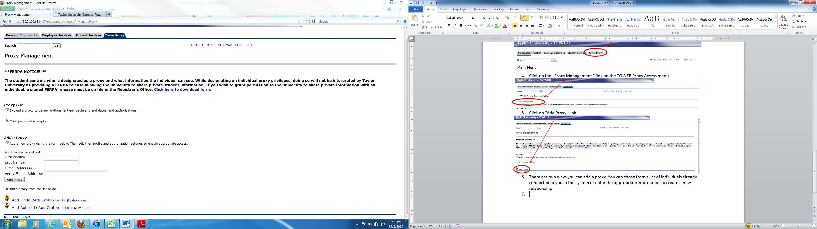

Add Dad Taylor [dadtaylor@my.email.com](mailto:dadtaylor@my.email.com)

1. After adding a proxy, select the relationship role (Parent or Legal Guardian), and enter a description for the individual. This MUST be done first.

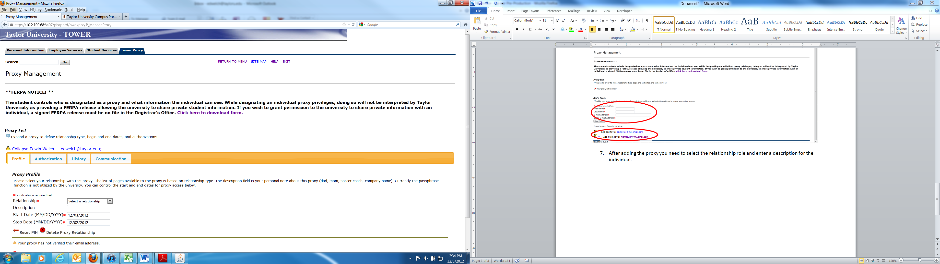

1. Move to the “Authorization” tab, and select the information you wish the individual to access. Click on a box to grant access to that area of information. You do not need to Save; just check the box.

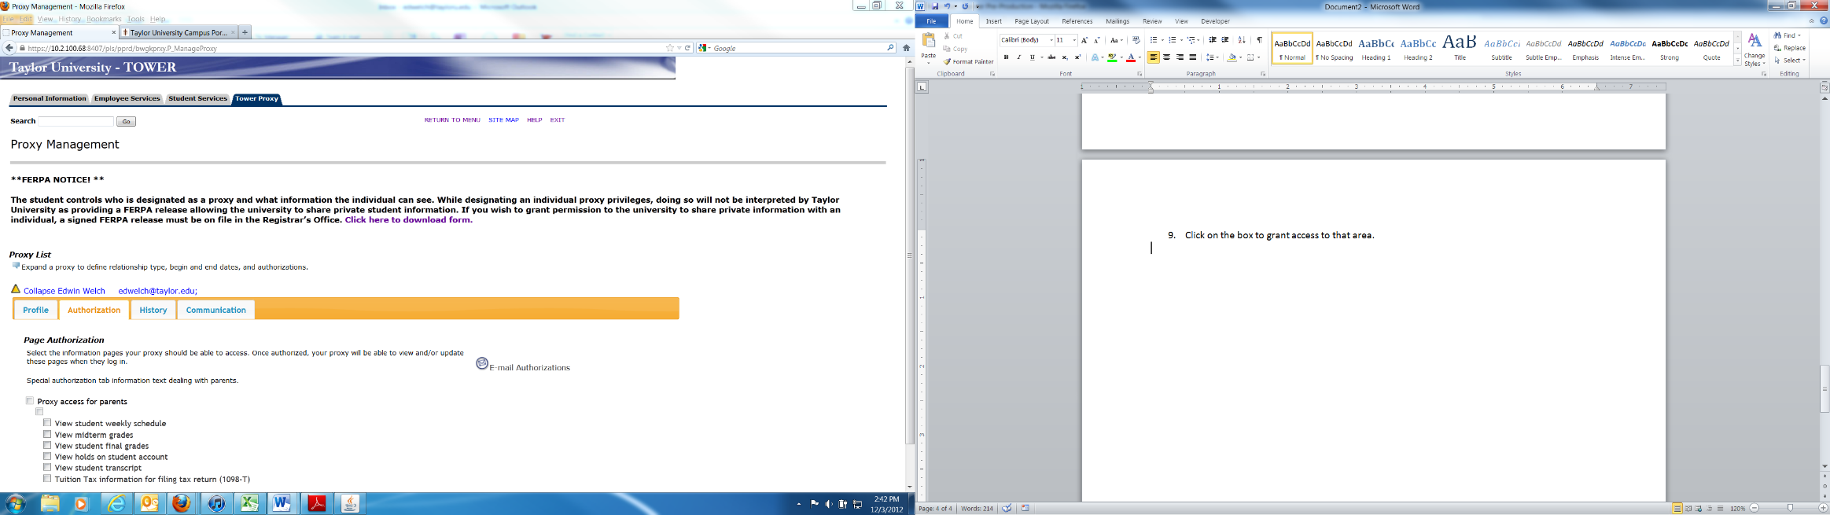

You have completed the necessary steps to create a proxy account for your parent or guardian. Your proxy will receive an e-mail notifying them that the account has been created. The e-mail will provide them with a user name (their e-mail address) and a temporary PIN/Password as well as a link for them to complete the registration/authentication process and reset the temporary PIN.

After completing the authentication process your proxy will be able to log on and view the information you authorized.

Questions regarding TOWER Proxy may be directed to Information Technology at [**4040@taylor.edu**](mailto:4040@taylor.edu) or by calling **(765) 998-4040** or **(866) 694-1385**.