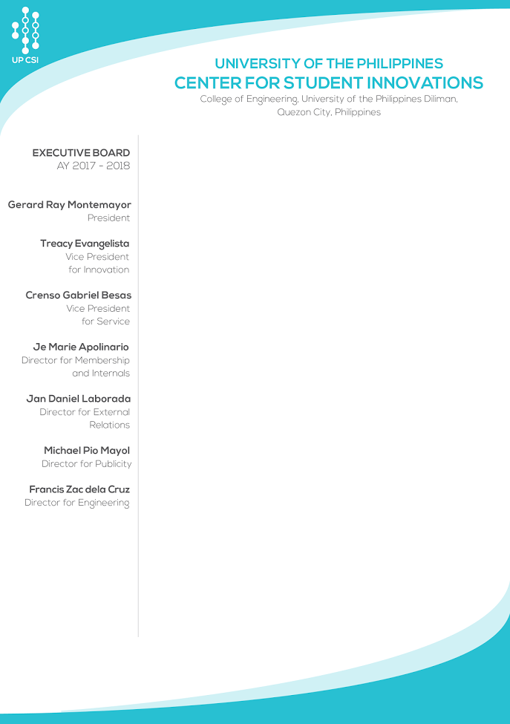`

Dear **Celine Anne Moredo**,

Greetings!

The UP Center for Student Innovations Executive Board would like to thank you for renewing as an active member for academic year 2017-2018. We are truly appreciative of the time and effort you have invested for our organization. And upon thorough and careful deliberations, we are glad to inform you that you have been granted **Full Membership status** under the **External Relations** Committee.

We are glad to welcome you back in our family and we hope that you remain active on the pursuit of our goal to learn, create, and innovate.

We hope that you enjoy your stay in UP CSI this academic year!

Thank you very much.

Sincerely yours,

UP Center for Student Innovations

Executive Board AY 2017-2018

Approved by:

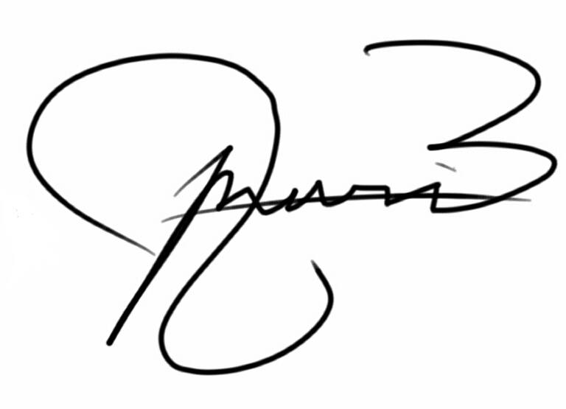

Je Marie Apolinario

Director for Membership and Internals

UP CSI

Noted by:

Gerard Ray Montemayor

President

UP CSI