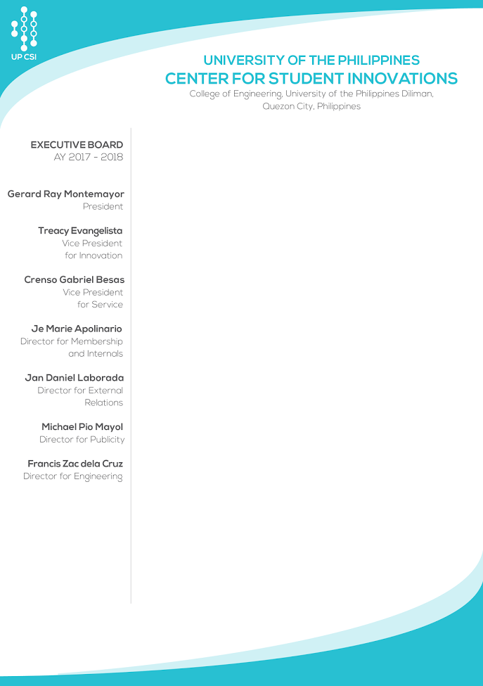`

Dear **Miguel Luis Posadas**,

Greetings!

The UP Center for Student Innovations Executive Board would like to thank you for renewing as an active member for academic year 2017-2018. We are truly appreciative of the time and effort you have invested for our organization. And upon thorough and careful deliberations, we are glad to inform you that you have been granted **Probationary Membership status** under the **Membership and Internals** Committee.

We are glad to welcome you back in our family and we hope that you remain active on the pursuit of our goal to learn, create, and innovate.

Conditions in lifting your probationary status are set by your committee director. If you have any concerns and inquiries regarding your status, please message Je Marie Apolinario or email membership.internals@up-csi.com.

We hope that you enjoy your stay in UP CSI this academic year!

Thank you very much.

Sincerely yours,

Executive Board AY 2017-2018

UP Center for Student Innovations

Approved by:

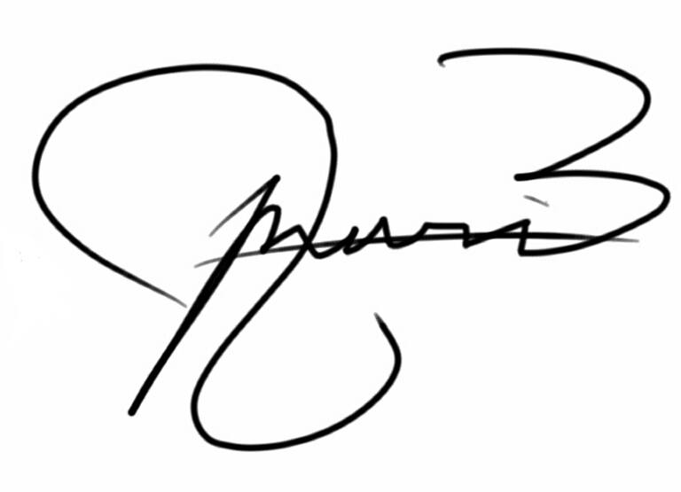

Je Marie Apolinario

Director for Membership and Internals

UP CSI

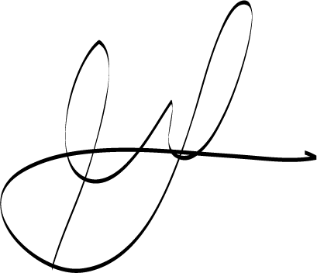Noted by:

Gerard Ray Montemayor

President

UP CSI