Table of Contents
Car pooling management System Application 3
ABSTRACT 3
CHAPTER 1 – INTRODUCTION 4
1.1 Objectives 5
1.2 System Specification 7
CHAPTER 2 – LITERATURE REVIEW 8
2.1Existing Definition 10
2.2 Proposed Solution: 12
CHAPTER 3 OVERALL DESCRIPTION OF THE PROPOSED SYSTEM 14
3.1 Product Perspective 14
3.2 Interfaces 14
3.3 System Features 14
3.2 Module Description 16
CHAPTER 4 – DESIGN 18
4.1UML Diagrams: 19
4.1.1Usecase Diagrams: 19
4.1.2 Sequence Diagram: 22
4.1.3 Collaboration Diagram: 24
4.1.4 Architecture Diagram 25
4.1.5. Data Flow Diagram 26
4.1.6 Table Design 29
4.1.7 Class Diagram 30
4.1.8 ER Diagram 31
4.1.9 WORKFLOW DIAGRAM 32
4.1.10 Activity DIAGRAM 33
CHAPTER 5 - OUTPUT SCREENSHOTS 34
CHAPTER 6 – IMPLEMENTATION DETAILS 38
6.1 Introduction to Html Framework 38
6.2 Cascading Style Sheets (CSS) 38
6.3 MYSQL Server 40
6.4PHP 40
6.5 ANGULAR JAVA SCRIPT 41
TECHNICAL FEASIBILITY 44
9. SYSTEM TESTING 47
TEST CASE 47
9.2 Integration Testing 52
CHAPTER 10– CONCLUSIONS 54
CHAPTER 11 – FUTURE ENHANCEMENT 55
CHAPTER 12- REFERENCES 56
CHAPTER 13- CODING 57

Carpooling management System Application

ABSTRACT

In today's world, there are lots of people commuting from place to place. Example: employees going back home. Students going home from university etc. And lot of times, people will be commuting via car or bike and there is place to take a fellow employee along with him to give a ride. But the problem is there is no easy way to know how many people a person can take and co-ordination is a huge issue that there is no effort by people to help each other by giving a lift and more over this saves the environment in reducing fuel usage, reduces traffic with fewer vehicles etc. The Carpool is an application which will provide the advanced searching techniques and provide most relevant results for the carpooling in the city. This will be help full in easy way Carpooling reduces the costs involved in repetitive or long distance driving by sharing cars, sharing rental charges, or paying the main car owner. Some countries have introduced high-occupancy vehicle (HOV) lanes to encourage carpooling and use of public transport, to combat rising traffic congestion

CHAPTER 1 – INTRODUCTION
In an era of increasing urbanization and daily commuting chaos, carpooling has emerged as a smart, sustainable, and economical solution for modern transportation needs. Every day, millions of people travel to and from their workplaces, colleges, or homes using private vehicles—often alone. Whether it’s an office-going employee, a student attending university, or a professional running errands, these solo journeys contribute significantly to traffic congestion, environmental pollution, and fuel consumption. Ironically, most of these private vehicles have unoccupied seats that could easily accommodate fellow travelers headed in the same direction. However, due to the lack of an effective system for coordination, communication, and trust, many potential carpooling opportunities go unnoticed and untapped.
The Car Pooling Management System is a digital initiative aimed at addressing this gap. It is designed to provide a centralized platform where users can easily offer and find rides based on location, timing, and seat availability. The system promotes collaboration among commuters, encouraging them to connect and share rides efficiently, thereby reducing overall vehicle count on the roads. With advanced search functionalities, user profile management, real-time ride matching, and secure communication channels, this application simplifies the process of organizing shared transport while ensuring convenience and safety.
The Need for Carpooling
Modern cities are facing a transportation crisis. With an ever-growing number of personal vehicles, traffic congestion has become a daily nightmare. This not only leads to wasted time and increased stress among commuters but also causes a spike in air and noise pollution. Fossil fuel consumption is reaching unsustainable levels, further accelerating climate change and environmental degradation. Public transportation systems, although helpful, often fail to cater to the flexible schedules and specific routes needed by many individuals.
In such a scenario, carpooling offers an eco-friendly and cost-effective alternative. Sharing rides means fewer vehicles on the road, reduced fuel consumption, and decreased greenhouse gas emissions. It also helps commuters save money on fuel, parking, tolls, and vehicle maintenance. In fact, several countries have recognized the importance of carpooling by introducing High Occupancy Vehicle (HOV) lanes to incentivize shared travel. Despite these advantages, carpooling has not become a mainstream practice due to a lack of awareness, coordination issues, and safety concerns.

Objectives
The objective of the Car Pooling Management System is to develop a user-friendly and efficient platform that facilitates ride-sharing among commuters by connecting drivers with empty vehicle seats to passengers traveling in the same direction. This system aims to reduce traffic congestion, lower transportation costs, and minimize environmental pollution by promoting shared travel. It seeks to improve commuter coordination through advanced search filters, real-time ride matching, and secure communication. Additionally, the platform enhances user safety and trust with features like profile verification and ride history. Overall, the system encourages sustainable, economical, and eco-friendly transportation practices in urban and semi-urban areas.

System Specification

Hardware Requirements:-
Processor : Intel 5
Installed memory (RAM) : 4 GB
Hard Disk : 500 GB
Operating System : Windows

Software Requirements: -
Front End: HTML5, CSS3, Bootstrap
Back End: PHP 8.1, MYSQL
Control End: Angular Java Script
Tools:
VS Code
xampp-win64-8.1

CHAPTER 2 – LITERATURE REVIEW
1. Title: Dynamic Carpooling System Based on Real-Time Data using Mobile Applications
Author: Ahmed S. Elmaghraby, Mohamed F. Tolba
IEEE Publication Year: 2020
Abstract:
This paper presents a real-time dynamic carpooling system that integrates mobile technology and location-based services to facilitate smart ride-sharing. The system allows users to register, create, and join trips based on live GPS data and time constraints. The authors emphasize reducing traffic congestion and emissions by optimizing route matching between drivers and passengers. A unique algorithm is proposed to minimize wait times and route deviations. Security features such as OTP verification and feedback rating systems are integrated. The study concludes that such smart systems are essential for sustainable transportation and urban mobility enhancement.
2. Title: A Ride Sharing Model for Urban Transport Using Blockchain and IoT
Author: Rakesh Kumar, Priya Sharma
IEEE Publication Year: 2019
Abstract:
This paper introduces a decentralized ride-sharing system that combines blockchain and Internet of Things (IoT) to ensure transparency, traceability, and security in carpooling services. The system enables trusted ride-sharing without centralized control, ensuring data integrity and identity verification using blockchain smart contracts. IoT devices are integrated into vehicles to track ride statistics, fuel usage, and passenger details. The paper also explores fare automation, feedback storage, and tamper-proof ride history. The authors report increased trust and reduced fraud in ride-sharing transactions. The model is particularly useful in metropolitan areas facing scalability and privacy issues with traditional systems.
3. Title: Optimizing Urban Carpooling Using Machine Learning Techniques
Author: Ritu Aggarwal, Sandeep K. Singh
IEEE Publication Year: 2021
Abstract:
The paper proposes a machine learning-based solution for intelligent carpool matchmaking in densely populated cities. Using user preferences, travel history, location data, and real-time traffic inputs, the model dynamically suggests optimal carpool combinations. Key ML algorithms such as KNN and Random Forest are employed to personalize recommendations. The study found that ML-enhanced systems improve ride acceptance rates and user satisfaction while significantly reducing search and wait times. The research emphasizes scalability and adaptability to urban travel behavior and concludes that data-driven systems can revolutionize eco-friendly transportation planning.
4. Title: Smart Carpooling System with Real-Time Traffic and Weather Analysis
Author: Neha Joshi, Vikas Rajput
IEEE Publication Year: 2018
Abstract:
This research focuses on enhancing user experience and trip reliability in carpooling by integrating traffic and weather analytics into the ride-matching process. The system retrieves real-time data from APIs to suggest optimal travel times and safer routes. Trip recommendations are adjusted dynamically to avoid traffic jams, road closures, or adverse weather. A route deviation minimization algorithm is developed to enhance driver-passenger satisfaction. The authors validate their model through simulation-based comparisons and demonstrate reduced travel duration and cancellations. The paper concludes that real-time contextual awareness is key to user trust in ride-sharing systems.
5. Title: Enhancing Safety and Privacy in Carpooling Applications Using Multi-Factor Authentication
Author: Abhishek Verma, Dr. Sheetal Bansal
IEEE Publication Year: 2022
Abstract:
This paper explores the critical concerns of safety and data privacy in carpooling systems and proposes a multi-layered authentication framework. Users are verified using biometric, OTP, and social trust ratings before being allowed to offer or book rides. The system also anonymizes trip data while retaining necessary metadata for audits. The proposed architecture helps prevent unauthorized access, fake profiles, and identity misuse. The research indicates that combining technical and social verification mechanisms can significantly increase adoption and satisfaction rates. The authors advocate for policy-level frameworks to mandate secure design in future carpool platforms.

2.1Existing Definition

In recent years, the problems of global warming and the energy crisis have aroused widespread public concern. One recommended solution for reducing the harmful factors leading to such problems is carpooling [1]. This type of transportation service could make a big difference if organized on a large scale by government or big companies, particularly large corporations with many branches or sub-companies. Carpooling schemes are designed to encourage commuters to share travel expenses and resources with colleagues [1]. Dynamic carpooling is also known as casual carpooling and a variety of other names, is already widespread in a few metropolitan regions. In each case, public policies encouraging multiple-occupancy vehicles were the impetus. For example, on the Bay Bridge connecting San Francisco and Oakland, traffic moves very slowly in rush hour except in the High Occupancy Vehicle (HOV) lane, which can only be used by vehicles with 3 or more occupants (2 for pickup trucks) [10].

Disadvantages of the Existing System
- Lack of Real-Time Matching:
Most traditional or semi-automated systems do not provide dynamic, real-time ride matching based on location or time, making it hard to find instant ride partners.
- Poor User Verification:
There's usually no proper identity verification, leading to trust and safety concerns among users, especially when sharing rides with strangers.
- Limited Reach & Scalability:
Many ride-sharing apps work in limited geographic regions or among limited groups, lacking the scalability to handle large user bases effectively.
- Coordination Issues:
Without a centralized system, it becomes difficult to coordinate trip details like pick-up points, drop locations, and timings smoothly.
- No Trip Optimization:
Current systems do not factor in traffic conditions, weather updates, or route deviations, leading to inefficient travel and delays.
- Low Feedback Mechanism:
Feedback or rating systems are either missing or poorly implemented, making it hard to identify trustworthy users.

2.2 Proposed Solution:
The proposed Car Pooling Management System is a web and mobile-based application designed to streamline and automate the process of ride-sharing between individuals traveling along similar routes. The system allows registered users to either offer a ride or book a ride based on their travel needs. It incorporates real-time ride matching, route optimization, automated payment, and security features such as user reviews.
The system enables users to post detailed trip information like source, destination, available seats, departure time, and fare. Interested passengers can search for suitable rides using advanced filters (location, time, cost, etc.) and book them directly. The application also supports features like ride tracking, payment history, feedback mechanism, and ride history for future references. Admins can monitor trip data and feedback to ensure a secure and fair platform.
This system is intended to promote eco-friendly commuting, reduce traffic congestion, and improve transportation affordability.

Advantages of the Proposed System
- Real-Time Ride Matching:
Matches passengers with drivers instantly based on current location, destination, and time, improving efficiency and convenience.
- User-Friendly Interface:
A simple and intuitive UI makes it easy for users to post and find rides quickly, encouraging widespread adoption.
- Cost-Effective Travel:
Reduces fuel and vehicle maintenance costs by splitting travel expenses among multiple passengers.
- Traffic and Pollution Reduction:
Fewer vehicles on the road lead to less traffic congestion and lower emissions, benefiting the environment.
- Integrated Payment System:
Supports online and in-app payments with automatic fare calculation and transparent transaction records.
- Trip Management Features:
Users can view upcoming trips, manage bookings, track trip status, and view payment or feedback history in one place.
- Feedback and Rating System:
Encourages accountability and improves service quality through user reviews and ratings.
- Scalable and Flexible:
Can be scaled to support organizations, universities, or even cities with custom modules as needed.
- Encourages Community Sharing:
Builds a sense of community and cooperation by connecting people with similar travel routes.

CHAPTER 3 OVERALL DESCRIPTION OF THE PROPOSED SYSTEM

3.1 Product Perspective
MD5 is the third message digest algorithm created by Rivest. All three (the others are MD2 and MD4) have similar structures, but MD2 was optimized for 8-bit machines, in comparison with the two later formulas, which are optimized for 32-bit machines. The MD5 algorithm is an extension of MD4, which the critical review found to be fast, but possibly not absolutely secure. In comparison, MD5 is not quite as fast as the MD4 algorithm, but offers much more assurance of data security. MD5 is a also known as cryptographic hash algorithm.MD5 produces hash value in hexadecimal format. It is mainly used for security and database efficiency.

3.2 Interfaces
The application will have a user friendly and menu based interface. Following user interface pages will be provided.
- Registration to have their detailed information to maintain database
- Login to validate and allow them to access these application complaints with already stored database.
- Admin enters the login and view complaint and prepare for solutions.
- Then user enters this application and view complaint status of their complaint.

3.3 System Features
In the life of the software development, problem analysis provides a base for design and development phase. The problem is analyzed so that sufficient matter is provided to design a new system. Large problems are sub-divided into smaller once to make them understandable and easy for finding solutions. Same in this project all the task are sub-divided and categorized.
System Modules:

- User Register
- User Login
- Post Trip
- View Trip
- Booked Trip
- Make Payment
- Payment Details
- Security
- Feed Backs
- View Feedbacks
- My Trip

3.2 Module Description
1. User Register
This module allows new users to sign up for the system by entering basic personal details such as name, email, phone number, and password. The registration process ensures secure user onboarding and stores user profiles for future login and trip management.
2. User Login
Registered users can securely log into the system by providing their email and password. The module authenticates credentials and provides access to user-specific features such as posting and booking trips.
3. Post Trip
This module is used by drivers to create and post carpool trips. Users can specify the trip’s source, destination, travel date and time, number of available seats, and estimated fare. It allows others to view and book the trip.
4. View Trip
This module enables users to view a list of available trips posted by others. It includes filters such as location, time, and cost to help passengers find the most relevant and convenient rides.
5. Booked Trip
Displays a list of trips the user has booked. It includes detailed trip information such as driver name, contact, pickup point, travel date/time, and status of the booking.
6. Make Payment
Passengers can make online or offline payments for their booked trips. This module may integrate with a payment gateway for secure and seamless transactions, ensuring the driver receives payment for the trip.
7. Payment Details
Shows the complete history of payments made or received. Users can view fare amounts, transaction dates, payment modes, and trip-related information for accountability and transparency.
8. Security
This module manages secure user authentication and encrypted passwords to protect user accounts. It ensures proper access control, safeguarding user data and maintaining the privacy and integrity of the system.
9. Feed Backs
After completing a trip, users (both passengers and drivers) can give feedback and rate each other based on the ride experience. This helps in maintaining service quality and builds trust in the system.
10. View Feedbacks
Allows users to view feedback and ratings given to other users (drivers/passengers). This helps users make informed decisions before booking a ride or accepting a booking request.
11. My Trip
A personalized dashboard where users can view all their posted and booked trips. It includes options to edit or delete trips, check booking statuses, and manage travel history efficiently.

CHAPTER 4 – DESIGN
Design is the first step in the development phase for any techniques and principles for the purpose of defining a device, a process or system in sufficient detail to permit its physical realization.
Once the software requirements have been analyzed and specified the software design involves three technical activities - design, coding, implementation and testing that are required to build and verify the software.
The design activities are of main importance in this phase, because in this activity, decisions ultimately affecting the success of the software implementation and its ease of maintenance are made. These decisions have the final bearing upon reliability and maintainability of the system. Design is the only way to accurately translate the customer’s requirements into finished software or a system.
Design is the place where quality is fostered in development. Software design is a process through which requirements are translated into a representation of software. Software design is conducted in two steps. Preliminary design is concerned with the transformation of requirements into data.

4.1UML Diagrams:
UML stands for Unified Modeling Language. UML is a language for specifying, visualizing and documenting the system. This is the step while developing any product after analysis. The goal from this is to produce a model of the entities involved in the project which later need to be built. The representation of the entities that are to be used in the product being developed need to be designed.
There are various kinds of methods in software design:

- Use case Diagram
- Sequence Diagram
- Collaboration Diagram

4.1.1Usecase Diagrams:
Use case diagrams model behavior within a system and helps the developers understand of what the user require. The stick man represents what’s called an actor.Use case diagram can be useful for getting an overall view of the system and clarifying who can do and more importantly what they can’t do.

Use case diagram consists of use cases and actors and shows the interaction between the use case and actors.
- The purpose is to show the interactions between the use case and actor.
- To represent the system requirements from user’s perspective.
- An actor could be the end-user of the system or an external system.

4.1.2 Sequence Diagram:
Sequence diagram and collaboration diagram are called INTERACTION DIAGRAMS. An interaction diagram shows an interaction, consisting of set of objects and their relationship including the messages that may be dispatched among them.
A sequence diagram is an introduction that empathizes the time ordering of messages. Graphically a sequence diagram is a table that shows objects arranged along the X-axis and messages ordered in increasing time along the Y-axis.

/user1
/user2
/database
1 :user1 register and login()
2 : user2 register and login()
3 : user1 updated details()
4 : user2 view details()
5 : view booking()
6 : user2 booking()
7 : alert mail()
8 : post feedback()
9 : view feedback()
10 : make payment()
11 : view payment()

4.1.3 Collaboration Diagram:
A collaboration diagram is a type of visual presentation that shows how various software objects interact with each other within an overall IT architecture and how users can benefit from this collaboration. A collaboration diagram often comes in the form of a visual chart that resembles a flow chart.

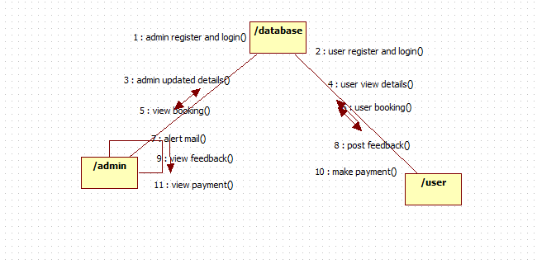

4.1.4 Architecture Diagram

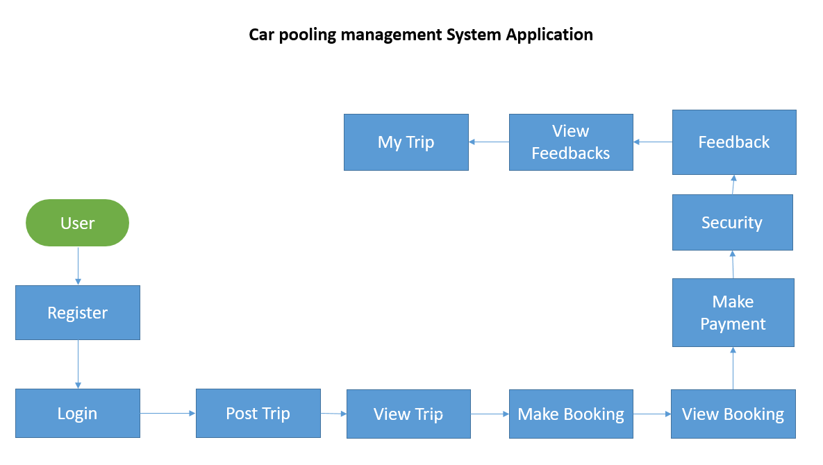

4.1.5. Data Flow Diagram

0-Level DFD
Post feedback
User

Post Trip Details
View Trip
App User

1-LEVEL DFD
Post Trip
All database
App User

View Trip Details

2-Level DFD
My profile
Business database

Post Trip Details
Register & Login
App

View Trip
Post feedbacks

User:

Start

Register

Login

Manage My Trip

View Trips
View feedback
Stop
post feedback
Manage Booking

4.1.6 Table Design
User Register & Login
ID | Name | Email Id | Password | Mobile | Address | City | Question 1 | Question 2
100 | 100 | 100 | 100 | 100 | 100 | 100 | 100 | 100
Int | Varchar | Varchar | Varchar | Integer | Varchar | Varchar | Varchar | Varchar
Primary Key

Feedback
ID | name | Feedback
100 | 100 | 100
Int | Varchar | Varchar
Primary Key

Trip Table
ID | Name | From | To | Date | Vehicle Type | Free Seat | Rule | Price | AC No | Hints
Int | Varchar | Varchar | Varchar | Varchar | Varchar | Varchar | Varchar | Varchar | Varchar | Varchar
100 | 100 | 100 | 100 | 100 | 100 | 100 | 100 | 100 | 100 | 100
Primary Key

4.1.7 Class Diagram

4.1.8 ER Diagram
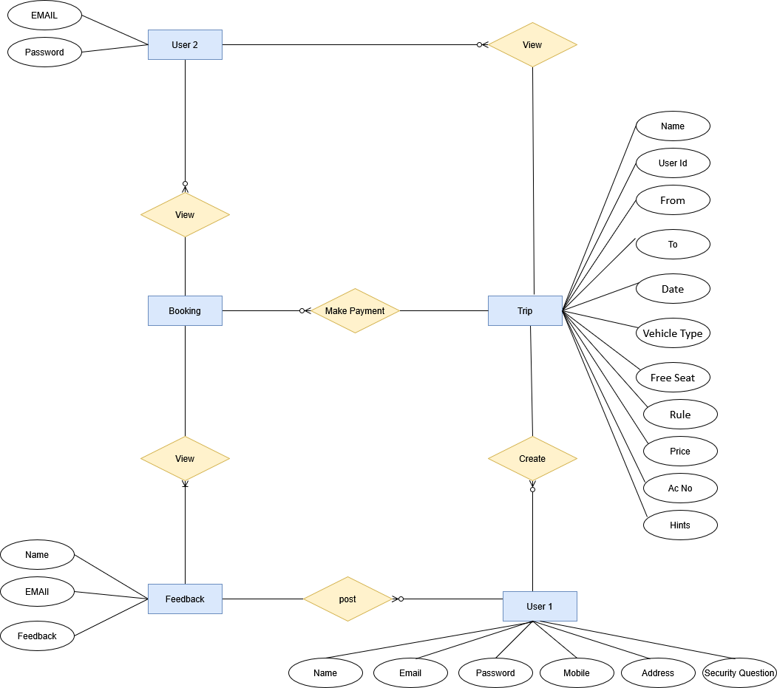

4.1.9 WORKFLOW DIAGRAM

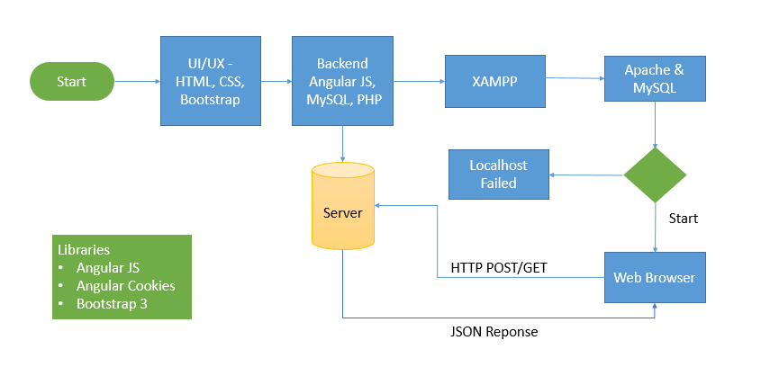

4.1.10 Activity DIAGRAM

CHAPTER 5 - OUTPUT SCREENSHOTS
Home
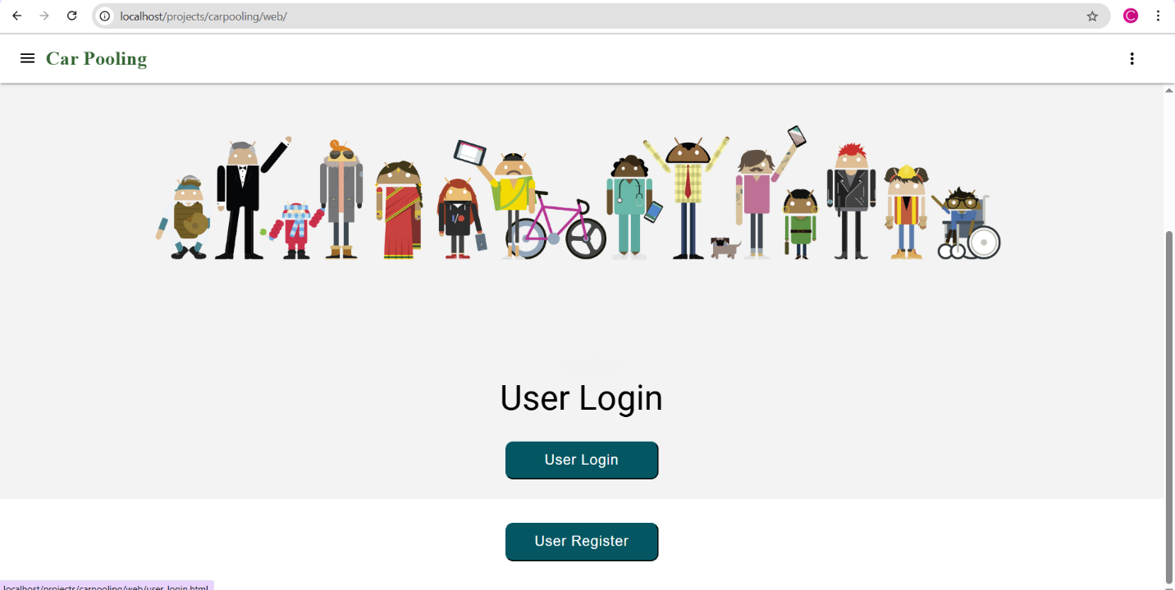
Register
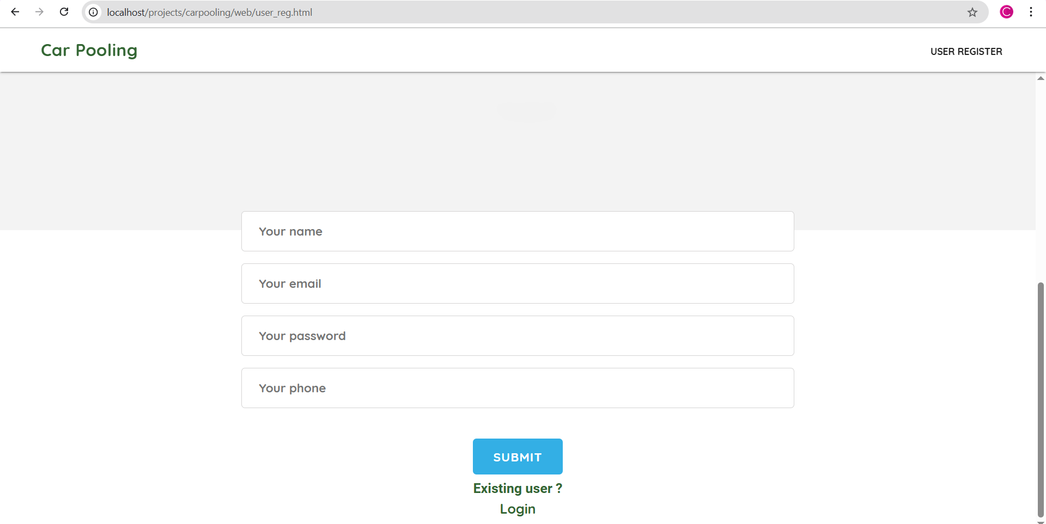

Login
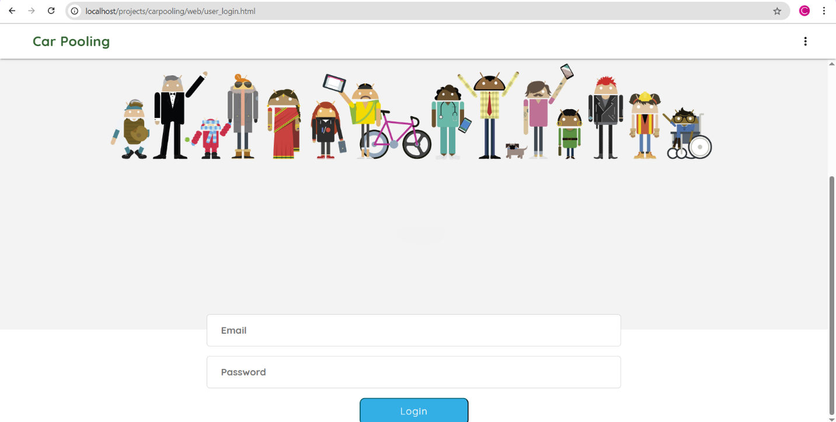

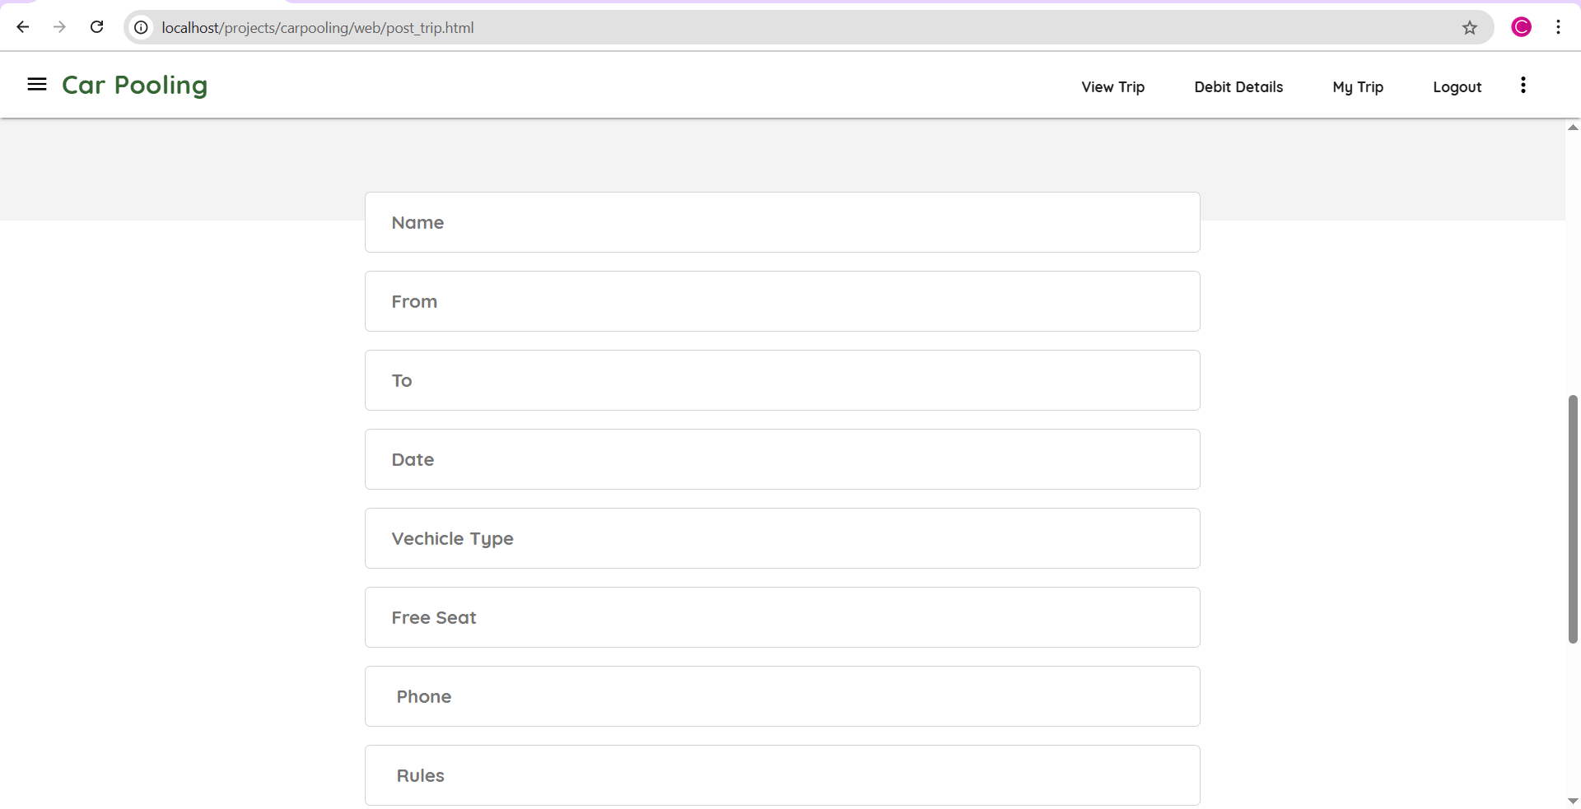

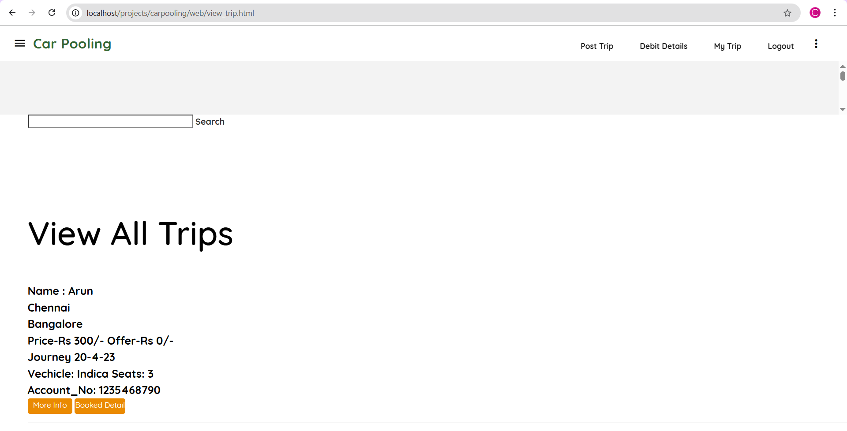

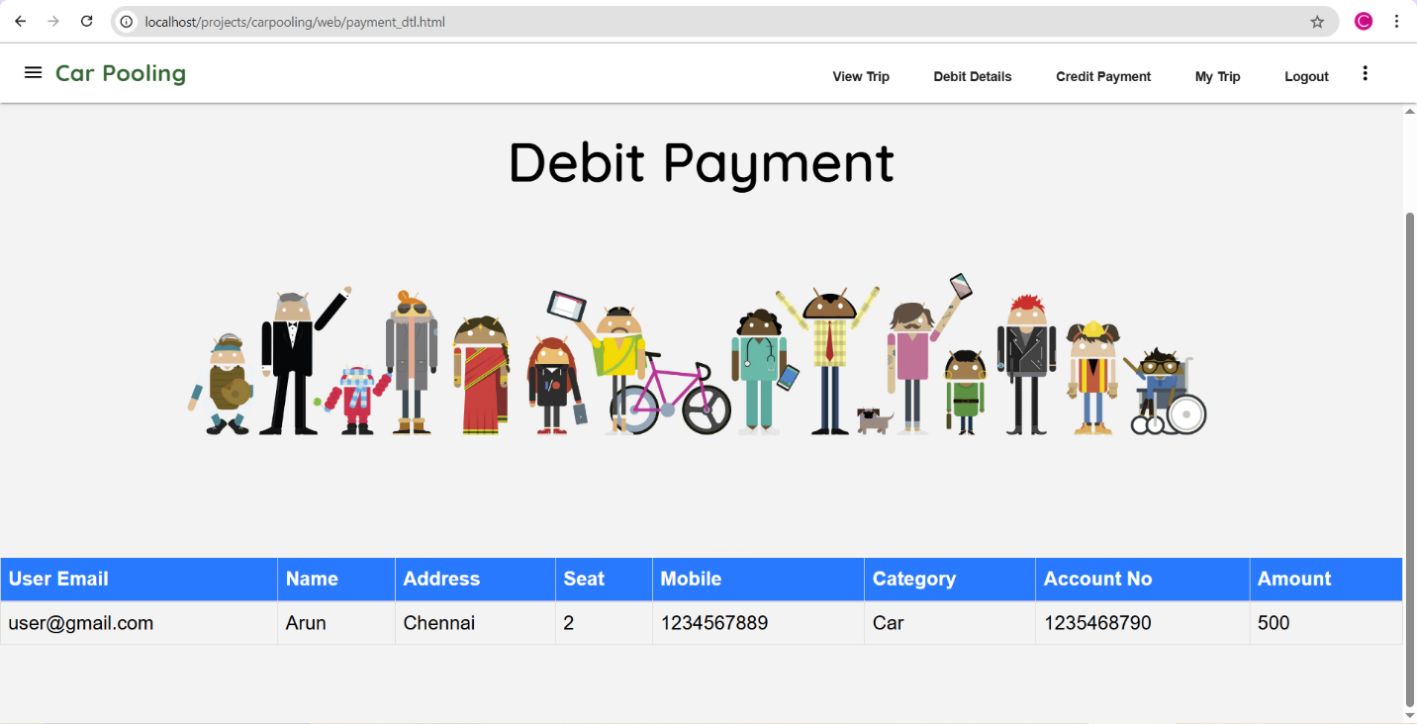

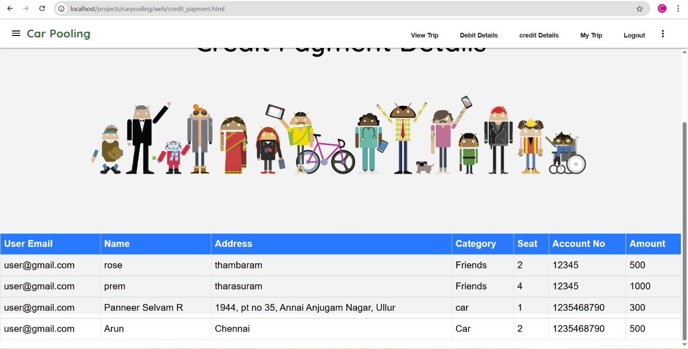

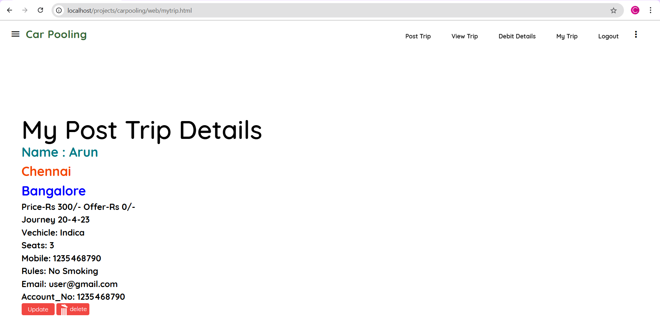

CHAPTER 6 – IMPLEMENTATION DETAILS

6.1 Introduction to Html Framework
HyperText Markup Language, commonly referred to as HTML, is the standard markup language used to create web pages. Along with CSS, and JavaScript, HTML is a cornerstone technology used to create web pages, as well as to create user interfaces for mobile and web applications. Web browsers can read HTML files and render them into visible or audible web pages. HTML describes the structure of a website semantically along with cues for presentation, making it a markup language, rather than a programming language.
HTML elements form the building blocks of HTML pages. HTML allows images and other objects to be embedded and it can be used to create interactive forms. It provides a means to create structured documents by denoting structuralsemantics for text such as headings, paragraphs, lists, links, quotes and other items. HTML elements are delineated bytags, written using angle brackets. Tags such as <img /> and <input /> introduce content into the page directly. Others such as <p>...</p> surround and provide information about document text and may include other tags as sub-elements. Browsers do not display the HTML tags, but use them to interpret the content of the page.
HTML can embed scripts written in languages such as JavaScript which affect the behavior of HTML web pages. HTML markup can also refer the browser to Cascading Style Sheets (CSS) to define the look and layout of text and other material

6.2 Cascading Style Sheets (CSS)
CSS is a style sheet language used for describing the presentation of a document written in a markup language. Although most often used to set the visual style of web pages and user interfaces written in HTML and XHTML, the language can be applied to any XML document, including plain XML, SVG andXUL, and is applicable to rendering in speech, or on other media. Along with HTML and JavaScript, CSS is a cornerstone technology used by most websites to create visually engaging webpages, user interfaces for web applications, and user interfaces for many mobile applications.
CSS is designed primarily to enable the separation of document content from document presentation, including aspects such as the layout, colors, and fonts. This separation can improve content accessibility, provide more flexibility and control in the specification of presentation characteristics, enable multiple HTML pages to share formatting by specifying the relevant CSS in a separate .css file, and reduce complexity and repetition in the structural content, such as semantically insignificant tables that were widely used to format pages before consistent CSS rendering was available in all major browsers. CSS makes it possible to separate presentation instructions from the HTML content in a separate file or style section of the HTML file. For each matching HTML element, it provides a list of formatting instructions. For example, a CSS rule might specify that "all heading 1 elements should be bold", leaving pure semantic HTML markup that asserts "this text is a level 1 heading" without formatting code such as a<bold> tag indicating how such text should be displayed.
This separation of formatting and content makes it possible to present the same markup page in different styles for different rendering methods, such as on-screen, in print, by voice (when read out by a speech-based browser orscreen reader) and on Braille-based, tactile devices. It can also be used to display the web page differently depending on the screen size or device on which it is being viewed. Although the author of a web page typically links to a CSS file within the markup file, readers can specify a different style sheet, such as a CSS file stored on their own computer, to override the one the author has specified. If the author or the reader did not link the document to a style sheet, the default style of the browser will be applied. Another advantage of CSS is that aesthetic changes to the graphic design of a document (or hundreds of documents) can be applied quickly and easily, by editing a few lines in one file, rather than by a laborious (and thus expensive) process of crawling over every document line by line, changing markup.
The CSS specification describes a priority scheme to determine which style rules apply if more than one rule matches against a particular element. In this so-called cascade, priorities (or weights) are calculated and assigned to rules, so that the results are predictable.

6.3 MYSQL Server
MySQL is an open-source relational database management system (RDBMS);[6] in July 2013, it was the world's second most widely used RDBMS, and the most widely used open-source client–server model RDBMS. It is named after co-founder Michael Widenius's daughter, My. The SQL acronym stands for Structured Query Language. The MySQL development project has made its source code available under the terms of the GNU General Public License, as well as under a variety of proprietary agreements. MySQL was owned and sponsored by a single for-profit firm, the Swedishcompany MySQL AB, now owned by Oracle Corporation. For proprietary use, several paid editions are available, and offer additional functionality.

6.4PHP
PHP is a server-side scripting language designed for web development but also used as a general-purpose programming language. Originally created by RasmusLerdorf in 1994, the PHP reference implementation is now produced by The PHP Group. PHP originally stood for Personal Home Page, but it now stands for therecursive backronym PHP: Hypertext Preprocessor.
PHP code may be embedded into HTML code, or it can be used in combination with various web template systems, web content management system and web frameworks. PHP code is usually processed by a PHPinterpreter implemented as a module in the web server or as a Common Gateway Interface (CGI) executable. The web server combines the results of the interpreted and executed PHP code, which may be any type of data, including images, with the generated web page. PHP code may also be executed with a command-line interface(CLI) and can be used to implement standalone graphical applications.
The standard PHP interpreter, powered by the Zend Engine, is free software released under the PHP License. PHP has been widely ported and can be deployed on most web servers on almost every operating system andplatform, free of charge.
The PHP language evolved without a written formal specification or standard until 2014, leaving the canonical PHP interpreter as a de facto standard. Since 2014 work has gone on to create a formal PHP specification.

6.5 ANGULAR JAVA SCRIPT
AngularJS (commonly referred to as "Angular" or "Angular.js") is an open-source web application framework mainly maintained by Google and by a community of individuals and corporations to address many of the challenges encountered in developing single-page applications. It aims to simplify both the development and the testing of such applications by providing a framework for client-side model–view–controller (MVC) and model–view–viewmodel(MVVM) architectures, along with components commonly used in rich Internet applications.
The AngularJS framework works by first reading the HTML page, which has embedded into it additional custom tag attributes. Angular interprets those attributes as directives to bind input or output parts of the page to a model that is represented by standard JavaScript variables. The values of those JavaScript variables can be manually set within the code, or retrieved from static or dynamic JSON resources.
According to JavaScript analytics service Libscore, AngularJS is used on the websites of Wolfram Alpha, NBC,Walgreens, Intel, Sprint, ABC News, and approximately 8,400 other sites out of 1 million tested in July 2015.
AngularJS is the frontend part of the MEAN stack, consisting of MongoDB database, Express.js web application server framework, Angular.js itself, and Node.js runtime environment.

7. SYSTEM STUDY
7.1 FEASIBILITY STUDY
The feasibility of the project is analyzed in this phase and business proposal is put forth with a very general plan for the project and some cost estimates. During system analysis the feasibility study of the proposed system is to be carried out. This is to ensure that the proposed system is not a burden to the company. For feasibility analysis, some understanding of the major requirements for the system is essential.
Three key considerations involved in the feasibility analysis are
- ECONOMICAL FEASIBILITY
- TECHNICAL FEASIBILITY
- SOCIAL FEASIBILITY

ECONOMICAL FEASIBILITY

This study is carried out to check the economic impact that the system will have on the organization. The amount of fund that the company can pour into the research and development of the system is limited. The expenditures must be justified. Thus the developed system as well within the budget and this was achieved because most of the technologies used are freely available. Only the customized products had to be purchased.

TECHNICAL FEASIBILITY

This study is carried out to check the technical feasibility, that is, the technical requirements of the system. Any system developed must not have a high demand on the available technical resources. This will lead to high demands on the available technical resources. This will lead to high demands being placed on the client. The developed system must have a modest requirement, as only minimal or null changes are required for implementing this system.
SOCIAL FEASIBILITY
The aspect of study is to check the level of acceptance of the system by the user. This includes the process of training the user to use the system efficiently. The user must not feel threatened by the system, instead must accept it as a necessity. The level of acceptance by the users solely depends on the methods that are employed to educate the user about the system and to make him familiar with it. His level of confidence must be raised so that he is also able to make some constructive criticism, which is welcomed, as he is the final user of the system.

8.1Non Functional Requirements
Non-functional requirements are the quality requirements that stipulate how well software does what it has to do. These are Quality attributes of any system; these can be seen at the execution of the system and they can also be the part of the system architecture.

8.2 Accuracy:
The system will be accurate and reliable based on the design architecture. If there is any problem in the accuracy then the system will provide alternative ways to solve the problem.

8.3 Usability:
The proposed system will be simple and easy to use by the users. The users will comfort in order to communicate with the system. The user will be provided with an easy interface of the system.

8.4 Accessibility:
The system will be accessible through internet and there should be no any known problem.

  - Performance:
The system performance will be at its best when performing the functionality of the system.

  - Reliability:
The proposed system will be reliable in all circumstances and if there is any problem that will be affectively handle in the design.

  - Security:
The proposed system will be highly secured; every user will be required registration and username/password to use the system. The system will do the proper authorization and authentication of the users based on their types and their requirements. The proposed system will be designed persistently to avoid any misuse of the application.

9. SYSTEM TESTING

The purpose of testing is to discover errors. Testing is the process of trying to discover every conceivable fault or weakness in a work product. It provides a way to check the functionality of components, sub-assemblies, assemblies and/or a finished product It is the process of exercising software with the intent of ensuring that the
Software system meets its requirements and user expectations and does not fail in an unacceptable manner. There are various types of test. Each test type addresses a specific testing requirement.

TEST CASE
Role | Scenario | Test Input | Expected Output | Actual Output (if applicable)
User | Registration | Valid name, email, password, phone number | Account successfully created | Pass
User | Login | Correct email and password | Logged in and redirected to dashboard | Pass
User | Login | Invalid password | Error message: "Invalid credentials" | Pass
Driver/User | Post Trip | Source: "City A", Destination: "City B", Date, Time, Seats: 3 | Trip posted successfully | Pass
Passenger | View Trip | Filter: Source = City A, Destination = City B | Display matching trips | Pass
Passenger | Book Trip | Trip ID: 102, Selected seats: 1 | Booking confirmed and seat count updated | Pass
Passenger | Make Payment | Booking ID: 102, Payment Mode: UPI | Payment successful, receipt generated | Pass
User | View Payment Details | User ID = 45 | Display list of previous transactions | Pass
User | Security (Login) | SQL injection or malformed input | Input rejected, system secure | Pass
User | Give Feedback | Trip ID: 102, Rating: 4, Comment: "Nice trip" | Feedback submitted and stored | Pass
User | View Feedback | Trip ID: 102 | Display user feedback and ratings | Pass
User | My Trip | User ID: 45 | Display list of posted and booked trips | Pass

TYPES OF TESTS

Unit testing
Unit testing involves the design of test cases that validate that the internal program logic is functioning properly, and that program inputs produce valid outputs. All decision branches and internal code flow should be validated. It is the testing of individual software units of the application .it is done after the completion of an individual unit before integration. This is a structural testing, that relies on knowledge of its construction and is invasive. Unit tests perform basic tests at component level and test a specific business process, application, and/or system configuration. Unit tests ensure that each unique path of a business process performs accurately to the documented specifications and contains clearly defined inputs and expected results.

Integration testing
Integration tests are designed to test integrated software components to determine if they actually run as one program. Testing is event driven and is more concerned with the basic outcome of screens or fields. Integration tests demonstrate that although the components were individually satisfaction, as shown by successfully unit testing, the combination of components is correct and consistent. Integration testing is specifically aimed at exposing the problems that arise from the combination of components.

Functional test
Functional tests provide systematic demonstrations that functions tested are available as specified by the business and technical requirements, system documentation, and user manuals.
Functional testing is centered on the following items:
Valid Input : identified classes of valid input must be accepted.
Invalid Input : identified classes of invalid input must be rejected.
Functions : identified functions must be exercised.
Output : identified classes of application outputs must be exercised.
Systems/Procedures: interfacing systems or procedures must be invoked.

Organization and preparation of functional tests is focused on requirements, key functions, or special test cases. In addition, systematic coverage pertaining to identify Business process flows; data fields, predefined processes, and successive processes must be considered for testing. Before functional testing is complete, additional tests are identified and the effective value of current tests is determined.

System Test
System testing ensures that the entire integrated software system meets requirements. It tests a configuration to ensure known and predictable results. An example of system testing is the configuration oriented system integration test. System testing is based on process descriptions and flows, emphasizing pre-driven process links and integration points.

White Box Testing
White Box Testing is a testing in which in which the software tester has knowledge of the inner workings, structure and language of the software, or at least its purpose. It is purpose. It is used to test areas that cannot be reached from a black box level.

Black Box Testing
Black Box Testing is testing the software without any knowledge of the inner workings, structure or language of the module being tested. Black box tests, as most other kinds of tests, must be written from a definitive source document, such as specification or requirements document, such as specification or requirements document. It is a testing in which the software under test is treated, as a black box .you cannot “see” into it. The test provides inputs and responds to outputs without considering how the software works.

9.1 Unit Testing:

Unit testing is usually conducted as part of a combined code and unit test phase of the software lifecycle, although it is not uncommon for coding and unit testing to be conducted as two distinct phases.

Test strategy and approach
Field testing will be performed manually and functional tests will be written in detail.

Test objectives
- All field entries must work properly.
- Pages must be activated from the identified link.
- The entry screen, messages and responses must not be delayed.

Features to be tested
- Verify that the entries are of the correct format
- No duplicate entries should be allowed
- All links should take the user to the correct page.

9.2 Integration Testing

Software integration testing is the incremental integration testing of two or more integrated software components on a single platform to produce failures caused by interface defects.
The task of the integration test is to check that components or software applications, e.g. components in a software system or – one step up – software applications at the company level – interact without error.
Test Results: All the test cases mentioned above passed successfully. No defects encountered.

9.3 Acceptance Testing
User Acceptance Testing is a critical phase of any project and requires significant participation by the end user. It also ensures that the system meets the functional requirements.

Test Results: All the test cases mentioned above passed successfully. No defects encountered.

CHAPTER 10– CONCLUSIONS
Dynamic Carpooling (DCP) application is used for efficient communication between car owner and ride seeker. It leads to the establishment of a well-organized transport facility. It is an application aimed at reducing fuel consumption and carbon emission. Thus it is an environment friendly application. Future implementations may include,
Notifications From Admin-The software can be further expanded in scope to include this additional facility. Notifications to the company employees can be sent using the application instantly.
Messages to User- Messages which are specific to an employee can be sent using this application. These messages may be in any context which would require confidentiality.

CHAPTER 11 – FUTURE ENHANCEMENT
- AI-Based Ride Matching
Implement intelligent algorithms to suggest the most optimal ride matches based on user preferences, travel history, and real-time data.
- Carbon Footprint Tracker
Show users how much CO₂ they’ve saved by carpooling, encouraging eco-friendly habits.
- Emergency Alert System
Include an emergency button to alert contacts or authorities in case of distress during a trip.
- Corporate or University Integration
Customize the platform for institutions or companies to support internal carpooling among employees or students.
- Multi-language Support
Support regional languages to make the system more accessible to users from diverse linguistic backgrounds.
- In-App Chat Feature
Allow secure communication between drivers and passengers within the platform before trip confirmation.

CHAPTER 12- REFERENCES
[1] Shangyao Yan, Chun-Ying Chen, and Yu-Fang Lin, “A Model with a Heuristic Algorithm for Solving the Long-Term Many-to-Many Carpooling Problem”, IEEE TRANSACTIONS ON INTELLIGENT TRANSPORTATION SYSTEMS, VOL. 12, NO. 4, DECEMBER 2011

[2] George Dimitrakopoulos, PanagiotisDemestichas, and Vera Koutra.“Intelligent Management Functionality for Improving Transportation Efficiency by Means of The Carpooling Concept”, IEEE TRANSACTIONS ON INTELLIGENT TRANSPORTATION SYSTEMS, VOL. 13, NO. 2, JUNE 2012.

[3] GéraldArnould, DjamelKhadraoui, Marcelo Armendáriz, Juan C. Burguillo, Ana Peleteiro,” A Transport Based Clearing System for Dynamic Carpooling Business Services” 2011 11th International Conference on ITS Telecommunications.

[4] YunfeiHou, Xu Li, IEEE Member, and ChunmingQiao, IEEE Fellow,TicTac: From Transfer-Incapable Carpooling to Transfer- Allowed Carpooling,Globecom 2012- Ad Hoc and Networking Symposium.

[5] . Liu, M. Liu et al "When Transportation Meets Communication: V2P over VANETs," IEEE ICDCS, 2010.

CHAPTER 13- CODING
User_login.html
<!doctype html>

<html ng-app="mylms">
<head>

<meta charset="utf-8">
<meta http-equiv="X-UA-Compatible" content="IE=edge">
<meta name="description" content="Introducing Lollipop, a sweet new take on Android.">
<meta name="viewport" content="width=device-width, initial-scale=1.0, minimum-scale=1.0">
<title>Car Pooling</title>

<!-- Page styles -->
<link rel="stylesheet" href="css/css.css">
<link rel="stylesheet" href="css/icon.css">
<link rel="stylesheet" href="css/material.min.css">
<link rel="stylesheet" href="styles.css">
<link rel="stylesheet" href="css/style.css">
<link rel="stylesheet" href="fonts/font.css">

<link rel="stylesheet" href="css/bootstrap.min.css">
<script src="js/jquery.min.js"></script>
<script src="js/bootstrap.min.js"></script>

<script>
function onLoad()
{
document.addEventListener("deviceready", deviceReady, false);
}
function deviceReady()
{
document.addEventListener("backbutton", backButtonCallback, false);
}
function backButtonCallback()
{
navigator.app.backHistory();
}
</script>
<style>
#view-source {
position: fixed;
display: block;
right: 0;
bottom: 0;
margin-right: 40px;
margin-bottom: 40px;
z-index: 900;
}
</style>
<script src="js/angular-1.3.js"></script>
<script src="js/angular_cookies.js"></script>

<link rel="stylesheet" href="css/bootstrap.min.css">
<script src="js/jquery.min.js"></script>
<script src="js/bootstrap.min.js"></script>
</head>
<body ng-controller="myLMSCtrl">
<div class="mdl-layout mdl-js-layout mdl-layout--fixed-header">

<div class="android-header mdl-layout__header mdl-layout__header--waterfall">
<div class="mdl-layout__header-row">
<span class="android-title mdl-layout-title">
<div id="head1" style="color:#336633; font-family:Quicksand; font-size: 25px; margin-left:-20px;"><b>Car Pooling</b></div>
</span>
<!-- Add spacer, to align navigation to the right in desktop -->
<div class="android-header-spacer mdl-layout-spacer"></div>

<span class="android-mobile-title mdl-layout-title">
<img class="android-logo-image" src="images/android-logo.png">
</span>
<button class="android-more-button mdl-button mdl-js-button mdl-button--icon mdl-js-ripple-effect" id="more-button">
<i class="material-icons">more_vert</i>
</button>
<ul class="mdl-menu mdl-js-menu mdl-menu--bottom-right mdl-js-ripple-effect" for="more-button">
<li class="mdl-menu__item">5.0 Lollipop</li>
<li class="mdl-menu__item">4.4 KitKat</li>
<li disabled class="mdl-menu__item">4.3 Jelly Bean</li>
<li class="mdl-menu__item">Android History</li>
</ul>
</div>
</div>

<div class="android-content mdl-layout__content">
<a name="top"></a>
<div class="android-be-together-section mdl-typography--text-center">
<div class="logo-font android-slogan">User Login.</div>
<div class="logo-font android-create-character">

<div class="contact-bottom" >
<form >
<input type="text" ng-model="log_email" placeholder="Email" />
<input type="text" ng-model="log_pass" placeholder="Password"/>

<div class="contact-but">
<button ng-click="login()" style="font-size:18px;background-color:#33afe5;border-radius:10px;border-color:#045762;width:200px;height:50px;color:#fff;letter-spacing:1px">Login</button><br>

</div>
</form>
</div>
</div>

</div>

<script src="js/material.min.js"></script>
<script type="text/javascript" src="js/angular_car_data.js"></script>
</body>
</html>

User_Login .php

<?php
/*********************

**********************/

/* Following code will match user login credentials */

// array for JSON response
$response = array();

// include db connect class
require_once __DIR__ . '/db_connect.php';

// connecting to db

$data = json_decode(file_get_contents("php://input"));
/*
$get_rollno ="6";
$get_password = "gugh";
*/

//$get_id = ($data->Id);
$get_email = ($data->Email);
$get_password = ($data->Password);

// get customer email from admin_login
$result = mysqli_query($conn,"SELECT * FROM user_reg WHERE email = '$get_email' AND password = '$get_password'");

// check for empty result
if(mysqli_num_rows($result))
{
// success
$response["success"] = 1;

// echoing JSON response
echo json_encode($response);
}
else
{
// unsuccess
$response["success"] = 0;

// echoing JSON response
echo json_encode($response);
}
?>

