# Blue Insurance Assignment

Name: Sean Haughey

Email Address: [seanthaughey@gmail.com](mailto:seanthaughey@gmail.com)

**Overview**

The backend application is developed in ASP.net core with RESTFUL N-tier MVC approach.

The view part of the code is done in React – notimplement.

**Technical environment**

In order to run the solution you need to use Visual Studio 2019 (Community edition is free to download at <https://visualstudio.microsoft.com/>)

If you get the following message – “You should only open projects from a trustworthy source while opening the solution”, click OK.

Make sure you have Internet access before buiding the solution, so the Nuget packages can be downloaded.

The database and storage procedures are automatically created when the code is compiled and ran.

The connection string is hardcode in the startup class. (It uses localhost).

To test the endpoints you can use swagger. See screenshot below.

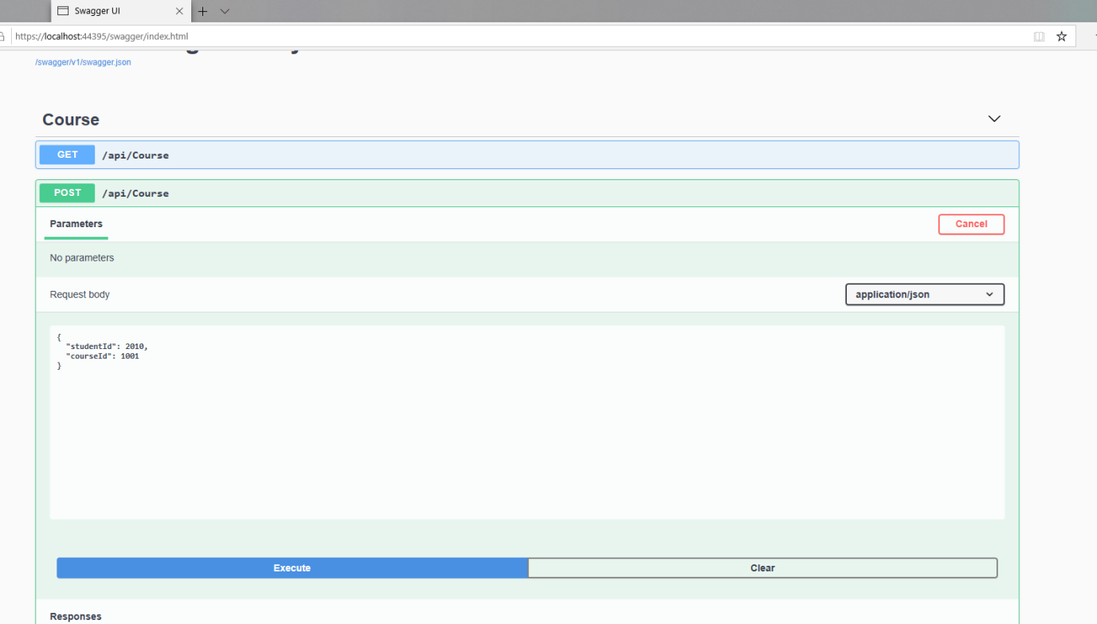

# How to run the Integration Tests.

To run the integration tests an instance of the application needs to be running. Go to debug start with debugging. Then run the integration tests.

I used a hybird approach of code first, EF and ADO.net. The integration test uses in-memory database for some queries. For the storage procedure I would use a real database.

If you have any questions please do not hesistae to contact me via email [seanthaughey@gmail.com](mailto:seanthaughey@gmail.com) or mobile0838893251