TEC “Illegal” Copy Party; Lane Cove, Sydney – June 1989

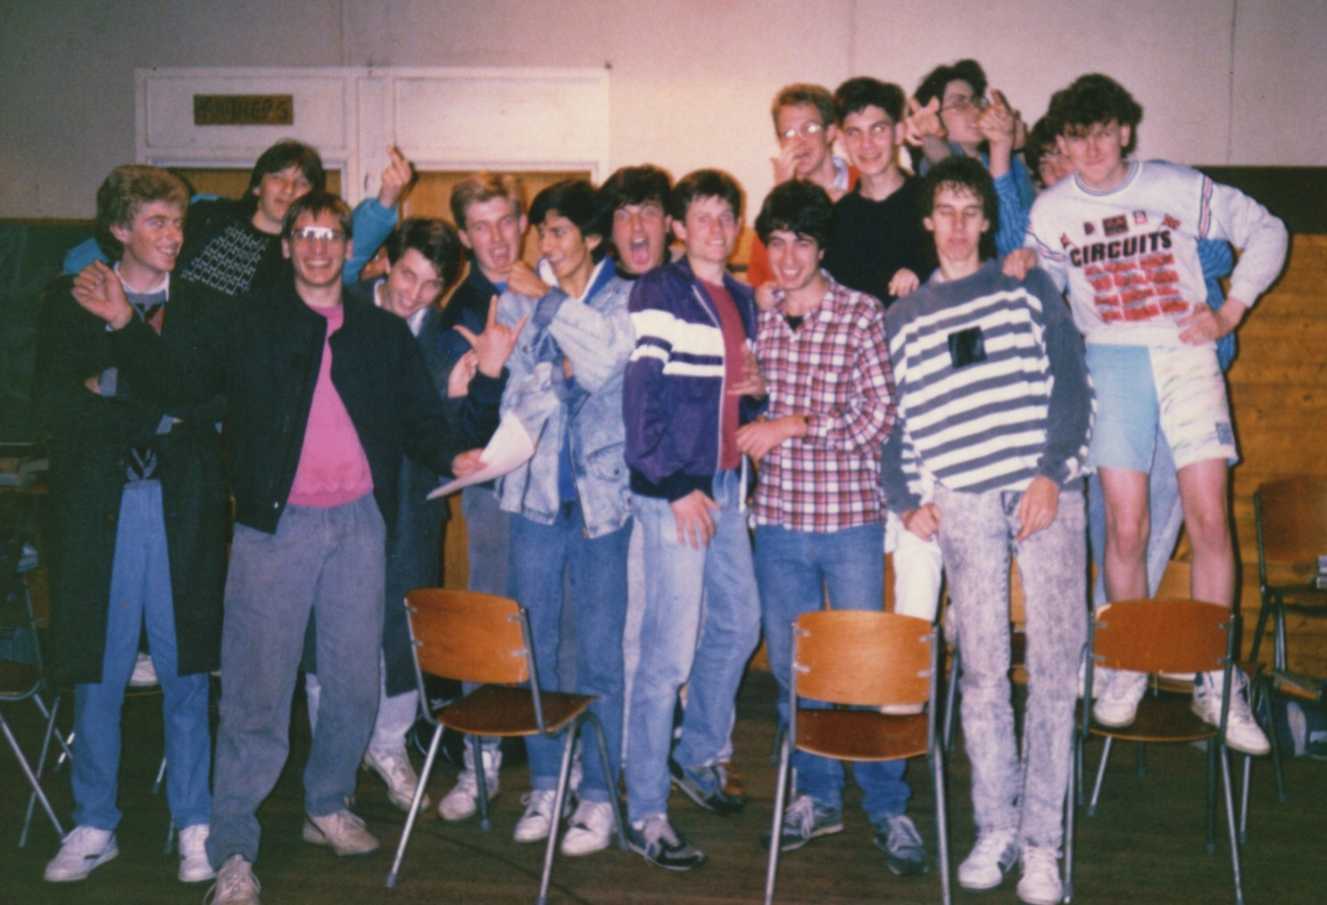

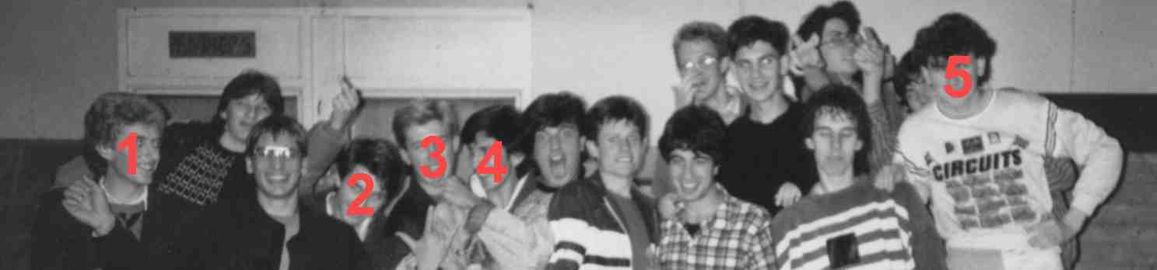

1 XLR8
2 MATT’
3 MISTIC
4 SNOOP
5 BEVAN

