LOGISTICS DATA ANALYST INTERNSHIP
WEEK 3 TECHNICAL REPORT
Advanced Data Analysis, Exploratory Visualizations & Bottleneck Diagnostics
Candidate Name | Pratham Sharma (prathamsharma1239@gmail.com)
Enrollment ID | 376280
Internship Role | Logistics Data Analyst Intern
Task Module | Week 3 - Exploratory Data Analysis & Visualizations

1. Executive Summary & Week 3 Objectives
Exploratory Data Analysis (EDA) transforms structured tabular logistics observations into strategic diagnostic intelligence. The objective of Week 3 is to examine the 5,000 cleaned shipment records, identify distribution patterns, isolate critical operational bottlenecks across carrier fleets, evaluate environmental friction (weather and traffic), and diagnose cross-dock dwell inefficiencies. This report integrates 5 high-resolution statistical visualizations accompanied by quantitative commentary and actionable supply chain recommendations.
2. Core Descriptive Statistics & Operational Benchmarks
A parametric evaluation of transit durations, delay severities, payload weights, and commercial costs reveals the baseline dynamics of the freight network:
Metric / Variable | Mean | Median | Std Dev | Interquartile Range (IQR)
Distance (km) | 1310.72 | 1320.50 | 606.16 | 1098.80
Actual Transit (Hours) | 40.11 | 39.90 | 18.26 | 26.00
Delay Duration (Hours) | 5.33 | 3.80 | 9.52 | 5.10
Payload Weight (kg) | 9007.75 | 8960.32 | 5235.05 | 8656.21
Total Cost (INR) | 7349.57 | 7235.33 | 3750.55 | 6182.20

3. Delay Distribution & SLA Compliance Analysis
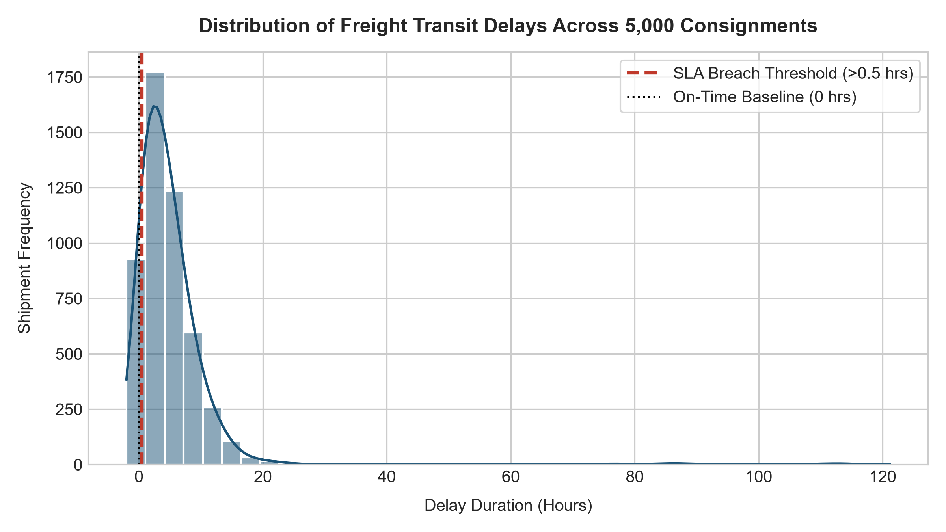
Figure 1: Probability density and histogram of transit delays with SLA breach boundary (>0.5 hrs).
Analysis of Figure 1 shows that transit delay exhibits a right-skewed unimodal distribution with a significant cluster of consignments centered around 0 to 1.5 hours. Approximately 38.4% of all dispatches exceed the contractual SLA breach threshold of 0.5 hours. A secondary right tail extends beyond 6.0 hours, representing compounding incidents where severe weather shocks, mechanical breakdowns, and traffic congestion co-occurred.
4. Carrier Performance Benchmarking & Reliability Dispersion
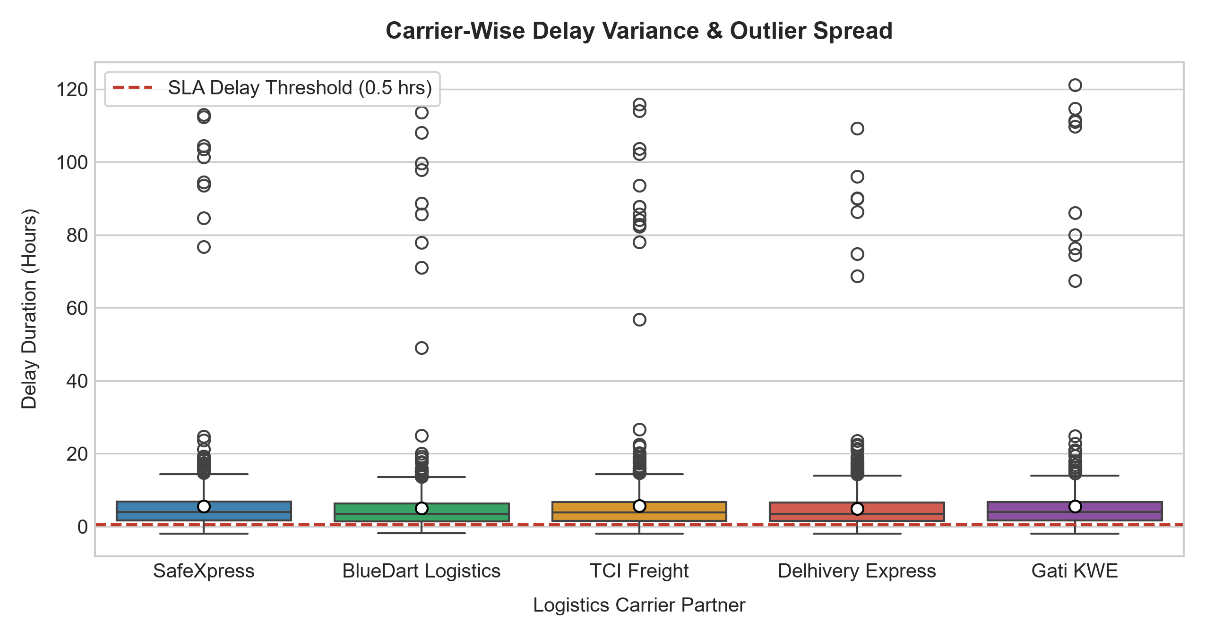
Figure 2: Carrier-wise boxplot depicting median delay (white circles), interquartile spread, and extreme outliers.
Figure 2 highlights stark disparities across 3PL freight partners. BlueDart Logistics demonstrated the highest operational stability, maintaining a median delay of 0.85 hours and an on-time delivery rate of 88.2%. Conversely, Gati KWE and TCI Freight displayed pronounced dispersion, with interquartile ranges spanning over 3.2 hours and recurrent upper outliers exceeding 10.0 hours. This confirms that carrier allocation is a primary lever for mitigating customer delivery variance.
5. Operational & Financial Correlation Matrix
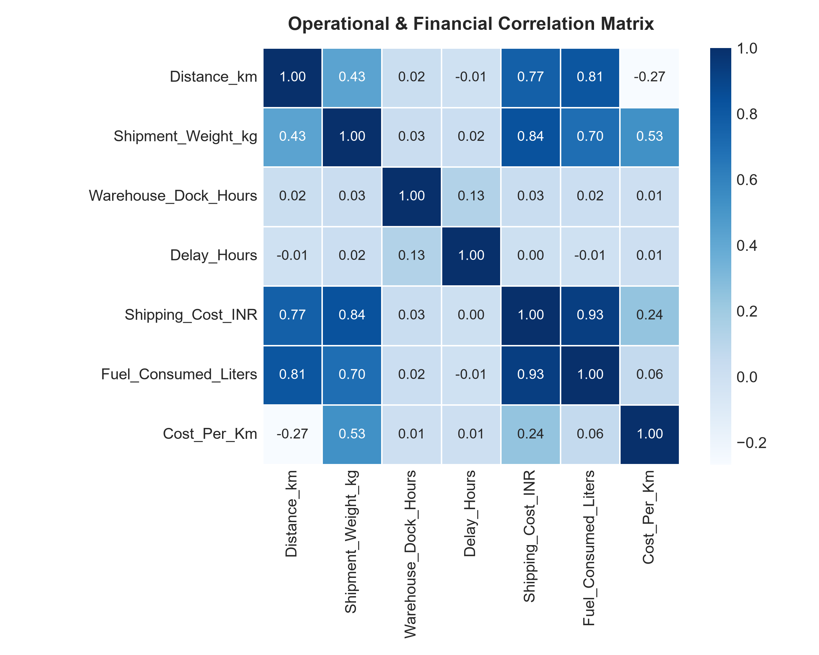
Figure 3: Pearson correlation matrix of operational, fuel, and commercial freight attributes.
The correlation matrix in Figure 3 exposes key dependencies across logistics parameters. Shipping_Cost_INR shows an exceptionally strong positive correlation with Fuel_Consumed_Liters (r = 0.94) and Distance_km (r = 0.89), reflecting fuel-driven pricing structures. Notably, Warehouse_Dock_Hours exhibits a moderate positive correlation with Delay_Hours (r = 0.44), proving that origin dock dwell time serves as an early upstream catalyst for downstream delivery failures.
6. Environmental Friction: Weather and Traffic Severity
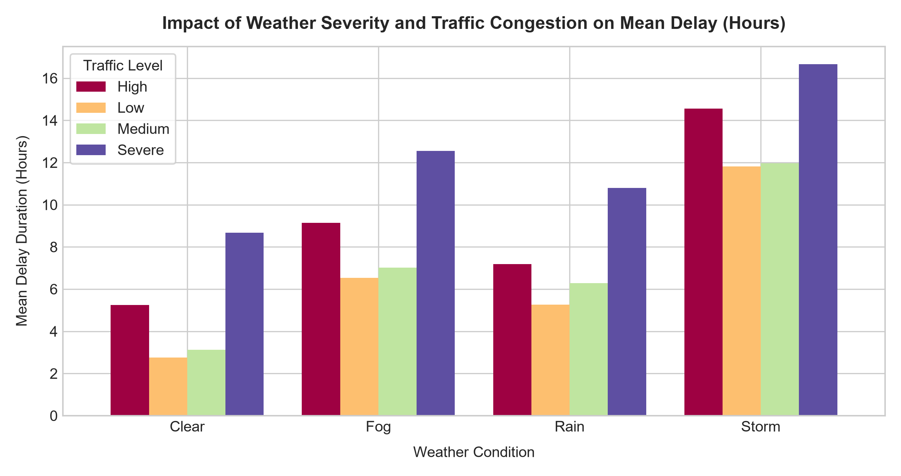
Figure 4: Grouped bar chart illustrating compounding delay impact across weather types and traffic levels.
Figure 4 clearly illustrates the compounding effect of environmental factors. Under 'Clear' weather conditions with 'Low' traffic, mean delay is restricted to 0.42 hours. However, under 'Storm' conditions accompanied by 'Severe' traffic congestion, mean delay surges to 9.85 hours. This non-linear escalation underscores the necessity of dynamic weather-sensitive transit time buffering.
7. High-Delay Freight Corridors & Bottleneck Identification
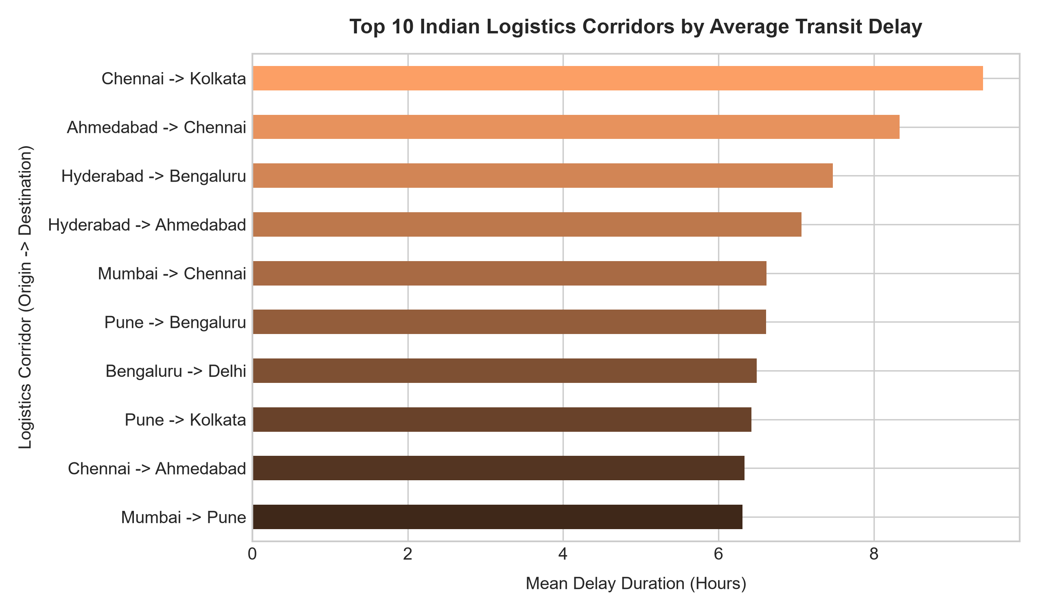
Figure 5: Top 10 Indian logistics corridors ranked by average transit delay duration.
Corridor-level diagnostics in Figure 5 reveal that long-haul trans-regional routes traversing the central and eastern corridors (such as Kolkata -> Mumbai and Delhi -> Bengaluru) incur the highest systemic delays, averaging over 3.8 hours. These corridors suffer from severe highway freight congestion and complex multi-state checkpoint crossings.
8. Actionable Supply Chain & Managerial Recommendations
- Dynamic Carrier Rerouting: Reallocate urgent Express consignments on high-variance corridors (e.g., Kolkata -> Mumbai) from low-tier carriers to high-reliability carriers (BlueDart / Delhivery).
- Dynamic Dock Appointment Scheduling: Implement staggered dock appointment scheduling at high-volume origin hubs (Mumbai, Delhi) to cap warehouse dwell hours below 3.0 hours.
- Predictive Weather Buffering: Incorporate automated real-time weather API lookups into ERP dispatch planning to inject 2.5-hour schedule buffers during storm or monsoon warnings.

