ZINKRO
DESIGN SYSTEM & INFORMATION ARCHITECTURE
Track It All. Automatically.
The Intelligent Operating System for Your Money
Version 1.0 | Foundational Reference for Product, Design & Engineering Teams

Table of Contents

Section 1 — Information Architecture
This section defines how Zinkro's features are organized, how users move through the product, and how Zinkro's current and future modules connect to one another. It is the structural foundation that the design system (Section 2) and all future screen designs are built on top of.

1.1 Mobile Navigation Structure
Zinkro's mobile app uses a 5-tab persistent bottom navigation bar, keeping the most-used destinations one tap away at all times. Each tab expands into a small set of secondary screens reached via cards, headers, or contextual actions within that tab.
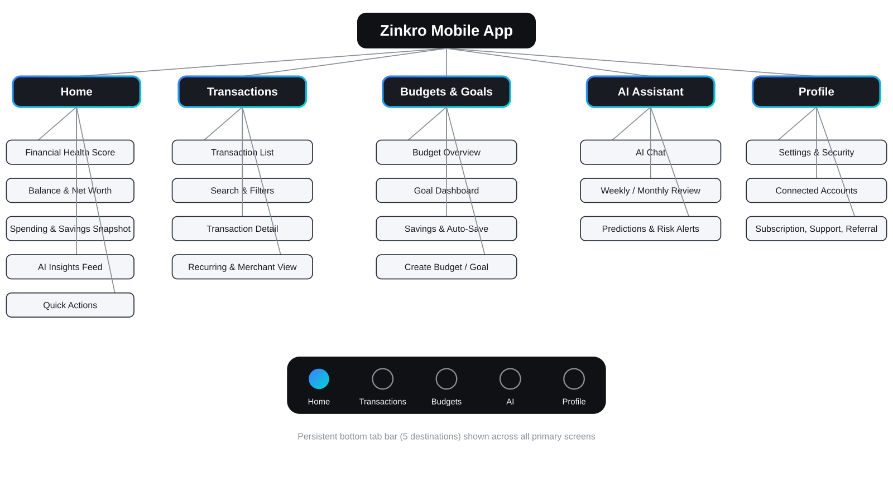
Tab | Primary Screen | Secondary Screens
Home | Home Dashboard | Financial Health Score detail, Net Worth detail, Notification center
Transactions | Transaction List | Transaction Detail, Search & Filters, Recurring Transactions, Merchant Analysis
Budgets & Goals | Budget Overview | Budget Categories, Budget Creation, Goal Dashboard, Goal Creation, Savings & Auto-Save
AI Assistant | AI Chat | Weekly Review, Monthly Review, Predictions & Risk Alerts
Profile | Profile / Settings | Security, Notifications, Connected Accounts, Privacy, Subscription, Support, Referral, Rewards

1.2 Web Navigation Structure
The web platform uses a persistent left sidebar (collapsible) for primary navigation, with a top bar reserved for account context, search, and notifications. This structure scales from individual user dashboards to admin, partner, investor, and business dashboards by swapping the sidebar's content while retaining the same shell.
Navigation Zone | Contents
Top Bar | Zinkro logo (lockup), workspace/account switcher, global search, notifications bell, profile menu
Left Sidebar — Personal | Dashboard, Transactions, Budgets, Goals, Savings, AI Assistant, Reports, Settings
Left Sidebar — Business (Zinkro Business) | Dashboard, Transactions, Cash Flow, Invoicing, Team, Reports, Settings
Left Sidebar — Admin Console | User Management, Transaction Monitoring, Support Tickets, System Health, Feature Flags
Left Sidebar — Partner / Investor Dashboard | Portfolio Overview, Usage Metrics, Financial Reports, Documents, Settings
Content Area | Renders the selected module; supports a secondary right-hand panel for AI insights or contextual detail on wide screens (≥1440px)

1.3 User Journey Map
Stage | User Goal | Key Touchpoints | Emotional State
Awareness | Understand what Zinkro does and whether it's worth trying | Landing website, social media, app store listing | Curious, skeptical of 'another finance app'
Onboarding | Set up account with minimal effort | Sign up, OTP, biometric setup, permissions | Cautious (especially around SMS/bank permissions), hopeful
Activation | See first automatic value | First synced transactions, first categorized summary | Surprised / delighted ('it actually worked')
Habit Formation | Check in regularly without needing to do data entry | Home dashboard, push notifications, AI insights | Increasingly trusting, building routine
Growth | Use Zinkro to actively improve finances | Budgets, goals, savings rules, AI recommendations | Empowered, motivated by visible progress
Expansion | Adopt additional Zinkro products as needs grow | Zinkro Wealth, Invest, Credit, Pay prompts within app | Confident, viewing Zinkro as a long-term financial partner
Advocacy | Share Zinkro with others | Referral program, social sharing of milestones | Proud, financially in control

1.4 Customer Lifecycle
- Acquisition — App store listing, social/content marketing (Section 15 of Brand Guide), referral links.
- Onboarding — Account creation, permission grants, and first automatic transaction sync (target: value visible within 24 hours).
- Engagement — Daily/weekly check-ins driven by push notifications, AI insights, and goal progress updates.
- Retention — Monthly summaries, savings milestones, and budget performance reviews reinforce ongoing value.
- Expansion — Cross-sell into Zinkro Wealth (savings/investing), Zinkro Credit (based on transaction history), and Zinkro Pay (transfers) as natural next steps once trust is established.
- Advocacy — Referral program and shareable milestone cards (e.g. 'I saved 12% more this month with Zinkro') drive organic growth.
- Win-back — Re-engagement notifications for dormant users, focused on 'here's what you missed' summaries rather than generic reminders.

1.5 Feature Hierarchy
Level 1 (Tab) | Level 2 (Module) | Level 3 (Feature)
Home | Overview | Financial Health Score, Total Balance, Net Worth Snapshot
Home | Activity Summary | Monthly Spending, Monthly Savings, Spending Trends
Home | Guidance | AI Insights, Goal Progress, Upcoming Bills, Quick Actions
Transactions | Browse | Transaction List, Transaction Timeline, Search, Filters
Transactions | Detail | Transaction Detail, Category Assignment, Merchant Analysis
Transactions | Patterns | Recurring Transactions
Budgets & Goals | Budgets | Budget Overview, Categories, Creation, Performance, Forecast, Overspending Alerts
Budgets & Goals | Goals | Goal Creation, Goal Dashboard, Progress Tracking, Milestones, Recommendations
Budgets & Goals | Savings | Savings Dashboard, Savings Rules, Auto-Save, Round-Up Savings, Emergency Fund Tracker
AI Assistant | Conversational | AI Chat, Financial Questions
AI Assistant | Proactive | Spending Analysis, Predictions, Risk Alerts, Weekly/Monthly Review, Recommendations
Profile | Account | Settings, Security, Connected Accounts, Privacy
Profile | Engagement | Notifications, Subscription, Referral Program, Rewards, Support
(Cross-cutting) | Reports | Monthly/Yearly Reports, Spending & Savings Trends, Financial Score, Income Analysis, PDF Export

1.6 Core User Flows

1.6.1 Onboarding Flow
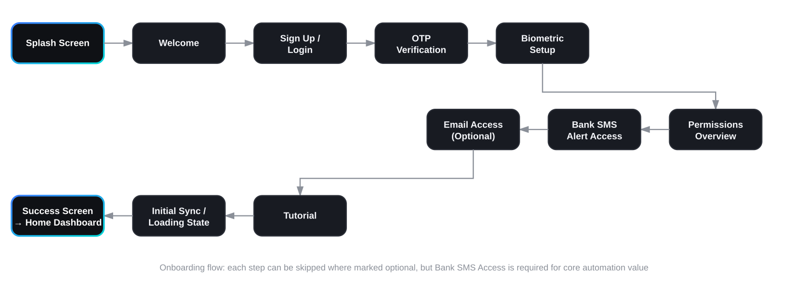
This flow is detailed further as the first set of mobile screens to be designed (see companion mockups). Bank SMS Alert Access is the single most important permission — it is the foundation of Zinkro's automatic-tracking value proposition — and is framed as a clear, trust-building step rather than a generic permission request.

1.6.2 Add / Review Transaction Flow
- Bank/telco SMS or email alert is received and parsed in the background.
- Transaction appears in the Transaction List with an auto-suggested category (badge: 'Auto-categorized').
- User taps the transaction to confirm or change the category (one-tap correction).
- If corrected, Zinkro's categorization model updates its rule for similar future transactions from that sender.
- Transaction is reflected immediately in Home Dashboard totals, the relevant Budget category, and any linked Goal.

1.6.3 Create Budget Flow
- From Budgets & Goals tab, user taps 'Create Budget'.
- User selects a category (pre-populated from existing transaction categories) or creates a custom one.
- Zinkro suggests a budget amount based on the user's average spend in that category over the last 3 months.
- User accepts, adjusts, and sets the budget period (monthly by default).
- Budget appears on the Budget Overview screen with a live progress bar updated automatically as transactions are categorized.

1.6.4 Goal Creation Flow
- From Budgets & Goals tab, user taps 'New Goal'.
- User names the goal, sets a target amount and target date (or selects an AI-recommended goal, e.g. 'Build a 3-month emergency fund').
- Zinkro calculates a suggested monthly contribution and, if Auto-Save is enabled, proposes a savings rule (e.g. round-up transactions, or a fixed weekly transfer).
- Goal appears on the Goal Dashboard with a progress ring; milestones (25%, 50%, 75%, 100%) trigger celebratory notifications.

1.6.5 AI Assistant Query Flow
- User opens AI Assistant tab or taps an AI Insight card from Home.
- User asks a question in natural language (e.g. 'How much did I spend on transport this month compared to last month?') or selects a suggested prompt.
- AI Assistant queries the user's transaction and budget data, returning a plain-language answer plus a relevant chart or comparison.
- AI may proactively suggest a follow-up action (e.g. 'Want me to set a transport budget of ₦25,000 based on this?') with a one-tap accept.

1.7 Product Ecosystem Diagram
Zinkro Core (expense tracking, budgets, goals, savings) sits on top of a shared data layer — transaction history, identity, and the AI engine — that every future Zinkro product reads from and contributes to. This means a user's financial history becomes more valuable to them over time, and new products can be introduced as natural extensions rather than separate apps.
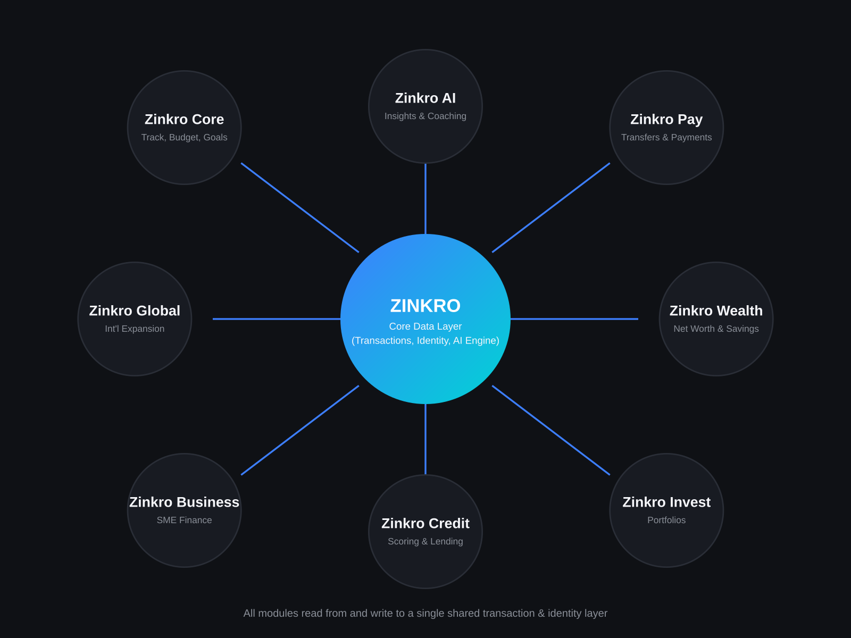

Section 2 — Design System
This design system translates the Zinkro Brand Guide (v1.0) into reusable tokens and components for both mobile and web. It is structured so that engineering teams can implement it directly as a shared token library (e.g. Style Dictionary, Tailwind config, or Figma Variables) consumed by both platforms.

2.1 Color Tokens
Tokens are defined once and resolve differently depending on the active theme (dark or light). Dark mode is the default experience; light mode uses the same token names with adjusted values for contrast on light surfaces.
Swatch | Token | Hex | Dark / Light | Usage
 | color/bg/canvas (Dark) | #0F1115 | Dark | Screen background — the base layer for all mobile and web screens
 | color/bg/canvas (Light) | #FFFFFF | Light | Screen background in light mode
 | color/bg/surface (Dark) | #181B22 | Dark | Cards, panels, sheets, navigation bars
 | color/bg/surface (Light) | #F5F6FA | Light | Cards, panels, sheets, navigation bars in light mode
 | color/border/default (Dark) | #2A2E37 | Dark | Dividers, card borders, input borders
 | color/border/default (Light) | #E2E4EA | Light | Dividers, card borders, input borders in light mode
 | color/text/primary (Dark) | #F5F6FA | Dark | Headings, primary body text, key figures
 | color/text/primary (Light) | #0F1115 | Light | Headings, primary body text, key figures in light mode
 | color/text/secondary | #8A8F98 | Both | Captions, timestamps, placeholders, helper text
 | color/accent/primary | #3D7FFF | Both | Primary buttons, links, active tab, focus rings
 | color/accent/secondary | #00D4D4 | Both | Gradient pairing, growth/positive highlights, AI accents
 | color/feedback/success | #34D399 | Both | Income, positive balances, completed goals, success toasts
 | color/feedback/error | #FF6B6B | Both | Errors, destructive actions, overspending alerts
 | color/feedback/warning | #FFB84D | Both | Warnings, pending states, approaching budget limits

2.2 Category Color Tokens
Used consistently for budget categories, transaction tags, and chart series across the entire product.
Swatch | Token | Hex | Dark / Light | Usage
 | category/utilities | #3D7FFF | Both | Utility bills (electricity, water, internet)
 | category/feeding | #FFB84D | Both | Food, groceries, dining
 | category/transport | #00D4D4 | Both | Transport, fuel, ride-hailing
 | category/gifts-family | #FF6B6B | Both | Gifts and family support transfers
 | category/rent-housing | #9B7EDE | Both | Rent, mortgage, housing costs
 | category/other | #8A8F98 | Both | Uncategorized or miscellaneous spend

2.3 Typography Scale
Inter (UI/body) and Sora (display/headings) form the complete type system, extending the scale defined in the Brand Guide (Section 8) with additional roles needed for dense financial interfaces.
Token | Typeface / Weight | Size / Line Height | Usage
type/display-xl | Sora Bold | 40px / 48px | Marketing hero headlines, web landing page
type/display | Sora Bold | 32px / 40px | Splash screens, large balance displays
type/h1 | Sora SemiBold | 28px / 36px | Screen titles ('Home', 'Transactions')
type/h2 | Sora SemiBold | 22px / 30px | Section headers within a screen
type/h3 | Inter SemiBold | 18px / 26px | Card titles, list group headers
type/body-l | Inter Regular | 16px / 24px | Primary reading text, AI chat messages
type/body-m | Inter Regular | 15px / 22px | Standard UI text, list item titles
type/body-s | Inter Regular | 13px / 20px | Secondary text, helper copy
type/caption | Inter Regular | 12px / 16px | Timestamps, metadata, legal text
type/overline | Inter SemiBold | 11px / 16px (uppercase, +1px tracking) | Section eyebrows, chart axis labels
type/numeric-display | Inter Bold (tabular) | 40px / 48px | Hero balance on Home Dashboard
type/numeric-l | Inter SemiBold (tabular) | 24px / 32px | Card-level totals (budget spent, goal progress)
type/numeric-m | Inter Medium (tabular) | 16px / 24px | Transaction amounts in lists
type/numeric-s | Inter Medium (tabular) | 13px / 20px | Inline figures within sentences
type/button | Inter SemiBold | 15px / 20px | Buttons, tabs, chips, badges

2.4 Spacing System
An 4px base unit underlies all spacing, padding, and layout decisions, ensuring visual rhythm across both platforms.
Token | Value | Typical Usage
space/2xs | 4px | Icon-to-label gaps, tight inline spacing
space/xs | 8px | Padding within small components (chips, badges)
space/sm | 12px | Spacing between related elements within a card
space/md | 16px | Default card padding, spacing between list items
space/lg | 24px | Spacing between distinct sections on a screen
space/xl | 32px | Top padding below navigation bars, major section breaks
space/2xl | 48px | Empty state vertical spacing, onboarding screen padding
space/3xl | 64px | Web layout section spacing
space/4xl | 96px | Web landing page section spacing

2.5 Grid System
Breakpoint | Width Range | Columns | Margin | Gutter
Mobile | < 600px | 4 | 16px | 8px
Tablet | 600px – 1023px | 8 | 24px | 16px
Desktop | 1024px – 1439px | 12 | 32px | 24px
Large Desktop | ≥ 1440px | 12 (max content width 1280px, centered) | Auto | 24px
- Mobile screens use single-column layouts; the 4-column grid governs alignment of cards, icons, and form fields rather than multi-column layouts.
- Tablet introduces two-column layouts for list+detail views (e.g. Transaction List beside Transaction Detail).
- Desktop and Large Desktop support the sidebar + content + optional right-panel layout described in Section 1.2.

2.6 Iconography
Extends the icon system defined in the Brand Guide (Section 9): 24px base grid, 1.75px stroke, rounded terminals, gradient reserved for active states.
Size Token | Pixel Size | Usage
icon/xs | 16px | Inline icons within body text, dense table rows
icon/sm | 20px | List item leading icons, input field icons
icon/md | 24px | Default size — navigation, buttons, cards
icon/lg | 32px | Empty states, onboarding illustrations, AI avatar
icon/xl | 48px | Splash screens, large feature callouts

2.7 Buttons
Variant | Appearance | Usage | States
Primary | Filled, accent/primary (#3D7FFF) background, white text, 12px corner radius | Main call-to-action per screen (one per screen maximum) | Default, Pressed (90% opacity), Disabled (40% opacity), Loading (spinner replaces label)
Secondary | Outlined, 1.5px border in accent/primary, transparent background, accent/primary text | Secondary actions alongside a primary button | Default, Pressed (10% accent fill), Disabled
Tertiary / Ghost | No border or fill, accent/primary text | Low-emphasis actions (e.g. 'Skip', 'Cancel') | Default, Pressed (underline), Disabled
Destructive | Filled, feedback/error (#FF6B6B) background, white text | Irreversible actions (e.g. 'Delete Goal', 'Disconnect Account') | Default, Pressed, Disabled, requires confirmation modal
Icon Button | 24px icon within a 40x40px tap target, optional surface background | Compact actions in headers, list items, chat input | Default, Pressed, Disabled, Active (filled background)
Gradient CTA | Filled with brand gradient (#3D7FFF → #00D4D4), white text | Single highest-priority action per major flow (e.g. 'Get Started', 'Connect Bank Alerts') | Default, Pressed (slight darken), Disabled

2.8 Cards
Card Type | Anatomy | Used On
Summary / Metric Card | Label (overline) + numeric-l value + optional trend indicator (▲/▼ with success/error color) + sparkline | Home Dashboard (Balance, Monthly Spending, Monthly Savings)
Transaction Card / Row | Merchant icon or initials avatar, merchant name (body-m), category tag (chip), timestamp (caption), amount (numeric-m, colored by income/expense) | Transaction List, Recent Transactions on Home
Budget Category Card | Category icon (category color), category name, progress bar (category color fill on surface track), 'spent of budget' (numeric-s) | Budget Overview
Goal Card | Goal name, target amount, circular progress ring (gradient fill), target date, milestone markers | Goal Dashboard
AI Insight Card | AI avatar (gradient circular badge), insight text (body-m), optional inline chart, one-tap action button | Home Dashboard feed, AI Assistant
Bill Reminder Card | Merchant/biller name, due date (highlighted if ≤ 3 days), amount, 'Mark as Paid' quick action | Home Dashboard — Upcoming Bills
All cards use color/bg/surface, 16-20px corner radius, space/md (16px) internal padding, and a 1px color/border/default border in dark mode (omitted in light mode in favor of subtle elevation shadow).

2.9 Charts
Chart Type | Usage | Color Mapping
Line Chart | Spending/income trends over time, balance history, net worth over time | Primary series in accent/primary; comparison series (e.g. previous period) shown as a dashed line in color/text/secondary
Bar Chart | Monthly comparisons (this month vs. last), category totals | Bars colored by category token (Section 2.2); current period at full opacity, comparison period at 40% opacity
Donut / Pie Chart | Spending breakdown by category for the current period | Each segment uses its category token; center displays total amount in numeric-l
Progress Ring | Goal progress, budget category progress, Financial Health Score | Gradient fill (#3D7FFF → #00D4D4) on a color/border/default track; success green when complete or under budget, error coral when over budget
Heatmap (Calendar) | Spending intensity by day across a month/year (Analytics) | 5-step scale from color/bg/surface (no spend) to accent/primary (highest spend day)
Sparkline | Compact trend indicator within Summary Cards | Single-color line in accent/secondary (teal), no axis labels

2.10 Tables (Web)
- Row height: 56px default, 48px in 'compact' density mode (user-toggleable in Settings).
- Header row: color/bg/surface background, type/overline labels, sortable columns indicated with a small directional caret.
- Zebra striping: alternating rows use a 2% opacity overlay of color/text/primary for subtle separation without heavy borders.
- Row interactions: hover state applies a 4% accent/primary tint; clicking a transaction row opens the Transaction Detail panel on the right (desktop) or navigates to a detail screen (tablet/mobile).
- Sticky header and sticky first column (date) for wide tables such as Transaction History and Reports.

2.11 Forms
Element | Specification
Text Input | 48px height, 12px corner radius, color/bg/surface fill, 1.5px color/border/default border; on focus, border becomes 2px accent/primary with a subtle glow
Input Label | type/body-s, positioned above the field, color/text/secondary, becomes accent/primary on focus
Helper / Error Text | type/caption below the field; helper text in color/text/secondary, error text in feedback/error with a small inline icon
Dropdown / Select | Same styling as Text Input with a chevron icon (icon/sm); opens a bottom sheet on mobile, inline popover on web
Toggle / Switch | Track in color/border/default (off) or accent/primary (on); thumb in color/bg/canvas; used for settings and savings rules (e.g. Round-Up Savings on/off)
Checkbox / Radio | 20px, rounded 6px (checkbox) or fully rounded (radio); checked state uses accent/primary fill with white check/dot
Currency Input | Right-aligned numeric-l text, currency symbol prefixed and locked based on user's primary currency, automatically formatted with thousands separators
Validation Timing | Inline validation on blur for individual fields; full-form validation summary shown on submit attempt if multiple fields are invalid

2.12 Alerts & Notifications
Type | Appearance | Examples
Inline Banner | Full-width card at top of screen content, left border accent in feedback color, icon + message + optional action link | 'You're 92% through your Feeding budget for this month.'
Toast | Temporary surface card, bottom of screen (mobile) or bottom-right (web), auto-dismisses after 4s | 'Transaction recategorized as Transport.'
Push Notification | OS-native notification using circular badge icon; title in Sora-equivalent system bold, body in plain language per Voice & Tone | 'You're ₦15,000 away from your Lagos Trip goal — on track for March 14.'
In-App Notification Center | List of past notifications grouped by day, unread items marked with accent/primary dot | Accessible from Home tab notification icon
Risk Alert | Higher-emphasis banner using feedback/error, cannot be dismissed without acknowledgement | 'Unusual transaction detected: ₦120,000 to a new recipient. Was this you?'

2.13 Modals & Bottom Sheets
- Mobile: contextual actions (category change, filter selection, confirmations) use bottom sheets that slide up over a dimmed scrim, with a drag handle and rounded top corners (20px).
- Mobile: full-screen modals are reserved for multi-step flows (Create Budget, Create Goal, Add Manual Transaction) and include a clear close (X) action top-left and primary action top-right.
- Web: equivalent interactions use centered dialog modals (max-width 480px for simple confirmations, 720px for multi-step flows) with the same dimmed scrim treatment.
- Destructive confirmations always require an explicit secondary tap (e.g. 'Delete' button disabled for 1 second after modal opens to prevent accidental taps).

2.14 Empty States
Screen | Empty State Message & Action
Transactions (before first sync) | Illustration (geometric, per Brand Guide Section 10) + 'Once you connect your bank alerts, your transactions will appear here automatically.' + 'Connect Now' button
Budgets (no budgets created) | 'You don't have any budgets yet. Want Zinkro to suggest one based on your spending?' + 'Get Suggestions' button
Goals (no goals created) | 'Set your first goal and Zinkro will help you get there automatically.' + 'Create a Goal' button
AI Assistant (first open) | Gradient AI avatar + 'Hi, I'm your Zinkro AI. Ask me anything about your money.' + 3 suggested prompts as chips
Search (no results) | 'No transactions match “[query]”. Try a different keyword or adjust your filters.'

2.15 Loading States & Skeleton Screens
- Initial app load and transaction sync use skeleton screens (animated shimmer over color/bg/surface blocks shaped like the eventual content) rather than spinners, to set accurate layout expectations.
- Skeletons are used for: Home Dashboard cards, Transaction List rows, Budget category bars, and AI Assistant response bubbles (shown as three animated dots within a chat bubble).
- Pull-to-refresh on Home and Transactions triggers a brief inline loading indicator using the brand gradient as a circular spinner.
- Any action expected to take longer than 2 seconds (e.g. PDF report export) shows a progress indicator with an estimated completion message.

2.16 Financial Widgets
Widget | Description
Balance Widget | Hero element on Home Dashboard: total balance across connected accounts in type/numeric-display, with an eye icon to toggle visibility (privacy mode) and small account-breakdown link below
Financial Health Score | Circular gauge (0-100) using the gradient fill, with a label (e.g. 'Good', 'Needs Attention') and a one-line explanation of the primary factor affecting the score
Budget Progress Bar | Horizontal bar showing spent vs. budgeted for a category, using the category color for the fill and feedback/error if over budget
Goal Progress Ring | Circular ring widget showing percentage toward a goal, with milestone tick marks at 25/50/75/100%
Net Worth Snapshot | Compact line chart (sparkline-style but larger) showing assets vs. liabilities trend over the last 6-12 months
Spending Breakdown Donut | Donut chart of current month's spending by category, tappable segments link to filtered Transaction List
Upcoming Bills List | Compact list of recurring bills due within the next 7 days, each with a 'Mark as Paid' quick action
Round-Up Tracker | Shows cumulative amount saved via round-up rules this month, with a small animation when a new round-up is added

2.17 AI Components
Component | Description
AI Avatar | Circular badge using the brand gradient (#3D7FFF → #00D4D4); subtly animated (slow pulse) when the AI is 'thinking' or generating a response
AI Insight Card | Surface card with AI Avatar, insight text in type/body-m, and an optional one-tap action button (e.g. 'Set Budget', 'View Details')
AI Chat Bubble (Assistant) | Left-aligned bubble, color/bg/surface background, type/body-l text, may contain embedded mini-charts or transaction lists
AI Chat Bubble (User) | Right-aligned bubble, accent/primary background at 15% opacity, type/body-l text
Suggested Prompt Chip | Rounded pill, 1px accent/primary border, tappable to populate the chat input with a common question
Confidence / Source Tag | Small caption-style tag beneath AI statements referencing data source and period (e.g. 'Based on your last 90 days of transactions') to reinforce trust and transparency
Weekly/Monthly Review Card | Expandable card summarizing key changes since the last period, opened from Home or AI Assistant tab

2.18 Accessibility Standards
- All color combinations meet WCAG AA contrast ratios (4.5:1 for body text, 3:1 for large text and UI components) in both dark and light modes.
- Every interactive element has a minimum 44x44px (mobile) / 40x40px (web) tap/click target, even where the visual icon is smaller.
- All financial state changes (income vs. expense, over vs. under budget) are conveyed through icon and/or text in addition to color.
- Screen reader labels are required for all icons, charts (with text alternatives summarizing key data points), and progress indicators.
- Animations (skeletons, AI avatar pulse, progress fills) respect the OS 'Reduce Motion' setting, falling back to instant state changes.
- Forms support full keyboard navigation on web, with visible focus states using a 2px accent/primary outline.

2.19 Dark Mode & Light Mode
Dark mode is the default experience and the primary design target, reflecting the 'sleek tech' brand direction. Light mode uses the same component structure and tokens (Section 2.1) with swapped background/text values — no components are restructured between modes, only re-themed.
Aspect | Dark Mode | Light Mode
Canvas / Surface | #0F1115 / #181B22 | #FFFFFF / #F5F6FA
Primary Text | #F5F6FA | #0F1115
Borders | #2A2E37 | #E2E4EA
Card Elevation | 1px border, no shadow | No border, subtle 0-2px soft shadow
Gradient Usage | Used freely for accents, AI avatar, progress | Same usage; ensure sufficient contrast against white surfaces
Charts | Category colors at full saturation on dark background | Category colors at full saturation on light background; gridlines lightened

2.20 Responsive Behavior
Breakpoint | Layout Behavior
Mobile (< 600px) | Single column, bottom tab navigation, full-screen modals for multi-step flows, charts simplified (fewer gridlines/labels)
Tablet (600-1023px) | Two-column list+detail layouts where applicable (Transactions, Settings); bottom navigation may convert to a left rail
Desktop (1024-1439px) | Persistent left sidebar navigation, multi-column dashboards (2-3 cards per row), modals become centered dialogs
Large Desktop (≥1440px) | Adds optional right-hand contextual panel (e.g. AI insights alongside Transaction List); content max-width capped at 1280px and centered
This design system, together with Section 1's information architecture, provides the foundation for the mobile screen designs (beginning with the Onboarding flow) and subsequent web platform designs.

