**Q1.**

1.1

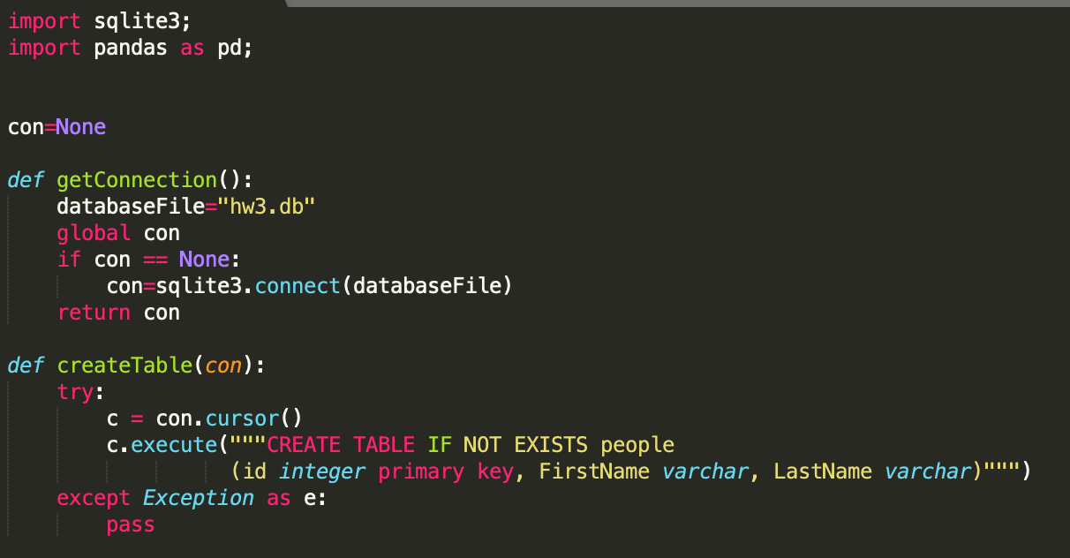

In the folder:



1.2

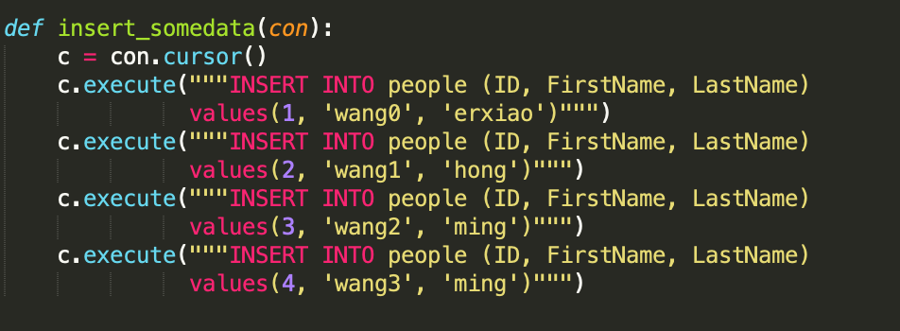

1.3

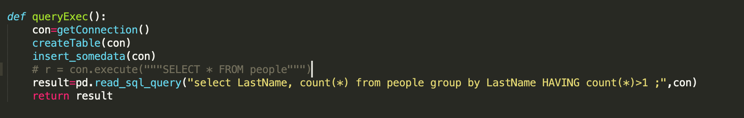

The outuput is:

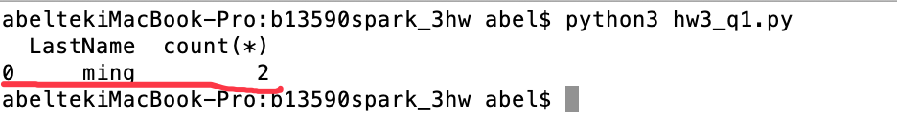

**Q2**