1. Goals and objectives (based on submitted proposals)

The main goal of this project is to develop effective inventory forecasting systems for two main types of products, as described in the reference paper "CUSTOMER DEMAND FORECASTING VIA SUPPORT VECTOR REGRESSION ANALYSIS" (A. A. LEVIS and L. G. PAPAGEORGIOU). 就是我文件夹的cherd.04246.pdf文件 our target is:

Study SVR (SUPPORT VECTOR REGRESSION) and implement at least three machine learning models, namely Linear Regression, Random Forest Regression, and Gradient Boosted Tree Regression, for inventory forecasting.

Compare the performance of these models in terms of variance and other relevant metrics.

Use a line chart to visualize the forecast results of the three models, where the X-axis represents time and the Y-axis represents demand.

Implement a user system, including registration, login, account information management (such as password and profile updates), and personal homepage functionality.

Integrate algorithmic components with a web-based user interface that allows users to interact with the inventory forecasting system.

2. Updated schedule/schedule and program constraints

The updated program schedule and schedule are as follows:

Weeks 1-2: Review reference papers and learn about PCA-based inventory forecasting techniques.

Weeks 3-4: Implement three machine learning models (linear regression, random forest regression, and gradient boosted tree regression) and compare their performance.

Week 5-6: Develop the user system, including registration, login, and account management functionality.

Week 7-8: Implement the profile feature, allowing users to manage their profile and product categories.

Weeks 9-10: Integrate algorithm components with a web-based user interface and interface with Jupyter Notebook for visualization of prediction results.

Project constraints include limited time and resources, which may affect the implementation of advanced features and the optimization of machine learning models. Additionally, any changes in requirements or scope can affect project timelines and deliverables.

3. List of functions in the application

The inventory forecasting system application will include the following features:

User registration and login system

Account information management, including password and profile updates

Personal home page with user profile information (e.g. interests, hobbies, personality description, self-introduction)

Manage analyzed product categories, including adding, deleting, editing, and viewing

Integrate implemented machine learning models (linear regression, random forest regression, gradient boosted tree regression) with a web-based user interface

Visualize forecast results with Jupyter Notebook integration, showing line graphs of actual and forecast demand for each model

e. Tools and techniques:

I. Collaboration tools such as version control systems, user testing, functional testing, and prototyping tools: Git, GitHub, Jira, Selenium, and Sketch

2. IDEs, programming languages, and technologies for application development: Python, flask (web framework), Jupyter Notebook, Scikit-learn (machine learning library), JavaScript, HTML5, and CSS3

3. Selected tools and/or services and other components: sqlite3/sqlchemy (database), my notebook (deployment cloud platform), matplot (visualization library)

4. Class diagrams /Activity diagrams

The inventory forecasting syste

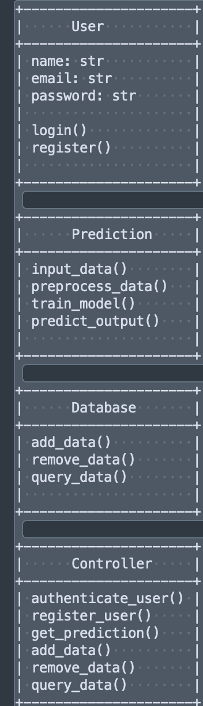

pasted-image.tiff

